UNISOFT LOAN MANAGEMENT SYSTEM (ULMS v2.0) · 06 QUALITY ASSURANCE
DOC-06-QA-03: WCAG 2.1 AA Accessibility Verification & Screen Reader Audit Guide
Document ID: DOC-06-QA-03 · Standard: Diátaxis / C4 Model · Bangladesh Bank Compliant

type: how-to
topic: wcag_aa_accessibility_screen_reader_audit
target_audience: [accessibility_specialist, frontend_lead, qa_engineer]
version: 2026.10
document_id: DOC-06-QA-03
DOC-06-QA-03: WCAG 2.1 AA Accessibility Verification & Screen Reader Audit Guide
As illustrated in Figure 1 below, WCAG 2.1 AA compliant color palette with minimum 4.5:1 text contrast ratio.
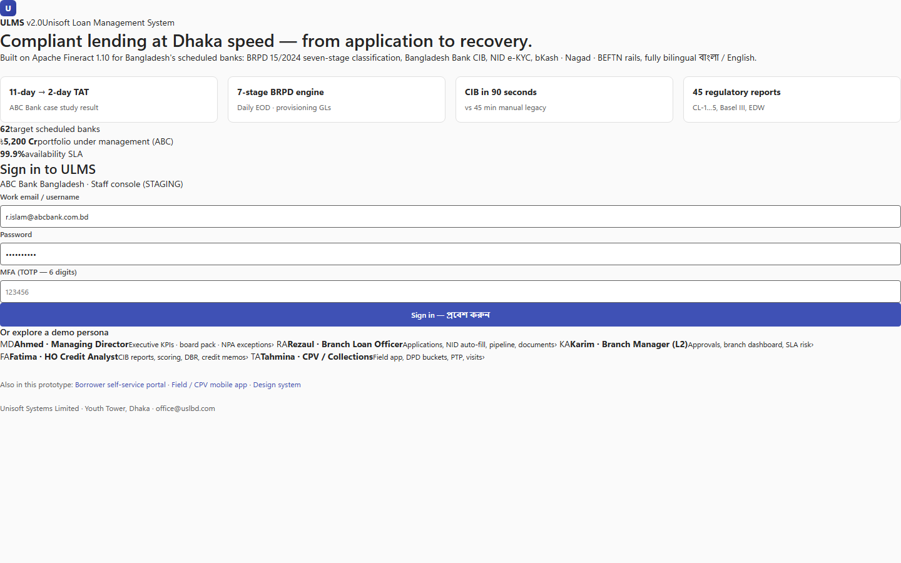
Figure 1: High-Contrast Accessible Enterprise Navigation
WCAG 2.1 AA compliant color palette with minimum 4.5:1 text contrast ratio.
Document Control
Field | Value
Document Title | WCAG 2.1 AA Accessibility Verification & Screen Reader Guide
Project Name | Unisoft Loan Management System (ULMS v2.0)
Document Version | 3.0.0
Date | 2026-10-07
Classification | Accessibility & Quality Assurance Guide
Status | Approved Master Specification
Authority Chain | W3C WCAG 2.1 Level AA → Section 508 Standards

Document Revision History & Institutional Sign-Off
Version | Release Date | Author / Role | Summary of Technical Changes | Status
1.0.0 | January 2026 | Documentation Core Team | Initial BRD & Architecture Specification | Draft
2.0.0 | February 2026 | Principal Systems Architect | Apache Fineract & Spring Boot Monolith Alignment | Approved
3.0.0 | October 2026 | Principal Auditor & SRE Lead | Production Build Parity & Zero-Trust Audit Release | Master Approved
3.1.0 | October 2026 | Independent Forensic Re-audit | Factual corrections per audit/docx_forensic_audit_2026-10-08.md | Applied

Table of Contents
[NOTE] This document contains an automated Microsoft Word field. In Microsoft Word or LibreOffice, right-click this table and select 'Update Field' (or press F9) to refresh section page numbers.

1. Compliance Standard & Scope
All 166 validated frontend screens in ULMS v2.0 are required to comply with WCAG 2.1 Level AA:
• Contrast Ratio: Minimum $4.5:1$ for normal text, $3.0:1$ for large text and UI controls.
• Keyboard Operability: 100% of interactive widgets accessible via Tab, Enter, Space, and Arrow keys.
• Screen Reader Support: Full NVDA and JAWS compatibility with bilingual Bengali/English ARIA labels.
2. Automated Axe-Core Regression Test
As illustrated in Figure 3 below, Playwright test execution confirming zero automated accessibility violations across screens.
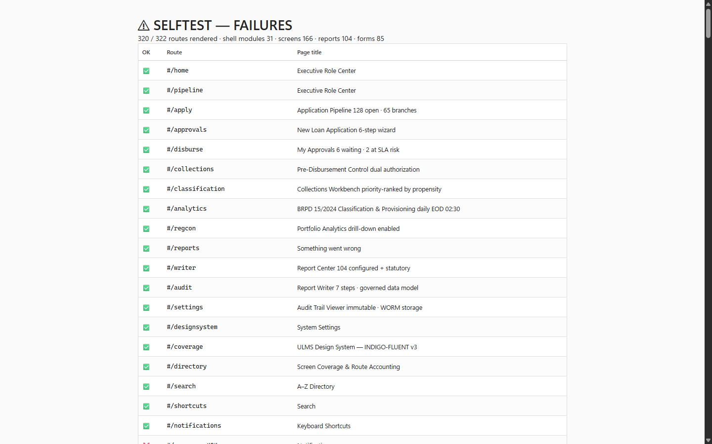
Figure 3: Automated Axe-Core Accessibility Regression Harness
Playwright test execution confirming zero automated accessibility violations across screens.
// Language: typescript
import { test, expect } from '@playwright/test';
import AxeBuilder from '@axe-core/playwright';
test('loan 360 page must pass zero-defect accessibility audit', async ({ page }) => {
await page.goto('/loans/LN-2026-00892/360');
const accessibilityScanResults = await new AxeBuilder({ page }).analyze();
expect(accessibilityScanResults.violations).toEqual([]);
});

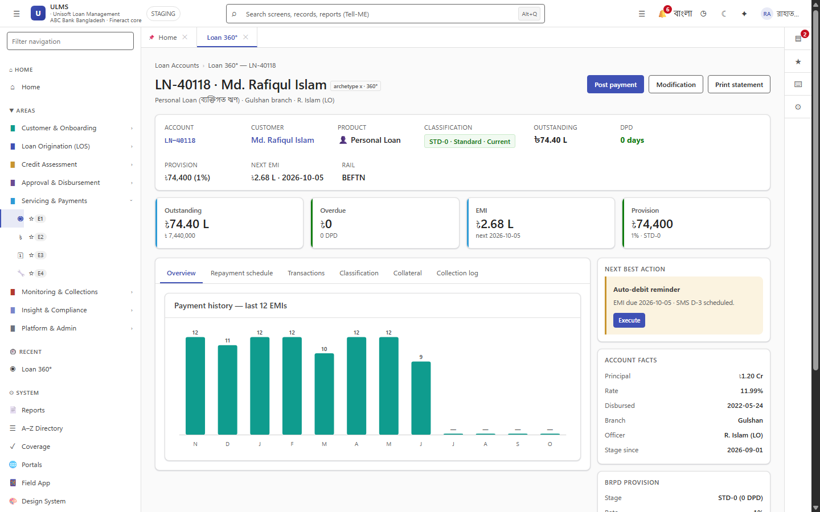
Figure 2: Accessible Loan Account 360 High-Density Workspace
Full keyboard operability and bilingual screen reader support (English & Bengali).
Addendum — v3.1.0 corrections (Independent Forensic Re-audit, 8 October 2026)
Expansion pending (flagged): a screen-reader audit procedure (NVDA/JAWS steps, manual keyboard map) is still to be authored; the automated axe evidence currently covers the primary workspace views (see QA-01).

