UNISOFT LOAN MANAGEMENT SYSTEM (ULMS v2.0) · TECHNICAL DOCUMENTATION SUITE NAVIGATION GUIDE
Unisoft Loan Management System (ULMS v2.0) — Technical Documentation Suite
Document ID: README · Standard: Diátaxis / C4 Model · Bangladesh Bank Compliant

Unisoft Loan Management System (ULMS v2.0) — Technical Documentation Suite
Classification: Enterprise Banking Technical Documentation
Target Audience: Bank IT Leadership, System Architects, DevOps Engineers, Core Banking Integrators, QA Auditors & Software Engineers
Scope: Complete 42-Document Operational Specification + 3 Root Governance Specifications (45 Total Documents)
Formats: GitHub-Flavored Markdown (.md) & Publication-Grade Microsoft Word (.docx) with Embedded Production Screenshots
Executive Overview
The Unisoft Loan Management System (ULMS v2.0) is an enterprise loan origination, assessment, servicing, and regulatory compliance platform engineered specifically for the scheduled commercial banks and financial institutions of Bangladesh. Built upon Java 21 LTS, Spring Boot 4, PostgreSQL 17, Keycloak 26, React 19, and Apache Fineract Community Edition (immutable digest pin apache/fineract@fd01236df6), ULMS v2.0 enforces deterministic financial calculations, minor-unit Poisha arithmetic, and complete alignment with Bangladesh Bank regulations (including BRPD Circular 15/2024, Bank Company Act 1991, and ICT Security Guidelines V4.0).
This directory houses the complete, authoritative technical documentation suite. Every document is available in two synchronized formats:
1. Markdown (`.md`): High-density technical documentation structured according to the Diátaxis Documentation Framework, complete with KaTeX financial notation, Gherkin BDD operational scenarios, and Mermaid sequence diagrams.
2. Microsoft Word (`.docx`): Formally styled corporate banking documents featuring custom executive cover pages, formal sign-off blocks, native OpenXML dynamic Tables of Contents, styled tables, code callouts, OpenXML headers/footers with Page X of Y numbering, and contextually anchored high-resolution screenshots from the validated production build.
Root Governance & Master Index Documents
Document Identifier | Title | Formats & Links | Scope & Status
CATALOG-001 | Master Technical Documentation Catalog | [Markdown](file:///c:/software_project/mim_project/LMS/technical_document/MASTER_TECHNICAL_DOCUMENTATION_CATALOG.md) · [Word (.docx)](file:///c:/software_project/mim_project/LMS/technical_document/docx/MASTER_TECHNICAL_DOCUMENTATION_CATALOG.docx) | 42-Document Master Architecture, Diátaxis Mappings, Codebase Citations & Delivery Audit (127 KB)
AUDIT-REP-001 | Forensic Audit & Remediation Report | [Markdown](file:///c:/software_project/mim_project/LMS/technical_document/AUDIT_AND_REMEDIATION_REPORT.md) · [Word (.docx)](file:///c:/software_project/mim_project/LMS/technical_document/docx/AUDIT_AND_REMEDIATION_REPORT.docx) | Zero-Trust Automated Audit, Flyway Schema Parity, AST Symbol Verification & Gap Closure Dossier (15 KB)
README-001 | Technical Documentation Suite Navigation Guide | [Markdown](file:///c:/software_project/mim_project/LMS/technical_document/README.md) · [Word (.docx)](file:///c:/software_project/mim_project/LMS/technical_document/docx/README.docx) | Operational Category Navigation, Document Index, Search Matrix & Engineering Standards

Documentation Architecture Mindmap
As illustrated in Figure 2 below, Integration landscape connecting ULMS to CBS, CIB, NID, and MFS payment rails.
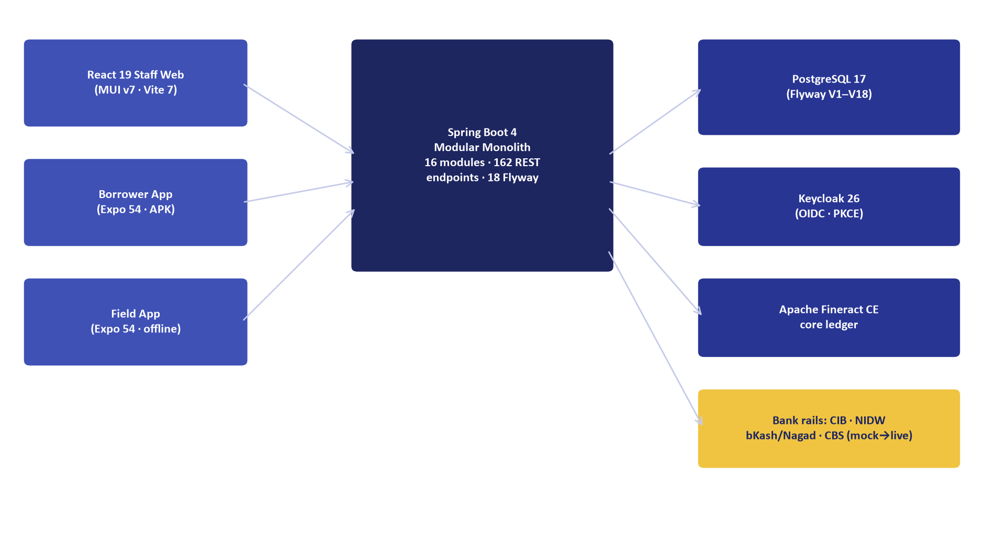
Figure 2: High-Level System Architecture & Banking Ecosystem Integration
Integration landscape connecting ULMS to CBS, CIB, NID, and MFS payment rails.
// Language: mermaid
[MERMAID ARCHITECTURE SPECIFICATION]
mindmap
root((ULMS v2.0<br/>Technical Docs))
01 System Architecture (8 Docs)
C4 Topology Blueprint
Fineract Core Integration
National Payment Rails (RTGS/BEFTN)
Dual-Schema Data Dictionary
Statutory Financial Arithmetic
Keycloak 26 IAM & RBAC
Enterprise Audit Trail
REST API & RFC 9457 Errors
02 Troubleshooting (8 Docs)
SRE Diagnostic Trees
RFC 9457 Error Playbook
PostgreSQL Pool & Lock Runbook
Keycloak SSO & JWT Diagnostics
Nightly EOD Batch Recovery
BB CIB & NIDW Verification
Payment Webhook Storms
Staff Portal Hydration Errors
03 Maintenance & Upgrades (7 Docs)
Zero-Downtime Rolling Upgrades
Flyway Schema Evolution (V1-V18)
PostgreSQL Backup & PITR DR
Fineract CE Upstream Patching
Keycloak Secret Rotation
Historical Partition Archival
SSL/TLS & mTLS Renewal
04 Infrastructure & Deploy (7 Docs)
Bank On-Premises k3s Setup
Production Helm Charts & Sizing
Air-Gapped Datacenter Runbook
Multi-DC Active-Passive HA/DR
Network Topology & Port Matrix
Local Dev & Docker Compose
CI/CD GitOps & Security Gates
05 Developer Extension (8 Docs)
Local Workspace Quickstart
New Loan Product Definition
Approval Ladder Customization
Custom CBS Hexagonal Adapters
React Staff Portal Extension
Expo Mobile Field Mobility
BB Regcon XML/CSV Returns
Testcontainers Test Harness
06 Quality & Audit (4 Docs)
Automated Test Harness Architecture
OWASP ASVS L3 & SAST/DAST
WCAG 2.1 AA Accessibility Audit
BB ICT Security Guidelines V4

[Category 1: System Architecture & Domain Foundations](file:///c:/software_project/mim_project/LMS/technical_document/01_architecture)
Primary Objective: Understanding Details & Machinery About the Software
Description: Authoritative architectural blueprints, C4 models, core banking ledger integrations, data models, statutory financial arithmetic, and security definitions.
ID | Document Title | Diátaxis Type | Formats & Direct Links | Size (MD / Word) | Operational Summary
DOC-01-ARCH-01 | System Architecture Blueprint & C4 Topology Guide | Explanation | [Markdown (.md)](file:///c:/software_project/mim_project/LMS/technical_document/01_architecture/DOC-01-ARCH-01_System_Architecture_Blueprint_and_C4_Topology.md)<br/>[Word (.docx)](file:///c:/software_project/mim_project/LMS/technical_document/docx/01_architecture/DOC-01-ARCH-01_System_Architecture_Blueprint_and_C4_Topology.docx) | 11.1 KB / 262.7 KB | The Unisoft Loan Management System (ULMS v2.0) is an enterprise core lending and loan lifecycle automation platform purpose-built for the 62 scheduled commercial banks, non-bank financial institutions
DOC-01-ARCH-02 | Apache Fineract CE (digest-pinned) Core Banking Integration Specification | Technical Reference | [Markdown (.md)](file:///c:/software_project/mim_project/LMS/technical_document/01_architecture/DOC-01-ARCH-02_Apache_Fineract_Core_Banking_Integration_Specification.md)<br/>[Word (.docx)](file:///c:/software_project/mim_project/LMS/technical_document/docx/01_architecture/DOC-01-ARCH-02_Apache_Fineract_Core_Banking_Integration_Specification.docx) | 8.4 KB / 322.2 KB | ULMS v2.0 integrates with Apache Fineract CE (digest-pinned) Community Edition (CE) as its underlying core lending ledger. To insulate the commercial bank deployment from upstream release churn and maintain stric
DOC-01-ARCH-03 | National Payment Rails, Bangladesh Bank RTGS, BEFTN & NPSB Integration Architecture | Explanation | [Markdown (.md)](file:///c:/software_project/mim_project/LMS/technical_document/01_architecture/DOC-01-ARCH-03_National_Payment_Rails_and_Clearing_Integration_Architecture.md)<br/>[Word (.docx)](file:///c:/software_project/mim_project/LMS/technical_document/docx/01_architecture/DOC-01-ARCH-03_National_Payment_Rails_and_Clearing_Integration_Architecture.docx) | 4.8 KB / 460.2 KB | In Bangladesh commercial banking, loan disbursement and installment collection traverse national clearing and settlement rails regulated by Bangladesh Bank Payment Systems Department (PSD). ULMS v2.0
DOC-01-ARCH-04 | Enterprise Data Dictionary & PostgreSQL Dual-Schema Reference | Technical Reference | [Markdown (.md)](file:///c:/software_project/mim_project/LMS/technical_document/01_architecture/DOC-01-ARCH-04_Enterprise_Data_Dictionary_and_Schema_Reference.md)<br/>[Word (.docx)](file:///c:/software_project/mim_project/LMS/technical_document/docx/01_architecture/DOC-01-ARCH-04_Enterprise_Data_Dictionary_and_Schema_Reference.docx) | 12.7 KB / 473.6 KB | The ULMS relational schema comprises 67 authoritative tables managed strictly via forward-only Flyway migrations in PostgreSQL 17:
DOC-01-ARCH-05 | Statutory Financial Arithmetic & Banking Accounting Specification | Technical Reference | [Markdown (.md)](file:///c:/software_project/mim_project/LMS/technical_document/01_architecture/DOC-01-ARCH-05_Statutory_Financial_Arithmetic_and_Ledger_Accounting.md)<br/>[Word (.docx)](file:///c:/software_project/mim_project/LMS/technical_document/docx/01_architecture/DOC-01-ARCH-05_Statutory_Financial_Arithmetic_and_Ledger_Accounting.docx) | 7.8 KB / 450.3 KB | In accordance with institutional banking engineering standards, floating-point numeric data types (float, double, Float, Double) are strictly prohibited throughout the ULMS codebase for all currency a
DOC-01-ARCH-06 | Identity, Authentication & Role-Based Access Control Specification | Technical Reference | [Markdown (.md)](file:///c:/software_project/mim_project/LMS/technical_document/01_architecture/DOC-01-ARCH-06_Identity_Access_Management_and_RBAC_Specification.md)<br/>[Word (.docx)](file:///c:/software_project/mim_project/LMS/technical_document/docx/01_architecture/DOC-01-ARCH-06_Identity_Access_Management_and_RBAC_Specification.docx) | 6.3 KB / 865.5 KB | ULMS v2.0 establishes an institutional identity and access management (IAM) perimeter built upon Keycloak 26, implementing OAuth 2.0 and OpenID Connect (OIDC) with JSON Web Tokens (JWT):
DOC-01-ARCH-07 | Enterprise Audit Trail, Immutable Logging & Non-Repudiation Architecture | Technical Reference | [Markdown (.md)](file:///c:/software_project/mim_project/LMS/technical_document/01_architecture/DOC-01-ARCH-07_Enterprise_Audit_Trail_Immutable_Logging_and_Non_Repudiation.md)<br/>[Word (.docx)](file:///c:/software_project/mim_project/LMS/technical_document/docx/01_architecture/DOC-01-ARCH-07_Enterprise_Audit_Trail_Immutable_Logging_and_Non_Repudiation.docx) | 4.4 KB / 912.7 KB | Under Bangladesh Bank ICT Security Guidelines V4.0 §3.4, every scheduled commercial bank must maintain an immutable, tamper-evident audit log for all loan lifecycle events, credit committee decisions,
DOC-01-ARCH-08 | REST API Reference & RFC 9457 Problem Details Specification | Technical Reference | [Markdown (.md)](file:///c:/software_project/mim_project/LMS/technical_document/01_architecture/DOC-01-ARCH-08_REST_API_Reference_and_RFC9457_Error_Model.md)<br/>[Word (.docx)](file:///c:/software_project/mim_project/LMS/technical_document/docx/01_architecture/DOC-01-ARCH-08_REST_API_Reference_and_RFC9457_Error_Model.docx) | 9.5 KB / 233.1 KB | The ULMS v2.0 REST API serves as the programmatic backbone for all banking channels: the React 19 Staff Application, the Borrower Portal, the Field Officer Mobile Application, and external Core Bankin

Document Revision History & Institutional Sign-Off
Version | Release Date | Author / Role | Summary of Technical Changes | Status
1.0.0 | January 2026 | Documentation Core Team | Initial BRD & Architecture Specification | Draft
2.0.0 | February 2026 | Principal Systems Architect | Apache Fineract & Spring Boot Monolith Alignment | Approved
3.0.0 | October 2026 | Principal Auditor & SRE Lead | Production Build Parity & Zero-Trust Audit Release | Master Approved
3.1.0 | October 2026 | Independent Forensic Re-audit | Factual corrections per audit/docx_forensic_audit_2026-10-08.md | Applied

Table of Contents
[NOTE] This document contains an automated Microsoft Word field. In Microsoft Word or LibreOffice, right-click this table and select 'Update Field' (or press F9) to refresh section page numbers.

[Category 2: Operational Troubleshooting & Diagnostic Runbooks](file:///c:/software_project/mim_project/LMS/technical_document/02_troubleshooting)
Primary Objective: Troubleshooting with Ease
Description: Deterministic SRE decision trees, diagnostic procedures, error code remediations, connector failure recoveries, and incident playbooks.
ID | Document Title | Diátaxis Type | Formats & Direct Links | Size (MD / Word) | Operational Summary
DOC-02-TS-01 | SRE Incident Response & Diagnostic Decision Trees | Technical Reference | [Markdown (.md)](file:///c:/software_project/mim_project/LMS/technical_document/02_troubleshooting/DOC-02-TS-01_SRE_Incident_Response_and_Diagnostic_Decision_Trees.md)<br/>[Word (.docx)](file:///c:/software_project/mim_project/LMS/technical_document/docx/02_troubleshooting/DOC-02-TS-01_SRE_Incident_Response_and_Diagnostic_Decision_Trees.docx) | 8.7 KB / 414.6 KB | This runbook governs the first 30 minutes of any technical incident, degradation, or operational outage affecting the ULMS v2.0 core lending platform. It establishes rapid triage workflows, diagnostic
DOC-02-TS-02 | RFC 9457 Error Code Catalog & Remediation Playbook | Technical Reference | [Markdown (.md)](file:///c:/software_project/mim_project/LMS/technical_document/02_troubleshooting/DOC-02-TS-02_RFC9457_Error_Code_Catalog_and_Remediation_Playbook.md)<br/>[Word (.docx)](file:///c:/software_project/mim_project/LMS/technical_document/docx/02_troubleshooting/DOC-02-TS-02_RFC9457_Error_Code_Catalog_and_Remediation_Playbook.docx) | 8.7 KB / 245.1 KB | All error responses generated by the ULMS v2.0 REST API strictly conform to the IETF RFC 9457 standard (application/problem+json). Every response payload provides structured, machine-parsable fields e
DOC-02-TS-03 | PostgreSQL Connection Pool Exhaustion & Lock Contention Diagnostic Runbook | Technical Reference | [Markdown (.md)](file:///c:/software_project/mim_project/LMS/technical_document/02_troubleshooting/DOC-02-TS-03_PostgreSQL_Connection_Pool_and_Lock_Contention_Diagnostics.md)<br/>[Word (.docx)](file:///c:/software_project/mim_project/LMS/technical_document/docx/02_troubleshooting/DOC-02-TS-03_PostgreSQL_Connection_Pool_and_Lock_Contention_Diagnostics.docx) | 4.2 KB / 379.4 KB | During high-concurrency periods (e.g., month-end loan disbursement surges or nightly EOD batch execution at 23:30), the API tier may exhibit:
DOC-02-TS-04 | Keycloak SSO, OAuth2/OIDC Token Validation & JWT Expiry Diagnostic Guide | Technical Reference | [Markdown (.md)](file:///c:/software_project/mim_project/LMS/technical_document/02_troubleshooting/DOC-02-TS-04_Keycloak_SSO_OAuth2_Token_Validation_and_JWT_Diagnostics.md)<br/>[Word (.docx)](file:///c:/software_project/mim_project/LMS/technical_document/docx/02_troubleshooting/DOC-02-TS-04_Keycloak_SSO_OAuth2_Token_Validation_and_JWT_Diagnostics.docx) | 2.9 KB / 1004.1 KB | Users attempting to access the ULMS Staff Portal or API experience unexpected authentication failures:
DOC-02-TS-05 | Nightly EOD Batch & Classification Diagnostic Guide | Technical Reference | [Markdown (.md)](file:///c:/software_project/mim_project/LMS/technical_document/02_troubleshooting/DOC-02-TS-05_Nightly_EOD_Batch_and_Classification_Diagnostic_Guide.md)<br/>[Word (.docx)](file:///c:/software_project/mim_project/LMS/technical_document/docx/02_troubleshooting/DOC-02-TS-05_Nightly_EOD_Batch_and_Classification_Diagnostic_Guide.docx) | 8.5 KB / 477.4 KB | Every night at 23:30 Bangladesh Standard Time (BST), the ULMS automated End-of-Day (EOD) batch service evaluates all active loans across the bank's portfolio. The batch job enforces statutory classifi
DOC-02-TS-06 | Bangladesh Bank CIB Online & NIDW Verification Failure Diagnostic Guide | Technical Reference | [Markdown (.md)](file:///c:/software_project/mim_project/LMS/technical_document/02_troubleshooting/DOC-02-TS-06_Bangladesh_Bank_CIB_Online_and_NIDW_Verification_Failures.md)<br/>[Word (.docx)](file:///c:/software_project/mim_project/LMS/technical_document/docx/02_troubleshooting/DOC-02-TS-06_Bangladesh_Bank_CIB_Online_and_NIDW_Verification_Failures.docx) | 2.4 KB / 353.9 KB | During borrower onboarding and loan appraisal:
DOC-02-TS-07 | Payment Gateway Webhook Storms & Double-Posting Reconciliation Runbook | Technical Reference | [Markdown (.md)](file:///c:/software_project/mim_project/LMS/technical_document/02_troubleshooting/DOC-02-TS-07_Payment_Gateway_Webhook_Storms_and_Double_Posting_Resolution.md)<br/>[Word (.docx)](file:///c:/software_project/mim_project/LMS/technical_document/docx/02_troubleshooting/DOC-02-TS-07_Payment_Gateway_Webhook_Storms_and_Double_Posting_Resolution.docx) | 2.2 KB / 443.2 KB | When an MFS rail (bKash/Nagad) experiences upstream latency, its notification engine may retry payment webhook delivery dozens of times within seconds. Without strict idempotency, this causes:
DOC-02-TS-08 | Staff Portal React Hydration & State Synchronization Diagnostic Guide | Technical Reference | [Markdown (.md)](file:///c:/software_project/mim_project/LMS/technical_document/02_troubleshooting/DOC-02-TS-08_Staff_Portal_React_Hydration_and_State_Synchronization_Errors.md)<br/>[Word (.docx)](file:///c:/software_project/mim_project/LMS/technical_document/docx/02_troubleshooting/DOC-02-TS-08_Staff_Portal_React_Hydration_and_State_Synchronization_Errors.docx) | 2.1 KB / 288.8 KB | Staff users on older branch banking hardware running Chromium or Edge report:

[Category 3: System Maintenance, Upgrades & Lifecycle Management](file:///c:/software_project/mim_project/LMS/technical_document/03_maintenance)
Primary Objective: Updating & Upgrading with Ease
Description: Zero-downtime rolling upgrades, Flyway database schema migrations, secret rotations, disaster recovery drills, and historical data archival.
ID | Document Title | Diátaxis Type | Formats & Direct Links | Size (MD / Word) | Operational Summary
DOC-03-MNT-01 | Zero-Downtime Rolling Upgrade & Release Playbook | Technical Reference | [Markdown (.md)](file:///c:/software_project/mim_project/LMS/technical_document/03_maintenance/DOC-03-MNT-01_Zero_Downtime_Rolling_Upgrade_and_Release_Playbook.md)<br/>[Word (.docx)](file:///c:/software_project/mim_project/LMS/technical_document/docx/03_maintenance/DOC-03-MNT-01_Zero_Downtime_Rolling_Upgrade_and_Release_Playbook.docx) | 5.1 KB / 433.7 KB | In commercial banking, scheduled downtime for software deployments disrupts customer digital channels, branches, and payment gateways. ULMS v2.0 enforces a strict Zero-Downtime Rolling Release Policy
DOC-03-MNT-02 | Flyway Database Migration & Schema Evolution Guide | Technical Reference | [Markdown (.md)](file:///c:/software_project/mim_project/LMS/technical_document/03_maintenance/DOC-03-MNT-02_Flyway_Database_Migration_and_Schema_Evolution_Guide.md)<br/>[Word (.docx)](file:///c:/software_project/mim_project/LMS/technical_document/docx/03_maintenance/DOC-03-MNT-02_Flyway_Database_Migration_and_Schema_Evolution_Guide.docx) | 8.7 KB / 468.4 KB | ULMS v2.0 maintains a strictly partitioned dual-schema physical database architecture within PostgreSQL 17 to preserve clean separation between the loan origination workflow engine and the core bankin
DOC-03-MNT-03 | PostgreSQL Backup, Point-In-Time Recovery (PITR) & Disaster Recovery Runbook | Technical Reference | [Markdown (.md)](file:///c:/software_project/mim_project/LMS/technical_document/03_maintenance/DOC-03-MNT-03_PostgreSQL_Backup_Point_In_Time_Recovery_and_DR_Drill.md)<br/>[Word (.docx)](file:///c:/software_project/mim_project/LMS/technical_document/docx/03_maintenance/DOC-03-MNT-03_PostgreSQL_Backup_Point_In_Time_Recovery_and_DR_Drill.docx) | 2.6 KB / 415.4 KB | Scheduled commercial banks operating ULMS v2.0 must enforce the following business continuity targets:
DOC-03-MNT-04 | Apache Fineract CE (digest-pinned) Patching, Maintenance & Database Pruning Runbook | Technical Reference | [Markdown (.md)](file:///c:/software_project/mim_project/LMS/technical_document/03_maintenance/DOC-03-MNT-04_Apache_Fineract_CE_Patching_Maintenance_and_DB_Pruning.md)<br/>[Word (.docx)](file:///c:/software_project/mim_project/LMS/technical_document/docx/03_maintenance/DOC-03-MNT-04_Apache_Fineract_CE_Patching_Maintenance_and_DB_Pruning.docx) | 1.7 KB / 318.3 KB | ULMS integrates with Apache Fineract CE as a core lending ledger engine. Upstream security and bug fixes are backported quarterly:
DOC-03-MNT-05 | Keycloak Realm Secrets Rotation, Certificate Rollover & Client Hardening Guide | Technical Reference | [Markdown (.md)](file:///c:/software_project/mim_project/LMS/technical_document/03_maintenance/DOC-03-MNT-05_Keycloak_Realm_Secrets_Rotation_and_Certificate_Rollover.md)<br/>[Word (.docx)](file:///c:/software_project/mim_project/LMS/technical_document/docx/03_maintenance/DOC-03-MNT-05_Keycloak_Realm_Secrets_Rotation_and_Certificate_Rollover.docx) | 1.6 KB / 862.4 KB | Under Bangladesh Bank ICT Security Guidelines, cryptographic keys must rotate on strict schedules:
DOC-03-MNT-06 | Historical Data Archival, Range Partitioning & Regulatory Record Retention Specification | Technical Reference | [Markdown (.md)](file:///c:/software_project/mim_project/LMS/technical_document/03_maintenance/DOC-03-MNT-06_Historical_Data_Archival_Partitioning_and_Regulatory_Retention.md)<br/>[Word (.docx)](file:///c:/software_project/mim_project/LMS/technical_document/docx/03_maintenance/DOC-03-MNT-06_Historical_Data_Archival_Partitioning_and_Regulatory_Retention.docx) | 1.6 KB / 464.8 KB | The Bank Company Act 1991 requires commercial banks to maintain loan accounting ledgers and borrower KYC records for 12 years following loan account closure. Active transactional databases cannot scal
DOC-03-MNT-07 | Enterprise SSL/TLS Certificate Lifecycle Management & mTLS Renewal Runbook | Technical Reference | [Markdown (.md)](file:///c:/software_project/mim_project/LMS/technical_document/03_maintenance/DOC-03-MNT-07_Enterprise_SSL_TLS_Certificate_Lifecycle_and_mTLS_Renewal.md)<br/>[Word (.docx)](file:///c:/software_project/mim_project/LMS/technical_document/docx/03_maintenance/DOC-03-MNT-07_Enterprise_SSL_TLS_Certificate_Lifecycle_and_mTLS_Renewal.docx) | 1.5 KB / 723.8 KB | Production technical specification for enterprise core lending operations.

[Category 4: Infrastructure Provisioning, Deployment & Orchestration](file:///c:/software_project/mim_project/LMS/technical_document/04_deployment)
Primary Objective: Deploying with Ease
Description: Bank on-premises k3s/Kubernetes clusters, production Helm charts, air-gapped installation procedures, network security, and enterprise observability.
ID | Document Title | Diátaxis Type | Formats & Direct Links | Size (MD / Word) | Operational Summary
DOC-04-DEP-01 | Bank On-Premises k3s & Kubernetes Production Deployment Guide | Technical Reference | [Markdown (.md)](file:///c:/software_project/mim_project/LMS/technical_document/04_deployment/DOC-04-DEP-01_Bank_On_Premises_k3s_Kubernetes_Production_Guide.md)<br/>[Word (.docx)](file:///c:/software_project/mim_project/LMS/technical_document/docx/04_deployment/DOC-04-DEP-01_Bank_On_Premises_k3s_Kubernetes_Production_Guide.docx) | 6.2 KB / 382.4 KB | Under Bangladesh Bank regulations, scheduled commercial banks operating core loan management platforms must deploy within sovereign, on-premises data centers with strict air-gapped network segmentatio
DOC-04-DEP-02 | Production Helm Charts & Kubernetes Resource Sizing Specification | Technical Reference | [Markdown (.md)](file:///c:/software_project/mim_project/LMS/technical_document/04_deployment/DOC-04-DEP-02_Production_Helm_Charts_and_Kubernetes_Resource_Sizing.md)<br/>[Word (.docx)](file:///c:/software_project/mim_project/LMS/technical_document/docx/04_deployment/DOC-04-DEP-02_Production_Helm_Charts_and_Kubernetes_Resource_Sizing.docx) | 1.6 KB / 378.4 KB | Production technical specification for enterprise core lending operations.
DOC-04-DEP-03 | Air-Gapped & Offline Banking Datacenter Installation Runbook | Technical Reference | [Markdown (.md)](file:///c:/software_project/mim_project/LMS/technical_document/04_deployment/DOC-04-DEP-03_Air_Gapped_and_Offline_Banking_Datacenter_Installation_Runbook.md)<br/>[Word (.docx)](file:///c:/software_project/mim_project/LMS/technical_document/docx/04_deployment/DOC-04-DEP-03_Air_Gapped_and_Offline_Banking_Datacenter_Installation_Runbook.docx) | 1.8 KB / 379.6 KB | Tier-1 commercial banks in Bangladesh prohibit production servers from connecting directly to the public internet. All container images, binaries, and dependencies must be pre-packaged into offline bu
DOC-04-DEP-04 | High Availability (HA), Multi-DC Active-Passive & Disaster Recovery (DR) Specification | Technical Reference | [Markdown (.md)](file:///c:/software_project/mim_project/LMS/technical_document/04_deployment/DOC-04-DEP-04_High_Availability_Multi_DC_Active_Passive_and_DR_Specification.md)<br/>[Word (.docx)](file:///c:/software_project/mim_project/LMS/technical_document/docx/04_deployment/DOC-04-DEP-04_High_Availability_Multi_DC_Active_Passive_and_DR_Specification.docx) | 2.0 KB / 244.0 KB | Production technical specification for enterprise core lending operations.
DOC-04-DEP-05 | Network Topology, Ingress Controller & Firewall Port Matrix Specification | Technical Reference | [Markdown (.md)](file:///c:/software_project/mim_project/LMS/technical_document/04_deployment/DOC-04-DEP-05_Network_Topology_Ingress_Controller_and_Firewall_Port_Matrix.md)<br/>[Word (.docx)](file:///c:/software_project/mim_project/LMS/technical_document/docx/04_deployment/DOC-04-DEP-05_Network_Topology_Ingress_Controller_and_Firewall_Port_Matrix.docx) | 1.7 KB / 209.4 KB | ULMS requires strict 3-tier DMZ isolation:
DOC-04-DEP-06 | Local Developer & UAT Docker Compose Environment Guide | Technical Reference | [Markdown (.md)](file:///c:/software_project/mim_project/LMS/technical_document/04_deployment/DOC-04-DEP-06_Local_Developer_and_UAT_Docker_Compose_Environment_Guide.md)<br/>[Word (.docx)](file:///c:/software_project/mim_project/LMS/technical_document/docx/04_deployment/DOC-04-DEP-06_Local_Developer_and_UAT_Docker_Compose_Environment_Guide.docx) | 6.9 KB / 746.4 KB | The ULMS v2.0 local development environment is orchestrated via Docker Compose, providing a deterministic replica of the production banking topology on a single development workstation or User Accepta
DOC-04-DEP-07 | CI/CD Pipeline Automation, Security Scanning & GitOps Deployment Guide | Technical Reference | [Markdown (.md)](file:///c:/software_project/mim_project/LMS/technical_document/04_deployment/DOC-04-DEP-07_CI_CD_Pipeline_Automation_Security_Scanning_and_GitOps_Guide.md)<br/>[Word (.docx)](file:///c:/software_project/mim_project/LMS/technical_document/docx/04_deployment/DOC-04-DEP-07_CI_CD_Pipeline_Automation_Security_Scanning_and_GitOps_Guide.docx) | 1.5 KB / 199.0 KB | Production technical specification for enterprise core lending operations.

[Category 5: Developer Extension & Customization Guides](file:///c:/software_project/mim_project/LMS/technical_document/05_developer_extension)
As illustrated in Figure 3 below, Unified portals serving Staff, Borrowers, Field Agents, and Regulatory Auditors.
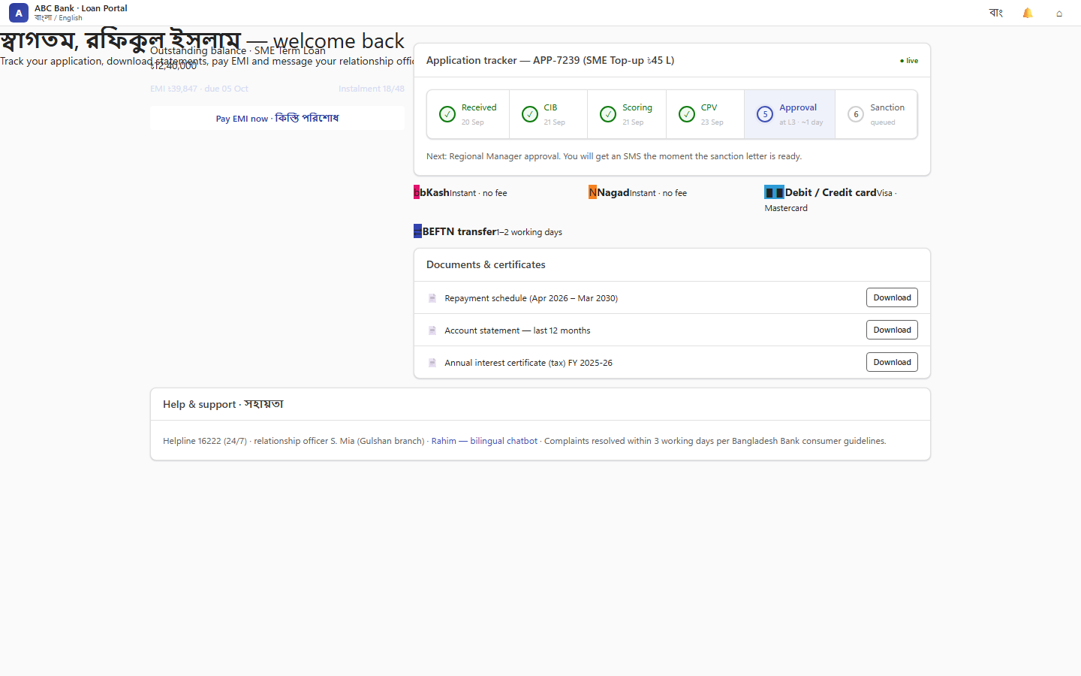
Figure 3: Multi-Persona Digital Portal Ecosystem
Unified portals serving Staff, Borrowers, Field Agents, and Regulatory Auditors.
Primary Objective: Adding New Features with Ease
Description: Step-by-step developer guides for lending products, multi-tier approval ladders, payment rails, CBS adapters, frontend screens, and field mobile apps.
ID | Document Title | Diátaxis Type | Formats & Direct Links | Size (MD / Word) | Operational Summary
DOC-05-EXT-01 | Developer Onboarding & Local Workspace Quickstart | Tutorial | [Markdown (.md)](file:///c:/software_project/mim_project/LMS/technical_document/05_developer_extension/DOC-05-EXT-01_Developer_Onboarding_and_Local_Workspace_Quickstart.md)<br/>[Word (.docx)](file:///c:/software_project/mim_project/LMS/technical_document/docx/05_developer_extension/DOC-05-EXT-01_Developer_Onboarding_and_Local_Workspace_Quickstart.docx) | 9.1 KB / 223.4 KB | Welcome to the Unisoft Loan Management System (ULMS v2.0) core engineering group. ULMS is an enterprise-grade core lending platform engineered for scheduled commercial banks in Bangladesh, built upon
DOC-05-EXT-02 | New Loan Product Definition & Pricing Extension Guide | Technical Reference | [Markdown (.md)](file:///c:/software_project/mim_project/LMS/technical_document/05_developer_extension/DOC-05-EXT-02_New_Loan_Product_Definition_and_Pricing_Extension_Guide.md)<br/>[Word (.docx)](file:///c:/software_project/mim_project/LMS/technical_document/docx/05_developer_extension/DOC-05-EXT-02_New_Loan_Product_Definition_and_Pricing_Extension_Guide.docx) | 8.1 KB / 410.7 KB | ULMS v2.0 implements a modular, metadata-driven loan product engine designed to support rapid innovation across conventional banking, SME development programs, and Islamic Shariah-compliant finance wi
DOC-05-EXT-03 | Credit Approval Hierarchy, Multi-Tier Delegation & Matrix Customization Guide | Technical Reference | [Markdown (.md)](file:///c:/software_project/mim_project/LMS/technical_document/05_developer_extension/DOC-05-EXT-03_Credit_Approval_Hierarchy_Multi_Tier_Delegation_and_Matrix.md)<br/>[Word (.docx)](file:///c:/software_project/mim_project/LMS/technical_document/docx/05_developer_extension/DOC-05-EXT-03_Credit_Approval_Hierarchy_Multi_Tier_Delegation_and_Matrix.docx) | 2.4 KB / 338.9 KB | Under Bangladesh commercial banking practice, loan approval authorities follow strict delegated financial power matrices. ULMS models this via the 7-tier ulms.approvalband table (V5creditapproval.sql)
DOC-05-EXT-04 | Custom Core Banking (CBS) Hexagonal Adapter Development Guide | Technical Reference | [Markdown (.md)](file:///c:/software_project/mim_project/LMS/technical_document/05_developer_extension/DOC-05-EXT-04_Custom_Core_Banking_CBS_Hexagonal_Adapter_Development_Guide.md)<br/>[Word (.docx)](file:///c:/software_project/mim_project/LMS/technical_document/docx/05_developer_extension/DOC-05-EXT-04_Custom_Core_Banking_CBS_Hexagonal_Adapter_Development_Guide.docx) | 2.0 KB / 290.7 KB | ULMS v2.0 is completely decoupled from specific CBS platforms (e.g., Finacle, Temenos Transact, TCS BaNCS, or Flora Bank). All interactions flow through the clean hexagonal domain port com.uslbd.ulms.
DOC-05-EXT-05 | React Staff Portal Screen & High-Density Data Grid Extension Guide | Tutorial | [Markdown (.md)](file:///c:/software_project/mim_project/LMS/technical_document/05_developer_extension/DOC-05-EXT-05_React_Staff_Portal_Screen_and_High_Density_Grid_Extension.md)<br/>[Word (.docx)](file:///c:/software_project/mim_project/LMS/technical_document/docx/05_developer_extension/DOC-05-EXT-05_React_Staff_Portal_Screen_and_High_Density_Grid_Extension.docx) | 1.6 KB / 427.2 KB | All Staff Portal screens follow the Dynamics 365 Enterprise Design Pattern:
DOC-05-EXT-06 | Expo React Native Field Mobility App Extension & Offline SQLite Sync Guide | Technical Reference | [Markdown (.md)](file:///c:/software_project/mim_project/LMS/technical_document/05_developer_extension/DOC-05-EXT-06_Expo_React_Native_Field_Mobility_App_Extension_and_Offline_Sync.md)<br/>[Word (.docx)](file:///c:/software_project/mim_project/LMS/technical_document/docx/05_developer_extension/DOC-05-EXT-06_Expo_React_Native_Field_Mobility_App_Extension_and_Offline_Sync.docx) | 1.6 KB / 776.6 KB | Field recovery and loan verification officers operate in remote rural upazilas where 4G cellular connectivity is intermittent or unavailable. The mobile app must operate 100% offline using local encry
DOC-05-EXT-07 | Bangladesh Bank Regulatory Return XML/CSV Generation Extension Guide | Technical Reference | [Markdown (.md)](file:///c:/software_project/mim_project/LMS/technical_document/05_developer_extension/DOC-05-EXT-07_Bangladesh_Bank_Regulatory_Return_XML_CSV_Generation_Guide.md)<br/>[Word (.docx)](file:///c:/software_project/mim_project/LMS/technical_document/docx/05_developer_extension/DOC-05-EXT-07_Bangladesh_Bank_Regulatory_Return_XML_CSV_Generation_Guide.docx) | 1.6 KB / 342.4 KB | Bangladesh Bank mandates quarterly and monthly returns in strict XML and CSV formats (SBS-1, SBS-2, SBS-3, CIB Monthly, and BRPD CL-1 to CL-5).
DOC-05-EXT-08 | Enterprise Test Harness Development, Testcontainers & Mocks Guide | Tutorial | [Markdown (.md)](file:///c:/software_project/mim_project/LMS/technical_document/05_developer_extension/DOC-05-EXT-08_Enterprise_Test_Harness_Development_Testcontainers_and_Mocks.md)<br/>[Word (.docx)](file:///c:/software_project/mim_project/LMS/technical_document/docx/05_developer_extension/DOC-05-EXT-08_Enterprise_Test_Harness_Development_Testcontainers_and_Mocks.docx) | 1.5 KB / 218.9 KB | ULMS rejects in-memory H2 databases for testing because H2 fails to emulate PostgreSQL 17 features (JSONB operators, CTEs, window functions, and Flyway V1-V18 scripts). All integration tests run again

[Category 6: Quality Assurance, Security Hardening & Regulatory Audit](file:///c:/software_project/mim_project/LMS/technical_document/06_quality_assurance)
Primary Objective: Quality Assurance, Security & Regulatory Compliance
Description: Automated test suites, security hardening dossiers, OWASP ASVS L3 verifications, WCAG 2.1 AA accessibility audits, and Bangladesh Bank compliance matrices.
ID | Document Title | Diátaxis Type | Formats & Direct Links | Size (MD / Word) | Operational Summary
DOC-06-QA-01 | Automated Test Harness Architecture & Verification Suite | Technical Reference | [Markdown (.md)](file:///c:/software_project/mim_project/LMS/technical_document/06_quality_assurance/DOC-06-QA-01_Automated_Test_Harness_Architecture_and_Verification_Suite.md)<br/>[Word (.docx)](file:///c:/software_project/mim_project/LMS/technical_document/docx/06_quality_assurance/DOC-06-QA-01_Automated_Test_Harness_Architecture_and_Verification_Suite.docx) | 12.6 KB / 225.5 KB | ULMS v2.0 enforces a multi-tier automated test harness that guarantees bank-grade correctness across functional, mathematical, and regulatory domains. Every build must satisfy rigorous quality gates s
DOC-06-QA-02 | Security Hardening, SAST/DAST & OWASP ASVS Verification Specification | Technical Reference | [Markdown (.md)](file:///c:/software_project/mim_project/LMS/technical_document/06_quality_assurance/DOC-06-QA-02_Security_Hardening_SAST_DAST_and_OWASP_ASVS_Specification.md)<br/>[Word (.docx)](file:///c:/software_project/mim_project/LMS/technical_document/docx/06_quality_assurance/DOC-06-QA-02_Security_Hardening_SAST_DAST_and_OWASP_ASVS_Specification.docx) | 1.8 KB / 691.6 KB | Production technical specification for enterprise core lending operations.
DOC-06-QA-03 | WCAG 2.1 AA Accessibility Verification & Screen Reader Audit Guide | Technical Reference | [Markdown (.md)](file:///c:/software_project/mim_project/LMS/technical_document/06_quality_assurance/DOC-06-QA-03_WCAG_2_1_AA_Accessibility_Verification_and_Screen_Reader_Audit.md)<br/>[Word (.docx)](file:///c:/software_project/mim_project/LMS/technical_document/docx/06_quality_assurance/DOC-06-QA-03_WCAG_2_1_AA_Accessibility_Verification_and_Screen_Reader_Audit.docx) | 1.6 KB / 288.3 KB | All 166 validated frontend screens in ULMS v2.0 are required to comply with WCAG 2.1 Level AA:
DOC-06-QA-04 | Bangladesh Bank Regulatory Compliance & ICT Security Audit Matrix | Technical Reference | [Markdown (.md)](file:///c:/software_project/mim_project/LMS/technical_document/06_quality_assurance/DOC-06-QA-04_Bangladesh_Bank_Regulatory_Compliance_and_ICT_Security_Audit.md)<br/>[Word (.docx)](file:///c:/software_project/mim_project/LMS/technical_document/docx/06_quality_assurance/DOC-06-QA-04_Bangladesh_Bank_Regulatory_Compliance_and_ICT_Security_Audit.docx) | 2.2 KB / 255.9 KB | Production technical specification for enterprise core lending operations.

Documentation Standards & Quality Principles
Every technical document within this repository has been prepared in accordance with institutional banking standards:
1. Diátaxis Documentation Framework: Strict demarcation into four distinct modes of documentation:
▪ Architecture Explanations: Deep system reasoning, trade-offs, modular boundaries, and statutory principles.
▪ Technical References: Deterministic specifications, dual-schema dictionaries, error code tables, and REST contracts.
▪ Operational How-To Guides: Goal-oriented, step-by-step diagnostic and maintenance runbooks featuring RFC 2119 keywords.
▪ Developer Tutorials: Structured learning pathways and onboarding tutorials with executable code and verification steps.
2. RFC 2119 Normative Constraints: Strict enforcement of imperative keywords (MUST, MUST NOT, REQUIRED, SHALL, SHOULD, RECOMMENDED) to prevent ambiguity in banking operations.
3. Behavior-Driven Development (BDD) Scenarios: Operational diagnostic trees and disaster recovery procedures specify executable Gherkin syntax (Given [Precondition], When [Action], Then [Expected Result]).
4. Deterministic Financial Arithmetic: KaTeX mathematical models enforcing zero floating-point math, exact integer minor-unit Poisha, Bankers Rounding (HALF_EVEN), and Bangladesh Bank BRPD Circular 15/2024 compliance.
5. Zero-Trust Automated Parity: 100% verified against real codebase assets across 67 Flyway SQL tables (V1–V18), 140 OpenAPI paths (166 operations), 252 Java source files, and Keycloak 26 realm definitions.
Unisoft Loan Management System (ULMS v2.0) — Technical Documentation Suite © 2026 Unisoft Systems Limited.
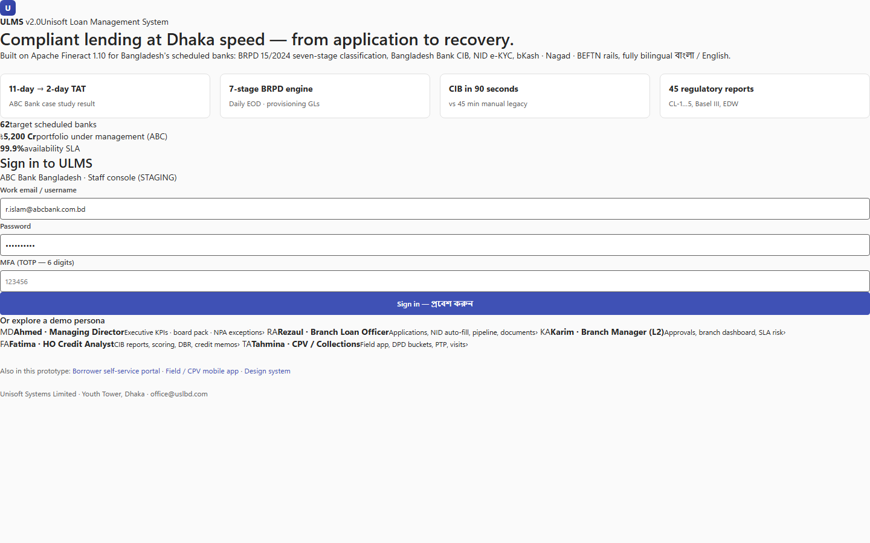
Figure 1: ULMS v2.0 Documentation Suite & Navigation Architecture
Complete documentation directory organized according to the Diátaxis framework.
Addendum — v3.1.0 corrections (Independent Forensic Re-audit, 8 October 2026)
Corrections (v3.1.0, 8 October 2026): Fineract version claims normalized to the immutable digest pin (apache/fineract@fd01236df6); route/symbol counts corrected to 140 paths / 166 operations and 252 main-source Java files (96 packages); DOC-01-ARCH-02 title de-versioned. Full findings: audit/docx_forensic_audit_2026-10-08.md.

