UNISOFT SYSTEMS LIMITED · A SUBSIDIARY OF SMART TECHNOLOGIES BD LTD
MEDDPIC Enterprise Deal Qualification & Discovery Questionnaire
Commercial Banking Documentation · Document Ref: DOC-09-SALES-03

Document Identifier | Release Version | Security Classification | Publication Date | Target Audience
DOC-09-SALES-03 | 2.0.0 | Confidential Internal Sales Playbook | 2026-10-08 | [sales_team, account_executive, solution_architect]

MEDDPIC Deal Qualification & Discovery Guide

Institutional Opportunity Scoring for Bangladesh Commercial Bank Deals
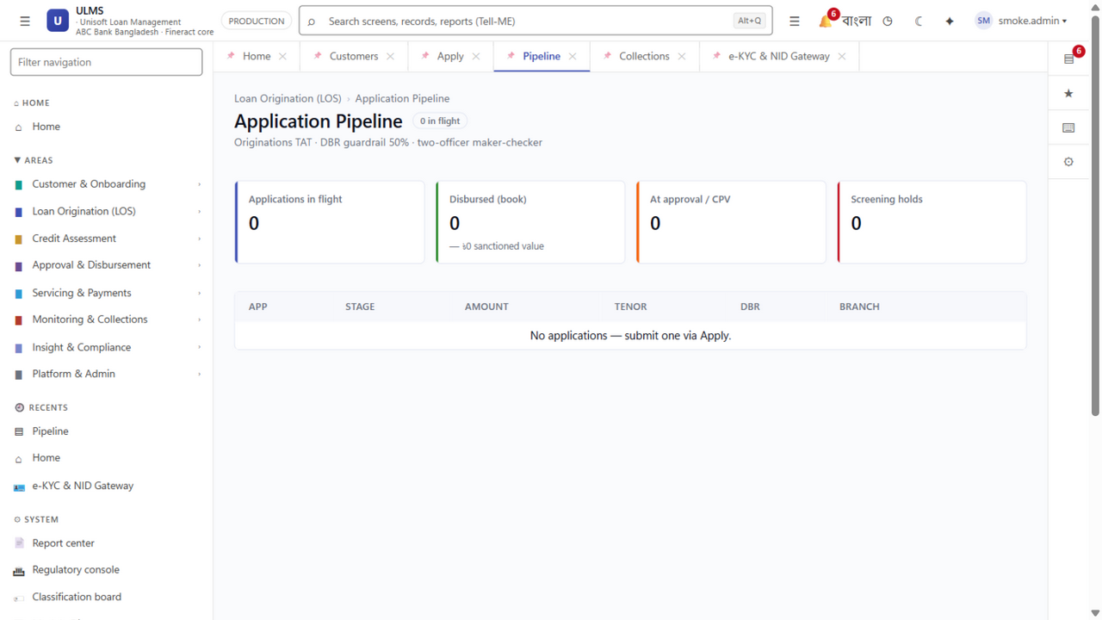
Figure 1: Production UI — Deal Progression Pipeline & Stage-Gate Tracking
Document Identifier: DOC-09-SALES-03
Target Sales Stage: Early Engagement, Lead Qualification & Pipeline Review
Author: Head of Business Development & Sales Operations Lead
Publisher: Unisoft Systems Limited (A Subsidiary of Smart Technologies BD Ltd)
Classification: Internal Sales Enablement Asset
Version: 2.0.0

1. Why MEDDPIC in Bangladesh Banking Sales?
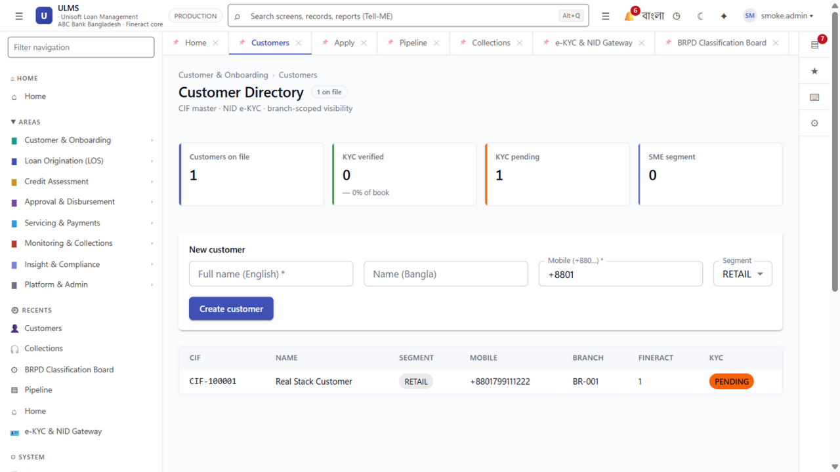
Figure 2: Production UI — Customer 360-Degree Profile & e-KYC Verification Dossier
Enterprise banking software deals in Bangladesh have long gestation cycles (6 to 12 months) and involve dozens of stakeholders. Unqualified deals waste hundreds of engineering hours, tie up pre-sales resources, and generate inaccurate revenue forecasts.
MEDDPIC is the enterprise qualification operating system used by top-tier enterprise technology companies. Every ULMS v2.0 opportunity must be scored against the seven MEDDPIC dimensions before pre-sales resources are committed:
┌──────────┬──────────────────────────────────────────────────────────────────┐
│ LETTER │ MEDDPIC PILLAR IN BANGLADESH BANKING CONTEXT │
├──────────┼──────────────────────────────────────────────────────────────────┤
│ M │ METRICS — Quantifiable operational & financial gains for the bank│
│ E │ ECONOMIC BUYER — The executive who holds discretionary budget │
│ D │ DECISION CRITERIA — The formal technical, financial & risk rules │
│ D │ DECISION PROCESS — The internal approval & Board governance steps│
│ P │ PAPER PROCESS — The legal, procurement (PPR 2008), & contract flow│
│ I │ IDENTIFY PAIN — The critical business crisis driving urgency │
│ C │ CHAMPION — The internal advocate with power who sells for us │
└──────────┴──────────────────────────────────────────────────────────────────┘

2. The 7 Pillars of MEDDPIC Applied to Bangladesh Banking
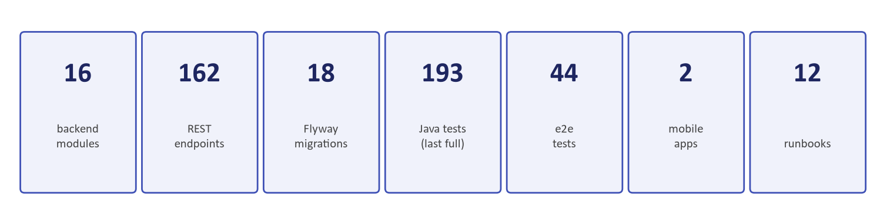
Figure 3: Economic Buyer Justification — Quantified Payback & TCO Reduction Models

M — Metrics (Quantifiable Business Impact)
- What We Must Uncover:
- Current average loan turnaround time (TAT) across retail and SME loans (e.g., 21 days).
- Annual loan origination file volume (e.g., 25,000 files/year).
- Current gross NPL ratio and annual loan loss provisioning expense.
- Direct staffing cost allocated to branch credit memos and BOCC paper preparation.
- Our Benchmark Metric Target:
- Can we demonstrate an 85% TAT reduction (from 21 days to 48 hours)?
- Can we show a 0.5%–1.0% reduction in portfolio loss through automated CIB deduplication?
- Can we prove full capital payback in under 9 months?

E — Economic Buyer (The Ultimate Decision Authority)
- What We Must Uncover:
- Who has the authority to release BDT 3 to 6 Crore without needing higher approval?
- In scheduled commercial banks, the Economic Buyer is almost always the Managing Director / CEO or the Chairman of the Board ICT Committee.
- A Head of Retail or Head of IT is NOT the Economic Buyer; they are evaluators or champions.
- Key Test: Have we had a direct, strategic conversation with the MD or Board ICT Chair? If not, the deal is NOT fully qualified.

D — Decision Criteria (The Evaluation Yardstick)
- What We Must Uncover:
- Technical Criteria: On-premise air-gapped deployment, REST APIs, PostgreSQL 17, CBS compatibility (T24, FLEXCUBE, Finacle).
- Functional Criteria: Native 7-stage BRPD 15/2024 classification, automated CIB Online REST, IFRS-9 ECL staging, offline mobile field app.
- Commercial Criteria: BDT domestic billing, total 5-year TCO, 20% capped AMC, milestone-based payments.
- Risk Criteria: ISO 27001, local 24/7 on-site support SLA, corporate longevity (Smart Technologies BD Ltd).
- Our Goal: Influence the bank's RFP to reflect our specific strengths before the tender is publicly released.

D — Decision Process (The Governance Roadmap)
- What We Must Uncover:
- What are the exact steps to go from demonstration to contract award?
- Typical Bangladesh Bank Procurement Chain:
1. Technical Evaluation Committee (TEC) Review & Demo Scoring
2. Head of Procurement Commercial Envelope Opening (QCBS)
3. Management Committee (MANCOM) Review
4. Board ICT Steering Committee Recommendation
5. Full Board of Directors Approval
- Key Test: Do we know the exact dates of the next Board ICT Committee and MANCOM meetings?

P — Paper Process (The Contracting & Legal Path)
- What We Must Uncover:
- Is this procurement governed by the Public Procurement Rules (PPR 2008) (common for SOCBs and state-linked entities) or the bank's private purchase policy?
- Who reviews the Master Software License Agreement (MSLA) and SLA? (Internal legal counsel or external law firm?)
- What security clearances, tax certificates (TIN, BIN), or bank guarantees (Performance Guarantee 10%) are required?
- How long does legal and procurement typically take to issue a Work Order after Board approval? (Average: 30 to 60 days).

I — Identify Pain (The Compelling Compulsion to Act)
- What We Must Uncover:
- Why must the bank buy NOW instead of waiting another year?
- Compelling Events in 2026/2027:
- Impending Bangladesh Bank BRPD Circular 15/2024 audit inspection with threatened fines for inaccurate 7-stage classification.
- The December 31, 2027 statutory deadline for mandatory IFRS-9 forward-looking Expected Credit Loss provisioning.
- Sudden surge in retail/SME NPLs forcing the Board to mandate automated underwriting.
- Failure or cancellation of an internal IT software build after 2 years of delays.
- Key Test: If there is no burning pain or deadline, the bank will default to doing nothing.

C — Champion (Our Internal Power Ally)
- What We Must Uncover:
- Who inside the bank will actively fight for Unisoft when we are not in the room?
- Characteristics of a True Champion:
- They have personal political capital and influence with the Managing Director.
- They have a personal stake in the project’s success (e.g., their promotion depends on modernizing digital lending).
- They share insider information with us (competitor bids, budget limits, committee dynamics).
- Typical Champions: Forward-looking Head of Retail Banking, Head of SME, or Chief Information Officer.
- Key Test: If our "champion" cannot get us a meeting with the Managing Director, they are a coach, not a champion.

3. The 50-Question Banking Discovery Questionnaire
Use these questions during Stage 2 Discovery calls to systematically diagnose the opportunity:

Category 1: Current Credit Operations & Metrics (Questions 1–10)
- What is your bank's current average turnaround time (TAT) from customer application to fund disbursement?
- How many physical hands or desks does a typical retail credit memo pass through before final approval?
- What percentage of retail or SME applications are abandoned by borrowers due to verification delays?
- How many total active loan accounts does your bank currently manage across all branches?
- What is your annual new loan origination volume (in BDT value and file count)?
- How many branch officers are dedicated to manual credit assessment and paper memo compilation?
- How long does your Branch Officers Credit Committee (BOCC) take to review weekly loan files?
- What is your current gross Non-Performing Loan (NPL) ratio, and what is the Board’s target for this year?
- What was your total provisioning charge on credit assets in the last audited fiscal year?
- What specific operational efficiency metric has the Managing Director tasked your division with achieving?

Category 2: Regulatory Compliance & Risk Pain Points (Questions 11–20)
- How is your bank currently executing the 7-stage loan classification mandated under BRPD Circular 15/2024?
- Is your DPD calculation and stage migration fully automated, or does it rely on manual branch reporting?
- How do you currently handle central bank eligible collateral deduction during provisioning calculations?
- What is your roadmap for complying with the mandatory IFRS-9 Expected Credit Loss deadline by December 2027?
- How many hours or days does your CIB cell take to return a credit report for a new loan applicant?
- How does your credit team currently verify whether an applicant has taken loans from other banks in the same week?
- How do you calculate and verify the borrower's Debt Burden Ratio (DBR) against central bank ceilings?
- Have you ever faced regulatory audit citations or restatement orders from Bangladesh Bank regarding loan classification?
- How do you verify borrower National ID (NID) and facial biometrics during onboarding?
- How is your bank handling beneficial ownership tracking ($\ge 20\%$) under recent BFIU AML/CFT directives?

Category 3: IT Infrastructure & Core Banking Integration (Questions 21–30)
- Which Core Banking System (CBS) and version is your bank running (e.g., Temenos T24, FLEXCUBE, Finacle, Flora Bank)?
- Is your CBS hosted entirely on-premise within your primary datacenter, and where is your DR site located?
- Does your bank IT policy permit the use of modern microservices or modular architectures running on Linux/PostgreSQL?
- How does your CBS currently expose APIs for external applications (e.g., REST, SOAP, database staging)?
- What has been your IT department's experience with previous core banking integration projects?
- Does your IT team prefer on-premises bare metal, VMware, or containerized deployments (k3s/Kubernetes)?
- What are your bank's mandatory Disaster Recovery targets for RPO (Recovery Point) and RTO (Recovery Time)?
- How does your IT security team enforce Multi-Factor Authentication (MFA) and Single Sign-On (SSO)?
- Has your IT team attempted to build an in-house lending workflow system, and what is its current status?
- Who is the primary enterprise architect responsible for approving third-party software integration?

Category 4: Decision Criteria & Competitor Dynamics (Questions 31–40)
- What are the top three technical and functional criteria your evaluation committee will score vendors on?
- What other solutions or vendors is the bank currently evaluating (e.g., Finastra, Temenos, Nucleus, Finacle)?
- What feedback or reservations has the committee expressed regarding foreign software vendors?
- Does the bank have a policy preference regarding local domestic software vendors versus international packages?
- What is the committee's stance on foreign exchange licensing liabilities given current central bank foreign currency controls?
- Is 24/7 on-site technical support in Dhaka considered a mandatory or weighted evaluation requirement?
- Does your bank require a dual-core platform that natively supports Islamic Shariah financing modes?
- How important is an offline mobile field agent application for your SME and rural lending operations?
- What is the maximum acceptable implementation timeline from contract signing to live branch pilot?
- What is the single biggest risk that would cause the committee to reject a software vendor?

Category 5: Decision Process, Procurement & Budget (Questions 41–50)
- Who is the formal Economic Buyer who will sign off on the financial expenditure for this project?
- Has capital budget already been formally allocated for this project in the current fiscal year?
- What is the budgeted investment range for software licenses, implementation, and first-year maintenance?
- Will this procurement be conducted through an open public tender, limited tender, or direct vendor selection?
- What are the specific steps and committees required to advance from technical scoring to final Board approval?
- When does the Board ICT Steering Committee meet next to review major technology investments?
- What is the expected timeline for issuing a formal Request for Proposal (RFP) or Expression of Interest (EOI)?
- Who from your legal, finance, and procurement departments will be involved in contract negotiations?
- What standard contractual terms (e.g., performance guarantees, warranty periods, SLA penalties) does your bank require?
- If our solution meets 100% of your functional and regulatory criteria, what would prevent us from signing a contract within 90 days?

4. Opportunity Scoring Rubric (RAG Gates)
Before committing senior engineering and pre-sales resources to an RFP response or extensive custom demonstration, the Account Executive must complete this rubric:
┌─────────────────────────────────────────────────────────────────────────────┐
│ ULMS OPPORTUNITY QUALIFICATION RUBRIC │
├─────────┬──────────────────────┬──────────────────────┬─────────────────────┤
│ PILLAR │ RED (Unqualified) │ AMBER (Conditional) │ GREEN (Fully Ready) │
├─────────┼──────────────────────┼──────────────────────┼─────────────────────┤
│ METRICS │ No clear TAT or NPL │ High-level pain but │ Hard metrics agreed:│
│ │ data; "just looking" │ unquantified costs │ 21d TAT, 12% NPLs │
├─────────┼──────────────────────┼──────────────────────┼─────────────────────┤
│ ECONOMIC│ No access to MD/CFO; │ Meeting with Head of │ Direct access to MD,│
│ BUYER │ dealing only with IT │ Retail or Head of IT │ CFO, or Board Chair │
├─────────┼──────────────────────┼──────────────────────┼─────────────────────┤
│ DECISION│ Criteria favor a │ Standard functional │ Criteria aligned │
│ CRITERIA│ foreign vendor brand │ requirements draft │ with local BRPD/CIB │
├─────────┼──────────────────────┼──────────────────────┼─────────────────────┤
│ DECISION│ Unclear steps; │ General timeline; │ Exact dates for TEC,│
│ PROCESS │ "committee will see" │ 3-stage process │ MANCOM & Board meet │
├─────────┼──────────────────────┼──────────────────────┼─────────────────────┤
│ PAPER │ Unknown tender rules │ Standard procurement │ Clear two-envelope │
│ PROCESS │ or legal guidelines │ timeline (60 days) │ QCBS & contract path│
├─────────┼──────────────────────┼──────────────────────┼─────────────────────┤
│ IDENTIFY│ No urgent deadline; │ Growing manual loan │ Hard deadline: BRPD │
│ PAIN │ "evaluating for future"│ processing backlog │ 15/2024 / IFRS-9 ECL│
├─────────┼──────────────────────┼──────────────────────┼─────────────────────┤
│ CHAMPION│ Contact is neutral │ Contact likes ULMS │ Active champion who │
│ │ or non-responsive │ but lacks power │ advocates with MD │
└─────────┴──────────────────────┴──────────────────────┴─────────────────────┘

Deal Progression Rules:
- GREEN STATUS (5+ Green Pillars): Priority 1 Deal. Commit Lead Solution Architect, prepare customized demo sandbox, offer structured 14-day PoC.
- AMBER STATUS (3–4 Green Pillars): Priority 2 Deal. Conduct executive nurturing; invite Champion to Unisoft headquarters; schedule MD briefing.
- RED STATUS (<3 Green Pillars): Priority 3 / Disqualified. Nurture via marketing newsletter and whitepaper distribution. Do NOT commit custom engineering or write bespoke tender responses.
Unisoft Systems Limited — Enterprise Sales Operations.

