UNISOFT SYSTEMS LIMITED · A SUBSIDIARY OF SMART TECHNOLOGIES BD LTD
Objection Handling & Risk Mitigation Battlecard
Commercial Banking Documentation · Document Ref: DOC-10-SALES-04

Document Identifier | Release Version | Security Classification | Publication Date | Target Audience
DOC-10-SALES-04 | 2.0.0 | Confidential Internal Sales Playbook | 2026-10-08 | [sales_team, account_executive, solution_architect]

Pre-Scripted Responses to 25+ Critical Banking Objections
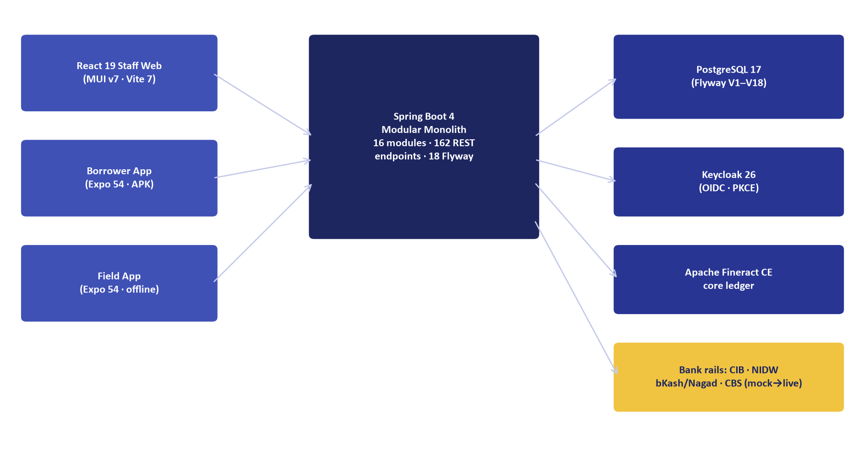
Figure 1: Architectural Proof — High-Performance Modular Monolith on Sovereign Infrastructure
Document Identifier: DOC-10-SALES-04
Target Sales Stage: Discovery, Product Demo, Commercial Negotiation
Author: Head of Business Development & Senior Pre-Sales Architect
Publisher: Unisoft Systems Limited (A Subsidiary of Smart Technologies BD Ltd)
Classification: Internal Sales Enablement Asset
Version: 2.0.0

1. The 4-Step Objection De-Escalation Protocol
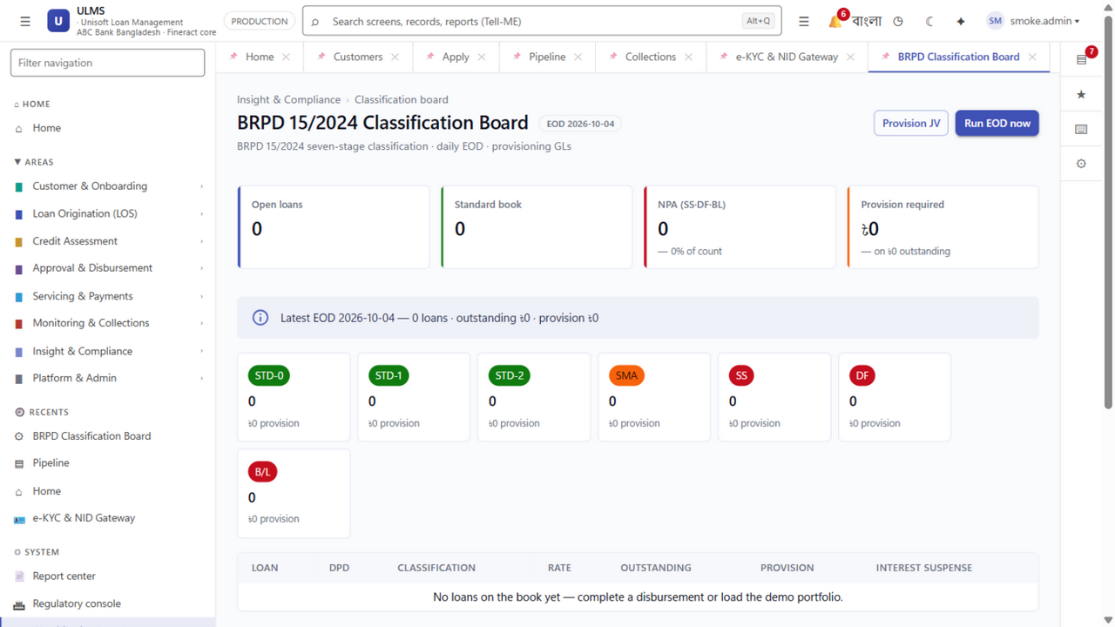
Figure 2: Regulatory Proof — Automated 7-Stage BRPD Circular 15/2024 Engine
Banking executives do not raise objections to be difficult; they raise objections because they have personal career risk if the software fails. When handling any objection:
┌─────────────────┐ ┌─────────────────┐ ┌─────────────────┐ ┌─────────────────┐
│ 1. ACKNOWLEDGE │ ──> │ 2. CLARIFY │ ──> │ 3. VALIDATE │ ──> │ 4. REFRAME │
│ "I understand │ │ "Are you worried│ │ "That is a valid│ │ "Here is how │
│ that concern." │ │ about X or Y?" │ │ concern because"│ │ ULMS solves it" │
└─────────────────┘ └─────────────────┘ └─────────────────┘ └─────────────────┘

- Acknowledge: Never argue or become defensive. Validate their perspective.
- Clarify: Ask an open-ended question to uncover the root anxiety behind the objection.
- Validate: Cite industry reality (e.g., "Many banks we talk to have had bad experiences with...").
- Reframe & Prove: Present the ULMS architectural or operational proof point backed by verifiable evidence.

2. Category A: Corporate Standing & Local vs. Foreign Vendor
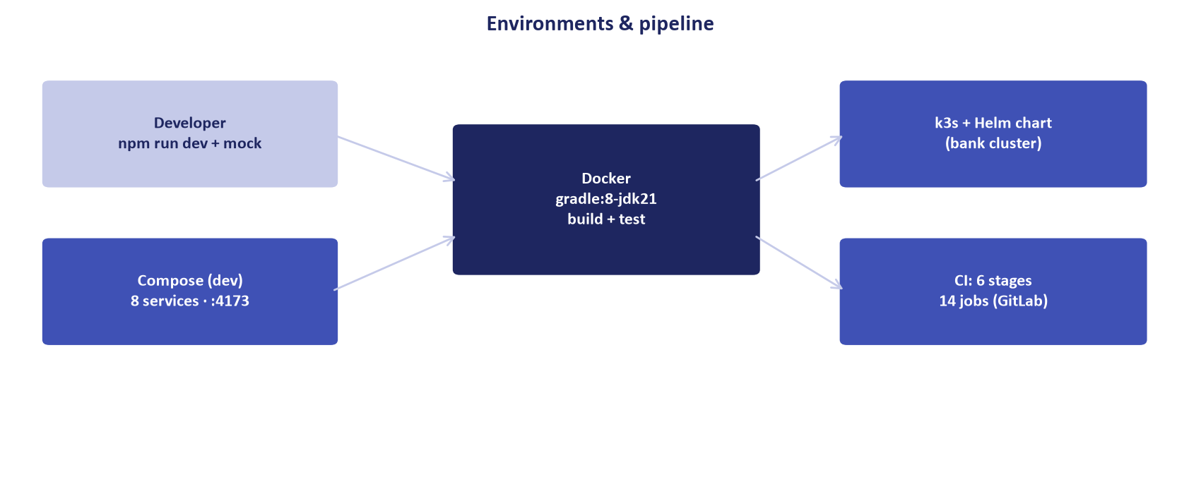
Figure 3: Resilience Proof — Dual Datacenter (DC/DR) Active-Active Containerized Cluster

Objection 01: "Why should our bank trust a local Bangladeshi software vendor over established global giants like Finastra, Temenos, or Nucleus?"
- The Underlying Fear: The Managing Director or CIO fears getting fired if a local company fails, whereas buying a global brand is seen as defensible ("Nobody gets fired for buying IBM/Temenos").
- Winning Response:
> "We completely understand that concern, sir. When banks evaluate software, they want institutional certainty. But let us look at the reality of global vendors in Bangladesh:
>
> 1. The Support Reality: When a foreign system encounters a critical bug or regulatory change, where is their engineering team? They are offshore in Bangalore, London, or Geneva. When you log a ticket, you wait days, and every minor adjustment triggers an expensive US Dollar change order.
> 2. The Regulatory Reality: Foreign systems were built for Western or Indian markets. They have zero native understanding of Bangladesh Bank BRPD Circular 15/2024 or real-time CIB REST APIs. They charge you millions of dollars to build custom scripts that end up brittle.
> 3. Unisoft’s Institutional Backing: Unisoft is not a small startup. We are a premier technology enterprise of Smart Technologies BD Ltd, a ৳2,000+ Crore national conglomerate. We have a 10-year track record and 150+ enterprise implementations. Our 40+ software engineers work permanently in Youth Tower, Begum Rokeya Sarani, Dhaka. If your team has an emergency, our lead architects will be sitting in your server room within 30 minutes.
> 4. The Proven Track Record: Look at ABC Bank Bangladesh—they evaluated global vendors, chose ULMS, went live in 12 weeks, and reduced their loan turnaround time by 85%."
- Supporting Asset: DOC-02_Corporate_Profile_Deck.md, DOC-05_Case_Study_Tier1_Bank.md.

Objection 02: "Will Unisoft be around in 10 years to support our software?"
- The Underlying Fear: Vendor insolvency or acquisition leading to product abandonment.
- Winning Response:
> "That is an essential question for any mission-critical core banking asset. Here are three facts that guarantee Unisoft's longevity:
> 1. Conglomerate Financial Strength: Unisoft is backed by Smart Technologies BD Ltd, one of Bangladesh's largest technology groups with annual revenue exceeding ৳2,000 Crore and over 25 years of corporate operations.
> 2. Audited Financial Reserves: Our balance sheet shows healthy, debt-free operational reserves with 10 consecutive years of profitable growth in enterprise software.
> 3. Source Code Escrow: In our Master Software License Agreement, we offer a formal Source Code Escrow Agreement held with a scheduled commercial bank or reputable national escrow agent in Dhaka. If Unisoft ever ceases operations, your bank receives complete access to the full source code and build environments."
- Supporting Asset: DOC-25_Vendor_PreQualification_EOI.md, DOC-40_Master_Software_License_Agrmt.md.

3. Category B: Core Banking System (CBS) Integration

Objection 03: "Our Core Banking System (Temenos T24 / Oracle FLEXCUBE / Finacle) is fragile. We don't want an external LMS causing database corruption."
- The Underlying Fear: The CIO fears downtime, database lock contention, or transaction mismatch in the general ledger.
- Winning Response:
> "That is precisely why ULMS was engineered with a Zero-Database-Touch architecture. ULMS never writes directly into your Core Banking database tables:
>
> 1. Clean Decoupled Integration: ULMS communicates with your CBS strictly via authenticated, encrypted REST web services, SOAP gateways, or isolated staging tables using your CBS’s native API adapters (e.g., Temenos OFS, Finacle FI, FLEXCUBE WebServices).
> 2. Transaction Isolation: All loan origination, BOCC workflows, scoring, and approval happen entirely within the ULMS database. Only when a loan is fully approved and ready for disbursement does ULMS send a signed voucher to your CBS to create the loan account and credit customer funds.
> 3. Two-Phase Commit & Reversals: If your CBS goes offline during disbursement, ULMS automatically pauses, retries, or rolls back without creating orphan records.
> We have already integrated with the leading Core Banking platforms in Bangladesh. Your CBS remains untouched and completely stable."
- Supporting Asset: DOC-27_Architecture_Integration_Annex.md.

Objection 04: "Why shouldn't we just use our Core Banking System's built-in loan module?"
- The Underlying Fear: The CIO or CFO wants to avoid paying for an additional software platform.
- Winning Response:
> "Many banks initially ask that question. But every bank that has tried using their legacy CBS loan module has run into three insurmountable walls:
>
> 1. CBS is a Ledger, Not an Origination Engine: Core banking systems are designed to calculate interest on existing accounts. They are terrible at managing digital loan applications, customer document uploads, field officer mobile visits, and multi-level BOCC credit committees.
> 2. The 21-Day Bottleneck: Because the CBS cannot handle front-end underwriting, branch officers still use physical paper folders and manual Excel sheets, keeping turnaround times at 21 days.
> 3. Exorbitant Customization Costs: Modifying a legacy CBS to support Bangladesh Bank's 7-stage BRPD 15/2024 classification or CIB Online requires hundreds of thousands of dollars in foreign consulting fees and takes over a year.
> ULMS acts as the modern, high-speed digital frontend and underwriting engine, feeding approved loans cleanly into your CBS ledger. You keep your core banking investments while modernizing your customer operations."
- Supporting Asset: DOC-01_Product_Overview_Brochure.md, DOC-12_Battlecard_ULMS_vs_Temenos.md.

4. Category C: Bangladesh Bank Regulatory Compliance

Objection 05: "Does ULMS strictly comply with Bangladesh Bank's newest BRPD Circular 15/2024? How do we know it won't fail an audit?"
- The Underlying Fear: The Chief Risk Officer fears central bank inspection penalties, provisioning restatements, or audit citations.
- Winning Response:
> "BRPD Circular 15/2024 is the foundational regulatory standard around which ULMS v2.0 was architected. Unlike foreign packages that retrofit rules via scripts, ULMS has native 7-stage classification built into its core engine:
>
> 1. The 7 Mandatory Stages: Nightly automated staging across STD-0, STD-1 (1–30 DPD), STD-2 (31–60 DPD), SMA (61–90 DPD), Sub-Standard (91–180 DPD), Doubtful (181–365 DPD), and Bad/Loss (>365 DPD).
> 2. Collateral Netting Engine: Precise calculation of general and specific provisions, automatically deducting central bank eligible collateral haircuts before computing provision amounts.
> 3. Automated Central Bank Returns: Generates standard CL-1 through CL-5 regulatory reporting returns automatically with zero manual spreadsheet compilation.
> 4. Audit Guarantee: We include a contractual warranty guaranteeing that ULMS will pass Bangladesh Bank inspection for loan classification, or our engineering team will rectify any variance within 24 hours at zero cost."
- Supporting Asset: DOC-35_BRPD_15_2024_Compliance_Paper.md.

Objection 06: "How does ULMS handle the upcoming December 31, 2027 mandatory IFRS-9 ECL deadline?"
- The Underlying Fear: The CRO and CFO are stressed about how they will calculate forward-looking Expected Credit Loss without hiring expensive international consulting firms.
- Winning Response:
> "Most banks in Bangladesh are terrified of the December 2027 IFRS-9 deadline because their existing systems only support historical incurred-loss accounting. ULMS v2.0 completely solves this problem today:
>
> 1. Native 3-Stage Staging: Automated migration across Stage 1 (12-month ECL), Stage 2 (Significant Increase in Credit Risk - SICR / Lifetime ECL), and Stage 3 (Credit-Impaired / Lifetime ECL).
> 2. Mathematical Engine: Embeds the complete formula $\text{ECL} = \sum (\text{PD} \times \text{LGD} \times \text{EAD} \times \text{DF})$ using Point-in-Time transition matrices.
> 3. Automated Accounting Entries: Generates balanced debit/credit journal entries ready for automated posting to your general ledger.
> By deploying ULMS now, your bank achieves complete IFRS-9 readiness nearly two years ahead of the central bank deadline."
- Supporting Asset: DOC-36_IFRS9_ECL_Calculation_Dossier.md.

Objection 07: "What happens if Bangladesh Bank issues a new circular next month modifying loan classification rules?"
- The Underlying Fear: Getting trapped with obsolete software that costs millions to update.
- Winning Response:
> "Because Unisoft is a domestic banking technology partner, regulatory adaptability is covered natively under our standard Annual Maintenance Contract (AMC):
> 1. Zero-Cost Regulatory Updates: All mandatory regulatory updates mandated by Bangladesh Bank circulars are provided free of charge as part of your standard AMC.
> 2. Immediate Turnaround: When Bangladesh Bank issues a circular, our regulatory engineering team in Dhaka immediately analyzes the directive and releases an audited patch within 10 to 14 business days.
> Compare that with foreign vendors who treat every central bank circular as a costly custom change request requiring months of offshore negotiations."
- Supporting Asset: DOC-34_AMC_Support_Tier_Agreement.md.

5. Category D: Datacenter Hosting, Security & Data Sovereignty

Objection 08: "Our board and Bangladesh Bank strictly prohibit public cloud hosting. Can ULMS run 100% on-premise in our private datacenter?"
- The Underlying Fear: The CISO and Compliance Head fear violating central bank data residency guidelines.
- Winning Response:
> "Yes, absolutely. ULMS was architected specifically for sovereign on-premise datacenter deployment.
>
> 1. 100% Air-Gapped Operation: ULMS can run completely isolated within your bank’s primary and disaster recovery datacenters with zero outbound internet connectivity.
> 2. Bare-Metal or Private Kubernetes: Runs on your certified hardware using enterprise PostgreSQL 17 and Spring Boot 4 containers managed via lightweight k3s or bare-metal Linux.
> 3. Zero Telemetry or Data Leakage: All customer data, credit scores, NIDs, and biometric templates remain strictly within your physical server perimeter. Zero bytes leave your bank."
- Supporting Asset: DOC-28_ICT_Security_Compliance_Annex.md.

Objection 09: "How does ULMS protect customer personal data and satisfy Bangladesh Bank ICT Security Guidelines V4.0?"
- The Underlying Fear: The CISO fears external hacking, insider data theft, or failed central bank security audits.
- Winning Response:
> "ULMS complies 100% with Bangladesh Bank ICT Security Guidelines V4.0, PCI-DSS, and ISO 27001 standards:
>
> 1. Military-Grade Encryption: AES-256 encryption for all data-at-rest (databases, document vault) and TLS 1.3 encryption for all data-in-transit.
> 2. Enterprise Identity & Access Governance: Powered by Keycloak 26 supporting Multi-Factor Authentication (MFA), Single Sign-On (SSO), and granular Role-Based Access Control (RBAC).
> 3. Four-Eye Maker-Checker Enforced: No loan can be created, approved, or disbursed by a single user. Mandatory dual-authorization is enforced across every critical workflow.
> 4. Tamper-Evident Audit Trails: Every user action, field modification, login attempt, and approval override is cryptographically logged with user identity, client IP, and exact timestamp."
- Supporting Asset: DOC-28_ICT_Security_Compliance_Annex.md.

6. Category E: In-House IT Build vs. Buying ULMS

Objection 10: "Our internal IT team says they can build a loan management system themselves in 6 months for free."
- The Underlying Fear: Internal IT leadership wants to protect their territory and budget.
- Winning Response:
> "We deeply respect the talent of your internal IT team. Many leading banks initially evaluated an in-house build. However, in our experience across the banking sector, internal builds almost always face four structural pitfalls:
>
> 1. The 6-Month Illusion: Building a rudimentary form is easy. Building an enterprise lending platform that handles BRPD 15/2024 classification, 7-level approval hierarchies, IFRS-9 ECL staging, real-time CIB REST APIs, e-KYC biometrics, and multi-CBS integration takes over 25,000 engineering hours. Internal builds routinely take 2 to 3 years.
> 2. Key-Person Risk: If the 2 or 3 lead developers who wrote the system resign to join another firm, your bank is left with undocumented, unmaintainable software.
> 3. The Total Cost Reality: Paying 6 to 8 internal senior software engineers, DBAs, and QA specialists for 24 months costs your bank ৳3 to 5 Crore in direct payroll—plus lost market opportunity while you wait.
> 4. Focus on Core Differentiation: Your IT team's highest value is serving business users and maintaining core banking operations, not reinventing complex financial infrastructure that has already been perfected and audited in ULMS.
> By partnering with Unisoft, your IT team becomes the hero that brings a world-class digital lending platform live in 12 weeks, with Unisoft providing full maintenance and regulatory updates."
- Supporting Asset: DOC-03_Executive_One_Pager_Why_ULMS.md, DOC-32_TCO_and_ROI_Calculator_Guide.md.

7. Category F: Pricing, Commercial Terms & Value

Objection 11: "Your price is higher than small local software firms who quoted us ৳50 Lakhs."
- The Underlying Fear: The procurement committee wants to ensure they are getting the best price and not overpaying.
- Winning Response:
> "Sir, if this were a simple website or an internal employee leave tracking system, a ৳50 Lakh tool might suffice. But this is the core credit engine of your bank, managing billions of Taka in depositor assets:
>
> 1. The 'Cheap Software' Trap: Small software shops sell empty templates. They lack banking analysts who understand BRPD Circular 15/2024, they lack high-availability enterprise clustering, and they have never executed a real-time CIB REST integration. Banks that hire them end up spending ৳2 Crore fixing bugs and eventually scrapping the project.
> 2. Enterprise Scale & Reliability: ULMS is benchmarked for 1,000+ concurrent branch users, provides sub-second decisioning, and includes 166 validated banking workflows.
> 3. Institutional Longevity: Unisoft brings the balance sheet of Smart Technologies BD Ltd, 10 years of audited operations, and guaranteed 24/7 on-site support.
> When you consider that ULMS prevents regulatory fines and cuts NPL losses by over ৳7 Crore annually, ULMS is incomparably cheaper in total business value."
- Supporting Asset: DOC-31_Commercial_Pricing_Matrix.md, DOC-32_TCO_and_ROI_Calculator_Guide.md.

Objection 12: "Can we do a free 3-month Proof of Concept (PoC) before committing to a contract?"
- The Underlying Fear: The bank wants to validate the system risk-free before spending money.
- Winning Response:
> "We completely welcome a hands-on Proof of Concept, and we are confident the software will exceed your expectations. However, an unstructured 3-month pilot is a disservice to your bank because without strict scope and dedicated teams, pilots drag on and lose momentum.
>
> Here is our proven, structured approach:
> 1. The 14-Day Structured PoC: We execute a formal 14-day evaluation charter (`DOC-39`) in a dedicated sandbox environment.
> 2. 10 Clear Acceptance Tests: We test your 10 most critical lending scenarios—including e-KYC onboarding, CIB inquiry, credit memo generation, BOCC approval, and BRPD classification—using anonymized test data.
> 3. Objective Pass/Fail Criteria: Both your evaluation committee and our team sign off on agreed success benchmarks.
> 4. Commercial Conversion: Upon successful completion of the 14-day criteria, the bank transitions smoothly into the implementation contract.
> This gives your leadership 100% risk-free technical proof while protecting the project from endless delays."
- Supporting Asset: DOC-39_PoC_Evaluation_Charter.md.

8. Summary Battlecard Quick-Reference Matrix
# | Common Objection | Winning Reframing Angle | Go-To Document
1 | "Why local over Finastra/Temenos?" | Offshore support delays vs. Dhaka 24/7 team; 80% lower cost | DOC-03, DOC-11
2 | "Will it break our Core Banking?" | Decoupled REST/OFS connectors; Zero direct database writes | DOC-27
3 | "Is it 100% compliant with BRPD 15/2024?" | Native 7-stage automated engine; guaranteed audit defense | DOC-35
4 | "How do you handle IFRS-9 ECL?" | Built-in Stage 1/2/3 mathematical engine ahead of Dec 2027 | DOC-36
5 | "What if central bank rules change?" | Free regulatory updates included in standard local AMC | DOC-34
6 | "Can it run on-premise air-gapped?" | 100% sovereign datacenter deployment; zero cloud leakage | DOC-28
7 | "Our IT team can build it in 6 months." | 25,000 engineering hours; key-person risk; 3-year reality | DOC-03, DOC-32
8 | "Why pay more than small local shops?" | Core banking reliability vs. cheap fragile templates | DOC-31
9 | "Can we run a 3-month free trial?" | 14-day structured PoC charter with 10 clear criteria | DOC-39
10 | "Does it support Islamic Shariah?" | Native Murabaha/Ijara engine with Shariah board audit trail | DOC-20

Unisoft Systems Limited — Enterprise Sales Operations.

