UNISOFT SYSTEMS LIMITED · A SUBSIDIARY OF SMART TECHNOLOGIES BD LTD
Competitive Battlecard: ULMS v2.0 vs. Finastra Fusion Loan IQ
Commercial Banking Documentation · Document Ref: DOC-11-BAT-01

Document Identifier | Release Version | Security Classification | Publication Date | Target Audience
DOC-11-BAT-01 | 2.0.0 | Confidential Internal Sales Enablement | 2026-10-08 | [account_executive, solution_architect, sales_director]

Winning Enterprise Core Lending Opportunities Against Finastra in Bangladesh
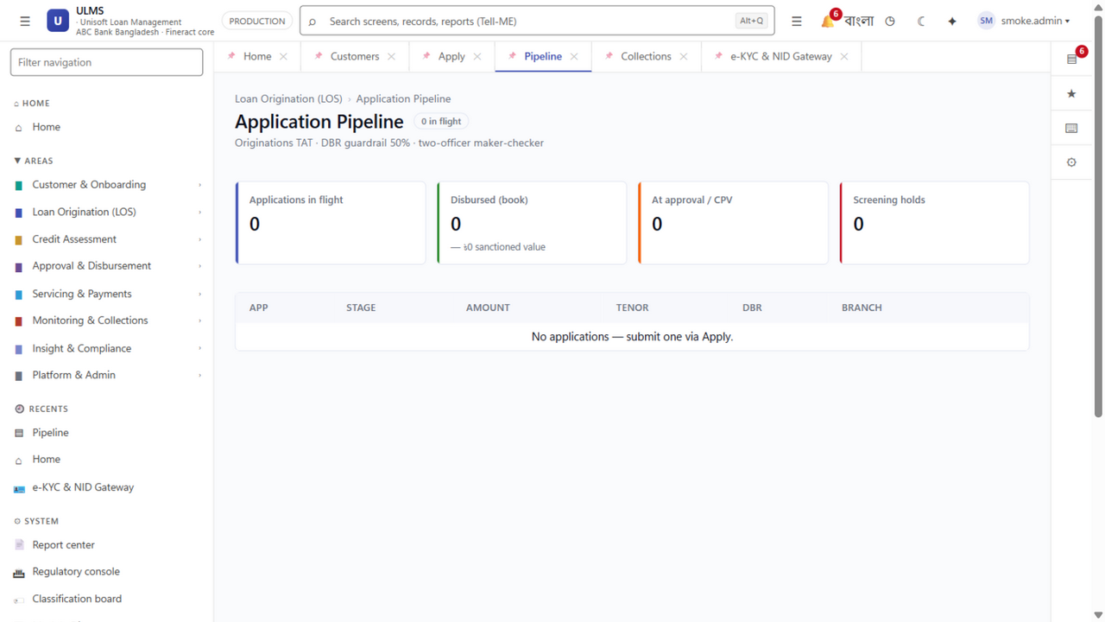
Figure 1: Usability Advantage — Agile Digital Origination vs. Finastra Legacy Monolith
Document Identifier: DOC-11-SALES-05
Target Competitor: Finastra (London, UK) — Fusion Loan IQ / Fusion Essence
Author: Head of Business Development & Competitive Intelligence Lead
Publisher: Unisoft Systems Limited (A Subsidiary of Smart Technologies BD Ltd)
Classification: Internal Commercial Strategy Asset
Version: 2.0.0

1. Competitor Overview & Market Footprint
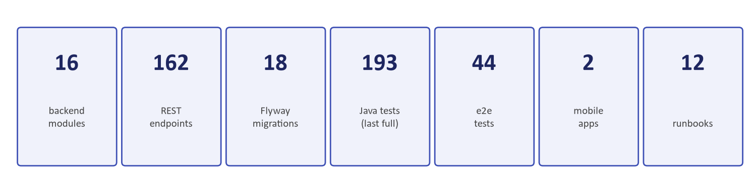
Figure 2: Commercial Advantage — 5-Year TCO Comparison & BDT 89 Crore Cost Avoidance
Finastra is a global financial software giant formed by the merger of Misys and D+H, headquartered in London. Its flagship lending product, Fusion Loan IQ, is widely recognized as the global market leader in complex commercial syndicated lending, handling approximately 70% of global syndicated loan volume.
┌─────────────────────────────────────────────────────────────────────────────┐
│ FINASTRA FUSION LOAN IQ PROFILE │
├─────────────────────┬───────────────────────────────────────────────────────┤
│ Headquarters │ London, United Kingdom │
│ Core Specialty │ Multi-currency commercial syndicated loans & agency │
│ Target Client Base │ Tier-1 Global Mega-Banks (Citibank, HSBC, Barclays) │
│ Typical Deal Size │ $3,000,000 to $6,000,000+ USD License + Implementation│
│ Annual Maintenance │ 22% to 25% USD-denominated recurring maintenance │
│ Deployment Timeline │ 18 to 24+ Months (Heavy external systems integration) │
│ Bangladesh Presence │ Zero permanent engineering development center in Dhaka│
└─────────────────────┴───────────────────────────────────────────────────────┘

2. Finastra's Strengths (What the Bank Believes)
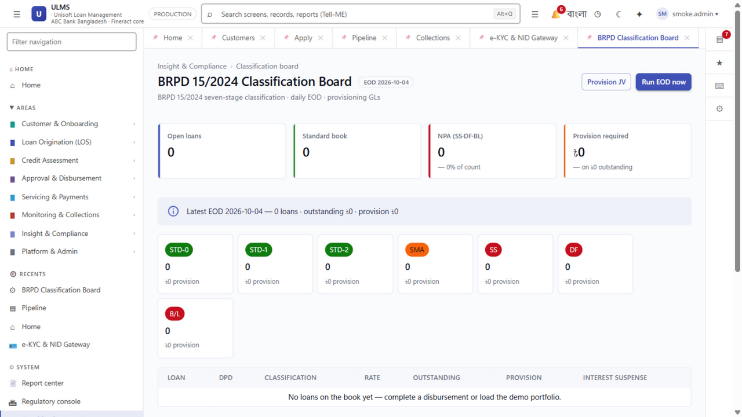
Figure 3: Compliance Speed — Instant BRPD 15 Engine vs. Finastra Multi-Month Customization Lag
- Global Brand Stature: Tier-1 international brand with widespread Wall Street and City of London credibility.
- Complex Syndicated Lending: Unsurpassed depth in multi-currency, multi-tranche syndicated facility accounting and agency bank workflows.
- Basel III Capital Modules: Sophisticated risk-weighted asset calculations designed for international regulatory regimes.

3. Finastra's Critical Vulnerabilities in Bangladesh

Vulnerability 1: Astronomical Capital & Foreign Currency Drain
- The Reality: Finastra licenses start at $3.0M to $5.0M USD (BDT 35 to 60+ Crore) with implementation consulting adding another $1.0M to $2.0M USD.
- The Forex Penalty: Recurring annual maintenance contracts (AMC) require substantial dollar remittances, requiring Bangladesh Bank foreign exchange approvals that face strict regulatory scrutiny in the current macroeconomic climate.
- The ULMS Win Theme: ULMS v2.0 is priced at BDT 3 to 6 Crore all-inclusive in local currency—delivering an immediate 85% capital expenditure reduction with zero foreign exchange liability.

Vulnerability 2: Mismatched Architecture (The Syndicated Overkill Trap)
- The Reality: Finastra Loan IQ was built for international cross-border syndicated finance. In Bangladesh, over 80% of bank lending volume is comprised of Retail Consumer Loans, MSME Working Capital, and Islamic Shariah Financing.
- The Functional Void: Loan IQ has virtually no native capability for:
- Field officer mobile applications for rural/semi-urban SME visits.
- Real-time automated Bangladesh Bank CIB Online REST inquiries.
- Election Commission NIDW biometric e-KYC integration.
- Native Islamic Murabaha, Ijara, and Diminishing Musharaka financing modes.
- The ULMS Win Theme: ULMS v2.0 was designed natively for Bangladesh’s retail, SME, and Islamic market reality, delivering high-speed automated credit decisioning out of the box.

Vulnerability 3: Zero Native Bangladesh Bank Regulatory Compliance
- The Reality: Finastra does not track Bangladesh Bank BRPD circulars. To comply with BRPD Circular 15/2024 (the 7-stage classification framework: STD-0, STD-1, STD-2, SMA, SS, DF, B/L), the bank must hire expensive third-party system integrators to write custom scripting on top of Finastra.
- The Regulatory Risk: Every time Bangladesh Bank amends a provisioning circular, the bank must negotiate an expensive change order with Finastra's offshore team.
- The ULMS Win Theme: ULMS v2.0 embeds BRPD 15/2024, CIB Online, and IFRS-9 ECL staging natively in its core engine, with guaranteed free regulatory updates under standard AMC.

Vulnerability 4: Remote Offshore Support with Zero Local Dhaka Engineers
- The Reality: Finastra services Bangladesh through offshore centers in India or Europe. They have zero dedicated engineering development center in Dhaka.
- The Support Pain: When a critical End-of-Day (EOD) classification batch stalls before a central bank inspection, the bank must log an offshore ticket and wait hours for a remote callback.
- The ULMS Win Theme: Unisoft provides a dedicated Tier-1/2/3 engineering center at Youth Tower, Begum Rokeya Sarani, Dhaka, with guaranteed 30-minute on-site response during emergencies.

4. Head-to-Head Feature & Commercial Comparison Matrix
Evaluation Dimension | Finastra Fusion Loan IQ | Unisoft ULMS v2.0 | Competitive Advantage
License & Implementation Cost | $4.0M – $7.0M USD (৳45 – 80+ Cr) | ৳3.0 – 6.0 Crore BDT | ULMS: 85% Lower TCO
Billing Currency | Foreign Currency (USD / GBP) | 100% Domestic Currency (BDT) | ULMS: Zero Forex Risk
Annual Maintenance (AMC) | 22% – 25% (in USD) | 20% Capped (in BDT) | ULMS: Predictable Budget
Implementation Timeline | 18 – 24+ Months | 12 Weeks to Pilot Go-Live | ULMS: 6x Faster Time to Value
BRPD 15/2024 7-Stage Classification | ❌ Custom Scripting Required | ✅ 100% Native Out-of-the-Box | ULMS: Zero Regulatory Risk
IFRS-9 ECL Forward-Looking Staging | ❌ Expensive Add-on Consulting | ✅ Native Mathematical Engine | ULMS: Pre-Configured for 2027
Bangladesh Bank CIB Online REST API | ❌ Manual Export / Custom API | ✅ Automated Machine-to-Machine | ULMS: Instant Dedupe & Scores
Election Commission NIDW e-KYC | ❌ Third-Party Middleware | ✅ Native Porichoy/NIDW Interface | ULMS: Instant Biometric Match
Islamic Shariah Financing Modes | ❌ Limited / Separate Package | ✅ Native Murabaha/Ijara/Musharaka | ULMS: Full Dual-Core Engine
Field Agent Offline Mobile App | ❌ Desktop / Web Only | ✅ Offline React Native App | ULMS: Total Field Enablement
Local Engineering Team in Dhaka | ❌ None (Offshore Remote) | ✅ 40+ Engineers in Youth Tower | ULMS: 30-Minute On-Site SLA

5. Trap-Setting Questions for RFP & Selection Committees
Arm your internal champion (Head of Retail, Head of IT, or CFO) with these questions to ask during Finastra vendor presentations:
- "Does your platform support Bangladesh Bank's 7-stage classification under BRPD Circular 15/2024 out of the box, or will our bank have to pay for custom development?"
- Expected Finastra Flounder: They will admit it requires custom configuration and scripting.
- "Can your platform execute real-time automated REST API inquiries into the Bangladesh Bank CIB Online system without requiring third-party middleware?"
- Expected Finastra Flounder: They will state that local credit bureau integration is an implementation-phase custom task.
- "Does Finastra maintain a permanent engineering office in Dhaka with full-time staff who can be on-site in our datacenter within 30 minutes in an outage?"
- Expected Finastra Flounder: They will have to acknowledge that technical support is delivered remotely from offshore centers.
- "Can Finastra accept 100% of license, implementation, and recurring AMC payments in BDT without requiring central bank foreign exchange outward remittance approvals?"
- Expected Finastra Flounder: They must confirm that licensing requires foreign currency remittance.
- "How does your system enforce Shariah asset possession and title transfer sequence for Islamic Murabaha and Ijara financing?"
- Expected Finastra Flounder: Loan IQ has no native asset-trading workflow for Islamic banking.

6. Winning Strategy Playbook Against Finastra
┌─────────────────────────────────────────────────────────────────────────────┐
│ THE 3-STEP PLAY TO DEFEAT FINASTRA │
├─────────────────────────────────────────────────────────────────────────────┤
│ 1. REFRAME SCOPE: Expose the "Syndicated Overkill" Trap │
│ Prove to the Board that 85% of the bank's revenue comes from Retail, │
│ SME, and Islamic loans where Finastra is weak, expensive, and unsuited. │
├─────────────────────────────────────────────────────────────────────────────┤
│ 2. EXPLOIT REGULATORY FEAR: Highlight BRPD 15/2024 & IFRS-9 │
│ Show the Chief Risk Officer that Finastra lacks native compliance with │
│ central bank directives and will expose the bank to audit citations. │
├─────────────────────────────────────────────────────────────────────────────┤
│ 3. DELIVER THE MATHEMATICAL KNOCKOUT: 85% TCO Savings │
│ Supply the CFO with DOC-32 showing that ULMS saves ৳30+ Crore over │
│ 5 years, has zero Forex drain, and goes live in 12 weeks. │
└─────────────────────────────────────────────────────────────────────────────┘

Unisoft Systems Limited — Competitive Intelligence Division.

