UNISOFT SYSTEMS LIMITED · A SUBSIDIARY OF SMART TECHNOLOGIES BD LTD
Competitive Battlecard - ULMS v2.0 vs. Temenos LMS / Transact
Commercial Banking Documentation · Document Ref: DOC-12-BAT-02

Document Identifier | Release Version | Security Classification | Publication Date | Target Audience
DOC-12-BAT-02 | 2.0.0 | Confidential Internal Sales Enablement | 2026-10-08 | [account_executive, solution_architect, sales_director, pre_sales_engineer]

Competitive Battlecard: ULMS v2.0 vs. Temenos LMS / Transact

Head-to-Head Competitive Intelligence, Trap-Setting Questions & Differentiation Playbook
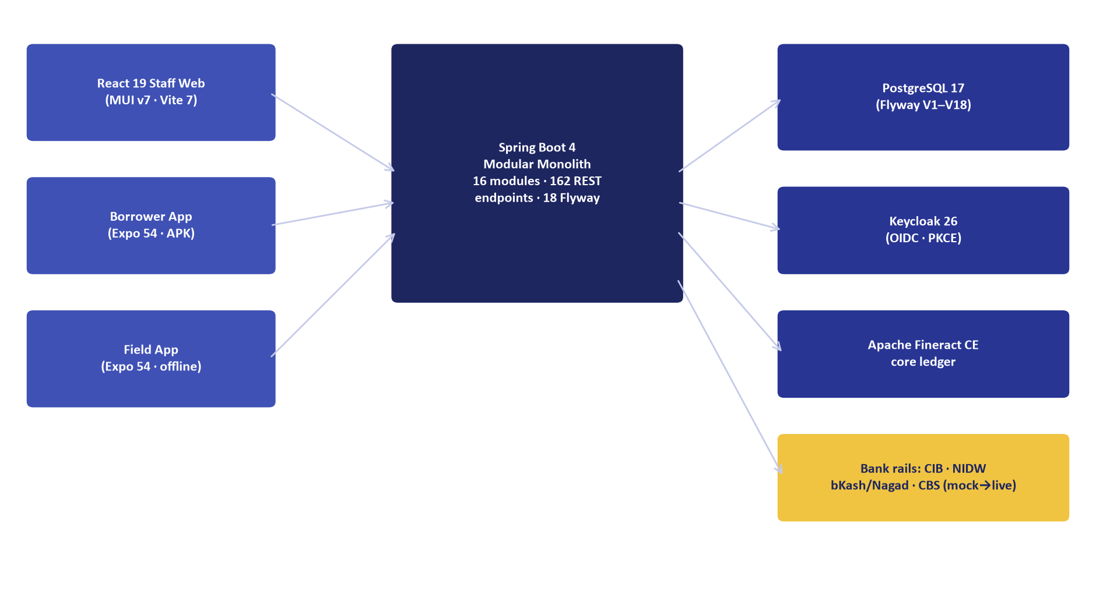
Figure 1: Architectural Advantage — CBS-Agnostic Modular Monolith vs. Rigid T24 Lock-In
Document Identifier: DOC-12-BAT-02
Target Competitor: Temenos AG (Temenos Transact / Temenos Lending Suite)
Author: Lead Competitive Intelligence Architect & Head of Banking Strategy
Publisher: Unisoft Systems Limited (A Subsidiary of Smart Technologies BD Ltd)
Classification: Strictly Confidential — Internal Sales Team Only

1. Executive Competitor Profile
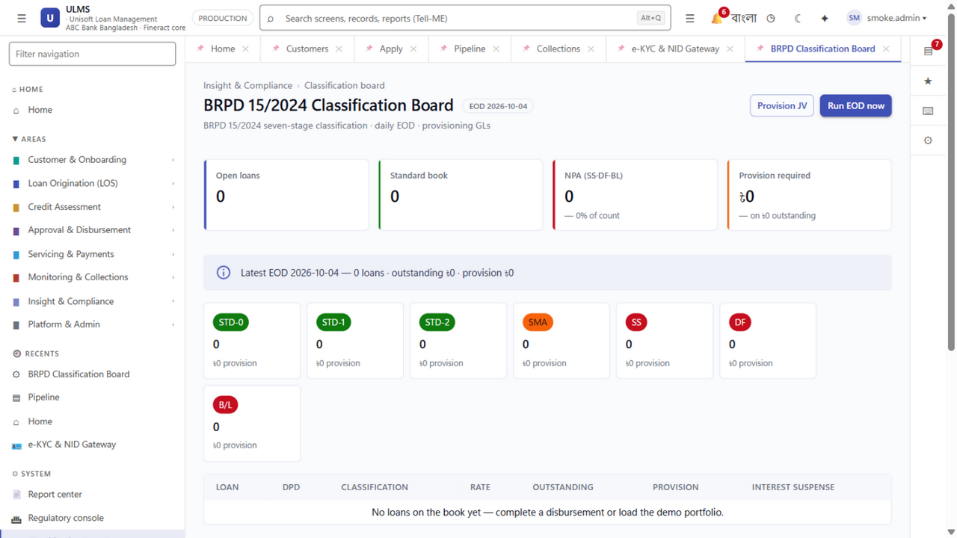
Figure 2: Compliance Advantage — Native Bangladesh Bank BRPD 15/2024 Engine vs. Temenos Lag
Parameter | Temenos Transact / Lending | Unisoft ULMS v2.0
Headquarters & Origin | Geneva, Switzerland | Dhaka, Bangladesh (Smart Technologies Group)
Bangladesh Footprint | Agrani Bank, Janata Bank, City Bank (Core Banking) | 150+ Enterprise Deployments, National Banking Footprint
Primary Architecture | Proprietary TAFJ/jBASE Runtime, Heavy Enterprise Monolith | Modular Monolith (Spring Boot 4, PostgreSQL 17, React 19)
Average Deal Size | $2.5M – $5.0M USD (৳30 – ৳60 Crore BDT) | BDT 4.00 Crore Turnkey (License + Impl + Training)
Implementation Horizon | 18 to 24 Months | 12 Weeks (Guaranteed Pilot Go-Live)
Local Support Model | Offshore Support Centers (India/Europe); fly-in consultants | 24/7/365 On-Site Engineering Team in Dhaka

2. Competitor Strengths (Where Temenos Excels)
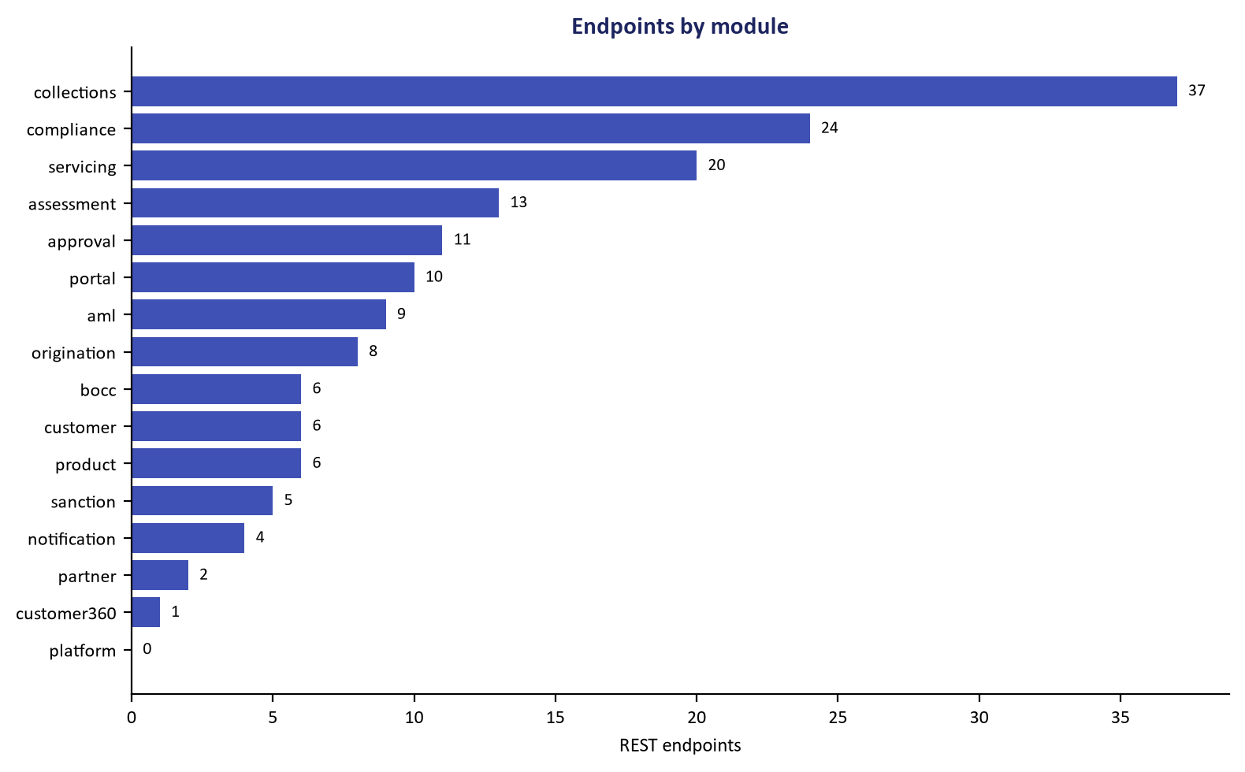
Figure 3: Integration Superiority — Open REST API Boundary vs. Proprietary Temenos Protocols
- Established Global Brand: Widely recognized by international rating agencies and multinational bank boards.
- Core Banking Footprint: Incumbent CBS in several leading Tier-1 and state-owned commercial banks in Bangladesh.
- Broad Functional Scope: Global treasury, multi-currency processing, and complex international trade finance.

3. Competitor Critical Vulnerabilities (Where ULMS Wins)
System Architecture Specification (Mermaid DSL): [Diagram Topology: flowchart TD]
flowchart TD
subgraph Temenos ["Temenos Lending Vulnerabilities"]
T1["High USD TCO: $3M+ License + 22% USD AMC"]
T2["Proprietary Lock-in: TAFJ/jBASE Consultant Shortage"]
T3["Regulatory Lag: No native BRPD 15 7-stage engine"]
T4["18-24 Month Average Implementation Cycle"]

1. The Core Banking Coupling Trap:
- The Reality: Temenos strongly pushes banks to adopt its full Transact stack. Deploying Temenos Lending as a standalone LMS alongside a non-Temenos CBS (e.g., Finacle or Misys) is notoriously complex, brittle, and expensive.
- The Pitch: "ULMS v2.0 is CBS-agnostic. Whether your bank runs Temenos, Finacle, or an in-house CBS, ULMS integrates via standard REST/ISO-20022 connectors within 4 weeks without disrupting your core ledger."

2. Astronomical Foreign Currency Total Cost of Ownership:
- The Reality: Temenos contracts are denominated in US Dollars or Swiss Francs. Under Bangladesh Bank foreign exchange rationing, remitting millions of dollars abroad requires central bank approval and creates heavy forex depreciation losses.
- The Pitch: "ULMS is 100% invoiced in Bangladeshi Taka (BDT) with full NBR VAT compliance. You eliminate all forex risk, avoid Bangladesh Bank remittance delays, and save over ৳85 Crore over 5 years."

3. Lack of Native Bangladesh Bank Regulatory Automation:
- The Reality: Temenos requires expensive external system integrators to write custom code for Bangladesh Bank BRPD Circular 15/2024 (7-stage classification), CIB Online REST inquiries, and BFIU e-KYC guidelines.
- The Pitch: "ULMS v2.0 was architected specifically for Bangladesh Bank regulations. The 7-stage BRPD 15 engine, real-time CIB parser, and Election Commission NIDW biometric matching work on Day 1 out of the box."

4. Head-to-Head Feature Comparison Matrix
Functional Dimension | Temenos Lending | Unisoft ULMS v2.0 | Win Evaluation
BRPD 15/2024 7-Stage Classification | Requires Custom Build ($150k+ change order) | Native Deterministic Engine Included | ULMS Decisive Win
Real-Time CIB Online REST Integration | Requires Custom Middleware | Certified Pre-Built Connector | ULMS Decisive Win
Election Commission e-KYC Integration | Requires 3rd-Party Gateway | Native Face Match & OCR Liveness | ULMS Decisive Win
Islamic Shariah Modes (Murabaha, Ijara) | Complex Module Upgrade ($300k+) | Native Multi-Asset Shariah Engine | ULMS Decisive Win
Field Collection Offline Mobile App | Basic / Third-party Dependent | Native Expo 54+ App with GPS Geotagging | ULMS Decisive Win
Time to Market | 18–24 Months | 12 Weeks Turnkey Pilot | ULMS Decisive Win
5-Year Total Cost of Ownership | ৳90+ Crore BDT equivalent | ৳7.50 Crore BDT (incl. AMC) | ULMS Saves ৳82+ Cr

5. Trap-Setting RFP Questions to Disqualify Temenos
Arm your internal champion (CIO, CRO, or Head of Procurement) with these mandatory RFP evaluation criteria:
- For the RFP Technical Committee:
> "Does the proposed loan management platform provide a pre-built, production-certified connector for Bangladesh Bank's CIB Online REST API, or does this require bespoke development and separate consulting charges?"
(Temenos must answer 'Custom Development', incurring heavy technical score penalties).
- For the Risk & Compliance Committee:
> "Can the system automatically classify loans into STD-0, STD-1, STD-2, SMA, SS, DF, and B/L per BRPD Circular 15/2024, deduct eligible collateral according to Bangladesh Bank haircuts, and generate regulatory returns CL-1 through CL-5 natively without spreadsheet export?"
(Temenos cannot do this natively).
- For the Tender & Commercial Committee:
> "Is the vendor willing to execute a 100% BDT-denominated contract with a fixed-fee implementation warranty, guaranteeing zero foreign currency outflow and on-site engineering SLA within 2 hours in Dhaka?"
(Temenos will refuse foreign exchange indemnification).
Unisoft Systems Limited — Competitive Intelligence & Banking Sales Operations.

