UNISOFT SYSTEMS LIMITED · A SUBSIDIARY OF SMART TECHNOLOGIES BD LTD
Master RFP Financial Proposal & Cost Breakdown Template (Envelope-2)
Commercial Banking Documentation · Document Ref: DOC-24-BID-02

Document Identifier | Release Version | Security Classification | Publication Date | Target Audience
DOC-24-BID-02 | 2.0.0 | Confidential Commercial Bid Asset | 2026-10-08 | [cfo, bid_manager, head_of_procurement, sales_director]

Quality and Cost-Based Selection (QCBS) Commercial Bid for Bangladesh Scheduled Commercial Banks
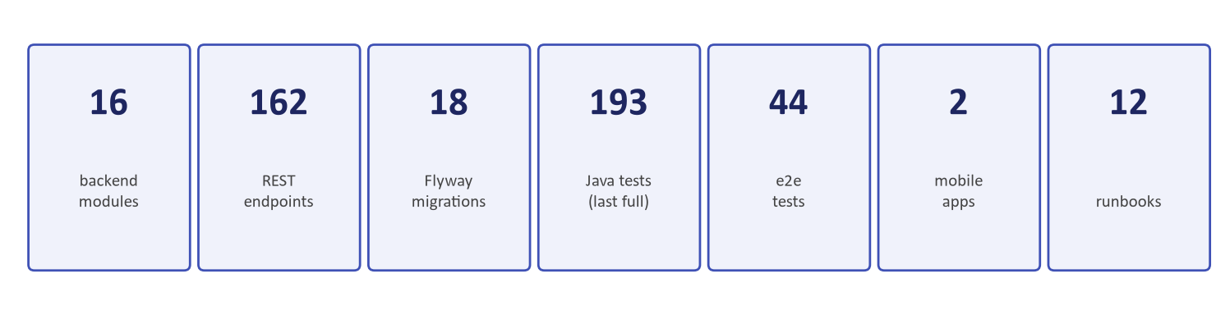
Figure 1: Financial Evaluation — Total Capital Recovery & 5-Year TCO Comparison Model
Document Identifier: DOC-24-BID-02
Procurement Reference: Standard Two-Envelope Banking RFP Financial Submission
Author: Chief Financial Officer & Head of Bid Management
Publisher: Unisoft Systems Limited (A Subsidiary of Smart Technologies BD Ltd)
Classification: Confidential Commercial Bid Asset
Version: 2.0.0

1. Financial Proposal Submission Form
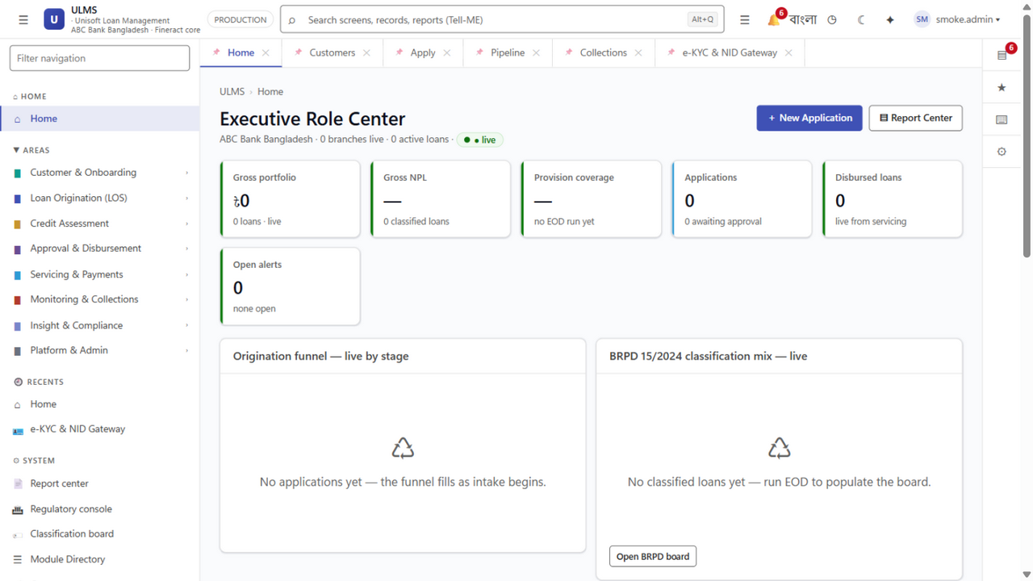
Figure 2: Operational Value — Portfolio Health & Cost Optimization Analytics
[To be printed on Unisoft Systems Limited Official Letterhead and Sealed in Envelope-2]
Date: [Insert Date]
To:
The Chairman, Proposal Evaluation Committee / Head of Procurement
[Insert Bank Name]
[Insert Bank Head Office Address, Dhaka, Bangladesh]
Subject: Financial Proposal for the Procurement of an Enterprise Loan Management System (LMS) — Tender Ref No: [Insert Tender Reference Number]
Dear Sir/Madam,
We, the undersigned, offer to provide the software license, implementation services, data integration, training, and maintenance for the Unisoft Loan Management System (ULMS v2.0) in accordance with your Request for Proposal (RFP) dated [Insert Date] and our Technical Proposal.
Our attached Financial Proposal is for the sum of:
$$\mathbf{BDT\ [Insert\ Amount\ in\ Figures]}\quad (\mathbf{Taka\ [Insert\ Amount\ in\ Words]\ Only)}$$
This amount is inclusive of all local statutory taxes, Advance Income Tax (AIT), and Value Added Tax (VAT) in accordance with the laws of the People's Republic of Bangladesh.
Our Financial Proposal shall be binding upon us subject to the modifications resulting from Contract negotiations, up to the expiration of the validity period of the Proposal, i.e., 120 (One Hundred Twenty) calendar days.
We confirm that there are no hidden costs, foreign exchange liabilities, or undisclosed recurring fees associated with our proposal.
We remain,
Yours sincerely,
_____________________________________________
[Authorized Signatory Name]
[Designation: Chief Financial Officer / Managing Director]
Unisoft Systems Limited
Youth Tower, Begum Rokeya Sarani, Dhaka-1216, Bangladesh

2. Master Schedule of Prices Summary
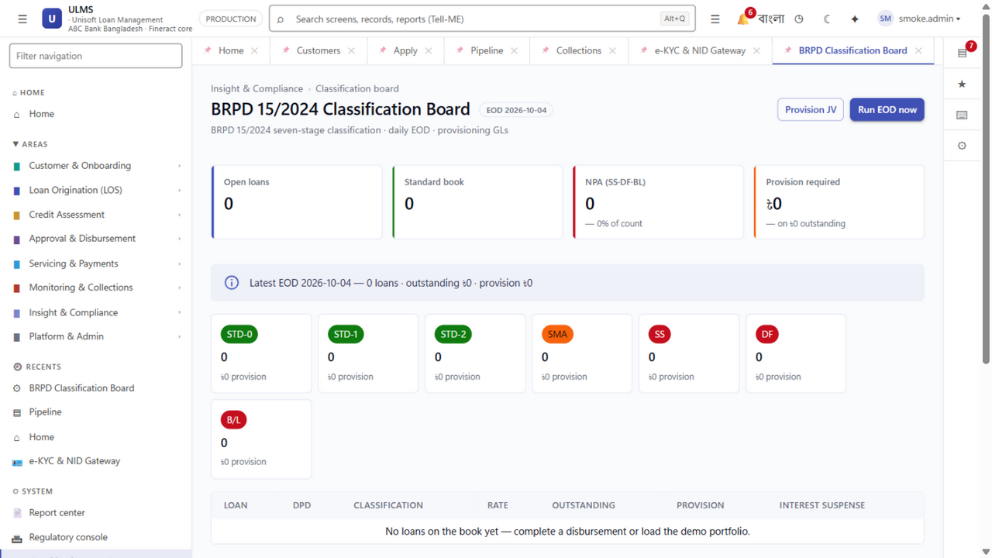
Figure 3: Balance Sheet Protection — Capital Adequacy Optimization via Granular Provisioning
The total commercial investment for the delivery, deployment, and operationalization of ULMS v2.0 is structured into four transparent components:
Component Code | Description of Services & Deliverables | Total Amount (BDT)<br/>*Excluding VAT* | Statutory NBR VAT (15%) | Total Contract Amount (BDT)<br/>*Including 15% VAT*
SCHEDULE-A | Core Software Perpetual License Fee | ৳ 2,50,00,000 | ৳ 37,50,000 | ৳ 2,87,50,000
SCHEDULE-B | Implementation, Customization & CBS Integration | ৳ 1,20,00,000 | ৳ 18,00,000 | ৳ 1,38,00,000
SCHEDULE-C | Training, UAT Support & Change Management | ৳ 30,00,000 | ৳ 4,50,000 | ৳ 34,50,000
SCHEDULE-D | First-Year Warranty & Level-3 Technical Support | Included (Zero Cost) | Included | Included (Zero Cost)
TOTAL INITIAL INVESTMENT | Turnkey Pilot & Network Deployment | ৳ 4,00,00,000 | ৳ 60,00,000 | ৳ 4,60,00,000

(In Words: Bangladeshi Taka Four Crore Sixty Lakh Only, including 15% statutory VAT).

3. Detailed Cost Breakdown Schedules

Schedule A: Core Software Perpetual License Fees
Grant of perpetual, irrevocable, enterprise-wide license for use within the bank's sovereign datacenter.
Item # | License Component / Module | Scope of License | Price (BDT)
A.1 | ULMS Core Engine (Origination, Assessment, BOCC) | Enterprise Bank-Wide | ৳ 80,00,000
A.2 | Approval Engine & 7-Level Delegation Hierarchy | Enterprise Bank-Wide | ৳ 30,00,000
A.3 | Automated CBS Disbursement & Servicing Engine | Enterprise Bank-Wide | ৳ 40,00,000
A.4 | BRPD Circular 15/2024 & IFRS-9 ECL Module | Enterprise Bank-Wide | ৳ 45,00,000
A.5 | Real-Time CIB Online REST Integration Gateway | Centralized Gateway | ৳ 25,00,000
A.6 | Election Commission NIDW / e-KYC Biometric Interface | Centralized Gateway | ৳ 15,00,000
A.7 | Islamic Shariah-Compliant Financing Module | Enterprise Bank-Wide | ৳ 15,00,000
SUB-TOTAL | Schedule A: Software Perpetual License |  | ৳ 2,50,00,000

Schedule B: Professional Services, Customization & CBS Integration
All engineering professional services delivered over the 12-week implementation timeline.
Item # | Professional Services Activity | Estimated Effort | Price (BDT)
B.1 | Business Requirements Study & Gap Specification (BRD/SRS) | 4 Man-Weeks | ৳ 15,00,000
B.2 | Core Banking System (CBS) Bi-Directional Connector Build | 8 Man-Weeks | ৳ 45,00,000
B.3 | CIB Online Gateway & Election Commission NIDW Config | 3 Man-Weeks | ৳ 15,00,000
B.4 | Legacy Loan Data Cleansing, Transformation & Migration | 6 Man-Weeks | ৳ 25,00,000
B.5 | System Integration Testing (SIT) & Performance Tuning | 4 Man-Weeks | ৳ 20,00,000
SUB-TOTAL | Schedule B: Implementation & Integration Services |  | ৳ 1,20,00,000

Schedule C: Training, Capacity Building & Pilot Support
Item # | Training / Change Management Service | Delivery Mode | Price (BDT)
C.1 | Train-the-Trainer (TTT) Master Workshop (25 Core Trainers) | On-Site Classroom (5 Days) | ৳ 10,00,000
C.2 | Branch Credit Officer & BOCC Workflow Training (100 Staff) | Regional Centers (10 Days) | ৳ 12,00,000
C.3 | System Administration, DBA & Security Operations Training | Technical Labs (5 Days) | ৳ 8,00,000
SUB-TOTAL | Schedule C: Training & Capacity Building |  | ৳ 30,00,000

4. Annual Maintenance Contract (AMC) & Support Fees (Years 2–5)
- Year 1 Maintenance: Completely FREE of charge under our comprehensive 12-month warranty period.
- Years 2 to 5 Maintenance: Fixed at exactly 20% of the Net Software License Value (Schedule A) annually:
$$\text{Annual AMC Fee} = 20\% \times \text{BDT } 2,50,00,000 = \mathbf{BDT\ 50,00,000\ /\ Year\ (+15\%\ VAT)}$$

Scope of Annual Maintenance Contract Coverage:
- Free Bangladesh Bank Regulatory Updates: All mandatory updates driven by new BRPD, BFIU, or CIB circulars are delivered at zero additional customization cost.
- Dedicated Dhaka Support Engineering: Tier-1 helpdesk, Tier-2 engineering, and Tier-3 architect escalations with 30-minute on-site response in Dhaka.
- Core Version Upgrades: All minor and major software version updates and security patches released by Unisoft during the active maintenance term.

5. Milestone-Based Payment Terms
Payments shall be tied strictly to verified project milestones, guaranteeing alignment of incentives:
Milestone # | Project Deliverable / Trigger | % of Total Contract | Amount (BDT)<br/>*Incl. VAT*
M1 | Contract Signing & Mobilization Advance (against Advance Bank Guarantee) | 20% | ৳ 92,00,000
M2 | Approval of Final Business Requirements Document (BRD) & Architecture | 20% | ৳ 92,00,000
M3 | Completion of CBS & CIB Integration and Delivery of Staging Sandbox | 20% | ৳ 92,00,000
M4 | Successful User Acceptance Testing (UAT) Sign-Off by Bank Committee | 20% | ৳ 92,00,000
M5 | Successful Pilot Branch Go-Live & First Live Loan Disbursement | 10% | ৳ 46,00,000
M6 | Final Project Acceptance Sign-Off (30 Days Post-Pilot Stable Run) | 10% | ৳ 46,00,000
TOTAL | 100% Contract Execution | 100% | ৳ 4,60,00,000

6. Statutory Taxes & VAT Statement
- VAT Compliance: Unisoft Systems Limited is fully registered under the Value Added Tax and Supplementary Duty Act, 2012, holding Business Identification Number (BIN): [Insert BIN Number].
- UniVAT™ Pedigree: Unisoft is the developer of the NBR-Approved UniVAT™ enterprise system, ensuring 100% flawless tax invoice (Mushak-6.3) issuance.
- Withholding Tax (AIT): Advance Income Tax (AIT) will be deducted at source by the Bank in accordance with the Income Tax Act, 2023, and Unisoft shall be furnished with formal withholding tax deduction certificates.
Unisoft Systems Limited — Financial & Commercial Operations.

