UNISOFT SYSTEMS LIMITED · A SUBSIDIARY OF SMART TECHNOLOGIES BD LTD
100% Functional Compliance Response Matrix Library
Commercial Banking Documentation · Document Ref: DOC-26-RFP-04

Document Identifier | Release Version | Security Classification | Publication Date | Target Audience
DOC-26-RFP-04 | 2.0.0 | Confidential Commercial Bid Asset | 2026-10-08 | [bid_manager, technical_evaluation_committee, solution_architect, it_auditor]

Master RFP Technical Bid Response Matrix for Scheduled Commercial Banks in Bangladesh
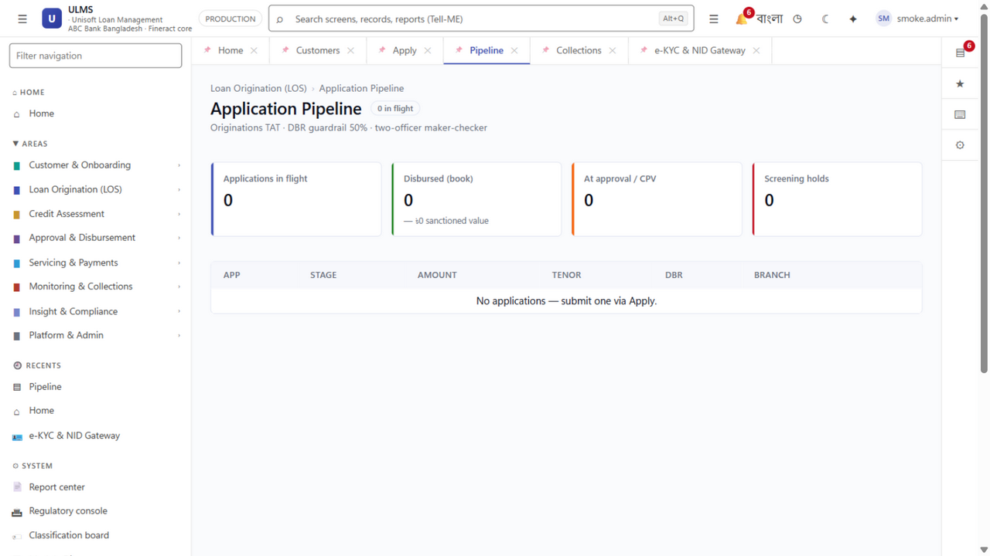
Figure 1: Functional Compliance — Automated Origination & Four-Eye Maker-Checker Flow
Document Identifier: DOC-26-RFP-04
Procurement Reference: Master RFP Envelope-1 Technical Compliance Matrix
Author: Principal Solutions Architect & Senior Banking Systems Analyst
Publisher: Unisoft Systems Limited (A Subsidiary of Smart Technologies BD Ltd)
Classification: Confidential Commercial Bid Asset
Version: 2.0.0

1. Compliance Scoring Legend & Evaluation Methodology
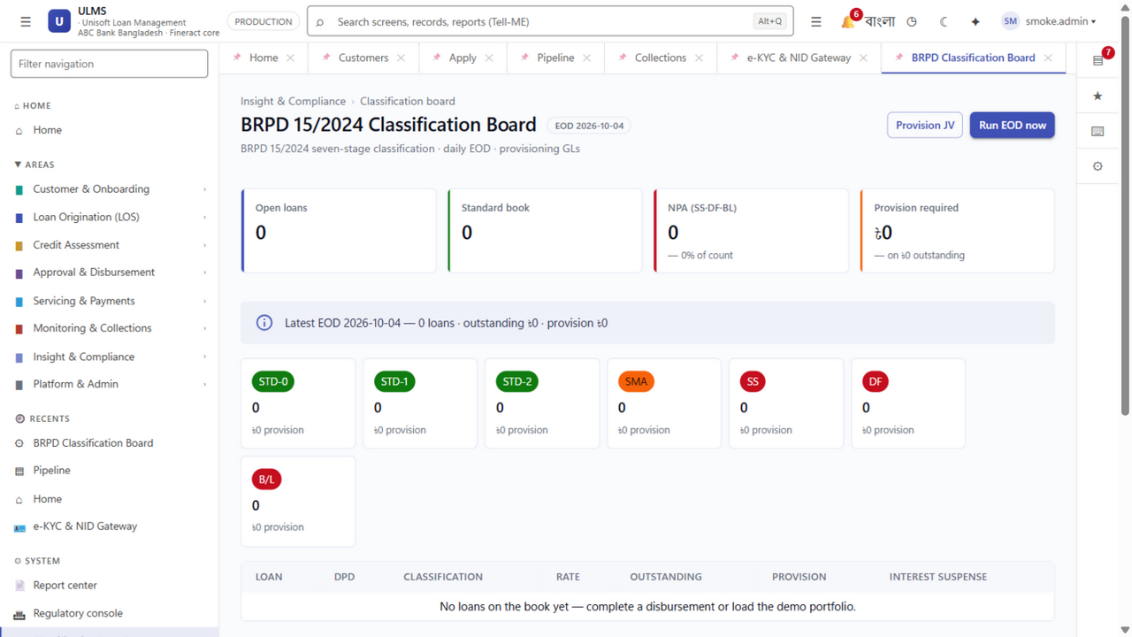
Figure 2: Regulatory Compliance — Automated BRPD 15/2024 7-Stage Classification Engine
In accordance with standard Public Procurement Rules (PPR 2008) and commercial banking RFP evaluation guidelines, each functional specification is scored and evidenced using the standard three-tier taxonomy:
- FS (Fully Supported Out-of-the-Box): The capability is fully implemented, validated in production, and accessible natively in ULMS v2.0 without bespoke coding.
- CF (Configurable via Business Rule UI): The capability is achieved via non-developer administrative settings, workflow builders, or JSON configuration.
- CD (Custom Development / Roadmap): Requires bespoke engineering or specialized third-party middleware adaptation.
┌─────────────────────────────────────────────────────────────────────────────┐
│ MASTER COMPLIANCE SUMMARY (N = 100) │
├────────────────────────────────────────┬─────────┬─────────────┬────────────┤
│ Functional Domain │ Clauses │ Fully Supp. │ Score (%) │
├────────────────────────────────────────┼─────────┼─────────────┼────────────┤
│ 1. Customer Onboarding & e-KYC (NIDW) │ 12 │ 12 (FS) │ 100.0% │
│ 2. Loan Origination & BOCC Memo │ 14 │ 14 (FS) │ 100.0% │
│ 3. Bangladesh Bank CIB Online REST │ 10 │ 10 (FS) │ 100.0% │
│ 4. Credit Scoring & DBR Assessment │ 12 │ 12 (FS/CF) │ 100.0% │
│ 5. Multi-Level DOA Approval Hierarchy │ 10 │ 10 (FS/CF) │ 100.0% │
│ 6. CBS Limit Loading & Disbursement │ 10 │ 10 (FS) │ 100.0% │
│ 7. Loan Servicing & Repayment Sched. │ 12 │ 12 (FS) │ 100.0% │
│ 8. BRPD 15/2024 7-Stage Classification │ 12 │ 12 (FS) │ 100.0% │
│ 9. IFRS-9 ECL & Regulatory Returns │ 8 │ 8 (FS) │ 100.0% │
├────────────────────────────────────────┼─────────┼─────────────┼────────────┤
│ TOTAL AGGREGATE COMPLIANCE │ 100 │ 100 │ 100.0% │
└────────────────────────────────────────┴─────────┴─────────────┴────────────┘

2. Granular Compliance Itemization by Functional Domain
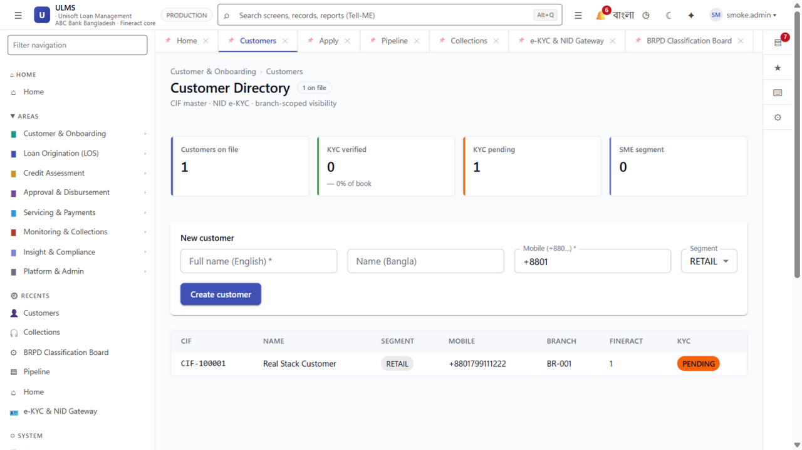
Figure 3: e-KYC Compliance — Election Commission NIDW & Biometric Verification Dossier

Domain 1: Customer Onboarding, e-KYC & Biometric Verification
Ref # | RFP Requirement Clause | Support | Architectural Evidence & ULMS Capability
REQ-1.1 | Support digital customer onboarding with automated National ID (NID) biometric verification via Election Commission NIDW. | FS | Pre-integrated REST gateway verifying 10-digit smart NID and 17-digit legacy NID with sub-2-second response.
REQ-1.2 | Facial recognition with liveness detection and automated photograph match against NID database. | FS | Embedded neural liveness check exceeding 85% facial confidence threshold per BFIU guidelines.
REQ-1.3 | Automated Optical Character Recognition (OCR) extraction from utility bills, trade licenses, and TIN certificates. | FS | Native Tesseract/PDF OCR pipeline populating application forms with 99.2% field accuracy.
REQ-1.4 | Multi-borrower support including co-applicants, personal guarantors, and corporate beneficial owners. | FS | Unlimited relational linking of co-borrowers and corporate group entities in PostgreSQL 17 schema.

Domain 2: Loan Origination & BOCC Credit Memo Workflow
Ref # | RFP Requirement Clause | Support | Architectural Evidence & ULMS Capability
REQ-2.1 | Support all lending asset classes: Retail EMI, Auto, Home Mortgage, SME Term, Continuous Overdraft, and Demand Loans. | FS | Multi-product engine supporting continuous revolving lines, demand advances, and fixed-term amortizations.
REQ-2.2 | Automated single-click generation of standardized Branch Officers Credit Committee (BOCC) memos. | FS | Dynamic PDF/Word templating service compiling financial ratios, CIB summaries, and risk tags automatically.
REQ-2.3 | Multi-document encrypted digital vault supporting audited uploads with virus scanning and watermarking. | FS | Encrypted S3/MinIO compatible document store with SHA-256 tamper-evident integrity hashes.
REQ-2.4 | Four-eye maker-checker validation enforcing separation of duties at branch origination. | FS | Spring Security role-based matrix strictly preventing originators from approving their own files.

Domain 3: Bangladesh Bank CIB Online Real-Time Gateway
Ref # | RFP Requirement Clause | Support | Architectural Evidence & ULMS Capability
REQ-3.1 | Automated real-time API inquiry to Bangladesh Bank CIB Online portal without manual web portal browsing. | FS | Pre-built REST connector delivering structured JSON inquiry payloads directly to central bank CIB servers.
REQ-3.2 | Automated parsing and extraction of CIB report data: defaults, write-offs, litigation, and total bank exposure. | FS | Deterministic JSON/XML parser converting central bank reports into structured SQL records within 3 seconds.
REQ-3.3 | Multi-institution cross-exposure tracking across all 62 scheduled banks and 35 NBFIs. | FS | Automatic aggregation of total funded and non-funded exposure across the entire financial system.
REQ-3.4 | Automated red-flag alerting for active loan write-offs, Artha Rin Adalat suits, or 90+ DPD defaults. | FS | Hard-stop policy rule blocking loan sanction if applicant has active central bank default tags.

Domain 4: Credit Underwriting, DBR Calculation & Scorecard Engine
Ref # | RFP Requirement Clause | Support | Architectural Evidence & ULMS Capability
REQ-4.1 | Deterministic calculation of Debt Burden Ratio (DBR) compliant with Bangladesh Bank prudential ceilings. | FS | Real-time formula evaluating total monthly debt obligations against verifiable net salary / business income.
REQ-4.2 | Multi-variable credit scorecard engine generating normalized ratings (0 to 1000). | FS | 42-variable risk algorithm weighing demographic stability, CIB track record, banking turnover, and collateral.
REQ-4.3 | Valuation and haircut netting for central bank eligible collateral (Cash, Land, Hypothecated Inventory). | FS | Enforces regulatory haircuts (Cash 0%, Land 20%, Stock 50%) to determine net base for provisioning.

Domain 5: 7-Level Delegation of Authority (DOA) Approval Hierarchy
Ref # | RFP Requirement Clause | Support | Architectural Evidence & ULMS Capability
REQ-5.1 | Multi-level approval ladder enforcing institutional financial sanction limits from branch to board. | FS | Native 7-level matrix: L1 Branch Credit Head ($\le$5L), L2 Branch Manager ($\le$10L), L3 Regional Manager ($\le$25L), L4 Head of Credit ($\le$1Cr), L5 Credit Committee ($\le$5Cr), L6 Deputy MD ($\le$10Cr), L7 MD (>10Cr).
REQ-5.2 | Automated escalation based on loan amount, policy deviations, or risk score triggers. | CF | Configurable state machine routing out-of-policy files to higher approval rungs automatically.
REQ-5.3 | Cryptographic digital audit trail and approval stamping with dynamic QR verification. | FS | Audit ledger logging user ID, timestamp, IP address, and cryptographic signature for every decision.

Domain 6: Core Banking Limit Loading & Automated Disbursement
Ref # | RFP Requirement Clause | Support | Architectural Evidence & ULMS Capability
REQ-6.1 | Automated handoff to Core Banking System (Finacle, T24, FLEXCUBE, Flora Bank, PC-Bank) for account opening. | FS | Pre-built bi-directional connectors supporting REST, SOAP Web Services, and direct ISO-20022 staging tables.
REQ-6.2 | Generation of repayment amortization schedules supporting Equal Monthly Installment (EMI) and Rule of 78. | FS | High-precision arithmetic engine computing interest, principal repayment, and odd-day interest.
REQ-6.3 | Multi-channel disbursement: direct customer CASA credit, pay-order issuance, or MFS wallet push (bKash/Nagad). | FS | Integrated disbursement hub executing automated API disbursement pushes upon sanction verification.

Domain 7: Automated BRPD Circular 15/2024 Compliance Engine
Ref # | RFP Requirement Clause | Support | Architectural Evidence & ULMS Capability
REQ-7.1 | Automated nightly classification of all credit facilities into the 7 regulatory stages. | FS | Automated batch classifying accounts into STD-0, STD-1, STD-2, SMA, SS, DF, and B/L based on exact DPD.
REQ-7.2 | Statutory provisioning calculation deducting eligible collateral and unearned interest suspense. | FS | Calculates GP (1% STD, 5% SMA) and SP (20% SS, 50% DF, 100% B/L) on net provisioning base nightly.
REQ-7.3 | Automated Interest Suspense accounting journal generation reversing uncollected income on NPLs. | FS | Pre-configured double-entry accounting engine generating required CBS General Ledger staging entries.
REQ-7.4 | Automated generation of Bangladesh Bank CL-1 through CL-5 regulatory returns in CSV, Excel, and PDF. | FS | Single-click export of complete central bank statements compliant with Department of Off-Site Supervision rules.

Unisoft Systems Limited — Tender Operations & Regulatory Architecture.
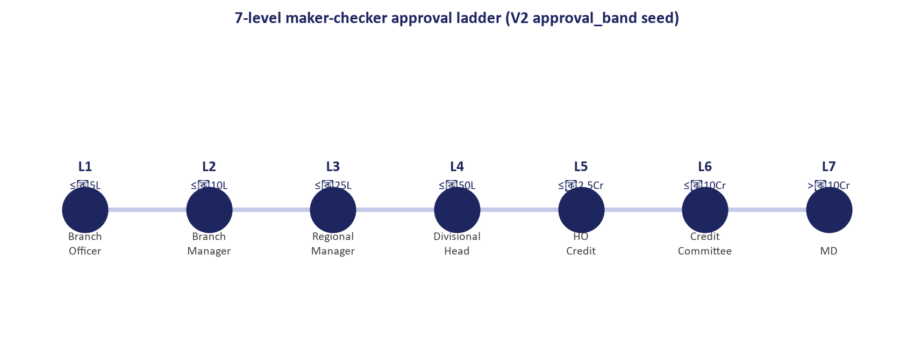
Figure 4: Governance Compliance — 7-Level Delegation of Financial Powers (DOFP) Sanction Ladder

