UNISOFT SYSTEMS LIMITED · A SUBSIDIARY OF SMART TECHNOLOGIES BD LTD
Commercial Pricing Model & Licensing Matrix
Commercial Banking Documentation · Document Ref: DOC-31-COM-01

Document Identifier | Release Version | Security Classification | Publication Date | Target Audience
DOC-31-COM-01 | 2.0.0 | Confidential Commercial Strategy Asset | 2026-10-08 | [cfo, sales_director, account_executive, bid_manager, head_of_procurement]

Turnkey Enterprise Perpetual Licensing, Implementation Tiers & Volume Sliding Scale
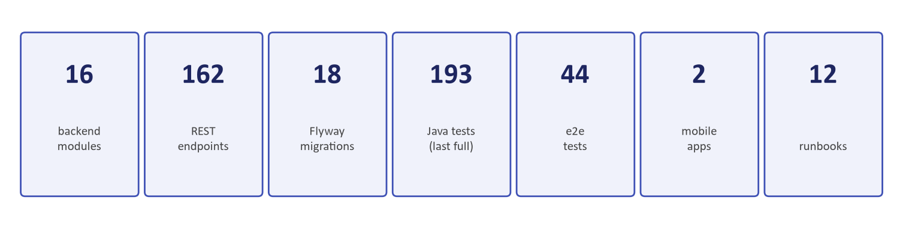
Figure 1: Commercial Justification — Investment Payback Horizon & ROI Projections
Document Identifier: DOC-31-COM-01
Author: Chief Commercial Officer & Head of Bid Management
Publisher: Unisoft Systems Limited (A Subsidiary of Smart Technologies BD Ltd)
Classification: Confidential Commercial Asset
Version: 2.0.0

1. Commercial Architecture & Value Principles
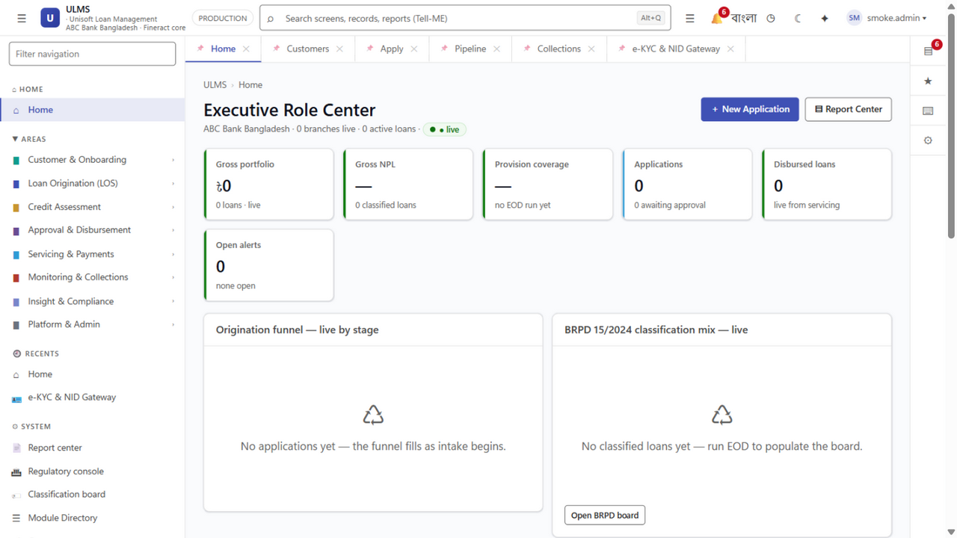
Figure 2: Enterprise Value — Branch Portfolio Monitoring & Asset Optimization
Unisoft’s pricing architecture for ULMS v2.0 eliminates the hidden consulting traps, offshore per-diem fees, and foreign exchange volatility typical of global legacy packages.

Four Binding Commercial Pillars:
- 100% Domestic Bangladeshi Taka (BDT) Invoicing: Zero US Dollar exposure, zero central bank outward remittance delays, and 100% eligible NBR VAT input tax credits via UniVAT™.
- Transparent Perpetual Enterprise Licensing: Bank owns an irrevocable perpetual license to operate the platform across all sovereign datacenters without per-seat employee surcharges.
- Turnkey Fixed-Price Implementation: Pre-defined milestone delivery guaranteeing no scope-creep change orders for agreed requirements.
- Capped Annual Maintenance Contract (AMC): Year 1 warranty is included free (0%); Years 2 through 5 are fixed at exactly 20% of the initial software license fee.

2. Enterprise Tier Pricing Matrix (Turnkey Deployments)
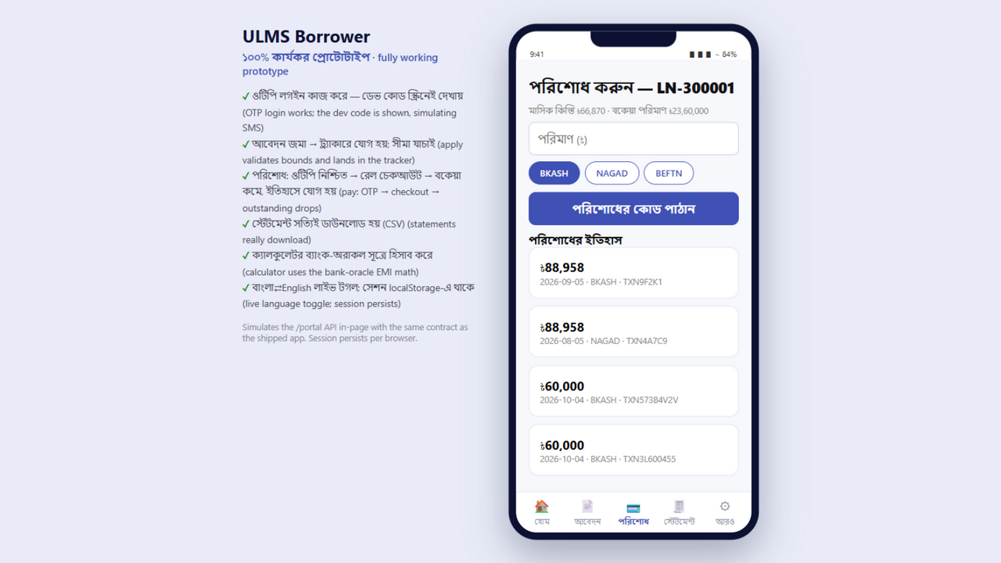
Figure 3: Transaction Velocity — Automated Collection Rails via Real-Time MFS Integration
┌─────────────────────────────────────────────────────────────────────────────┐
│ ULMS v2.0 COMMERCIAL TIER MATRIX │
├───────────────────────────────┬──────────────┬──────────────┬───────────────┤
│ Commercial Dimension │ TIER 1: │ TIER 2: │ TIER 3: │
│ │ Scheduled │ Islamic │ Specialized / │
│ │ PCB (Conv.) │ Banking (Full│ NBFI / Digital│
├───────────────────────────────┼──────────────┼──────────────┼───────────────┤
│ Portfolio Capacity │ ৳10,000 Cr+ │ ৳10,000 Cr+ │ Up to ৳2,000Cr│
│ Branch / Outlet License │ Up to 150 Br.│ Up to 150 Br.│ Up to 40 Br. │
│ Staff User Seats │ Unlimited │ Unlimited │ Up to 250 │
├───────────────────────────────┼──────────────┼──────────────┼───────────────┤
│ 1. Software License Fee │ ৳ 2,50,00,000│ ৳ 2,75,00,000│ ৳ 1,60,00,000 │
│ 2. Implementation & CBS │ ৳ 1,20,00,000│ ৳ 1,30,00,000│ ৳ 80,00,000 │
│ 3. Training & UAT Support │ ৳ 30,00,000│ ৳ 35,00,000│ ৳ 20,00,000 │
│ 4. Year 1 Warranty │ Included (৳0)│ Included (৳0)│ Included (৳0) │
├───────────────────────────────┼──────────────┼──────────────┼───────────────┤
│ TOTAL INITIAL INVESTMENT │৳4,00,00,000│৳4,40,00,000│৳2,60,00,000│
├───────────────────────────────┼──────────────┼──────────────┼───────────────┤
│ Annual AMC (Years 2-5) │ ৳ 50,00,000/y│ ৳ 55,00,000/y│ ৳ 32,00,000/y │
└───────────────────────────────┴──────────────┴──────────────┴───────────────┘
*(All prices in Bangladeshi Taka (BDT) excluding statutory 15% NBR VAT)*

3. Modular Perpetual License Component Breakdown
For banks procuring modular capabilities or specialized subsystem add-ons:
Module Identifier | Functional Capability | Perpetual License Price (BDT)
MOD-01 | ULMS Core Lending Engine: Retail, SME, BOCC Memo Generator, Document Vault | ৳ 80,00,000
MOD-02 | 7-Level Delegation of Authority (DOA) Approval Hierarchy: Multi-level state engine | ৳ 30,00,000
MOD-03 | Core Banking Disbursement & Servicing Hub: EMI calculator, limit loading, GL staging | ৳ 40,00,000
MOD-04 | BRPD 15/2024 & IFRS-9 ECL Engine: Automated 7-stage classifier & CL-1..5 exporter | ৳ 45,00,000
MOD-05 | Real-Time CIB Online REST Gateway: Automated parser & multi-facility deduplication | ৳ 25,00,000
MOD-06 | Election Commission NIDW / e-KYC Module: Facial liveness & biometric OCR | ৳ 15,00,000
MOD-07 | Islamic Shariah Multi-Asset Engine: Murabaha, Ijara, Bai-Muajjal accounting rules | ৳ 25,00,000
MOD-08 | Field Officer Mobility App (Expo 54+): Offline GPS collection, receipts & sync | ৳ 20,00,000

4. Implementation Services Milestone Billing Schedule
To ensure zero delivery risk for bank leadership, implementation fees (BDT 1,20,00,000 for Tier-1) are strictly tied to verifiable technical milestones:
┌─────────────────────────────────────────────────────────────────────────────┐
│ MILESTONE-BASED DISBURSEMENT SCHEDULE │
├─────────┬───────────────────────────────────────────┬──────────┬────────────┤
│ Milestone│ Verifiable Deliverable Acceptance │ Timeline │ Billing % │
├─────────┼───────────────────────────────────────────┼──────────┼────────────┤
│ M-01│ Contract Execution & Initiation Sign-off │ Week 1 │ 20% │
│ M-02│ System Architecture & CBS Gap Sign-off │ Week 3 │ 20% │
│ M-03│ Sandbox Deployment & CBS Connector Live │ Week 7 │ 25% │
│ M-04│ User Acceptance Testing (UAT) Sign-off │ Week 10 │ 20% │
│ M-05│ Production Go-Live & Pilot Sign-off │ Week 12 │ 15% │
├─────────┼───────────────────────────────────────────┼──────────┼────────────┤
│ TOTAL│ Complete Turnkey Operationalization │ 12 Weeks │ 100% │
└─────────┴───────────────────────────────────────────┴──────────┴────────────┘

5. Professional Services Rate Card (Change Orders & Custom Modules)
For bespoke software customizations beyond the baseline Statement of Work (SOW):
Engineering Role / Level | Daily Rate (BDT) | Monthly Rate (BDT) | Minimum Commitment
Principal Banking Solutions Architect | ৳ 45,000 | ৳ 8,50,000 | 5 Days
Senior Spring Boot / Fineract Engineer | ৳ 32,000 | ৳ 6,00,000 | 10 Days
Senior React 19 Frontend Engineer | ৳ 28,000 | ৳ 5,20,000 | 10 Days
Senior Database & PostgreSQL DBA | ৳ 30,00,000 | ৳ 5,50,000 | 5 Days
Quality Assurance & Automation Engineer | ৳ 20,000 | ৳ 3,80,000 | 10 Days

Unisoft Systems Limited — Commercial Operations & Enterprise Pricing Directorate.

