UNISOFT SYSTEMS LIMITED · A SUBSIDIARY OF SMART TECHNOLOGIES BD LTD
Master Software License Agreement (MSLA) Template
Commercial Banking Documentation · Document Ref: DOC-40-CON-02

Document Identifier | Release Version | Security Classification | Publication Date | Target Audience
DOC-40-CON-02 | 2.0.0 | Confidential Legal & Commercial Contract | 2026-10-08 | [legal_counsel, cfo, managing_director, head_of_procurement]

Master Software License Agreement (MSLA)

Turnkey Enterprise Software License Agreement for Scheduled Commercial Banks in Bangladesh
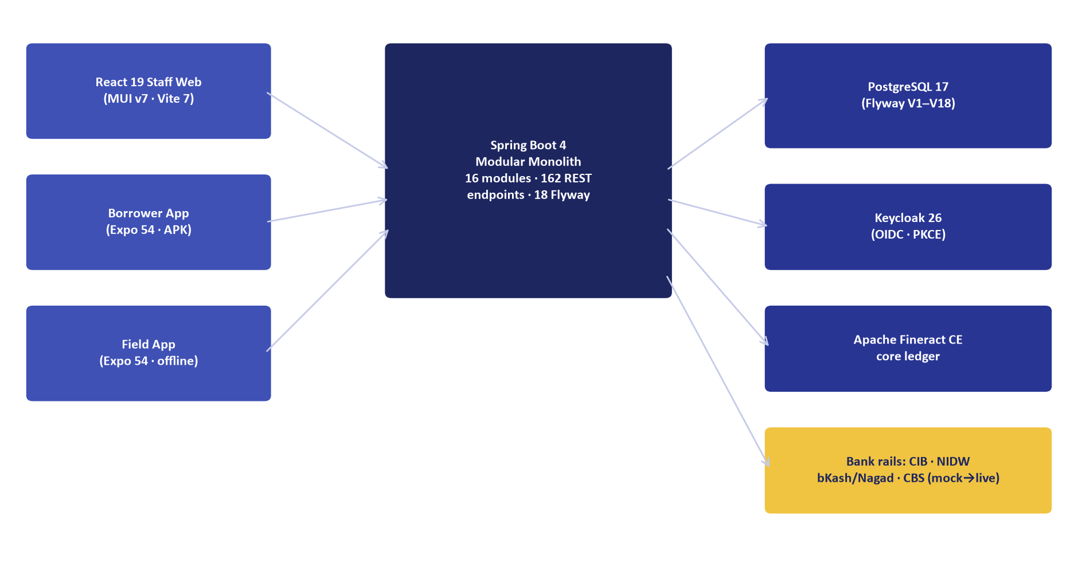
Figure 1: Licensed Architecture — ULMS v2.0 Sovereign Modular Monolith & Core Components
Document Identifier: DOC-40-CON-02
Contract Reference: Standard Enterprise Master Software License Agreement (Bank Edition)
Author: Chief Legal Counsel & Managing Director
Publisher: Unisoft Systems Limited (A Subsidiary of Smart Technologies BD Ltd)
Classification: Confidential Legal Contract Asset
Version: 2.0.0

1. Parties & Recitals
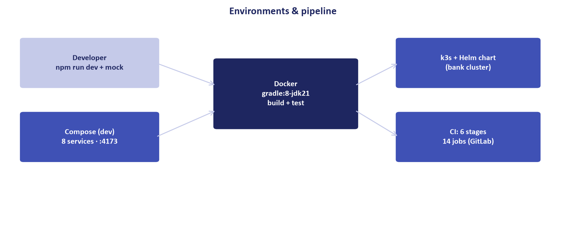
Figure 2: Permitted Deployment Topology — Dual Datacenter (DC/DR) Active-Active Enterprise Infrastructure
This Master Software License Agreement ("Agreement") is entered into as of this [___] day of [_______], 2026 ("Effective Date"), by and between:
- UNISOFT SYSTEMS LIMITED, a private limited company incorporated under the Companies Act 1994 of Bangladesh, having its corporate headquarters at Youth Tower, Begum Rokeya Sarani, Dhaka-1216, Bangladesh (hereinafter referred to as the "Licensor", which expression shall unless repugnant to the context include its successors and permitted assigns); and
- [NAME OF SCHEDULED COMMERCIAL BANK], a scheduled commercial bank licensed by Bangladesh Bank under the Bank Company Act, 1991, having its registered Head Office at [Insert Bank Address, Dhaka, Bangladesh] (hereinafter referred to as the "Licensee" or the "Bank").

Recitals:
- WHEREAS, Licensor is the proprietary developer, copyright owner, and vendor of the Unisoft Loan Management System (ULMS v2.0);
- WHEREAS, Licensee desires to obtain a non-exclusive, perpetual enterprise license to deploy, operate, and utilize ULMS v2.0 across its sovereign banking operations;
- WHEREAS, Licensor agrees to grant such license and deliver turnkey implementation, maintenance, and support services subject to the covenants set forth herein;
NOW, THEREFORE, THE PARTIES AGREE AS FOLLOWS:

2. Grant of License & Operational Scope
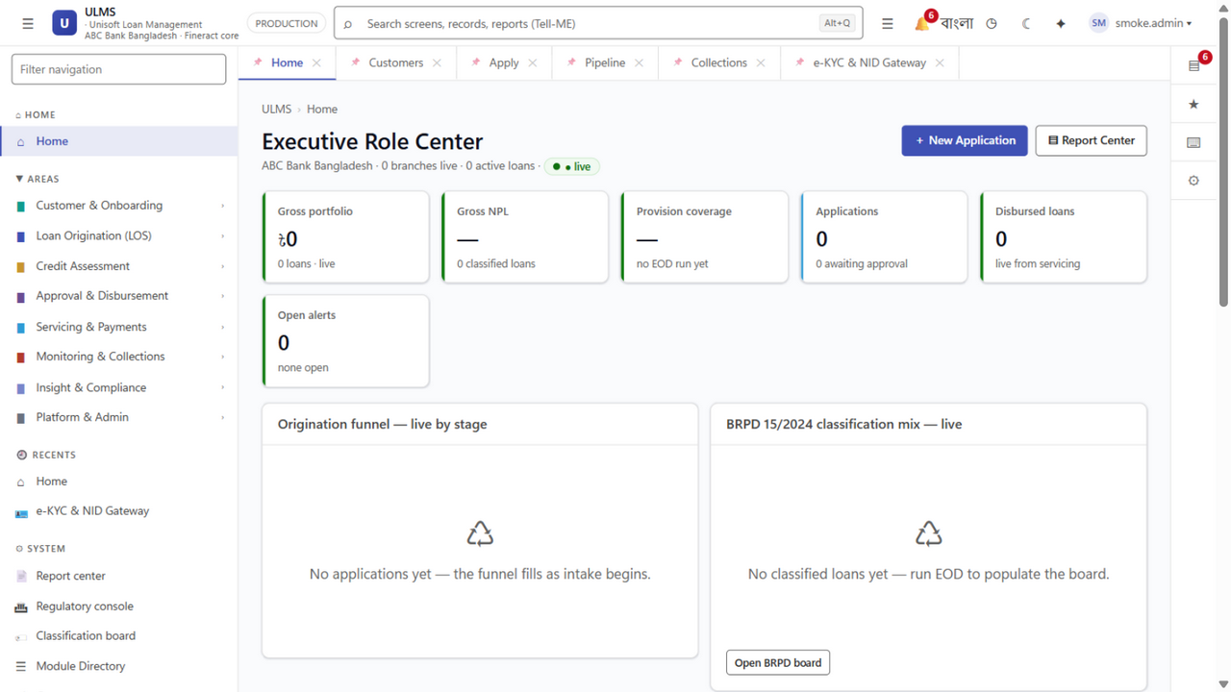
Figure 3: Enterprise Operations — Branch Portfolio Health & Multi-Tenancy Scope
- Scope of Grant: Subject to the payment of the agreed Perpetual Software License Fee (Schedule A of DOC-24), Licensor hereby grants to Licensee a perpetual, irrevocable, non-exclusive, non-transferable enterprise license to install, operate, and utilize ULMS v2.0.
- Authorized Environment: Licensee is authorized to run the software on its primary on-premise datacenter, secondary disaster recovery (DR) site, and internal development/UAT environments located within the sovereign territory of the People's Republic of Bangladesh.
- Usage Volume: The license permits unlimited staff user seats and unlimited branch processing across Licensee's domestic branch and agent banking network.

3. Intellectual Property Rights & Software Ownership
- Retained Ownership: Licensor retains all worldwide right, title, and interest, including all patents, copyrights, trade secrets, trademarks, and other intellectual property rights in and to ULMS v2.0, its source code, and associated architectural documentation.
- Customer Data Sovereignty: Licensee retains exclusive, unencumbered ownership of all customer records, transaction histories, financial ledgers, and loan data processed by the software. Under no circumstances shall Licensor claim ownership over Bank data.

4. Regulatory Warranties & Bangladesh Bank Compliance
- Statutory Regulatory Warranty: Licensor explicitly warrants that ULMS v2.0 natively satisfies all applicable mandatory requirements of:
- Bangladesh Bank BRPD Circular No. 15/2024 (7-stage credit classification, DPD tracking, statutory provisioning);
- Bangladesh Financial Intelligence Unit (BFIU) Circulars 25, 26, and 31 (e-KYC biometric verification and AML/CFT guidelines);
- Bangladesh Bank Credit Information Bureau (CIB) Online REST integration specifications.
- Free Regulatory Patch Guarantee: During any active Annual Maintenance Contract (AMC) period, Licensor covenants to deliver mandatory software updates to maintain compliance with future Bangladesh Bank BRPD circulars at zero additional license fee.

5. Warranties, Support & Defect Rectification
- 12-Month Comprehensive Warranty: Licensor warrants that for a period of twelve (12) months following formal User Acceptance Testing (UAT) sign-off, ULMS v2.0 shall operate substantially in conformance with the functional specifications set forth in DOC-26_Functional_Compliance_Matrix.md.
- Rectification SLA: Any Priority-1 defect (system down or core CBS integration failure) reported by Licensee shall be responded to within fifteen (15) minutes and restored within two (2) hours by Licensor’s engineering team in Dhaka.

6. Limitation of Liability & Indemnification
- Liability Cap: Except for breaches of confidentiality or gross negligence, neither party's aggregate cumulative liability arising under this Agreement shall exceed the total license fee paid by Licensee under this Agreement.
- IP Infringement Indemnity: Licensor agrees to defend, indemnify, and hold harmless Licensee against any third-party claim alleging that the software infringes any valid copyright, patent, or intellectual property right enforceable in Bangladesh.

7. Source Code Escrow Agreement
To provide absolute institutional continuity for Licensee:
- Licensor agrees to deposit a copy of the ULMS v2.0 source code, build scripts, and database schema definitions with an accredited commercial Source Code Escrow Agent in Dhaka.
- The escrow deposit shall be released to Licensee solely upon the occurrence of a verified Release Condition (such as Licensor entering formal corporate bankruptcy or permanently ceasing operations without assigning maintenance obligations).

8. Governing Law & Dispute Resolution
- Governing Law: This Agreement shall be governed by, construed, and enforced in accordance with the substantive laws of the People's Republic of Bangladesh.
- Arbitration: Any dispute, controversy, or claim arising out of this Agreement that cannot be resolved amicably within thirty (30) days shall be referred to binding arbitration conducted in Dhaka under the rules of the Bangladesh International Arbitration Centre (BIAC) or the Dhaka Chamber of Commerce and Industry (DCCI).

9. Signatures of Authorized Representatives
IN WITNESS WHEREOF, the authorized representatives of the Parties have executed this Master Software License Agreement as of the date first written above.
For and on behalf of: For and on behalf of:
UNISOFT SYSTEMS LIMITED [NAME OF COMMERCIAL BANK]

_____________________________________ _____________________________________
Authorized Signature Authorized Signature

Name: _______________________________ Name: _______________________________
Title: Managing Director Title: Managing Director & CEO
Date: _______________________________ Date: _______________________________

Witness 1: __________________________ Witness 1: __________________________
Witness 2: __________________________ Witness 2: __________________________

Unisoft Systems Limited — Corporate Legal Directorate & Enterprise Contracts.

