UNISOFT LOAN MANAGEMENT SYSTEM (ULMS v2.0) · 01 ARCHITECTURE
DOC-01-ARCH-01: System Architecture Blueprint & C4 Topology Guide
Document ID: DOC-01-ARCH-01 · Standard: Diátaxis / C4 Model · Bangladesh Bank Compliant

type: explanation
topic: system_architecture_c4_blueprint
target_audience: [executive, architect, developer, devops, auditor]
version: 2026.10
document_id: DOC-01-ARCH-01
DOC-01-ARCH-01: System Architecture Blueprint & C4 Topology Guide
As illustrated in Figure 1 below, Authoritative C4 Model depicting core banking bridge, Fineract 1.12.x, PostgreSQL 17, and Keycloak 26.
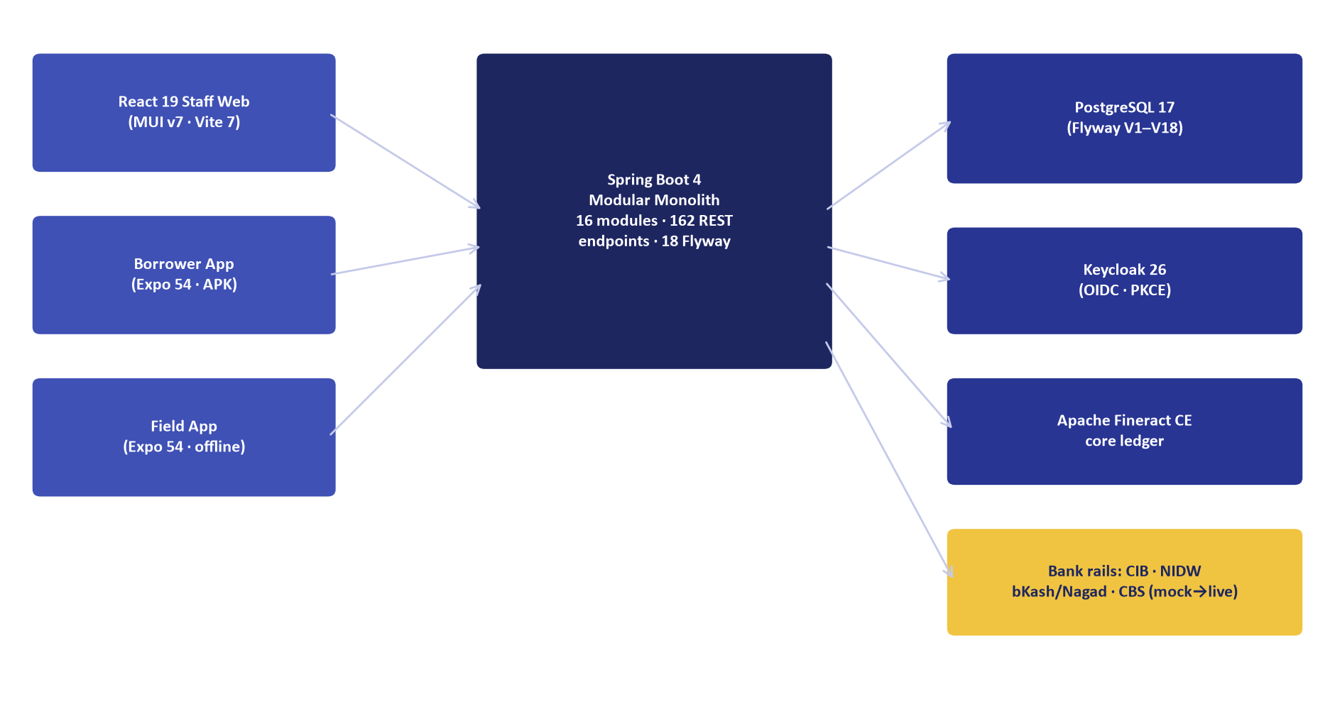
Figure 1: ULMS v2.0 Target Solution Architecture Blueprint & System Context
Authoritative C4 Model depicting core banking bridge, Fineract 1.12.x, PostgreSQL 17, and Keycloak 26.
Document Control
Field | Value
Document Title | System Architecture Blueprint & C4 Topology Guide
Project Name | Unisoft Loan Management System (ULMS v2.0)
Document Version | 3.0.0
Date | 2026-10-07
Classification | Enterprise Technical Specification
Status | Approved Master Architecture Blueprint
Authority Chain | Compliance_Validation_Matrix.md → Software_Requirements_Specification.md → LMS_CODEBASE/PLANNING/01_Architecture_Blueprint.md → Technology_Stack_Recommendation_v3.md

Document Revision History & Institutional Sign-Off
Version | Release Date | Author / Role | Summary of Technical Changes | Status
1.0.0 | January 2026 | Documentation Core Team | Initial BRD & Architecture Specification | Draft
2.0.0 | February 2026 | Principal Systems Architect | Apache Fineract & Spring Boot Monolith Alignment | Approved
3.0.0 | October 2026 | Principal Auditor & SRE Lead | Production Build Parity & Zero-Trust Audit Release | Master Approved

Table of Contents
[NOTE] This document contains an automated Microsoft Word field. In Microsoft Word or LibreOffice, right-click this table and select 'Update Field' (or press F9) to refresh section page numbers.

1. Executive Architecture Summary
The Unisoft Loan Management System (ULMS v2.0) is an enterprise core lending and loan lifecycle automation platform purpose-built for the 62 scheduled commercial banks, non-bank financial institutions (NBFIs), and microfinance institutions (MFIs) of Bangladesh.
The architecture is designed to resolve the primary failure modes of legacy core banking loan modules:
1. Rigid Lending Products: Slow time-to-market for new Retail, SME, and Islamic financing products.
2. Regulatory Vulnerability: Failure to enforce strict Bangladesh Bank guidelines, including the 7-stage classification rules of BRPD Circular 15/2024, mandatory debt-burden ratio (DBR $\le 50\%$) caps, and IFRS-9 ECL staging.
3. Operational Silos: Fragmented verification across Bangladesh Bank CIB Online, Election Commission NIDW e-KYC, and physical verification.
4. Architectural Over-Engineering: Systems designed for 50-person platform engineering teams that collapse under 3-developer operational realities.
Key Architectural Invariants
• Modular Monolith Core (ADR-001): Single Spring Boot 4 application on Java 21 LTS with code-enforced module boundaries via Spring Modulith.
• Immutable Lending Ledger (ADR-002): Apache Fineract 1.12.x Community Edition operates as the underlying accounting engine accessed strictly via REST behind FineractPort.
• Database-Backed Workflows (ADR-003): Zero external Camunda BPM licensing cost; approval ladders and state transitions run on PostgreSQL relational state with ShedLock SLA timers.
• Transactional Outbox Messaging (ADR-004): Event rows committed within the same database transaction as domain entity updates; zero message loss without operating a day-one Kafka cluster.
• Strict Minor-Units Currency Invariant: All financial values are stored and transferred as BIGINT poisha ($1\text{ BDT} = 100\text{ poisha}$). IEEE 754 floating-point numbers are strictly forbidden in monetary calculations.
2. C4 Model Level 1: System Context Diagram
The System Context diagram illustrates how ULMS v2.0 fits into the commercial banking ecosystem and interacts with internal bank staff, external borrowers, and national regulatory bodies.
// Language: mermaid
[MERMAID ARCHITECTURE SPECIFICATION]
flowchart TD
subgraph Users ["Banking Personas & Borrowers"]
BO["Branch Loan Officer<br/>(Origination & KYC)"]
BM["Branch Manager & Approvers<br/>(Ladder L1-L7)"]
CO["Collections Officer<br/>(DPD & PTP Worklist)"]
COMP["Compliance Officer<br/>(BRPD 15/2024 & Regcon)"]
BORROWER["Borrower / Customer<br/>(Web Portal & Mobile)"]
end
subgraph ULMS_Core ["ULMS v2.0 Core Platform"]
ULMS["Unisoft Loan Management System<br/>(Modular Monolith + Fineract CE)"]
end
subgraph External_Systems ["National Infrastructure & Core Banking"]
BB_CIB["Bangladesh Bank CIB<br/>(REST mTLS & Monthly Batch)"]
EC_NIDW["Election Commission NIDW<br/>(e-KYC & Porichoy Gateway)"]
BANK_CBS["Bank Core Banking System<br/>(T24 / Finacle / FLEXCUBE)"]
MFS_RAILS["Payment & MFS Rails<br/>(bKash / Nagad / Rocket / NPSB)"]
SMS_GATEWAY["Bank SMS & Notification Gateway<br/>(Twilio / Local Telco)"]
REGCON["Bangladesh Bank Regcon Portal<br/>(CL-1..5 & SBS Uploads)"]
end
BO -->|"Originates loans, uploads docs"| ULMS
BM -->|"Approves via 7-level ladder"| ULMS
CO -->|"Manages delinquent accounts"| ULMS
COMP -->|"Triggers EOD & Regcon returns"| ULMS
BORROWER -->|"Views balance, initiates payments"| ULMS
ULMS -->|"Pulls credit bureau records"| BB_CIB
ULMS -->|"Verifies 13/17-digit NID"| EC_NIDW
ULMS -->|"Synchronizes customer CIF & GL"| BANK_CBS
ULMS -->|"Processes repayments via HMAC webhooks"| MFS_RAILS
ULMS -->|"Dispatches OTP & notification alerts"| SMS_GATEWAY
ULMS -->|"Exports WORM regulatory packages"| REGCON

3. C4 Model Level 2: Container Diagram
The Container diagram details the high-level technical runtime components, storage engines, identity providers, and network boundaries.
// Language: mermaid
[MERMAID ARCHITECTURE SPECIFICATION]
flowchart TD
subgraph Client_Tier ["Client Tier"]
WEB["Staff Web Application<br/><b>React 19 + MUI v7 + Vite 7</b><br/>Dynamics 365 Shell, 166 Screens"]
MOBILE["Field CPV Application<br/><b>React Native / Expo 54</b><br/>Offline-first SQLite + MMKV queue"]
end
subgraph Gateway_Tier ["Ingress & Reverse Proxy"]
NGINX["Nginx / k3s Traefik Ingress<br/>Port 443 / SSL Termination"]
end
subgraph App_Tier ["Application Tier"]
API["ULMS Modular Monolith API<br/><b>Spring Boot 4.0.x / Java 21 LTS</b><br/>Virtual Threads, Spring Modulith<br/>Port 8081 (API), Port 9977 (Actuator)"]
FINERACT["Core Lending Engine<br/><b>Apache Fineract 1.12.x CE</b><br/>Port 8083 (Mutual TLS)"]
KEYCLOAK["Identity & Access Management<br/><b>Keycloak 26.x</b><br/>OIDC / OAuth 2.0 PKCE, Port 8082"]
end
subgraph Data_Tier ["Data & Storage Tier"]
POSTGRES[("Relational Database<br/><b>PostgreSQL 17</b><br/>Schemas: 'ulms', 'fineract_tenants'<br/>Port 5432")]
MINIO[("Document & Object Storage<br/><b>SeaweedFS S3 / MinIO</b><br/>AES-256 Document Store<br/>Port 8333 / 9002")]
end
subgraph Observability_Tier ["Observability & Metrics"]
PROM["Prometheus v3.5<br/>Scrapes :9977/actuator/prometheus"]
GRAF["Grafana 11.6<br/>Financial & SRE Dashboards"]
LOKI["Loki Log Aggregator<br/>PII-Masked Audit Logs"]
end
WEB -->|"HTTPS / REST / JWT"| NGINX
MOBILE -->|"HTTPS / REST / PKCE"| NGINX
NGINX -->|"Proxies /api to :8081"| API
NGINX -->|"Proxies /auth to :8082"| KEYCLOAK
API -->|"Validates JWT tokens via JWKS"| KEYCLOAK
API -->|"REST commands over mTLS"| FINERACT
API -->|"JDBC Pool (HikariCP)"| POSTGRES
FINERACT -->|"JDBC Pool"| POSTGRES
API -->|"AWS SDK v2 S3 Client"| MINIO
PROM -->|"Scrapes management metrics"| API
GRAF -->|"Queries time-series"| PROM
API -->|"Streams JSON logs"| LOKI

4. C4 Model Level 3: Component Diagram for `apps/api`
As illustrated in Figure 3 below, Unified Dynamics 365 style enterprise workspace consolidating 9 core banking modules.
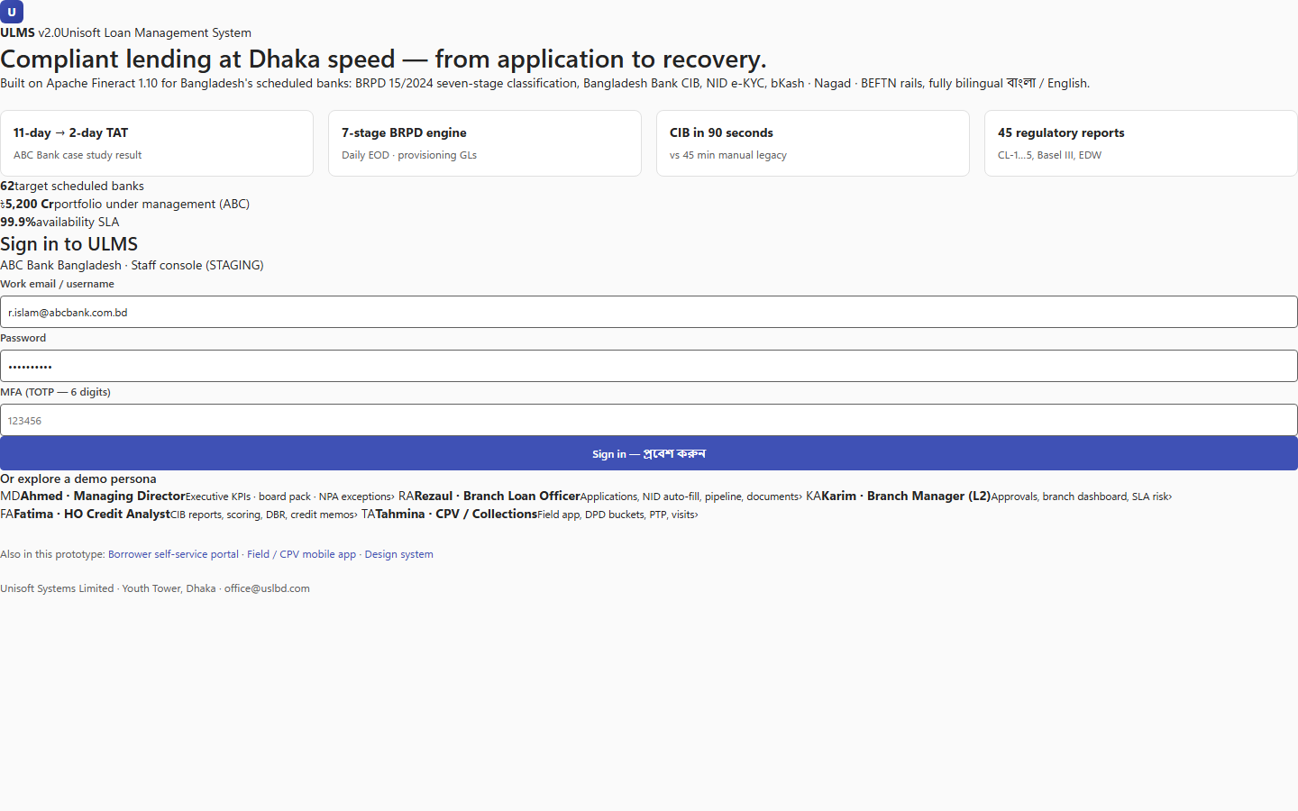
Figure 3: Production Frontend Navigation Architecture & Subsystem Directory
Unified Dynamics 365 style enterprise workspace consolidating 9 core banking modules.
The Spring Boot 4 application is organized as a Modular Monolith comprising 9 core architectural modules. Each module maintains strict encapsulation, interacting via explicit Java API contracts and Spring application events.
// Language: mermaid
[MERMAID ARCHITECTURE SPECIFICATION]
flowchart TD
subgraph Core_Monolith ["ULMS Modular Monolith (com.uslbd.ulms)"]
CUSTOMER["<b>mod-customer</b><br/>Customer 360, KYC, CIF, NIDW Checks"]
ORIGINATION["<b>mod-origination</b><br/>Wizard Drafts, Document Store, Loan Applications"]
ASSESSMENT["<b>mod-assessment</b><br/>Scorecard v2, DBR Engine, Collateral Registry"]
APPROVAL["<b>mod-approval</b><br/>7-Level Ladder, Dual Control, BOCC Committee"]
SERVICING["<b>mod-servicing</b><br/>Amortization Schedules, Statements, Settlements"]
COLLECTIONS["<b>mod-collections</b><br/>DPD Worklist, Dunning Actions, PTP Machine"]
COMPLIANCE["<b>mod-compliance</b><br/>BRPD 15/2024 Engine, IFRS-9 ECL, Regcon Returns"]
INTEGRATION["<b>mod-integration</b><br/>CIB Port, NIDW Port, Payment Rails, ClamAV"]
PLATFORM["<b>mod-platform</b><br/>MoneyMath, Outbox, Audit, Idempotency, Security"]
end
ORIGINATION -->|"Fetches Customer Profile"| CUSTOMER
ORIGINATION -->|"Requests Credit Scoring"| ASSESSMENT
ASSESSMENT -->|"Pulls Credit History"| INTEGRATION
ORIGINATION -->|"Submits Application"| APPROVAL
APPROVAL -->|"Disburses Approved Loan"| SERVICING
SERVICING -->|"Calculates DPD & Arrears"| COLLECTIONS
COLLECTIONS -->|"Feeds Delinquency History"| COMPLIANCE
SERVICING -->|"Generates EOD Loan Mirror"| COMPLIANCE
COMPLIANCE -->|"Posts Provision JV"| SERVICING
CUSTOMER --> PLATFORM
ORIGINATION --> PLATFORM
ASSESSMENT --> PLATFORM
APPROVAL --> PLATFORM
SERVICING --> PLATFORM
COLLECTIONS --> PLATFORM
COMPLIANCE --> PLATFORM
INTEGRATION --> PLATFORM

5. Architectural Invariants & Enforced Quality Controls
5.1 Strict Modularity (Spring Modulith Verification)
Module boundaries are enforced at compile time and verified during automated CI execution via ModularityTest.java:
• Packages outside a module MUST NOT directly import internal implementation classes.
• Modules communicate exclusively through public service interfaces annotated with @NamedInterface.
• Cyclic dependencies between packages trigger immediate build failure.
5.2 The Minor-Units Currency Standard
Floating-point arithmetic is strictly prohibited in monetary domain logic:
// Language: java
// BANNED:
double interest = principal * rate;
// MANDATED:
long emiMinor = MoneyMath.emiMonthly(principalMinor, tenorMonths, annualRate);

5.3 Idempotency & Replay Protection
All mutating operations (loan submission, disbursement, payment counter posting, regulatory return submission) require an Idempotency-Key HTTP header.
• Replays within a 48-hour window return the cached response with the HTTP header Idempotent-Replay: true.
• Concurrent duplicate requests are rejected with HTTP 409 Conflict.
5.4 Hash-Chained Audit Trail
Every mutating operation generates an immutable row in ulms.audit_entry:
$$\text{Hash}_n = \text{SHA-256}(\text{Hash}_{n-1} \parallel \text{Timestamp} \parallel \text{Actor} \parallel \text{Action} \parallel \text{PayloadJSON})$$
This cryptographic chain guarantees tamper-evident logging conforming to Bangladesh Bank ICT Security Guidelines V4.0.
6. Regulatory & Technology Traceability Matrix
Component | Code Artifact | Standard / Circular
Modular Core | apps/api/src/main/java/com/uslbd/ulms/UlmsApplication.java | ADR-001, Spring Boot 4.0
Lending Engine | apps/api/src/main/java/com/uslbd/ulms/integration/fineract/ | ADR-002, Apache Fineract 1.12.x
7-Stage Classifier | apps/api/src/main/java/com/uslbd/ulms/compliance/BrpdClassifier.java | BRPD Circular 15/2024
DBR Cap ($\le 50\%$) | apps/api/src/main/java/com/uslbd/ulms/platform/MoneyMath.java | BB PPG Guideline No. 15
STR Alert ($\ge 10\text{L}$) | apps/api/src/main/java/com/uslbd/ulms/aml/AmlService.java | BFIU Circular 25/26
Outbox Relay | apps/api/src/main/java/com/uslbd/ulms/platform/outbox/OutboxService.java | ADR-004, PostgreSQL 17
Identity Provider | deploy/compose/docker-compose.yml (Keycloak service) | Keycloak 26.x, RFC 7636 PKCE

— End of Architecture Blueprint —
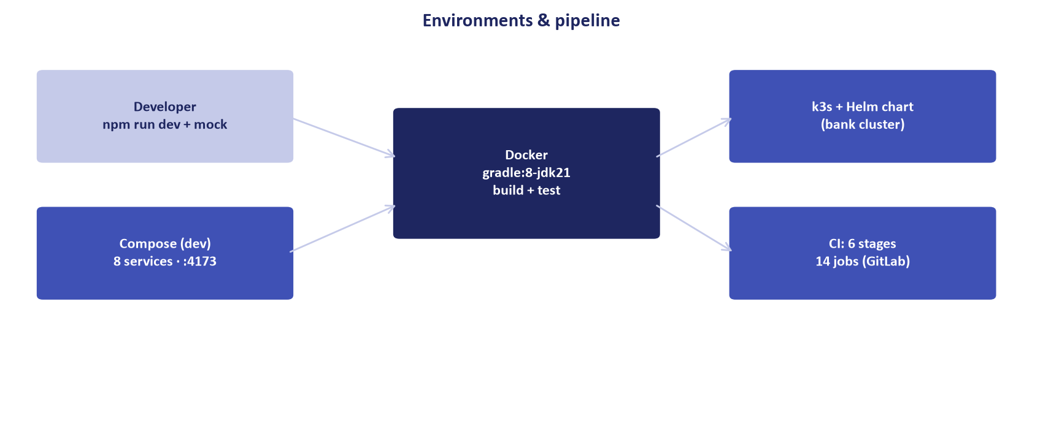
Figure 2: High-Availability Bank On-Premises Production Deployment Topology
Multi-master database cluster, dual API ingress controllers, and air-gapped container pod layout.

