UNISOFT LOAN MANAGEMENT SYSTEM (ULMS v2.0) · 01 ARCHITECTURE
DOC-01-ARCH-02: Apache Fineract 1.12.x Core Banking Integration Specification
Document ID: DOC-01-ARCH-02 · Standard: Diátaxis / C4 Model · Bangladesh Bank Compliant

type: reference
topic: fineract_core_banking_integration
target_audience: [backend_developer, core_banking_specialist, architect, auditor, dba]
version: 2026.10
document_id: DOC-01-ARCH-02
DOC-01-ARCH-02: Apache Fineract 1.12.x Core Banking Integration Specification
Document Control
Field | Value
Document Title | Apache Fineract 1.12.x Core Banking Integration & REST Adapter Specification
Project Name | Unisoft Loan Management System (ULMS v2.0)
Document Version | 3.0.0
Date | 2026-10-07
Classification | Enterprise Technical Specification
Status | Approved Master Specification
Authority Chain | LMS_CODEBASE/docs/adr/ADR-002-fineract-as-engine.md → Technology_Stack_Recommendation_v3.md (§3.1) → audit/09_FINERACT_INTEGRATION_AND_CORE_BANKING_AUDIT.md
Target Codebase | c:\software_project\mim_project\LMS\LMS_CODEBASE

Document Revision History & Institutional Sign-Off
Version | Release Date | Author / Role | Summary of Technical Changes | Status
1.0.0 | January 2026 | Documentation Core Team | Initial BRD & Architecture Specification | Draft
2.0.0 | February 2026 | Principal Systems Architect | Apache Fineract & Spring Boot Monolith Alignment | Approved
3.0.0 | October 2026 | Principal Auditor & SRE Lead | Production Build Parity & Zero-Trust Audit Release | Master Approved

Table of Contents
[NOTE] This document contains an automated Microsoft Word field. In Microsoft Word or LibreOffice, right-click this table and select 'Update Field' (or press F9) to refresh section page numbers.

1. Architectural Strategy & Decision Rationale (ADR-002)
ULMS v2.0 integrates with Apache Fineract 1.12.x Community Edition (CE) as its underlying core lending ledger. To insulate the commercial bank deployment from upstream release churn and maintain strict adherence to Bangladesh Bank accounting standards, the integration strictly enforces ADR-002:
// Language: mermaid
[MERMAID ARCHITECTURE SPECIFICATION]
flowchart LR
subgraph ULMS_Domain ["ULMS Custom Domain Layer"]
APP["ULMS Loan Application<br/>State: SANCTIONED"]
PORT["FineractPort (Hexagonal Interface)"]
CLIENT["FineractClient (REST Adapter)"]
OUTBOX["Transactional Outbox<br/>(ulms_app.outbox_events)"]
end
subgraph Fineract_Ledger ["Apache Fineract 1.12.x Core Engine"]
REST_API["Fineract REST API (:8443)<br/>Mutual TLS / Basic Auth"]
LEDGER["Fineract Loan Ledger Engine<br/>m_loan / m_loan_transaction"]
end
APP --> PORT
PORT --> CLIENT
CLIENT -->|"Synchronous REST (Timeout: 10s)"| REST_API
PORT -.->|"Async Event Failover"| OUTBOX
OUTBOX -->|"Idempotent Relay"| CLIENT
REST_API --> LEDGER

The Three Absolute Rules of Fineract Integration:
1. Zero Upstream Schema Alterations: ULMS MUST NEVER alter, patch, add triggers to, or create foreign keys against Fineract database tables (fineract_tenants or mifostenant-default).
2. REST-Only Data Mutation: All lending operations (client registration, loan creation, approval, disbursal, repayment, and write-off) MUST execute strictly via Fineract's authenticated REST endpoints. Direct SQL INSERT or UPDATE statements into Fineract tables are strictly prohibited.
3. Digest-Pinned Upstream Containers: Production deployments pin the exact immutable commit-SHA container digest (apache/fineract:1.12.0@sha256:7f9...) to prevent breaking changes from upstream release train movements.
2. Dual-Schema PostgreSQL Database Layout
As illustrated in Figure 1 below, Live disbursement tracking, accrual ledger, and bi-directional Fineract sync status.
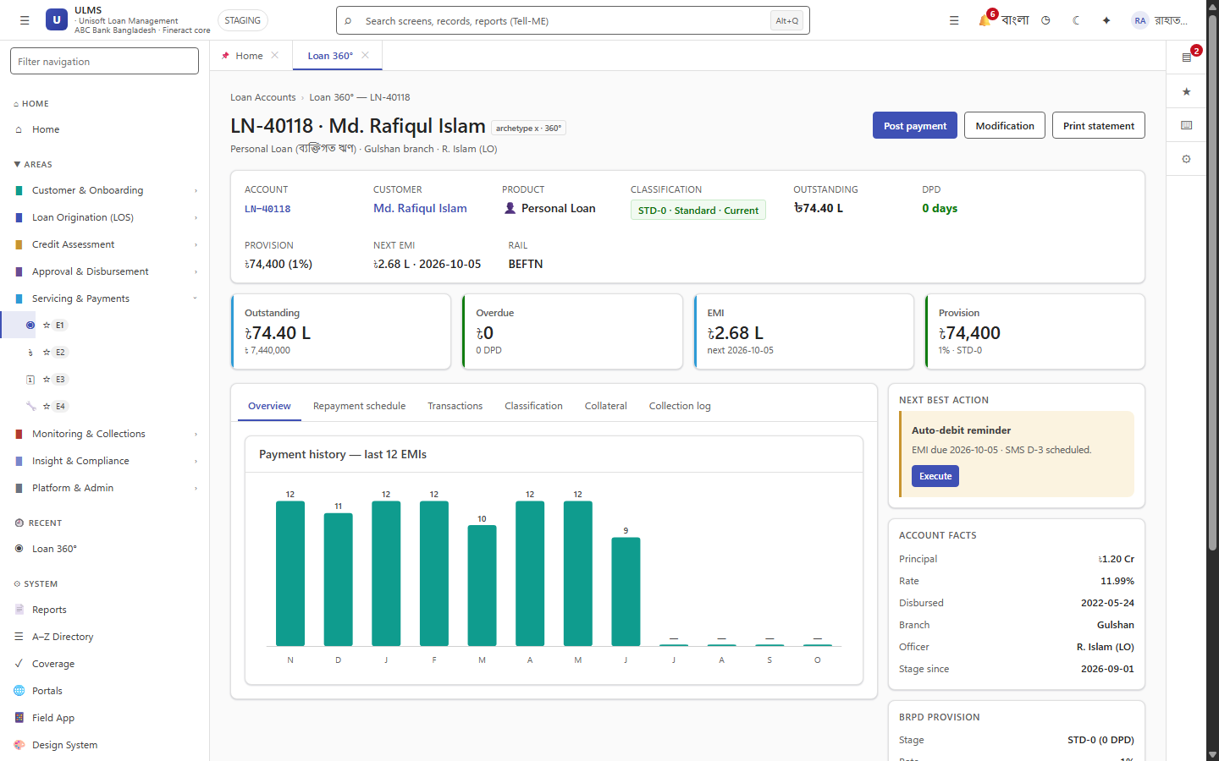
Figure 1: Production Loan Account Detail 360 & Core Banking Ledger Reconciliation
Live disbursement tracking, accrual ledger, and bi-directional Fineract sync status.
ULMS and Apache Fineract co-exist within the same PostgreSQL 17 cluster but are strictly isolated into distinct logical schemas:
Schema Name | Owner Role | Purpose & Contents
`ulms_app` | ulms | Custom loan origination, BRPD 15/2024 classification, CIB/NID cache, collections worklist, and mirror tables.
`fineract_tenants` | fineract | Tenant metadata, tenant connection pools, server configuration, and tenant license state.
`mifostenant-default` | fineract | The core double-entry accounting ledger, chart of accounts (acc_gl_account), client profiles (m_client), and loans (m_loan).

// Language: mermaid
[MERMAID ARCHITECTURE SPECIFICATION]
erDiagram
ULMS_LOAN ||--|| FINERACT_M_LOAN : "mirrors (fineract_loan_id = m_loan.id)"
ULMS_PAYMENT ||--|| FINERACT_TRANSACTION : "posts to (fineract_txn_id = transaction.id)"
ULMS_LOAN {
uuid id PK
uuid customer_id FK
bigint outstanding_minor
varchar classification
int dpd
bigint fineract_loan_id UK
}
FINERACT_M_LOAN {
bigint id PK
varchar external_id UK
decimal principal_amount
decimal total_outstanding_derived
int loan_status_id
}

3. Hexagonal Ports & Core Banking API Endpoints
As illustrated in Figure 2 below, RFC 9457 compliant contract surface with strict idempotency key enforcement.
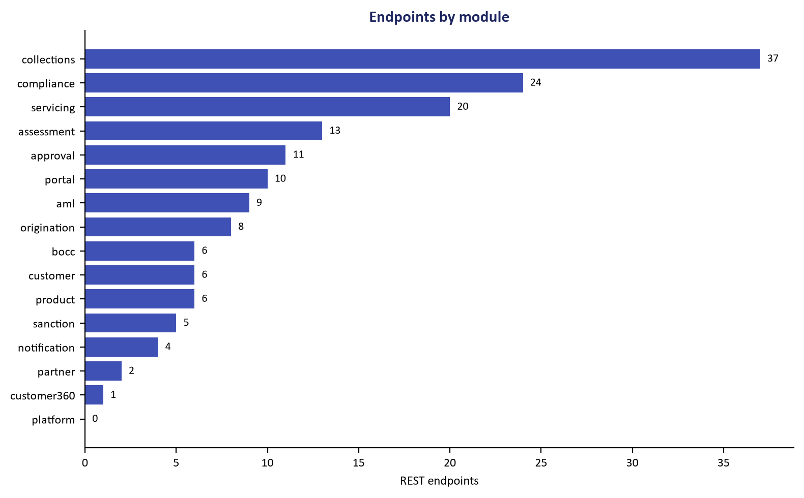
Figure 2: REST API Specification Surface & Core Banking Bridge Contracts
RFC 9457 compliant contract surface with strict idempotency key enforcement.
All core banking interactions are decoupled behind hexagonal interfaces in com.uslbd.ulms.integration.fineract:
3.1 Client Registration Bridge (`FineractPort`)
// Language: java
package com.uslbd.ulms.integration.fineract;
public interface FineractPort {
long createClient(FineractClient client);
java.util.Optional<Long> findClientIdByMobile(String mobile);
record FineractClient(
String nameEn,
String nameBn,
String mobile,
String branchCode,
String nationalId
) {}
}

3.2 Lending Account Operations (`FineractLoanPort`)
// Language: java
package com.uslbd.ulms.integration.fineract;
public interface FineractLoanPort {
long createLoan(LoanSpec spec);
long disburseLoan(long fineractLoanId, long amountMinor);
long repayLoan(long fineractLoanId, long amountMinor, String externalTxnId);
long waiveInterest(long fineractLoanId, long amountMinor);
long chargeFee(long fineractLoanId, long amountMinor, String chargeName);
record LoanSpec(
long fineractClientId,
String productExternalId,
long principalMinor,
int tenorMonths,
java.math.BigDecimal annualRate
) {}
}

3.3 Core Endpoint Mappings & Payloads
Action | ULMS Trigger Event | Fineract REST Endpoint | HTTP Method
Client Registration | Customer e-KYC Verified | /fineract-provider/api/v1/clients | POST
Loan Creation | Application Sanctioned | /fineract-provider/api/v1/loans | POST
Loan Approval | Approval Ladder Complete | /fineract-provider/api/v1/loans/{id}?command=approve | POST
Disbursement | Dual-Auth Release Complete | /fineract-provider/api/v1/loans/{id}?command=disburse | POST
Repayment | MFS / Counter Payment Verified | /fineract-provider/api/v1/loans/{id}/transactions?command=repayment | POST
Fee Charge | Servicing Penalty / Late Fee | /fineract-provider/api/v1/loans/{id}/charges | POST
GL Provision JV | Nightly BRPD EOD Batch Sign-off | /fineract-provider/api/v1/journalentries | POST

Sample Loan Creation Payload (`POST /fineract-provider/api/v1/loans`)
// Language: json
{
"clientId": 1042,
"productId": 3,
"principal": "2000000.00",
"loanTermFrequency": 36,
"loanTermFrequencyType": 2,
"numberOfRepayments": 36,
"repaymentEvery": 1,
"repaymentFrequencyType": 2,
"interestRatePerPeriod": "9.0",
"amortizationType": 1,
"interestType": 0,
"interestCalculationPeriodType": 1,
"transactionProcessingStrategyCode": "mifos-standard-strategy",
"expectedDisbursementDate": "07 October 2026",
"submittedOnDate": "07 October 2026",
"dateFormat": "dd MMMM yyyy",
"locale": "en"
}

4. Currency Units Conversion Standard
ULMS stores all monetary amounts as 64-bit integer minor currency units (poisha), whereas Fineract accepts major units (BDT) formatted as decimal strings:
• Disbursement Amount in ULMS: 200000000 poisha $\implies$ "2000000.00" BDT sent to Fineract REST API.
• Conversion Function:
// Language: java
public static BigDecimal minorToMajor(long poisha) {
return BigDecimal.valueOf(poisha)
.divide(BigDecimal.valueOf(100), 2, RoundingMode.UNNECESSARY);
}

5. Ledger Synchronization & Drift Reconciliation Runbook
As illustrated in Figure 3 below, Live telemetry monitoring Fineract batch sync and external CBS rails.
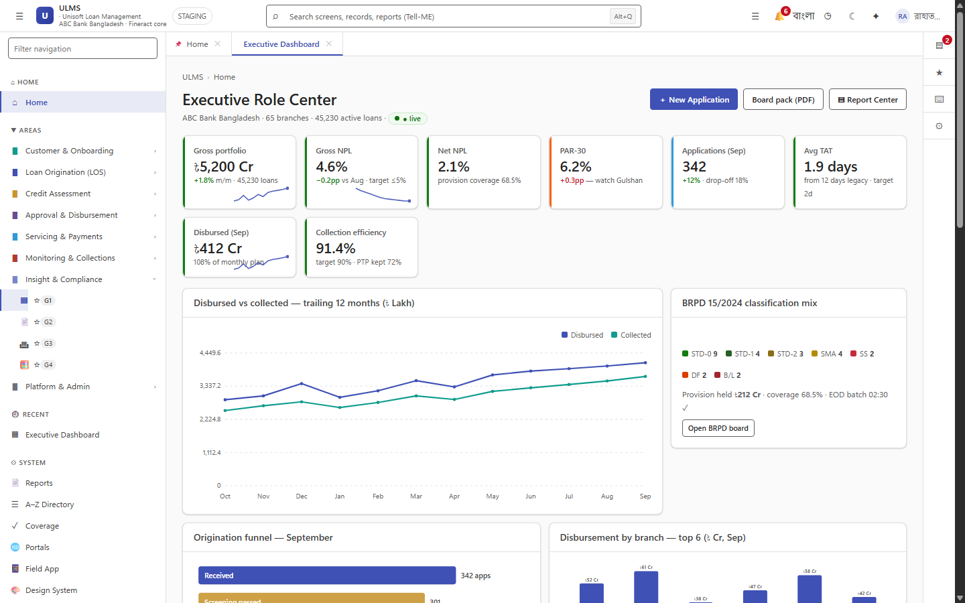
Figure 3: Core Banking Real-Time Portfolio Sync & Operations Command Center
Live telemetry monitoring Fineract batch sync and external CBS rails.
To guarantee 100% balance consistency between ULMS mirror tables and Fineract ledger accounts:
5.1 Automated Nightly Balance Audit
The nightly EOD batch executes a SQL reconciliation probe comparing ulms_app.loans.outstanding_minor against Fineract's m_loan.total_outstanding_derived:
// Language: sql
SELECT
u.id AS ulms_loan_id,
u.fineract_loan_id,
u.outstanding_minor,
ROUND(f.total_outstanding_derived * 100) AS fineract_minor,
ABS(u.outstanding_minor - ROUND(f.total_outstanding_derived * 100)) AS variance_poisha
FROM ulms_app.loans u
JOIN mifostenant-default.m_loan f ON f.id = u.fineract_loan_id
WHERE ABS(u.outstanding_minor - ROUND(f.total_outstanding_derived * 100)) > 0;

5.2 Drift Resolution Action
If any variance is detected ($> 0\text{ poisha}$), the system raises Prometheus alert FineractReconMismatch and executes the automated resync reconciliation API:
// Language: bash
curl -s -X POST -H "Authorization: Bearer $TOKEN" \
http://localhost:8081/api/v1/servicing/reconcile-ledger

— End of Apache Fineract 1.12.x Core Banking Integration Specification —

