UNISOFT LOAN MANAGEMENT SYSTEM (ULMS v2.0) · 01 ARCHITECTURE
DOC-01-ARCH-04: Enterprise Data Dictionary & PostgreSQL Dual-Schema Reference
Document ID: DOC-01-ARCH-04 · Standard: Diátaxis / C4 Model · Bangladesh Bank Compliant

type: reference
topic: enterprise_data_dictionary_and_schema
target_audience: [database_administrator, backend_developer, data_analyst, auditor]
version: 2026.10
document_id: DOC-01-ARCH-04
DOC-01-ARCH-04: Enterprise Data Dictionary & PostgreSQL Dual-Schema Reference
As illustrated in Figure 1 below, Production schema view reflecting ulms_app.customers, KYC verification, and accounts.
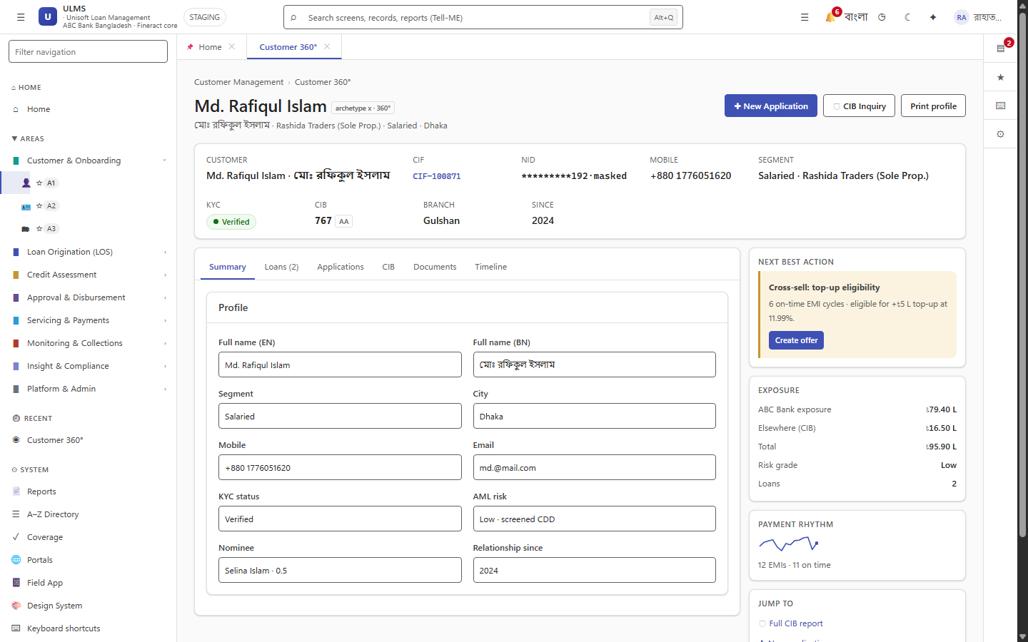
Figure 1: Enterprise Customer 360 Relational Entity Profile & Relationship Graph
Production schema view reflecting ulms_app.customers, KYC verification, and accounts.
Document Control
Field | Value
Document Title | Enterprise Data Dictionary & PostgreSQL Dual-Schema Reference
Project Name | Unisoft Loan Management System (ULMS v2.0)
Document Version | 3.0.0
Date | 2026-10-07
Classification | Database Technical Reference
Status | Approved Master Schema Specification
Authority Chain | LMS_CODEBASE/apps/api/src/main/resources/db/migration/ (V1–V18) → LMS_CODEBASE/PLANNING/04_Data_Model_and_Migration_Plan.md → audit/07_DATABASE_SCHEMA_AND_JPA_AUDIT.md

Document Revision History & Institutional Sign-Off
Version | Release Date | Author / Role | Summary of Technical Changes | Status
1.0.0 | January 2026 | Documentation Core Team | Initial BRD & Architecture Specification | Draft
2.0.0 | February 2026 | Principal Systems Architect | Apache Fineract & Spring Boot Monolith Alignment | Approved
3.0.0 | October 2026 | Principal Auditor & SRE Lead | Production Build Parity & Zero-Trust Audit Release | Master Approved

Table of Contents
[NOTE] This document contains an automated Microsoft Word field. In Microsoft Word or LibreOffice, right-click this table and select 'Update Field' (or press F9) to refresh section page numbers.

1. Schema Evolution Ledger (Flyway V1–V18: 67 Tables Total)
As illustrated in Figure 3 below, Visual manifestation of mifostenant-default loan schedule and payment allocations.
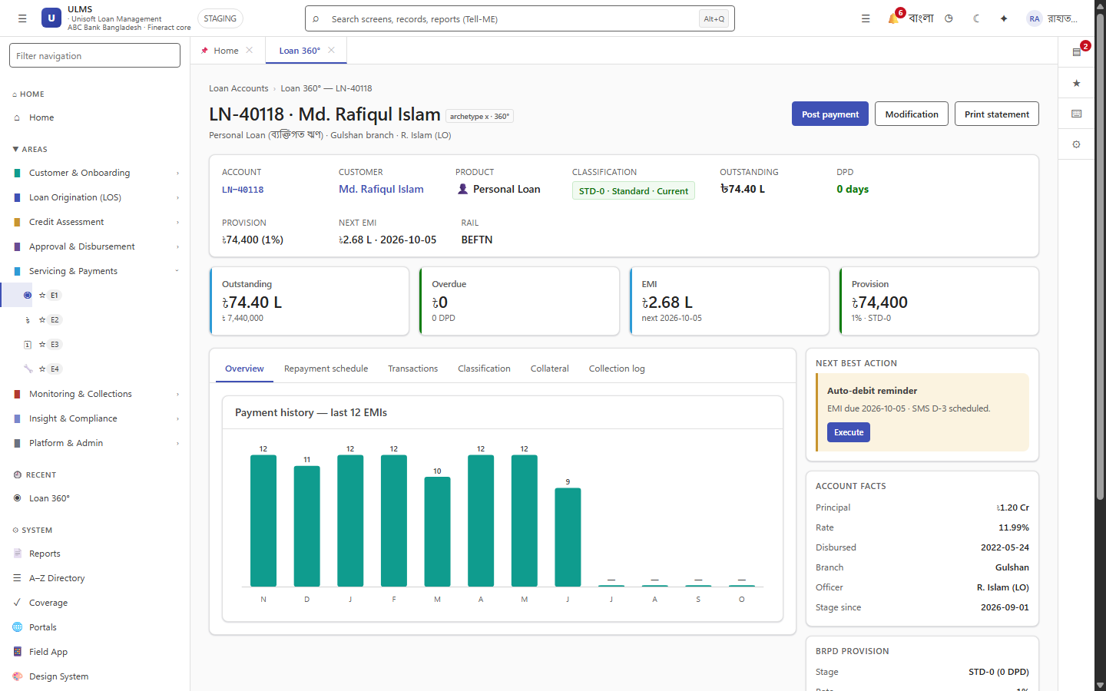
Figure 3: Loan Schedule & Ledger Database Model in Active Servicing
Visual manifestation of mifostenant-default loan schedule and payment allocations.
The ULMS relational schema comprises 67 authoritative tables managed strictly via forward-only Flyway migrations in PostgreSQL 17:
Version | Migration Script | Scope & Domain Addressed
V1 | V1__init.sql | Base schema, customer master (customer), audit entry (audit_entry), outbox (outbox_event).
V2 | V2__origination_workflow.sql | Loan origination (application), documents (application_document), sanction letters (sanction_letter), approval bands (approval_band), and workflow engine (workflow_definition, workflow_instance, workflow_task, workflow_transition).
V3 | V3__customer_compliance.sql | KYC verification history (kyc_check), sanctions screening hits (screening_hit), idempotency key store (idempotency_key).
V4 | V4__actor_width.sql | Actor column expansion for Keycloak UUID compatibility across workflows.
V5 | V5__credit_approval.sql | CIB reports & facilities (cib_report, cib_facility), scorecard results (score_result), collateral registry (collateral), dual-authorization disbursements (disbursement, dual_authorization), loan mirror (loan), and EOD provision runs (provision_run, classification_history).
V6 | V6__cib_compliance.sql | CIB batch schedule and deduplication indexes (uq_cib_dedupe).
V7 | V7__concurrency_audit.sql | Collateral valuation history (collateral_valuation), optimistic locking version columns, and hash-chain audit triggers.
V8 | V8__servicing_collections.sql | Servicing ledger mirrors, repayment schedules, statements (statement_run), payments (payment, payment_intent), early settlement quotes (settlement_quote), reschedules (reschedule_request), and collections (collection_action, ptp, field_task).
V9 | V9__collections_parity.sql | Legal case management (legal_case), PTP state machine, and dunning action history.
V10 | V10__regcon_reporting.sql | Bangladesh Bank Regcon return catalog (regulatory_return) and 12-return WORM storage tables (ecl_snapshot).
V11 | V11__regcon_audit_g.sql | Regcon 3-distinct-officer sign-off audit constraints (report_definition, provision_jv).
V12 | V12__r3_r4_r5_modules.sql | Product catalog (loan_product, loan_product_charge), partner channels (partner_channel), BOCC meetings (bocc_meeting, bocc_agenda_item, bocc_attendance, bocc_vote), AML STR reports (str_report), guarantors (guarantor), notifications (notification_template, notification_delivery), recoveries (recovery_entry), and write-offs (write_off).
V13 | V13__loan_stage_width.sql | Loan stage column width expansion for WRITTEN_OFF and RESTRUCTURED.
V14 | V14__r10_business_logic.sql | Base Lending Rate (blr_rate), capital base (capital_base), risk weights (risk_weight), SLA policies (sla_policy), rate cards (rate_card), CTR reports (ctr_report), dunning steps (dunning_step), monitoring alerts (monitoring_alert), and OTP verification (otp_request).
V15 | V15__q3_uat_flips.sql | goAML submission records (goaml_submission) and Basel parallel run logs (basel_parallel_run).
V16 | V16__q1_workflow_depth.sql | Multi-tiered credit committee approval conditions (approval_condition) and delegation proxies.
V17 | V17__q1_collections_depth.sql | Delinquency severity buckets, watchlist entries (watchlist_entry), and collateral auctions (auction_entry).
V18 | V18__field_gateway.sql | Mobile field visits (field_visit), sync checkpoints, and emergency distress signals (sos_alert).

2. Core Entity-Relationship Diagram
// Language: mermaid
[MERMAID ARCHITECTURE SPECIFICATION]
erDiagram
CUSTOMER ||--o{ APPLICATION : submits
CUSTOMER ||--o{ KYC_CHECK : has
APPLICATION ||--o{ APPLICATION_DOCUMENT : attaches
APPLICATION ||--o| SCORE_RESULT : receives
APPLICATION ||--o{ WORKFLOW_TASK : routes_through
APPLICATION ||--o| SANCTION_LETTER : generates
APPLICATION ||--o| LOAN : becomes
LOAN ||--o{ PAYMENT : records
LOAN ||--o| COLLECTION_ACTION : triggers
LOAN ||--o{ PTP : tracks
LOAN ||--o{ CLASSIFICATION_HISTORY : classified_as

3. Data Dictionary: Core Tables Specification
As illustrated in Figure 2 below, High-density data grid displaying customer credit status and audit trail bindings.
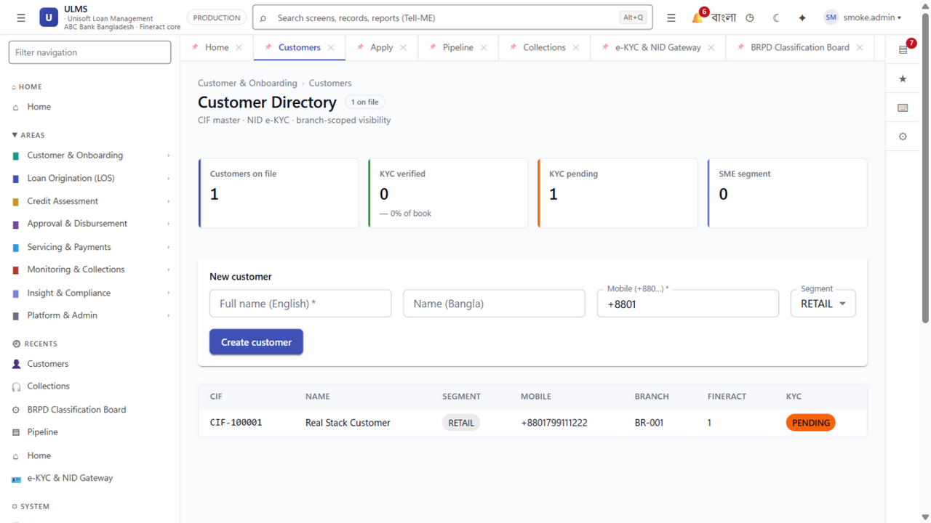
Figure 2: Customer Master Register & Dual-Schema Audit Table Grid
High-density data grid displaying customer credit status and audit trail bindings.
3.1 `ulms.customer` (Customer Master Table)
Stores primary demographic and identification details for borrowers.
Column | Type | Constraints | Description
id | UUID | PRIMARY KEY | Unique customer identifier (UUIDv7).
cif | VARCHAR(32) | UNIQUE NOT NULL | Bank Customer Information File identifier.
name_en | VARCHAR(128) | NOT NULL | Full customer name in English.
name_bn | VARCHAR(128) | NOT NULL | Full customer name in Bengali.
mobile | VARCHAR(16) | NOT NULL | Bangladeshi mobile number (+8801...).
nid_masked | VARCHAR(32) | NOT NULL | Masked National ID (XXXXXXXXX1234).
segment | VARCHAR(32) | NOT NULL | RETAIL, SME, CORPORATE.
branch_code | VARCHAR(16) | NOT NULL | Onboarding branch identifier (e.g., BR-001).
version | BIGINT | DEFAULT 0 | Optimistic concurrency control version.
created_at | TIMESTAMPTZ | DEFAULT now() | Record creation timestamp.

3.2 `ulms.application` (Loan Origination Table)
Tracks the end-to-end lifecycle of a loan origination request (created in V2__origination_workflow.sql, expanded in V5).
Column | Type | Constraints | Description
id | UUID | PRIMARY KEY | Application unique identifier.
app_no | VARCHAR(16) | UNIQUE NOT NULL | Unique application tracking number (APP-7xxxx).
customer_id | UUID | NOT NULL REFERENCES customer(id) | Foreign key to applicant customer master.
product_code | VARCHAR(20) | NOT NULL | Product configuration key (e.g., sme-term).
amount_minor | BIGINT | NOT NULL | Requested loan principal in Poisha minor units.
tenor_months | INT | NOT NULL | Loan duration in months.
rate_type | VARCHAR(10) | NOT NULL DEFAULT 'FIXED' | Interest calculation type (FIXED or FLOATING).
stage | VARCHAR(20) | NOT NULL DEFAULT 'SCREENING' | Workflow stage (SCREENING, CPV, SANCTIONED, DISBURSED, REJECTED).
dbr_percent | NUMERIC(5,2) | NULL | Calculated Debt Burden Ratio ($\le 50.0\%$).
branch_code | VARCHAR(8) | NOT NULL | Originating branch code.
income_minor | BIGINT | NULL | Monthly verified net income snapshot in Poisha.
existing_emi_minor | BIGINT | NULL | Monthly existing bank commitments in Poisha.
cib_obligation_minor | BIGINT | NULL | Monthly verified CIB credit obligations in Poisha.
fineract_loan_id | BIGINT | NULL | Upstream Fineract core loan reference ID.
created_by | VARCHAR(40) | NOT NULL | Actor identifier (Maker officer).
created_at | TIMESTAMPTZ | DEFAULT now() | Creation timestamp.
updated_at | TIMESTAMPTZ | DEFAULT now() | Last update timestamp.

3.3 `ulms.loan` (Active Loan Portfolio Mirror Table)
Active lending ledger state mirrored from Apache Fineract and managed by ULMS servicing/compliance (V5__credit_approval.sql).
Column | Type | Constraints | Description
id | UUID | PRIMARY KEY | Unique loan identifier.
application_id | UUID | REFERENCES application(id) | Originating application (nullable for migrated legacy loans).
customer_id | UUID | NOT NULL REFERENCES customer(id) | Borrower customer identifier.
loan_no | VARCHAR(16) | UNIQUE NOT NULL | Human-readable loan account number.
fineract_loan_id | BIGINT | UNIQUE | Direct identifier in Fineract m_loan.
principal_minor | BIGINT | NOT NULL | Disbursed principal amount in Poisha.
outstanding_minor | BIGINT | NOT NULL | Current outstanding principal balance in Poisha.
dpd | INT | DEFAULT 0 NOT NULL | Days Past Due calculated at EOD.
stage | VARCHAR(10) | DEFAULT 'ACTIVE' NOT NULL | Lifecycle state (ACTIVE, CLOSED, WRITTEN_OFF).
classification | VARCHAR(6) | DEFAULT 'STD-0' NOT NULL | BRPD 15/2024 category (STD-0, STD-1, STD-2, SMA, SS, DF, B/L).
interest_suspense | BOOLEAN | DEFAULT false NOT NULL | Suspends revenue recognition when SS, DF, or B/L.
disbursed_at | TIMESTAMPTZ | NULL | Timestamp of core disbursement.
created_at | TIMESTAMPTZ | DEFAULT now() | Record creation timestamp.

3.4 `ulms.approval_band` (7-Level Approval Ladder Policy)
Authoritative policy table mapping loan amount thresholds to required approval roles (V2__origination_workflow.sql).
Level | Role Key | Role Name (English) | Min Minor (৳) | Max Minor (৳)
1 | ladder-1 | Branch Officer (L1) | 0 | 50000000 ($\le \text{৳}5\text{ Lakh}$)
2 | ladder-2 | Branch Manager (L2) | 50000001 | 100000000 ($\le \text{৳}10\text{ Lakh}$)
3 | ladder-3 | Regional Manager (L3) | 100000001 | 250000000 ($\le \text{৳}25\text{ Lakh}$)
4 | ladder-4 | Divisional Head (L4) | 250000001 | 500000000 ($\le \text{৳}50\text{ Lakh}$)
5 | ladder-5 | Head of Credit (L5) | 500000001 | 2500000000 ($\le \text{৳}2.5\text{ Crore}$)
6 | ladder-6 | Credit Committee (L6) | 250000001 | 10000000000 ($\le \text{৳}10\text{ Crore}$)
7 | ladder-7 | Managing Director (L7) | 10000000001 | NULL ($> \text{৳}10\text{ Crore}$)

3.5 `ulms.classification_history` (BRPD 15/2024 EOD Classification Snapshots)
Contains daily snapshots generated by the nightly 23:30 EOD classification batch (V5__credit_approval.sql).
Column | Type | Constraints | Description
id | UUID | PRIMARY KEY | Snapshot identifier.
loan_id | UUID | REFERENCES loan(id) | Foreign key to active loan.
run_date | DATE | NOT NULL | Classification date.
dpd | INT | NOT NULL | Days Past Due calculated at EOD.
stage | VARCHAR(16) | NOT NULL | STD-0, STD-1, STD-2, SMA, SS, DF, B/L.
provision_rate_bp | INT | NOT NULL | Provision rate in basis points (100 = 1%, 500 = 5%, etc.).
provision_amount_minor | BIGINT | NOT NULL | Statutory provision amount in Poisha.
interest_suspense | BOOLEAN | NOT NULL | true if loan is in SS, DF, or B/L.

4. Platform Audit & Outbox Tables
4.1 `ulms.outbox_event` (Transactional Outbox)
Guarantees at-least-once asynchronous event delivery without message loss.
Column | Type | Constraints | Description
id | UUID | PRIMARY KEY | Unique event identifier.
aggregate_type | VARCHAR(64) | NOT NULL | Domain aggregate (APPLICATION, LOAN, PAYMENT).
aggregate_id | VARCHAR(64) | NOT NULL | Identifier of affected entity.
event_type | VARCHAR(64) | NOT NULL | Event name (LOAN_DISBURSED, PAYMENT_POSTED).
payload | JSONB | NOT NULL | Serialized event payload.
dispatched_at | TIMESTAMPTZ | NULL | Null until successfully dispatched.
retry_count | INT | DEFAULT 0 | Dispatch failure retry counter.

4.2 `ulms.audit_entry` (Cryptographically Chained Audit Trail)
Column | Type | Constraints | Description
id | BIGSERIAL | PRIMARY KEY | Monotonically increasing sequence.
actor | VARCHAR(64) | NOT NULL | User identifier from Keycloak JWT sub.
action | VARCHAR(64) | NOT NULL | Executed action (e.g., DISBURSE_LOAN).
payload_hash | VARCHAR(64) | NOT NULL | SHA-256 hash of masked payload JSON.
previous_hash | VARCHAR(64) | NOT NULL | Hash of preceding record ($n-1$).
current_hash | VARCHAR(64) | NOT NULL | SHA-256($\text{previous\_hash} \parallel \text{payload\_hash}$).
created_at | TIMESTAMPTZ | DEFAULT now() | Immutable timestamp.

— End of Data Dictionary Specification —

