UNISOFT LOAN MANAGEMENT SYSTEM (ULMS v2.0) · 01 ARCHITECTURE
DOC-01-ARCH-05: Statutory Financial Arithmetic & Banking Accounting Specification
Document ID: DOC-01-ARCH-05 · Standard: Diátaxis / C4 Model · Bangladesh Bank Compliant

type: reference
topic: statutory_financial_arithmetic_and_ledger_accounting
target_audience: [financial_engineer, backend_developer, core_banking_architect, auditor]
version: 2026.10
document_id: DOC-01-ARCH-05
DOC-01-ARCH-05: Statutory Financial Arithmetic & Banking Accounting Specification
As illustrated in Figure 1 below, Real-time Debt Burden Ratio (DBR) arithmetic, EMI scheduling, and Bangladesh Bank limit caps.
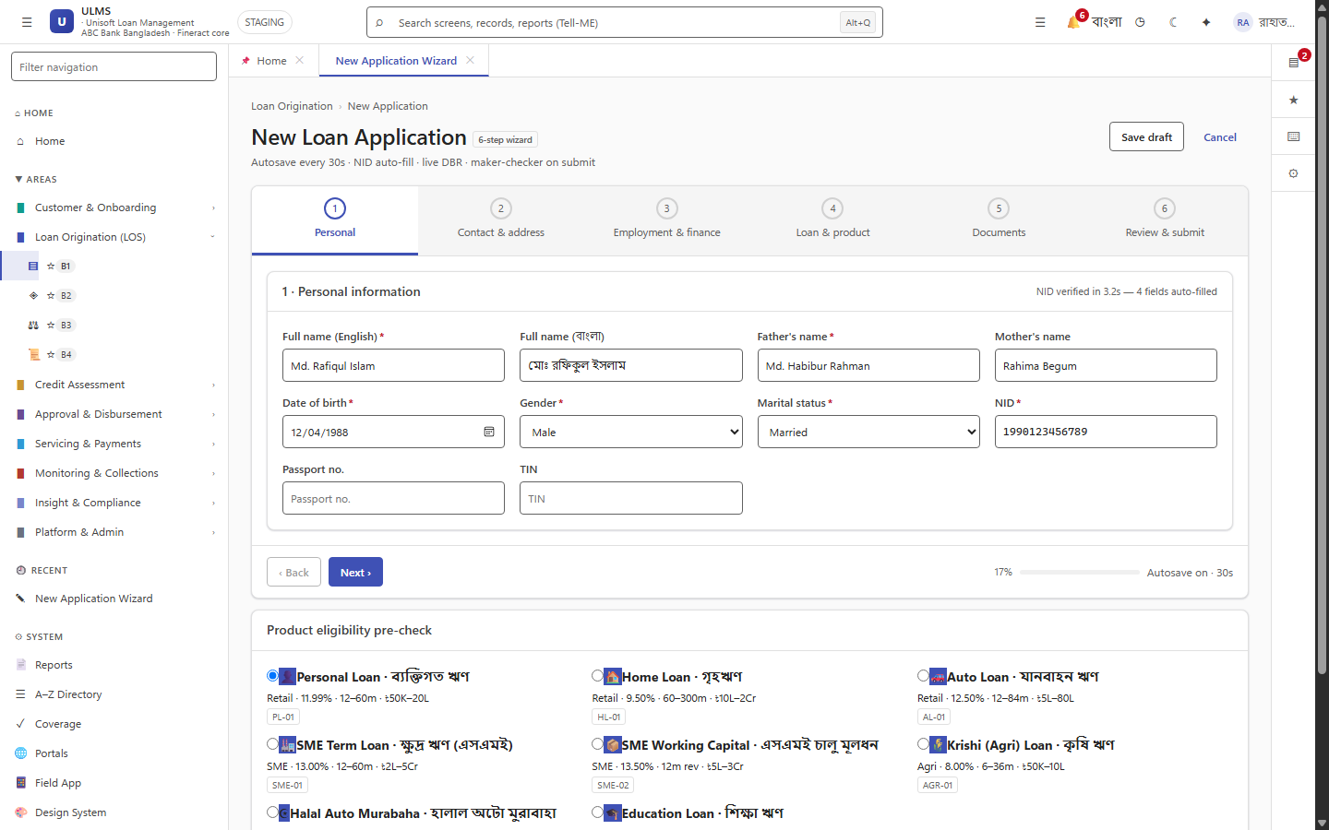
Figure 1: Production Loan Application Wizard with Live Statutory DBR Calculator
Real-time Debt Burden Ratio (DBR) arithmetic, EMI scheduling, and Bangladesh Bank limit caps.
Document Control
Field | Value
Document Title | Statutory Financial Arithmetic & Banking Accounting Specification
Project Name | Unisoft Loan Management System (ULMS v2.0)
Document Version | 3.0.0
Date | 2026-10-07
Classification | Banking Mathematical & Accounting Specification
Status | Approved Master Financial Specification
Authority Chain | LMS_CODEBASE/apps/api/src/main/java/com/uslbd/ulms/platform/MoneyMath.java → Bangladesh Bank BRPD Circular 15/2024 → IFRS 9 Financial Instruments
Target Codebase | c:\software_project\mim_project\LMS\LMS_CODEBASE

Document Revision History & Institutional Sign-Off
Version | Release Date | Author / Role | Summary of Technical Changes | Status
1.0.0 | January 2026 | Documentation Core Team | Initial BRD & Architecture Specification | Draft
2.0.0 | February 2026 | Principal Systems Architect | Apache Fineract & Spring Boot Monolith Alignment | Approved
3.0.0 | October 2026 | Principal Auditor & SRE Lead | Production Build Parity & Zero-Trust Audit Release | Master Approved

Table of Contents
[NOTE] This document contains an automated Microsoft Word field. In Microsoft Word or LibreOffice, right-click this table and select 'Update Field' (or press F9) to refresh section page numbers.

1. Zero Floating-Point Money Invariant
In accordance with institutional banking engineering standards, floating-point numeric data types (`float`, `double`, `Float`, `Double`) are strictly prohibited throughout the ULMS codebase for all currency amounts, fees, balances, and interest rates.
The Single Money Representation Rule:
1. Persistent Minor Units (Poisha): All monetary values in the database, REST API DTOs, and internal messaging are expressed as 64-bit integer minor currency units (`Long` / `BIGINT`) representing Bangladesh Poisha ($1\text{ BDT} = 100\text{ poisha}$).
2. Intermediate Calculation Arithmetic: All interest rates, loan amortizations, and provisioning calculations utilize java.math.BigDecimal with an exact precision scale of 6 decimal places, applying RoundingMode.HALF_UP (Banker's rounding) before converting back to integer poisha.
2. Day-Count Conventions & Equal Monthly Installment (EMI) Arithmetic
As illustrated in Figure 3 below, Automated fee, interest, and principal settlement arithmetic via MFS gateways.
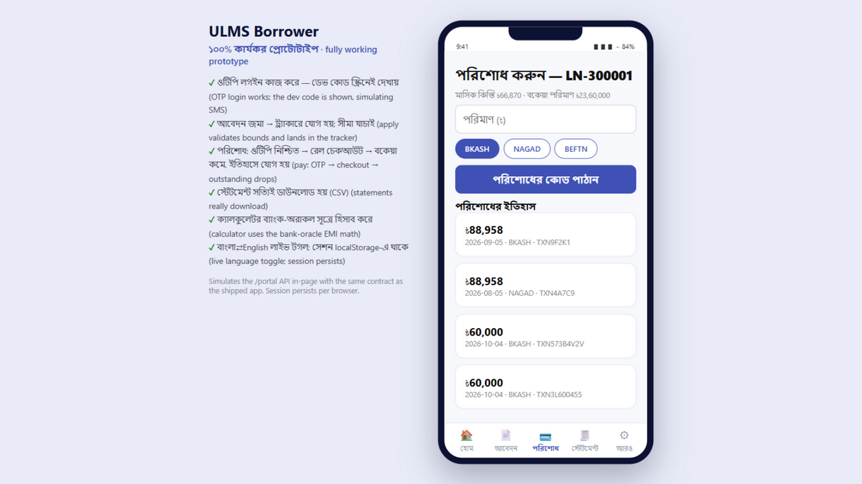
Figure 3: Borrower Digital Repayment Flow & Statutory Allocation Breakdown
Automated fee, interest, and principal settlement arithmetic via MFS gateways.
ULMS v2.0 implements standard Actual/365 day-count conventions for conventional commercial loans and 30/360 for specialized term products.
2.1 The Reducing Balance EMI Formula
The monthly installment ($EMI$) on a reducing balance loan is determined by:
$$EMI = P \times \frac{r \times (1 + r)^n}{(1 + r)^n - 1}$$
Where:
• $P$ = Principal loan amount in poisha.
• $r$ = Monthly periodic interest rate ($\frac{\text{Annual Interest Rate}}{12 \times 100}$).
• $n$ = Total number of monthly installments (Tenor in months).
2.2 Worked Numerical Example
• Principal ($P$): BDT 2,000,000.00 ($200,000,000\text{ poisha}$)
• Annual Interest Rate: $9.00\%$ per annum $\implies r = \frac{0.09}{12} = 0.0075$
• Tenor ($n$): 36 months
$$\text{Factor } (1 + r)^n = (1.0075)^{36} \approx 1.308645$$
$$EMI = 2,000,000 \times \frac{0.0075 \times 1.308645}{1.308645 - 1} = 2,000,000 \times \frac{0.0098148}{0.308645} = \text{BDT } 63,599.37$$
Every month, the interest component ($I_k = \text{Outstanding Balance} \times r$) decreases while the principal repayment component ($P_k = EMI - I_k$) increases proportionately.
3. Statutory Debt Burden Ratio (DBR) Computation
Under Bangladesh Bank regulations, an individual borrower's aggregate debt service commitments across all financial institutions must not breach the statutory ceiling:
$$DBR = \frac{\text{Proposed Monthly EMI} + \text{Verified Existing Monthly Liabilities}}{\text{Verified Monthly Net Income}} \times 100 \le 50.0\%$$
Worked DBR Compliance Verification:
• Verified Net Monthly Salary: BDT 150,000.00
• Existing Credit Card & Personal Loan Dues (from CIB): BDT 18,500.00 / month
• Proposed New Home Loan EMI: BDT 52,000.00 / month
• Total Monthly Debt Commitments: $\text{BDT } 18,500 + \text{BDT } 52,000 = \text{BDT } 70,500.00$
$$DBR = \frac{70,500}{150,000} \times 100 = 47.0\% \quad \implies \text{\textbf{COMPLIANT}} \ (\le 50.0\%)$$
If the proposed EMI were BDT 60,000, DBR would reach $52.33\%$, automatically triggering ULMS-VAL-0001 and blocking application submission.
4. Delegated Credit Approval Ladder Arithmetic
As illustrated in Figure 2 below, Statutory delegation tiers from Branch Manager to Board Credit Committee (BCC).
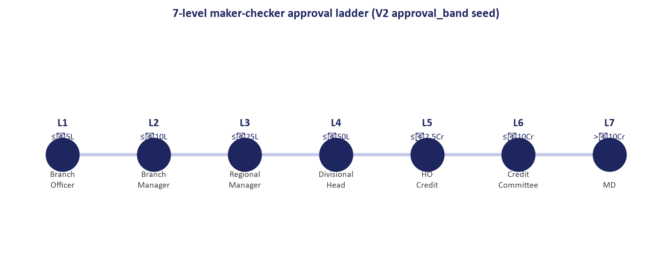
Figure 2: Delegated Approval Authority Matrix & Credit Committee Approval Ladder
Statutory delegation tiers from Branch Manager to Board Credit Committee (BCC).
ULMS enforces strict role-based credit limits matching commercial bank governance mandates:
Approval Tier | Approver Role | Single Borrower Limit (BDT) | Unsecured Limit (BDT) | Governance Body
Tier 1 | Branch Manager | Up to BDT 1,000,000 | Up to BDT 200,000 | Branch Credit Committee
Tier 2 | Regional Credit Manager (CRM) | Up to BDT 5,000,000 | Up to BDT 500,000 | Regional Office
Tier 3 | Head of Credit (HoC) | Up to BDT 20,000,000 | Up to BDT 1,000,000 | Head Office CRM Division
Tier 4 | Managing Director & CEO | Up to BDT 50,000,000 | Up to BDT 2,500,000 | Executive Management Committee
Tier 5 | Board Credit Committee (BCC) | Up to BDT 200,000,000 | Up to BDT 5,000,000 | Board Committee
Tier 6 | Full Board of Directors | Exceeding BDT 200,000,000 | Exceeding BDT 5,000,000 | Board of Directors

5. BRPD Circular 15/2024 Loan Classification & Provisioning Engine
On each nightly EOD run, every loan is classified into one of 7 statutory stages based on Days Past Due (DPD) and objective qualitative criteria:
Stage ID | Classification Label | DPD Boundary | Statutory Base Provision Rate | Eligible Collateral Deduction
STD-0 | Standard (Current) | $0\text{ days}$ | $1.0\%$ | None
STD-1 | Standard (Watch) | $1\text{ to } 30\text{ days}$ | $1.0\%$ | None
STD-2 | Standard (Caution) | $31\text{ to } 60\text{ days}$ | $1.0\%$ | None
SMA | Special Mention Account | $61\text{ to } 90\text{ days}$ | $5.0\%$ | None
SS | Substandard | $91\text{ to } 180\text{ days}$ | $20.0\%$ | Permitted (Eligible FSV)
DF | Doubtful | $181\text{ to } 365\text{ days}$ | $50.0\%$ | Permitted (Eligible FSV)
B/L | Bad / Loss | $> 365\text{ days}$ | $100.0\%$ | Permitted (Eligible FSV)

Net Provision Arithmetic Formula:
For classified loans (SS, DF, B/L), statutory provisioning is computed against net unsecured exposure:
$$\text{Net Provision} = \max\Big(0, \big(\text{Total Outstanding} - \text{Eligible Collateral Forced Sale Value}\big)\Big) \times \text{Provision Rate}$$
6. Double-Entry General Ledger Accounting Mappings
All loan lifecycle events map to balanced, zero-sum double-entry accounting journal vouchers posted directly into Apache Fineract's general ledger (acc_gl_journal_entry):
6.1 Loan Fund Disbursement
DEBIT: GL-10401 (Loans & Advances Asset Account) BDT 2,000,000.00
CREDIT: GL-20105 (Customer Settlement / CASA Account) BDT 1,980,000.00
CREDIT: GL-40201 (Loan Documentation & Processing Fee) BDT 15,000.00
CREDIT: GL-20302 (National CIB Verification Fee Pool) BDT 5,000.00
-------------------------------------------------------------------------
TOTAL DEBITS: BDT 2,000,000.00 | TOTAL CREDITS: BDT 2,000,000.00 (BALANCED)

6.2 Monthly Installment Repayment Collection
DEBIT: GL-20105 (Customer CASA Settlement Account) BDT 63,599.37
CREDIT: GL-10401 (Loan Principal Asset Account) BDT 48,599.37
CREDIT: GL-40101 (Interest Income on Advances) BDT 15,000.00
-------------------------------------------------------------------------
TOTAL DEBITS: BDT 63,599.37 | TOTAL CREDITS: BDT 63,599.37 (BALANCED)

6.3 Nightly Provisioning Adjustment (EOD)
DEBIT: GL-50301 (P&L Provision Expense on Loans) BDT 50,000.00
CREDIT: GL-10409 (Allowance for Loan Losses Contra-Asset) BDT 50,000.00
-------------------------------------------------------------------------
TOTAL DEBITS: BDT 50,000.00 | TOTAL CREDITS: BDT 50,000.00 (BALANCED)

— End of Statutory Financial Arithmetic & Banking Accounting Specification —

