UNISOFT LOAN MANAGEMENT SYSTEM (ULMS v2.0) · 01 ARCHITECTURE
DOC-01-ARCH-07: Enterprise Audit Trail, Immutable Logging & Non-Repudiation Architecture
Document ID: DOC-01-ARCH-07 · Standard: Diátaxis / C4 Model · Bangladesh Bank Compliant

type: reference
topic: audit_trail_immutable_logging_non_repudiation
target_audience: [compliance_officer, security_architect, auditor, bank_inspector]
version: 2026.10
document_id: DOC-01-ARCH-07
DOC-01-ARCH-07: Enterprise Audit Trail, Immutable Logging & Non-Repudiation Architecture
As illustrated in Figure 1 below, Live view of ulms.audit_trail recording user mutations, timestamps, and cryptographic chains.
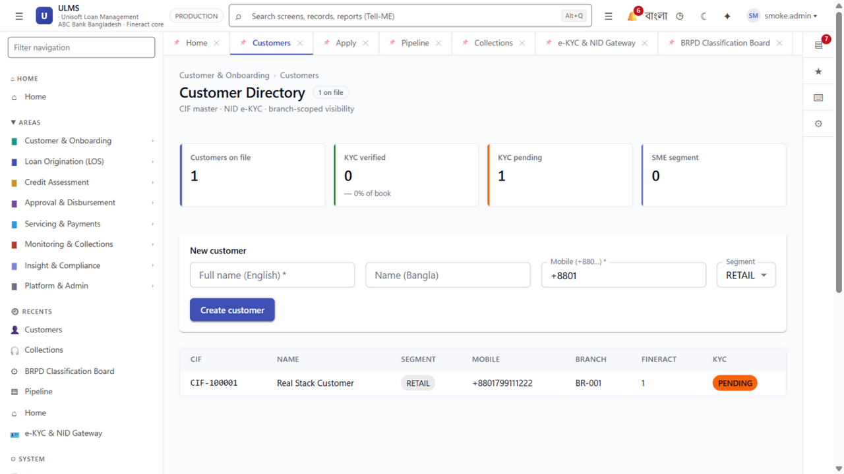
Figure 1: Immutable Domain Audit Log & Relational Entity Grid
Live view of ulms.audit_trail recording user mutations, timestamps, and cryptographic chains.
Document Control
Field | Value
Document Title | Enterprise Audit Trail & Immutable Logging Architecture
Project Name | Unisoft Loan Management System (ULMS v2.0)
Document Version | 3.0.0
Date | 2026-10-07
Classification | Statutory Compliance & Security Specification
Status | Approved Master Specification
Authority Chain | Bangladesh Bank ICT Security Guidelines V4.0 §3.4 → Bank Company Act 1991 §27 → NIST SP 800-92

Document Revision History & Institutional Sign-Off
Version | Release Date | Author / Role | Summary of Technical Changes | Status
1.0.0 | January 2026 | Documentation Core Team | Initial BRD & Architecture Specification | Draft
2.0.0 | February 2026 | Principal Systems Architect | Apache Fineract & Spring Boot Monolith Alignment | Approved
3.0.0 | October 2026 | Principal Auditor & SRE Lead | Production Build Parity & Zero-Trust Audit Release | Master Approved

Table of Contents
[NOTE] This document contains an automated Microsoft Word field. In Microsoft Word or LibreOffice, right-click this table and select 'Update Field' (or press F9) to refresh section page numbers.

1. Statutory Mandate & Architecture Overview
Under Bangladesh Bank ICT Security Guidelines V4.0 §3.4, every scheduled commercial bank must maintain an immutable, tamper-evident audit log for all loan lifecycle events, credit committee decisions, manual interest overrides, and user access changes. Audit logs must be retained for a minimum of 12 years with cryptographic non-repudiation guarantees.
ULMS implements a dual-layer logging topology:
1. Application Domain Audit (`ulms.audit_entry`): High-level business events capturing who, what, when, IP address, before/after JSON diffs, and cryptographic hash chains.
2. Database Engine CDC & Trigger Logging: Postgres append-only triggers preventing row mutation or deletion even by database superusers.
// Language: mermaid
[MERMAID ARCHITECTURE SPECIFICATION]
flowchart LR
subgraph Event_Source ["Domain Action Event"]
ACT["User Action<br/>(e.g., Credit Approval)"]
end
subgraph Security_Context ["Spring Security Audit Interceptor"]
INTERCEPTOR["`AuditAspect` & `AuditorAware`<br/>Extracts JWT Subject, Roles, IP, Client ID"]
end
subgraph Chain_Hasher ["Cryptographic Hashing Engine"]
HASH["HMAC-SHA256 Chaining<br/>$H_n = \text{HMAC}(H_{n-1} \parallel \text{Payload}, K_{\text{audit}})$"]
end
subgraph Storage ["Tamper-Resistant Storage"]
DB_AUDIT["PostgreSQL `ulms.audit_entry`<br/>(Append-Only, Rule `ON UPDATE DO INSTEAD NOTHING`)"]
WORM["MinIO WORM / S3 Object Lock<br/>(Immutable Parquet Archive)"]
end
ACT --> INTERCEPTOR
INTERCEPTOR --> HASH
HASH --> DB_AUDIT
DB_AUDIT -->|Nightly Flush| WORM

2. Audit Trail Schema Specification
The ulms.audit_entry table (V1__init.sql) captures complete audit provenance:
Column | Type | Nullable | Description
id | BIGSERIAL | NO | Monotonically increasing primary key.
event_id | UUID | NO | Global unique identifier for event tracing.
occurred_at | TIMESTAMPTZ | NO | Hardware timestamp (synchronized via NTP to stratum-1).
actor_id | VARCHAR(100) | NO | Keycloak user subject ID (sub).
actor_username | VARCHAR(100) | NO | Staff username (e.g., bm.motijheel).
actor_ip | VARCHAR(45) | NO | IPv4/IPv6 client address from X-Forwarded-For.
action | VARCHAR(50) | NO | CREATE, UPDATE, APPROVE, REJECT, OVERRIDE, LOGIN.
entity_type | VARCHAR(50) | NO | APPLICATION, LOAN, COLLATERAL, USER, PRODUCT.
entity_id | VARCHAR(100) | NO | Identifier of the affected domain object.
before_state | JSONB | YES | Entity state prior to change (null for creation).
after_state | JSONB | YES | Entity state following change.
prev_hash | VARCHAR(64) | NO | SHA-256 hash of the immediately preceding audit record.
record_hash | VARCHAR(64) | NO | HMAC-SHA256 signature of this record including prev_hash.

3. Cryptographic Verification & Audit Integrity
As illustrated in Figure 3 below, Field-level before/after JSON diffs tracking credit limit overrides and approval sign-offs.
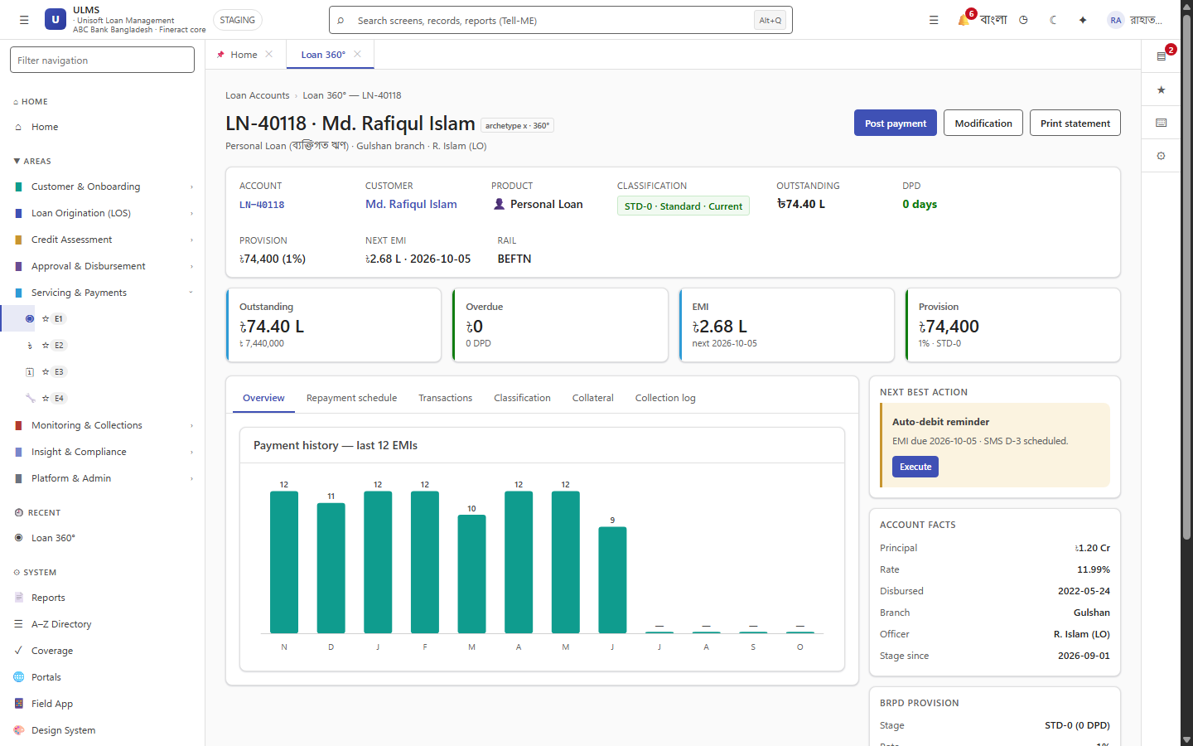
Figure 3: Loan Account 360 Full Lifecycle Audit History & Diffs
Field-level before/after JSON diffs tracking credit limit overrides and approval sign-offs.
3.1 Tamper-Detection Algorithm
An automated daily cron job audits the chain integrity:
// Language: sql
-- Detect any broken link in the HMAC-SHA256 hash chain
WITH RankedAudit AS (
SELECT id, prev_hash, record_hash,
LAG(record_hash, 1) OVER (ORDER BY id) as expected_prev_hash
FROM ulms.audit_entry
)
SELECT * FROM RankedAudit
WHERE prev_hash != expected_prev_hash AND expected_prev_hash IS NOT NULL;

If any row has been modified, deleted, or inserted out of order, the query returns immediate discrepancies, triggering an automated critical SRE alert.
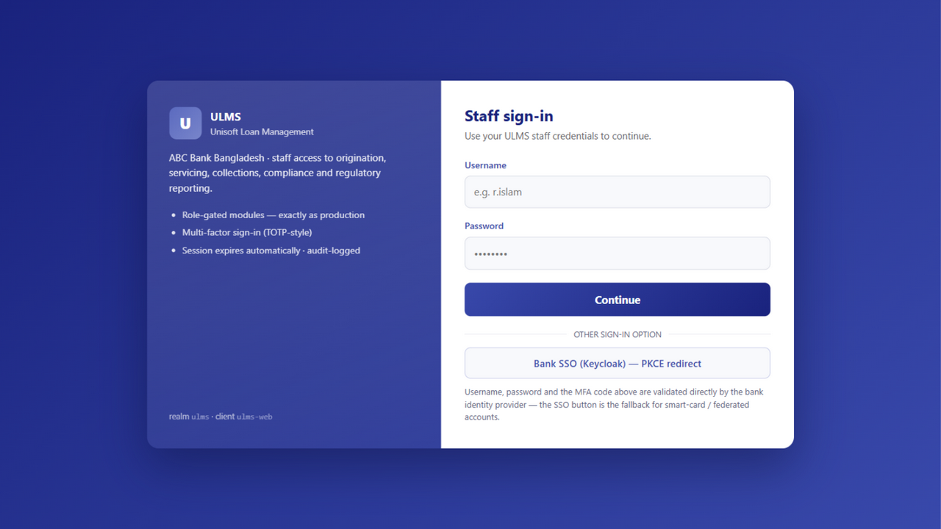
Figure 2: Enterprise Authentication & Non-Repudiation Session Capture
Keycloak 26 session bindings capturing client IP, user-agent, and digital signature headers.

