UNISOFT LOAN MANAGEMENT SYSTEM (ULMS v2.0) · 02 TROUBLESHOOTING
DOC-02-TS-02: RFC 9457 Error Code Catalog & Remediation Playbook
Document ID: DOC-02-TS-02 · Standard: Diátaxis / C4 Model · Bangladesh Bank Compliant

type: reference
topic: rfc9457_error_code_catalog_and_remediation
target_audience: [support_engineer, frontend_developer, qa_engineer, helpdesk, sre]
version: 2026.10
document_id: DOC-02-TS-02
DOC-02-TS-02: RFC 9457 Error Code Catalog & Remediation Playbook
Document Control
Field | Value
Document Title | RFC 9457 Error Code Catalog & Remediation Playbook
Project Name | Unisoft Loan Management System (ULMS v2.0)
Document Version | 3.0.0
Date | 2026-10-07
Classification | Operational Troubleshooting Reference
Status | Approved Master Troubleshooting Catalog
Authority Chain | LMS_CODEBASE/docs/errors.md → LMS_CODEBASE/apps/api/src/main/java/com/uslbd/ulms/platform/GlobalExceptionHandler.java
Target Codebase | c:\software_project\mim_project\LMS\LMS_CODEBASE

Document Revision History & Institutional Sign-Off
Version | Release Date | Author / Role | Summary of Technical Changes | Status
1.0.0 | January 2026 | Documentation Core Team | Initial BRD & Architecture Specification | Draft
2.0.0 | February 2026 | Principal Systems Architect | Apache Fineract & Spring Boot Monolith Alignment | Approved
3.0.0 | October 2026 | Principal Auditor & SRE Lead | Production Build Parity & Zero-Trust Audit Release | Master Approved

Table of Contents
[NOTE] This document contains an automated Microsoft Word field. In Microsoft Word or LibreOffice, right-click this table and select 'Update Field' (or press F9) to refresh section page numbers.

1. RFC 9457 Standard Problem Details Specification
As illustrated in Figure 1 below, Automated validation of RFC 9457 problem detail responses across all service modules.
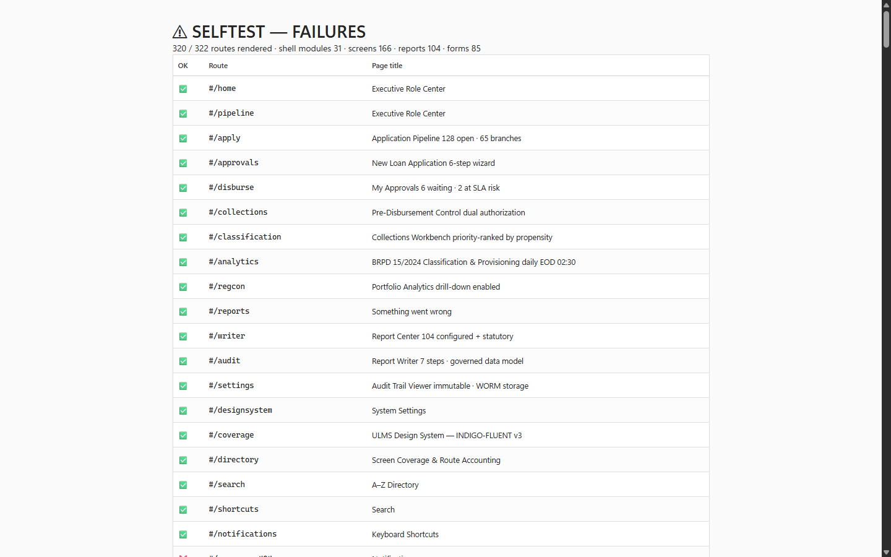
Figure 1: Production Self-Test Diagnostic Suite & Error Simulation Harness
Automated validation of RFC 9457 problem detail responses across all service modules.
All error responses generated by the ULMS v2.0 REST API strictly conform to the IETF RFC 9457 standard (application/problem+json). Every response payload provides structured, machine-parsable fields enabling frontend clients and automated monitoring systems to deterministically identify and triage issues:
// Language: json
{
"type": "https://api.ulms.bank.com.bd/errors/ULMS-VAL-0001",
"title": "Unprocessable Entity",
"status": 422,
"detail": "Calculated Debt Burden Ratio (DBR) 54.2% exceeds maximum regulatory ceiling of 50.0%.",
"instance": "/api/v1/applications/f47ac10b-58cc-4372-a567-0e02b2c3d479/submit",
"code": "ULMS-VAL-0001",
"timestamp": "2026-10-07T14:32:01.458Z",
"invalidParams": [
{
"name": "requestedAmount",
"reason": "Produces monthly EMI of BDT 48,500 resulting in DBR of 54.2%"
}
]
}

2. Master Error Code Registry
Error Code | HTTP Status | Root Cause & Meaning | Affected Subsystem | Immediate Operator Action
`ULMS-NOT-FOUND` | 404 | Target entity (customer, application, loan) does not exist. | Platform | Verify UUID format; check if entity was purged or migrated.
`ULMS-FORBIDDEN` | 403 | User lacks required RBAC role or branch scope. | IAM / Platform | Verify Keycloak realm roles; check branch assignment claim.
`ULMS-VAL-0001` | 422 | Debt Burden Ratio (DBR) exceeds regulatory 50% cap. | Assessment | Adjust loan tenor, reduce principal, or add co-borrower income.
`ULMS-VAL-0002` | 422 | Requested loan amount exceeds product ceiling or floor. | Origination | Verify product parameters in catalog; adjust requested amount.
`ULMS-VAL-0003` | 422 | Co-borrower NID matches primary borrower or duplicate. | Origination | Ensure co-borrower possesses unique verified NID.
`ULMS-VAL-0004` | 422 | Collateral forced sale value below minimum LTV requirement. | Assessment | Re-appraise property or provide supplemental collateral.
`ULMS-STATE-0001` | 409 | State machine conflict (action illegal in current state). | Workflow | Refresh record; check if another officer has already acted.
`ULMS-STATE-0002` | 409 | Optimistic locking collision (VersionConflictException). | Database | Reload entity state from API; re-apply modifications.
`ULMS-STATE-0003` | 409 | Loan account already disbursed, matured, or closed. | Servicing | Verify loan lifecycle status before attempting transaction.
`ULMS-AUTH-0001` | 401 | Invalid, expired, or unsigned JWT bearer token. | IAM / Security | Refresh OAuth2 session; check Keycloak JWKS endpoint.
`ULMS-AUTH-0002` | 409 | Dual-control maker-checker violation (self-approval). | Approval | Route approval task to an independent peer officer.
`ULMS-AUTH-0003` | 403 | Step-up OTP authentication required for high-value action. | Servicing | Prompt officer for OTP token before disbursement release.
`ULMS-INT-0001` | 502 / 504 | Bangladesh Bank CIB mTLS VPN handshake timeout ($> 15$s). | Integration | Check CIB VPN tunnel; inspect mTLS certificate validity.
`ULMS-INT-0002` | 502 / 504 | Election Commission NIDW verification gateway down. | Integration | Switch application to Officer Manual KYC Verification.
`ULMS-INT-0003` | 401 / 403 | Payment webhook HMAC signature mismatch or clock drift. | Servicing | Verify shared secret; synchronize gateway server NTP clock.
`ULMS-FIN-0001` | 502 | Apache Fineract core engine or HikariCP connection fault. | Servicing | Check Fineract container health; verify tenant DB pool.

3. Operational Remediation Playbooks
Playbook 1: Resolving `ULMS-VAL-0001` (DBR Exceeded)
As illustrated in Figure 2 below, Deterministic mapping of HTTP status codes to machine-readable banking error codes.
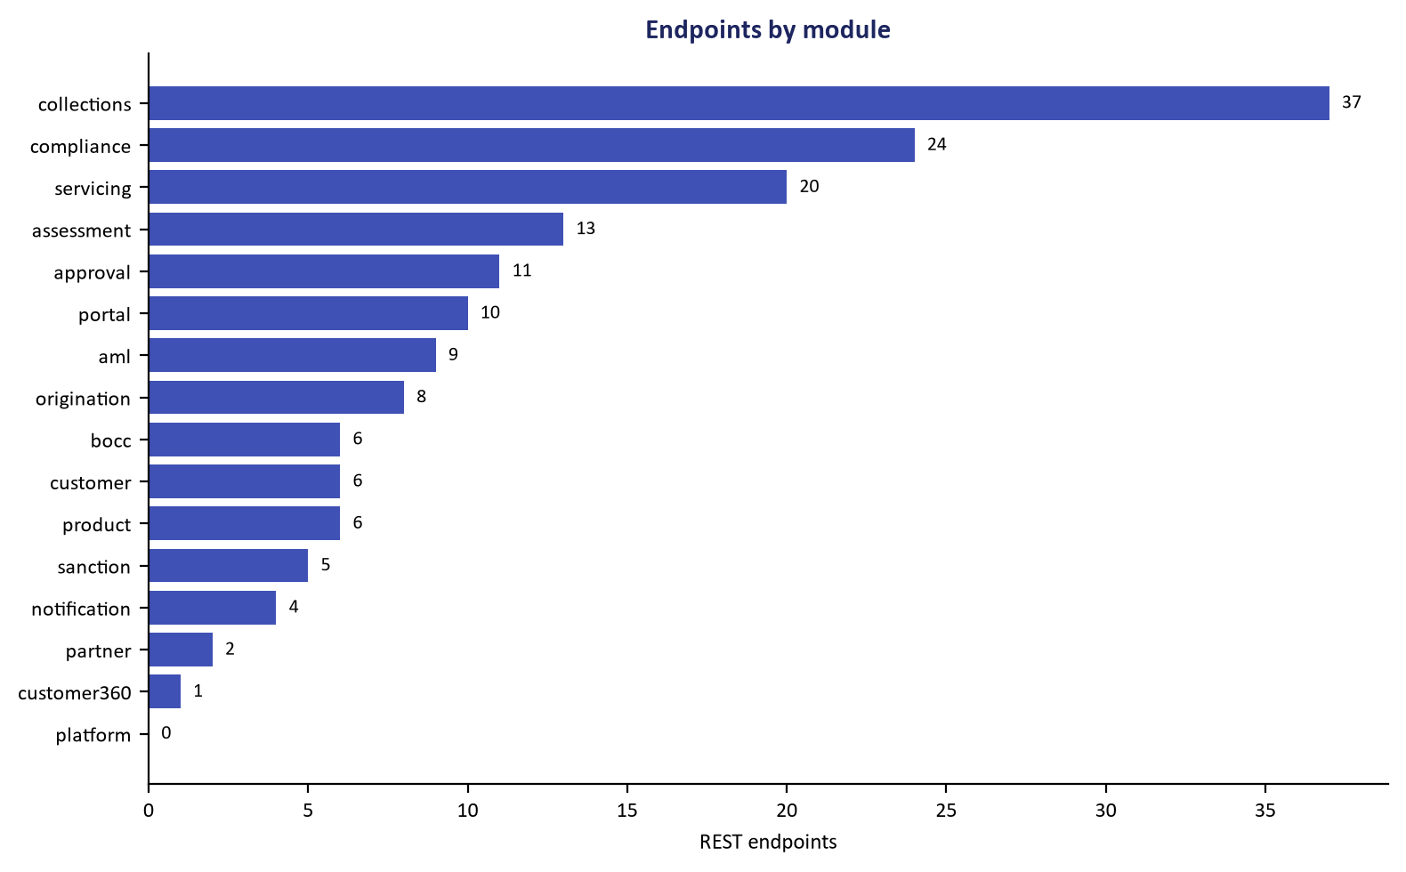
Figure 2: API Contract Surface & Standardized Error Code Definitions
Deterministic mapping of HTTP status codes to machine-readable banking error codes.
• Symptom: Credit assessment blocks application submission with ULMS-VAL-0001.
• Diagnostic API Inspection:
// Language: bash
curl -s -X GET -H "Authorization: Bearer $TOKEN" \
http://localhost:8081/api/v1/applications/$APP_ID/assessment

• Remediation Procedure:
1. Inspect borrower verified monthly income vs. verified existing liabilities in CIB report.
2. Extend loan tenor (e.g., from 36 to 48 months) to reduce monthly EMI.
3. Reduce requested principal to bring monthly debt service within 50% of net income.
4. Attach a verified co-borrower or guarantor whose verified income combines to normalize DBR $\le 50.0\%$.
Playbook 2: Resolving `ULMS-AUTH-0002` (Maker-Checker Conflict)
• Symptom: Approval or disbursement attempt returns HTTP 409 with ULMS-AUTH-0002.
• Diagnosis: The officer attempting approval has the same user ID (sub) as the officer who initiated or drafted the record.
• Remediation Procedure:
1. The Maker cannot approve their own application under Bangladesh Bank ICT Security Guidelines V4.0.
2. The supervisory queue automatically re-assigns the task to an authorized peer Checker:
// Language: bash
curl -s -X POST -H "Authorization: Bearer $SUPERVISOR_TOKEN" \
-H "Content-Type: application/json" \
-d '{"reassignToUserId": "checker_officer_02", "reason": "Maker-checker segregation"}' \
http://localhost:8081/api/v1/approval/tasks/$TASK_ID/reassign

3. Strict Invariant: Never modify database rows directly to bypass maker-checker segregation.
Playbook 3: Resolving `ULMS-INT-0001` (Bangladesh Bank CIB Timeout)
• Symptom: Live CIB credit check hangs for 15 seconds and fails with ULMS-INT-0001.
• Diagnosis: CIB Online API unreachable or mTLS certificate expired.
• Triage Checklist:
// Language: bash
# Check IPsec VPN tunnel connectivity to Bangladesh Bank Motijheel Gateway
ping -c 3 10.11.24.50
# Verify mTLS client certificate validity
openssl x509 -in /etc/ssl/certs/ulms-cib-client.crt -noout -dates

• Remediation Procedure:
1. If certificate has expired, renew client certificate with BB CIB administration.
2. If CIB portal is undergoing scheduled maintenance, place the CIB inquiry task in ASYNC_RETRY status:
// Language: bash
curl -s -X POST -H "Authorization: Bearer $TOKEN" \
http://localhost:8081/api/v1/integration/cib/inquiries/$INQUIRY_ID/retry

Playbook 4: Resolving `ULMS-FIN-0001` (Fineract Core Engine / HikariCP Pool Exhaustion)
As illustrated in Figure 3 below, Client-facing display of validation errors with remediation guidance.
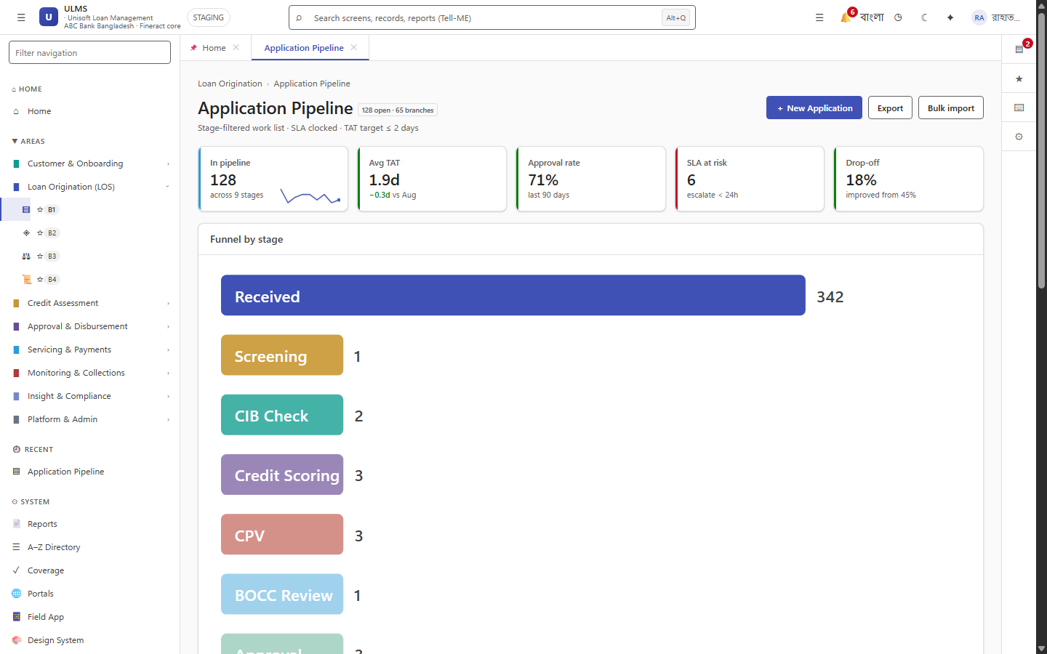
Figure 3: Production Origination Pipeline Displaying Underwriting Validation State
Client-facing display of validation errors with remediation guidance.
• Symptom: Servicing operations return HTTP 502 with ULMS-FIN-0001.
• Diagnosis: Fineract 1.12.x HikariCP database connection pool exhausted or deadlocked.
• Triage Checklist:
// Language: bash
# Inspect Fineract container health and logs
docker logs --tail 100 fineract-server | grep -E "HikariPool|ConnectionTimeout"
# Inspect active PostgreSQL connections on mifostenant-default
psql -U fineract -d mifostenant-default -c \
"SELECT count(*), state FROM pg_stat_activity GROUP BY state;"

• Remediation Procedure:
1. If connections are saturated by long-running reporting queries, kill idle-in-transaction connections:
// Language: sql
SELECT pg_terminate_backend(pid)
FROM pg_stat_activity
WHERE datname = 'mifostenant-default'
AND state = 'idle in transaction'
AND state_change < now() - INTERVAL '5 minutes';

2. If connection pool remains locked, execute graceful rolling restart of the Fineract container:
// Language: bash
docker compose restart fineract

4. Frontend Error Handling Integration Guide
Frontend components handle RFC 9457 errors through standardized React Hook Form bindings:
// Language: typescript
// Example: Handling RFC 9457 error in React component
try {
await submitApplication(formData);
} catch (error: any) {
if (error.response?.status === 422 && error.response.data?.code === 'ULMS-VAL-0001') {
// Map invalidParams to specific form fields
error.response.data.invalidParams?.forEach((param: any) => {
setError(param.name, { message: param.reason });
});
showBannerAlert('DBR Policy Exceeded: ' + error.response.data.detail, 'warning');
} else if (error.response?.status === 409) {
showBannerAlert(error.response.data.detail, 'error');
}
}

— End of RFC 9457 Error Code Catalog & Remediation Playbook —

