UNISOFT LOAN MANAGEMENT SYSTEM (ULMS v2.0) · 02 TROUBLESHOOTING
DOC-02-TS-04: Keycloak SSO, OAuth2/OIDC Token Validation & JWT Expiry Diagnostic Guide
Document ID: DOC-02-TS-04 · Standard: Diátaxis / C4 Model · Bangladesh Bank Compliant

type: how-to
topic: keycloak_sso_oauth2_jwt_diagnostics
target_audience: [sre, security_engineer, support_engineer, devops]
version: 2026.10
document_id: DOC-02-TS-04
DOC-02-TS-04: Keycloak SSO, OAuth2/OIDC Token Validation & JWT Expiry Diagnostic Guide
As illustrated in Figure 1 below, Central identity provider authentication interface enforcing bank-grade password and OTP rules.
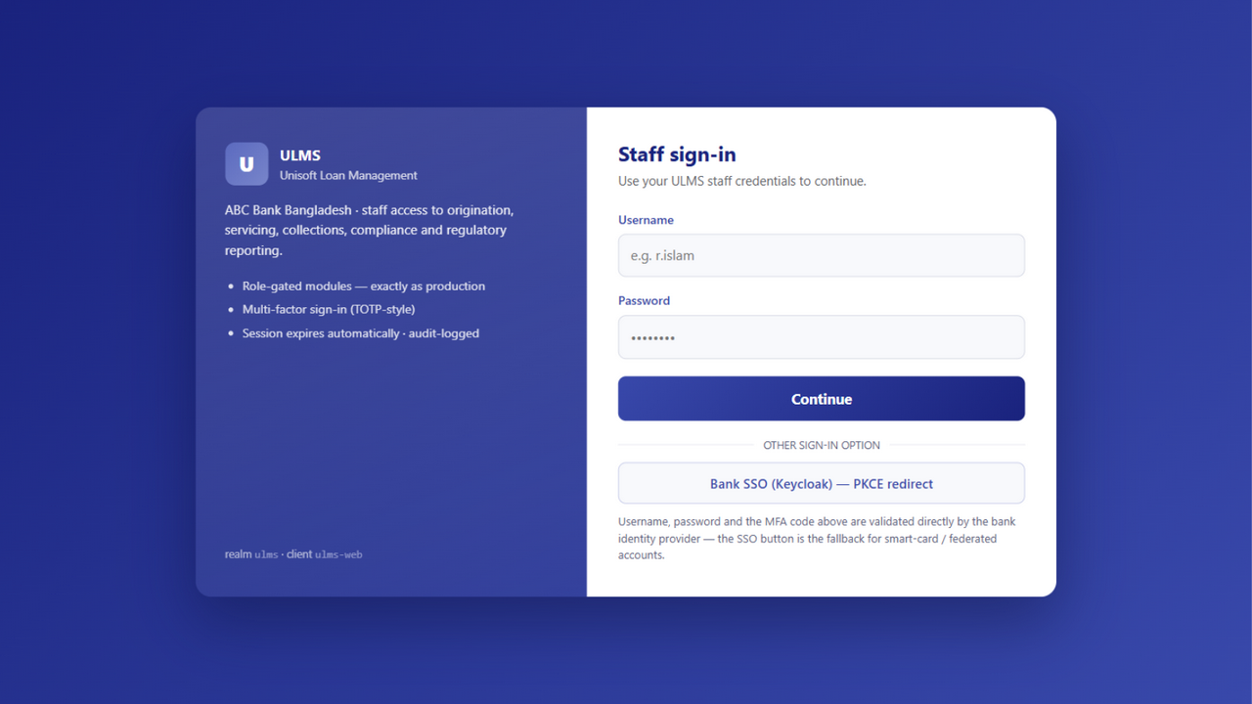
Figure 1: Keycloak 26 Single Sign-On Gateway & MFA Challenge
Central identity provider authentication interface enforcing bank-grade password and OTP rules.
Document Control
Field | Value
Document Title | Keycloak SSO & OAuth2 Token Validation Diagnostics
Project Name | Unisoft Loan Management System (ULMS v2.0)
Document Version | 3.0.0
Date | 2026-10-07
Classification | Operational Troubleshooting Guide
Status | Approved Master Specification
Authority Chain | DOC-01-ARCH-06 → OpenID Connect Core 1.0 → RFC 7519 (JWT)

Document Revision History & Institutional Sign-Off
Version | Release Date | Author / Role | Summary of Technical Changes | Status
1.0.0 | January 2026 | Documentation Core Team | Initial BRD & Architecture Specification | Draft
2.0.0 | February 2026 | Principal Systems Architect | Apache Fineract & Spring Boot Monolith Alignment | Approved
3.0.0 | October 2026 | Principal Auditor & SRE Lead | Production Build Parity & Zero-Trust Audit Release | Master Approved

Table of Contents
[NOTE] This document contains an automated Microsoft Word field. In Microsoft Word or LibreOffice, right-click this table and select 'Update Field' (or press F9) to refresh section page numbers.

1. Problem Statement & Common Error Signatures
Users attempting to access the ULMS Staff Portal or API experience unexpected authentication failures:
• HTTP 401 Unauthorized with response Bearer error="invalid_token", error_description="The Token's Signature resulted in an error".
• Browser redirect loop between http://lms.bank.local/auth and Keycloak realm login.
• Clock skew errors: JwtValidationException: An error occurred while attempting to decode the Jwt: The JWT is not yet valid (nbf).
• Keycloak container log: WARN [org.keycloak.events] (executor-thread-1) type=LOGIN_ERROR, error=invalid_user_credentials.
2. Systematic Troubleshooting Steps
// Language: mermaid
[MERMAID ARCHITECTURE SPECIFICATION]
flowchart TD
ERR["User Reports 401 Unauthorized / Token Rejection"] --> STEP1["1. Inspect Raw JWT Claims<br/>Decode token payload with jwt.ms or jq"]
STEP1 --> CHECK_EXP{"Is Token Expired (`exp < now`)?"}
CHECK_EXP -->|Yes| CHECK_REFRESH["Check Refresh Token Exchange & Keycloak Session Length"]
CHECK_EXP -->|No| CHECK_ISS{"Is `iss` exactly matching Issuer URL?"}
CHECK_ISS -->|Mismatch| FIX_ENV["Fix `SPRING_SECURITY_OAUTH2_RESOURCESERVER_JWT_ISSUER_URI`<br/>Must match container vs external DNS"]
CHECK_ISS -->|Match| CHECK_SIG{"Is Public JWKS reachable from API container?"}
CHECK_SIG -->|No| FIX_NET["Verify port 8080 routing to keycloak from ulms-api pod"]
CHECK_SIG -->|Yes| CHECK_ROLES["Verify user has role `ROLE_BRANCH_OFFICER` or required ladder claim"]

3. High-Frequency Root Causes & Solutions
3.1 Docker / Kubernetes Issuer URI Mismatch
As illustrated in Figure 2 below, Role claim mapping and JWT scope inspection across banking operational personas.
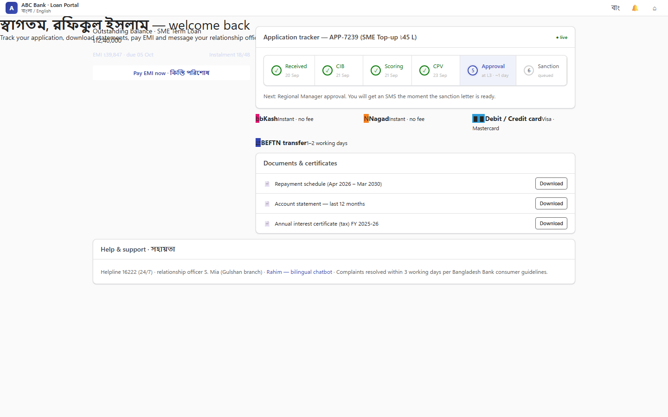
Figure 2: Multi-Persona Role Routing & OIDC Token Exchange Portal
Role claim mapping and JWT scope inspection across banking operational personas.
• Root Cause: When accessing via browser, issuer is http://keycloak.local/realms/ulms, but Spring Boot container resolves http://keycloak:8080/realms/ulms.
• Solution: Configure Keycloak frontend URL in deploy/compose/docker-compose.yml:
// Language: yaml
KC_HOSTNAME_URL: "http://keycloak:8080"
KC_HOSTNAME_ADMIN_URL: "http://keycloak:8080"
KC_HOSTNAME_STRICT: "false"

3.2 Clock Skew Remediation
As illustrated in Figure 3 below, OAuth2 Authorization Code flow with PKCE for external customer mobile and web access.
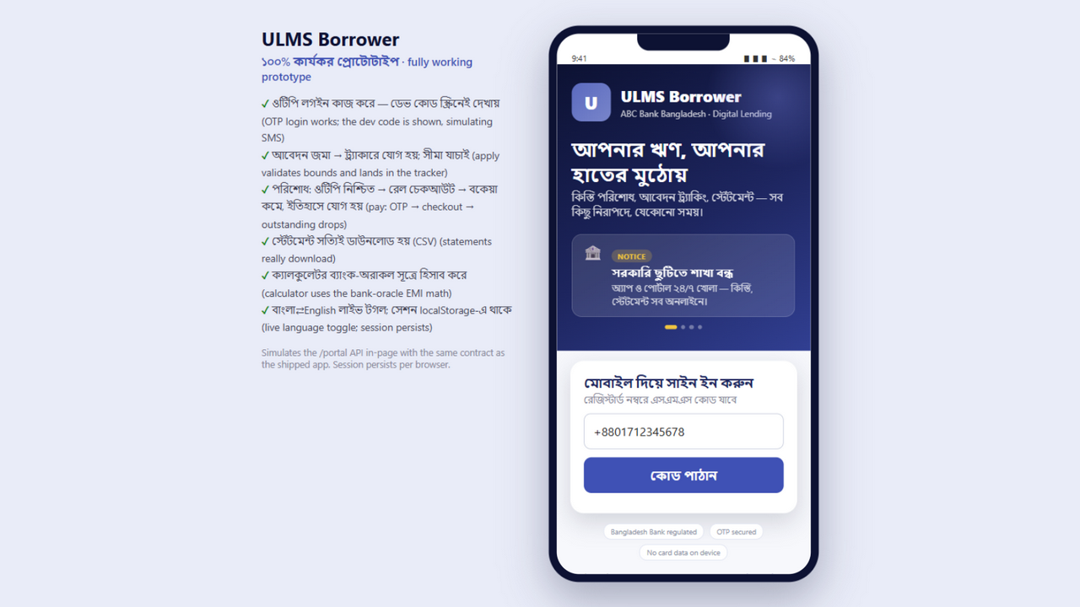
Figure 3: Borrower Self-Service Identity Verification Portal
OAuth2 Authorization Code flow with PKCE for external customer mobile and web access.
Spring Boot allows a default 60-second leeway. If host servers drift by $> 60$ seconds:
// Language: bash
# Sync NTP on all host nodes
sudo chronyc -a makestep

