UNISOFT LOAN MANAGEMENT SYSTEM (ULMS v2.0) · 02 TROUBLESHOOTING
DOC-02-TS-05: Nightly EOD Batch & Classification Diagnostic Guide
Document ID: DOC-02-TS-05 · Standard: Diátaxis / C4 Model · Bangladesh Bank Compliant

type: how-to
topic: eod_batch_and_classification_diagnostics
target_audience: [sre, batch_operator, compliance_officer, dba, risk_analyst]
version: 2026.10
document_id: DOC-02-TS-05
DOC-02-TS-05: Nightly EOD Batch & Classification Diagnostic Guide
Document Control
Field | Value
Document Title | Nightly EOD Batch & Classification Diagnostic Guide
Project Name | Unisoft Loan Management System (ULMS v2.0)
Document Version | 3.0.0
Date | 2026-10-07
Classification | Operational Troubleshooting Guide
Status | Approved Master Troubleshooting Guide
Authority Chain | LMS_CODEBASE/docs/runbooks/RB-03_eod_rerun.md → LMS_CODEBASE/apps/api/src/main/java/com/uslbd/ulms/compliance/EodBatchService.java → Bangladesh Bank BRPD Circular 15/2024
Target Codebase | c:\software_project\mim_project\LMS\LMS_CODEBASE

Document Revision History & Institutional Sign-Off
Version | Release Date | Author / Role | Summary of Technical Changes | Status
1.0.0 | January 2026 | Documentation Core Team | Initial BRD & Architecture Specification | Draft
2.0.0 | February 2026 | Principal Systems Architect | Apache Fineract & Spring Boot Monolith Alignment | Approved
3.0.0 | October 2026 | Principal Auditor & SRE Lead | Production Build Parity & Zero-Trust Audit Release | Master Approved

Table of Contents
[NOTE] This document contains an automated Microsoft Word field. In Microsoft Word or LibreOffice, right-click this table and select 'Update Field' (or press F9) to refresh section page numbers.

1. Executive Overview & Batch Rhythm (23:30 BST SLA)
As illustrated in Figure 1 below, 7-stage classification pipeline (STD-0 to B/L) with real-time provisioning calculations.
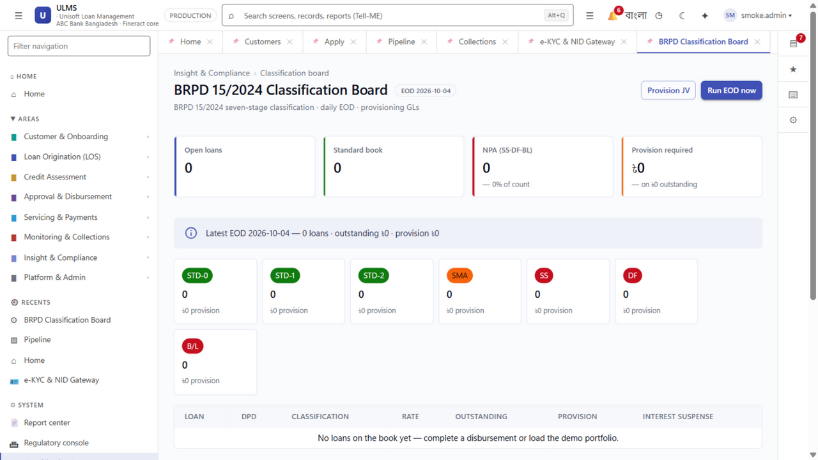
Figure 1: Production BRPD Circular 15/2024 Loan Classification Board
7-stage classification pipeline (STD-0 to B/L) with real-time provisioning calculations.
Every night at 23:30 Bangladesh Standard Time (BST), the ULMS automated End-of-Day (EOD) batch service evaluates all active loans across the bank's portfolio. The batch job enforces statutory classification, calculates required loan loss provisioning in poisha, and generates balanced accounting journal vouchers (JVs) for the general ledger.
// Language: mermaid
[MERMAID ARCHITECTURE SPECIFICATION]
flowchart TD
subgraph EOD_Pipeline ["Nightly EOD Batch Execution Pipeline (23:30 BST)"]
P1["Phase 1: DPD Recalculation<br/>Compare due dates against system EOD date<br/>Calculate exact overdue days per loan"]
P2["Phase 2: BRPD 15/2024 Classification<br/>Evaluate 7-stage classification rules<br/>Check for qualitative overrides & stay orders"]
P3["Phase 3: Statutory Provisioning<br/>Apply rates (1%, 5%, 20%, 50%, 100%)<br/>Calculate base provision & net provisions in poisha"]
P4["Phase 4: History Snapshot<br/>Insert immutable records into<br/>ulms_app.classification_history"]
P5["Phase 5: Fineract GL Journal Entry<br/>Prepare balanced zero-sum JV<br/>Post provision delta to General Ledger"]
end
P1 --> P2 --> P3 --> P4 --> P5

Batch SLA & Performance Thresholds
• Target Execution Window: 23:30 BST to 00:15 BST (Maximum 45 minutes for 500,000 active loans).
• Critical Threshold Alert: Prometheus triggers EodBatchDurationExceeded if batch execution exceeds 45 minutes.
• Transaction Chunk Size: Evaluated in cursor-based batches of 1,000 loans per transaction to prevent memory saturation and excessive row locks.
2. Common Failure Modes & SRE Diagnostic Decision Trees
As illustrated in Figure 2 below, Nightly batch staging board displaying automated classification transitions.
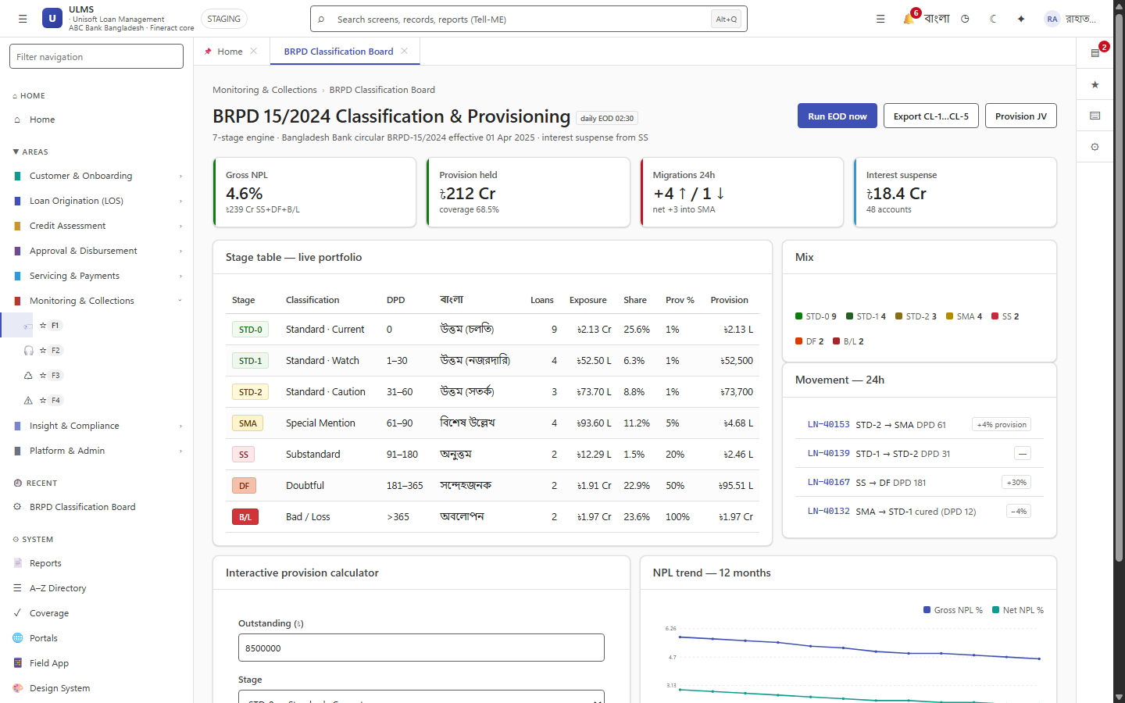
Figure 2: Bangladesh Bank Regulatory Reporting & Days Past Due (DPD) Aging Board
Nightly batch staging board displaying automated classification transitions.
Failure Mode 1: Batch Stalled Due to Database Row Lock Contention
• Symptom: Batch progress stops; log output freezes at a specific chunk; EodBatchDurationExceeded alert fires.
• Root Cause: A long-running analytical query or uncommitted interactive transaction holds an exclusive lock on customers or loans.
• Triage Query:
// Language: sql
SELECT
blocked_locks.pid AS blocked_pid,
blocked_activity.usename AS blocked_user,
blocking_locks.pid AS blocking_pid,
blocking_activity.usename AS blocking_user,
blocking_activity.query AS blocking_statement,
now() - blocking_activity.query_start AS blocking_duration
FROM pg_catalog.pg_locks blocked_locks
JOIN pg_catalog.pg_stat_activity blocked_activity ON blocked_activity.pid = blocked_locks.pid
JOIN pg_catalog.pg_locks blocking_locks
ON blocking_locks.locktype = blocked_locks.locktype
AND blocking_locks.database IS NOT DISTINCT FROM blocked_locks.database
AND blocking_locks.relation IS NOT DISTINCT FROM blocked_locks.relation
AND blocking_locks.page IS NOT DISTINCT FROM blocked_locks.page
AND blocking_locks.tuple IS NOT DISTINCT FROM blocked_locks.tuple
AND blocking_locks.virtualxid IS NOT DISTINCT FROM blocked_locks.virtualxid
AND blocking_locks.transactionid IS NOT DISTINCT FROM blocked_locks.transactionid
AND blocking_locks.classid IS NOT DISTINCT FROM blocked_locks.classid
AND blocking_locks.objid IS NOT DISTINCT FROM blocked_locks.objid
AND blocking_locks.objsubid IS NOT DISTINCT FROM blocked_locks.objsubid
AND blocking_locks.pid != blocked_locks.pid
JOIN pg_catalog.pg_stat_activity blocking_activity ON blocking_activity.pid = blocking_locks.pid
WHERE NOT blocked_locks.granted;

• Remediation Action:
1. Identify the blocking query PID. If it is an unapproved ad-hoc reporting query, terminate it safely:
// Language: sql
SELECT pg_cancel_backend($BLOCKING_PID);
-- If still hung after 30 seconds:
SELECT pg_terminate_backend($BLOCKING_PID);

2. The batch worker will resume automatically once the lock is cleared.
Failure Mode 2: Fineract GL Posting Rejection (The 409 Conflict Drifted JV Trap)
• Symptom: Phases 1–4 succeed, but Phase 5 fails with HTTP 409 Conflict: Provision JV already posted for batch date.
• Root Cause: The batch was run earlier in the evening or a preliminary run took place, and a provision Journal Voucher (JV) was already created in Fineract. Re-running the batch changes the provision amount, causing Fineract to reject the duplicate booking date.
• The Golden Rule: Never manually edit or delete general ledger rows in PostgreSQL.
• Remediation Action:
1. The Compliance Officer and Finance Lead must execute a dual-authorized JV Reversal for the prior entry:
// Language: bash
# Step 1: Inquire existing provision JV reference
curl -s -X GET -H "Authorization: Bearer $TOKEN" \
http://localhost:8081/api/v1/compliance/provision-jv/by-date/2026-10-06
# Step 2: Post reversing entry
curl -s -X POST -H "Authorization: Bearer $TOKEN" -H "Content-Type: application/json" \
-d '{"reversalReason": "EOD recomputation adjustment", "dualAuthOfficerId": "fin_head_01"}' \
http://localhost:8081/api/v1/compliance/provision-jv/$ORIGINAL_JV_ID/reverse

2. Re-trigger Phase 5 GL posting to post the newly adjusted, balanced journal entry.
3. Safe Historical EOD Rerun Procedure (`RB-03`)
As illustrated in Figure 3 below, Authoritative decision logic for qualitative and objective classification overrides.
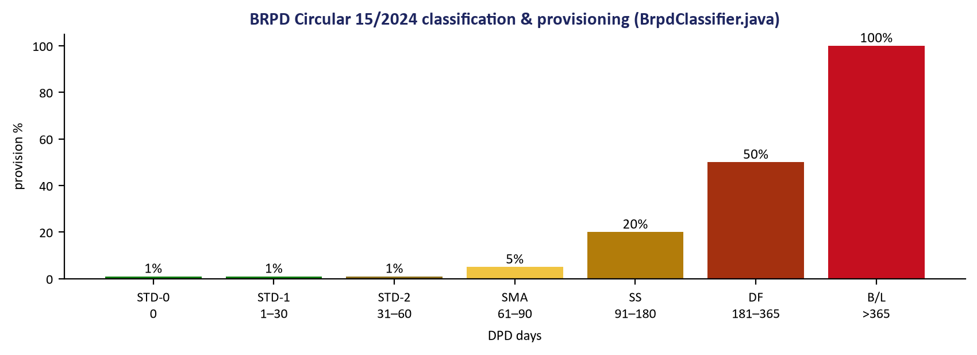
Figure 3: Bangladesh Bank Statutory Provisioning Rules & Overdue Calculation Flowchart
Authoritative decision logic for qualitative and objective classification overrides.
When a scheduled batch fails, a court stay order is processed retroactively, or the 23:30 window is missed due to an infrastructure outage, execute the following deterministic rerun runbook:
Step 1: Freeze Pre-Rerun Evidence (Regulatory Audit Requirement)
Before modifying classification snapshots, capture current counts and totals to an audit file:
// Language: bash
docker compose exec -T postgres psql -U ulms -d ulms -c "
SELECT
run_date,
loans_classified,
total_standard_minor,
total_classified_minor,
total_provision_minor,
created_at
FROM ulms_app.provision_run
WHERE run_date >= CURRENT_DATE - INTERVAL '3 days'
ORDER BY run_date DESC;" > /var/log/ulms/eod_pre_rerun_audit_$(date +%Y%m%d_%H%M%S).txt

Step 2: Acquire Dual-Authorized Compliance Token
// Language: bash
TOKEN=$(curl -s http://localhost:8082/realms/ulms/protocol/openid-connect/token \
-d grant_type=password \
-d client_id=ulms-web \
-d username=compliance_officer \
-d password="$COMPLIANCE_PASSWORD" | jq -r .access_token)

Step 3: Trigger Idempotent Date-Bound Rerun API
// Language: bash
curl -s -X POST -H "Authorization: Bearer $TOKEN" \
-H "Content-Type: application/json" \
-d '{
"targetDate": "2026-10-06",
"forceRecalculate": true,
"authorizationCode": "AUTH-EOD-RERUN-20261006-01"
}' \
http://localhost:8081/api/v1/compliance/eod/run | jq .

Expected Response:
// Language: json
{
"status": "COMPLETED",
"targetDate": "2026-10-06",
"loansProcessed": 48210,
"standardLoans": 46150,
"specialMention": 1240,
"classifiedLoans": 820,
"totalProvisionBDT": "99452300.00",
"glPostingStatus": "POSTED",
"glJournalVoucherId": "JV-20261006-PROV-02"
}

4. Court Stay Orders & Qualitative Overrides
Under Bangladesh Bank regulations, High Court stay orders or credit committee qualitative assessments can freeze or reclassify a loan account regardless of its objective DPD:
4.1 Applying a Legal Stay Order
// Language: bash
curl -s -X POST -H "Authorization: Bearer $TOKEN" \
-H "Content-Type: application/json" \
-d '{
"loanId": "a1b2c3d4-e5f6-7890-abcd-ef1234567890",
"overrideClassification": "STD-0",
"reason": "High Court Writ Petition No. 14205/2026 stay order",
"expiryDate": "2027-04-30",
"supportingDocumentRef": "DOC-STAY-WP14205"
}' \
http://localhost:8081/api/v1/compliance/overrides

When evaluated by the EOD batch, the engine detects the active stay order, retains STD-0 classification, logs a QUALITATIVE_OVERRIDE event, and flags the account on the CIB Monthly Export statement.
— End of Nightly EOD Batch & Classification Diagnostic Guide —

