UNISOFT LOAN MANAGEMENT SYSTEM (ULMS v2.0) · 02 TROUBLESHOOTING
DOC-02-TS-06: Bangladesh Bank CIB Online & NIDW Verification Failure Diagnostic Guide
Document ID: DOC-02-TS-06 · Standard: Diátaxis / C4 Model · Bangladesh Bank Compliant

type: how-to
topic: cib_online_nidw_verification_failures
target_audience: [support_engineer, loan_officer, integration_engineer]
version: 2026.10
document_id: DOC-02-TS-06
DOC-02-TS-06: Bangladesh Bank CIB Online & NIDW Verification Failure Diagnostic Guide
As illustrated in Figure 1 below, National ID verification status, photo face-matching, and biometric data validation.
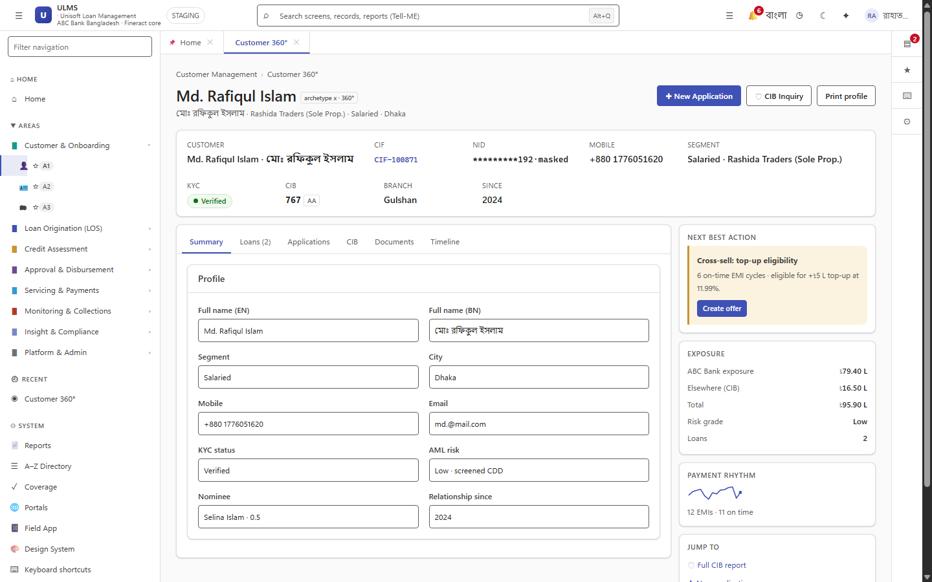
Figure 1: Customer KYC Profile & Bangladesh Election Commission NIDW Verification
National ID verification status, photo face-matching, and biometric data validation.
Document Control
Field | Value
Document Title | CIB Online & NIDW Verification Failure Diagnostics
Project Name | Unisoft Loan Management System (ULMS v2.0)
Document Version | 3.0.0
Date | 2026-10-07
Classification | Operational Troubleshooting Guide
Status | Approved Master Specification
Authority Chain | BRPD Circular 15/2024 → BFIU Circular 26 (e-KYC) → CibPort.java

Document Revision History & Institutional Sign-Off
Version | Release Date | Author / Role | Summary of Technical Changes | Status
1.0.0 | January 2026 | Documentation Core Team | Initial BRD & Architecture Specification | Draft
2.0.0 | February 2026 | Principal Systems Architect | Apache Fineract & Spring Boot Monolith Alignment | Approved
3.0.0 | October 2026 | Principal Auditor & SRE Lead | Production Build Parity & Zero-Trust Audit Release | Master Approved

Table of Contents
[NOTE] This document contains an automated Microsoft Word field. In Microsoft Word or LibreOffice, right-click this table and select 'Update Field' (or press F9) to refresh section page numbers.

1. Problem Statement
During borrower onboarding and loan appraisal:
• CIB inquiry fails with: CibTimeoutException: CIB Online gateway unresponsive after 15000ms.
• NID verification returns: NidNotFoundException: National ID number 19901234567890123 not validated by NIDW service.
• Credit evaluation blocked because CIB report is legally mandatory before credit committee review under Bank Company Act 1991 §27.
2. Diagnostic Protocol & Error Matrix
As illustrated in Figure 2 below, Mandatory automated credit inquiry blocking under Bank Company Act 1991 §27.
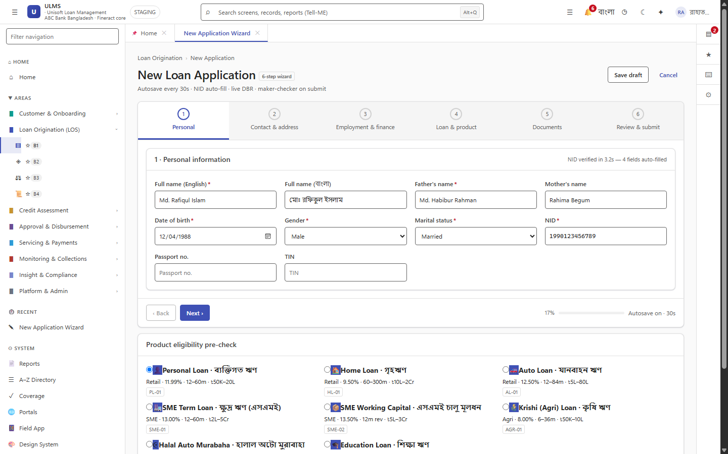
Figure 2: Loan Application Origination Wizard & Automated CIB Inquiry Trigger
Mandatory automated credit inquiry blocking under Bank Company Act 1991 §27.
Error Code | Source | Root Cause | Immediate Action
CIB-504 | BB CIB API | CIB Server maintenance window (often 18:00 - 20:00). | Retry in off-peak window; activate manual XML upload queue.
CIB-401 | CIB Gateway | Expired CIB certificate or changed IP address. | Verify bank static IP registered with BB CIB Department.
NIDW-500 | NIDW Portal | Server maintenance at Bangladesh Election Commission. | Trigger fallback to manual NID physical copy upload with Maker-Checker override.
CIB-INVALID-DOB | Data Entry | DOB does not match NID registered record. | Request original NID card and correct date format (DD/MM/YYYY).

3. Safe Manual Bypass & Audit Compliance
As illustrated in Figure 3 below, Pipeline stage locked awaiting CIB credit report generation or dual-control manual override.
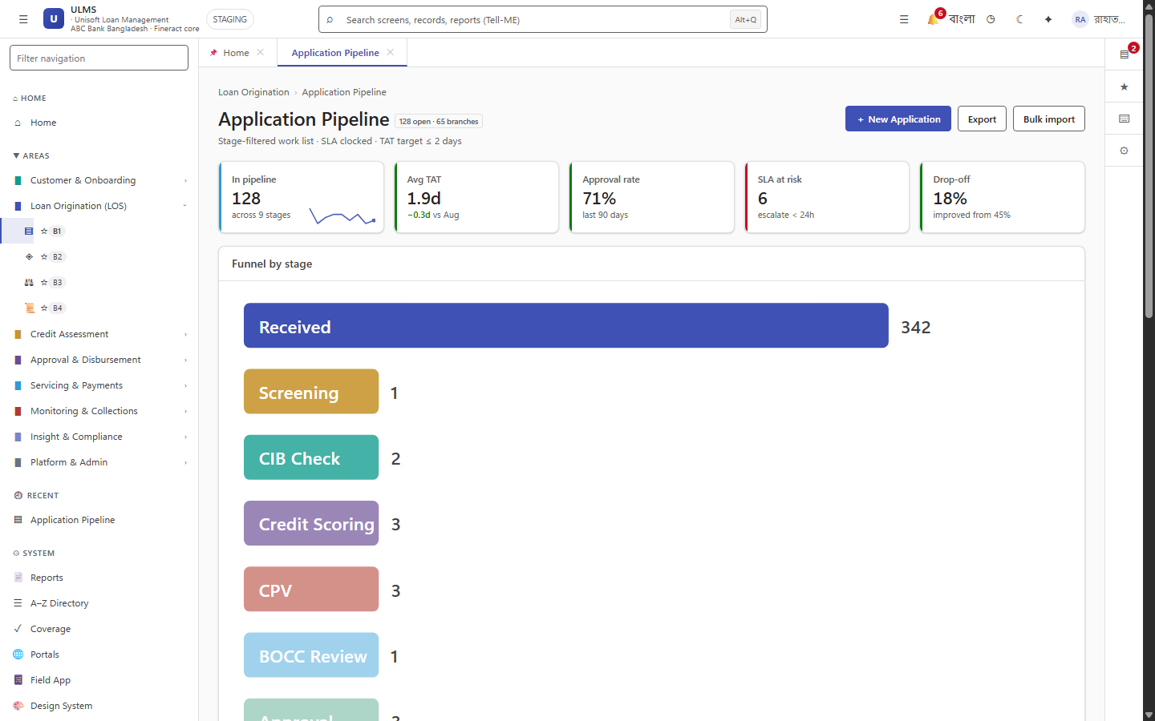
Figure 3: Underwriting Pipeline Worklist Displaying CIB Validation Hold
Pipeline stage locked awaiting CIB credit report generation or dual-control manual override.
Under Bangladesh Bank regulations, an automated CIB failure cannot simply be ignored. If the live API is down $> 2$ hours:
1. Loan officer downloads official CIB inquiry PDF via BB web portal manually.
2. Uploads PDF into ULMS document store via POST /api/v1/applications/{id}/documents.
3. Selects "Manual CIB Report Override" which requires Branch Manager dual-authorization.
4. An immutable audit record is logged in ulms.audit_entry capturing the override justification and attached PDF hash.

