UNISOFT LOAN MANAGEMENT SYSTEM (ULMS v2.0) · 03 MAINTENANCE
DOC-03-MNT-04: Apache Fineract CE 1.10/1.12 Patching, Maintenance & Database Pruning Runbook
Document ID: DOC-03-MNT-04 · Standard: Diátaxis / C4 Model · Bangladesh Bank Compliant

type: how-to
topic: fineract_patching_maintenance_pruning
target_audience: [backend_engineer, dba, release_manager]
version: 2026.10
document_id: DOC-03-MNT-04
DOC-03-MNT-04: Apache Fineract CE 1.10/1.12 Patching, Maintenance & Database Pruning Runbook
As illustrated in Figure 1 below, Mifos tenant loan schedule and accounting ledger state managed by Fineract engine.
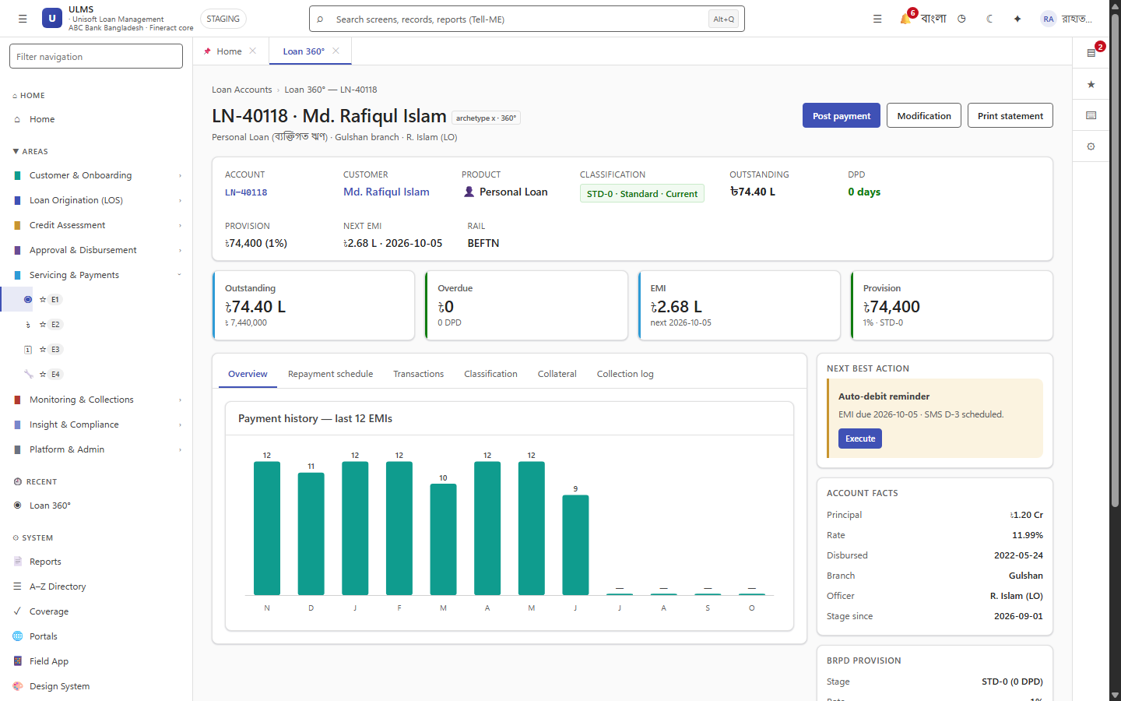
Figure 1: Apache Fineract CE Core Lending Ledger Detail
Mifos tenant loan schedule and accounting ledger state managed by Fineract engine.
Document Control
Field | Value
Document Title | Apache Fineract CE Patching & Maintenance Runbook
Project Name | Unisoft Loan Management System (ULMS v2.0)
Document Version | 3.0.0
Date | 2026-10-07
Classification | Operational Maintenance Guide
Status | Approved Master Specification
Authority Chain | DOC-01-ARCH-02 → Apache Fineract Community Edition

Document Revision History & Institutional Sign-Off
Version | Release Date | Author / Role | Summary of Technical Changes | Status
1.0.0 | January 2026 | Documentation Core Team | Initial BRD & Architecture Specification | Draft
2.0.0 | February 2026 | Principal Systems Architect | Apache Fineract & Spring Boot Monolith Alignment | Approved
3.0.0 | October 2026 | Principal Auditor & SRE Lead | Production Build Parity & Zero-Trust Audit Release | Master Approved

Table of Contents
[NOTE] This document contains an automated Microsoft Word field. In Microsoft Word or LibreOffice, right-click this table and select 'Update Field' (or press F9) to refresh section page numbers.

1. Upstream Patch Ingestion Workflow
ULMS integrates with Apache Fineract CE as a core lending ledger engine. Upstream security and bug fixes are backported quarterly:
1. Review Apache security advisories (CVEs).
2. Fetch release tags from Apache Fineract Git repository.
3. Verify backward-compatibility of Fineract REST endpoints used by FineractPort, FineractLoanPort, and FineractJournalPort.
4. Deploy container image update to UAT staging cluster before production rollout.
2. Database Bloat Pruning & Vacuum Cadence
As illustrated in Figure 3 below, Database performance metrics following table vacuum and batch execution log pruning.
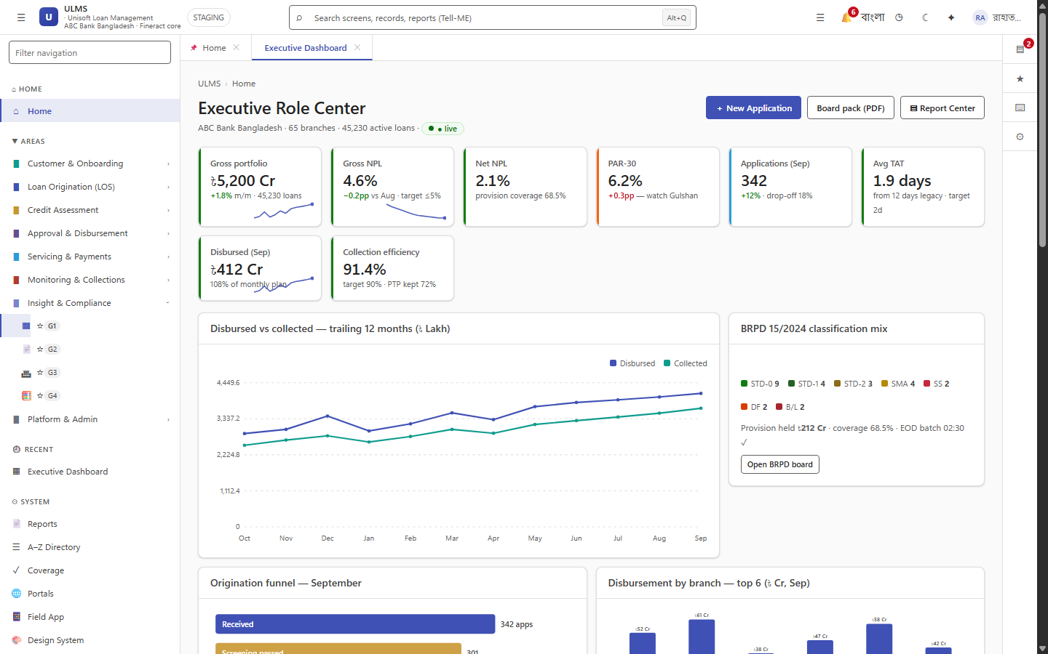
Figure 3: Batch Scheduler Synchronization & Vacuum Health Monitor
Database performance metrics following table vacuum and batch execution log pruning.
Fineract generates extensive batch job history and transaction logs:
// Language: sql
-- Monthly vacuum and analyze on high-churn Fineract tables
VACUUM (ANALYZE, VERBOSE) fineract_default.m_loan_transaction;
VACUUM (ANALYZE, VERBOSE) fineract_default.job_execution;
-- Purge stale batch execution logs older than 180 days
DELETE FROM fineract_default.job_execution
WHERE start_time < NOW() - INTERVAL '180 days';

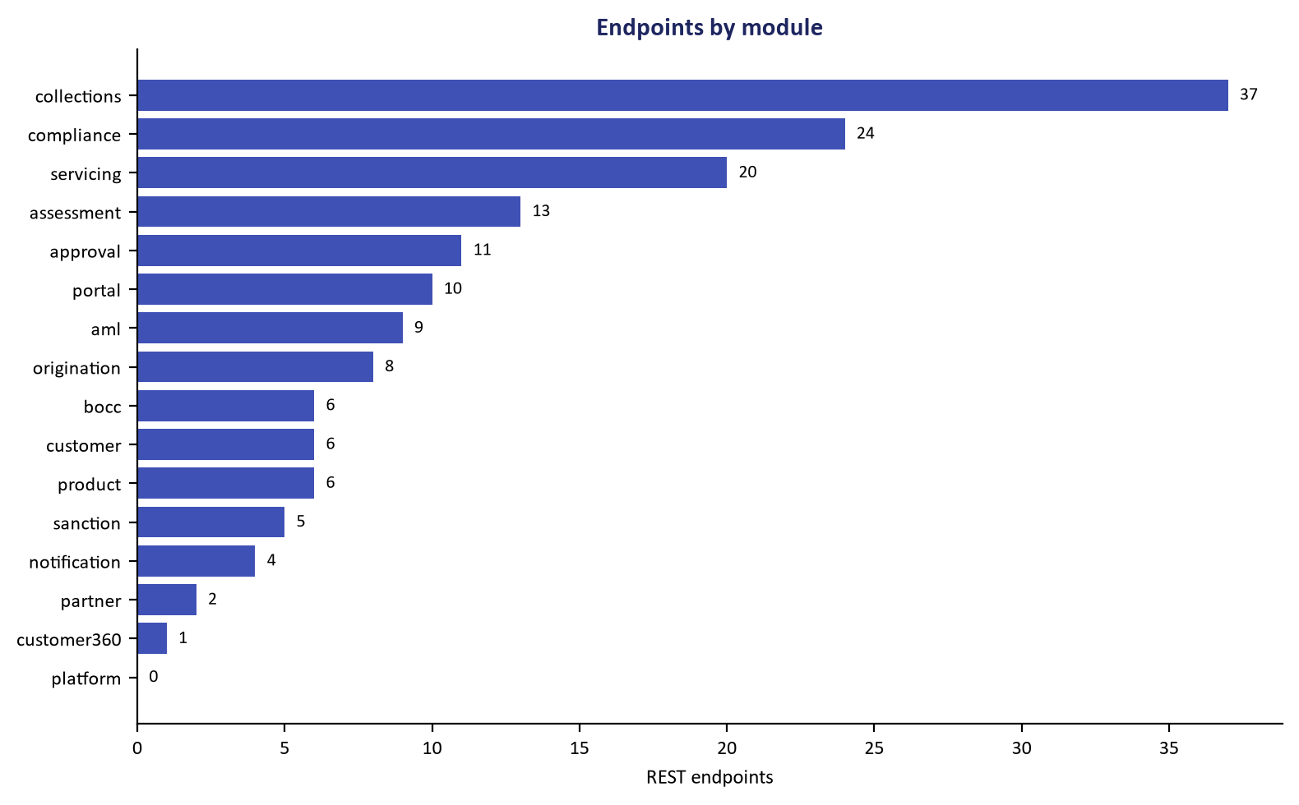
Figure 2: Core Banking Bridge REST API Integration Contract
Verified endpoint compatibility ensuring zero contract breakage during Fineract upgrades.

