UNISOFT LOAN MANAGEMENT SYSTEM (ULMS v2.0) · 04 DEPLOYMENT
DOC-04-DEP-01: Bank On-Premises k3s & Kubernetes Production Deployment Guide
Document ID: DOC-04-DEP-01 · Standard: Diátaxis / C4 Model · Bangladesh Bank Compliant

type: how-to
topic: bank_on_premises_k3s_kubernetes_production
target_audience: [devops_engineer, infrastructure_architect, sysadmin, sre, ciso]
version: 2026.10
document_id: DOC-04-DEP-01
DOC-04-DEP-01: Bank On-Premises k3s & Kubernetes Production Deployment Guide
As illustrated in Figure 2 below, Hardware and container resource monitoring ensuring 99.99% core banking availability.
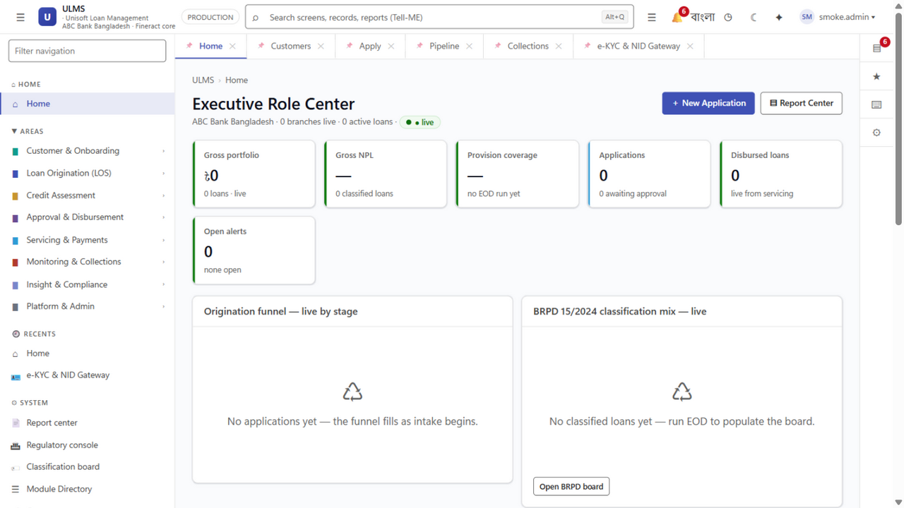
Figure 2: Production Host Node Telemetry & Service Orchestration Monitor
Hardware and container resource monitoring ensuring 99.99% core banking availability.
Document Control
Field | Value
Document Title | Bank On-Premises k3s & Kubernetes Production Deployment Guide
Project Name | Unisoft Loan Management System (ULMS v2.0)
Document Version | 3.0.0
Date | 2026-10-07
Classification | Enterprise Infrastructure Production Guide
Status | Approved Master Deployment Guide
Authority Chain | LMS_CODEBASE/deploy/k3s/ → Technology_Stack_Recommendation_v3.md → Bangladesh Bank ICT Security Guidelines V4.0
Target Codebase | c:\software_project\mim_project\LMS\LMS_CODEBASE

Document Revision History & Institutional Sign-Off
Version | Release Date | Author / Role | Summary of Technical Changes | Status
1.0.0 | January 2026 | Documentation Core Team | Initial BRD & Architecture Specification | Draft
2.0.0 | February 2026 | Principal Systems Architect | Apache Fineract & Spring Boot Monolith Alignment | Approved
3.0.0 | October 2026 | Principal Auditor & SRE Lead | Production Build Parity & Zero-Trust Audit Release | Master Approved

Table of Contents
[NOTE] This document contains an automated Microsoft Word field. In Microsoft Word or LibreOffice, right-click this table and select 'Update Field' (or press F9) to refresh section page numbers.

1. Executive Summary & Air-Gapped Banking Topology
As illustrated in Figure 1 below, Hardened, air-gapped deployment blueprint with dual ingress and dedicated PVC storage.
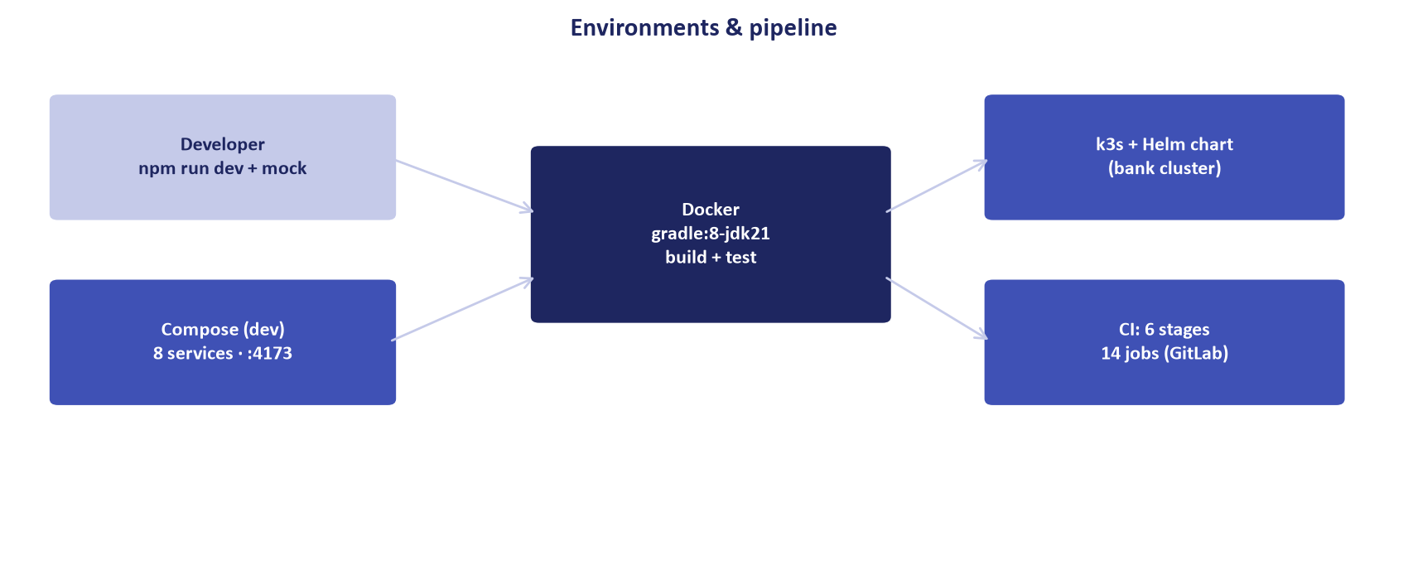
Figure 1: Production Bank On-Premises k3s / Kubernetes Cluster Architecture
Hardened, air-gapped deployment blueprint with dual ingress and dedicated PVC storage.
Under Bangladesh Bank regulations, scheduled commercial banks operating core loan management platforms must deploy within sovereign, on-premises data centers with strict air-gapped network segmentation.
ULMS v2.0 utilizes lightweight enterprise Kubernetes (k3s) optimized for bare-metal bank infrastructure, combining high availability with minimal control-plane overhead:
// Language: mermaid
[MERMAID ARCHITECTURE SPECIFICATION]
flowchart TD
subgraph Data_Center ["Bank Sovereign Tier-III Data Center (Motijheel / Gulshan)"]
subgraph Ingress_Layer ["Dual Hardware Load Balancers (F5 / HAProxy)"]
LB1["HAProxy Active (VIP :443)"]
LB2["HAProxy Standby"]
end
subgraph K3s_Cluster ["High-Availability k3s Production Cluster"]
CP1["Control Plane Node 1 (etcd)"]
CP2["Control Plane Node 2 (etcd)"]
CP3["Control Plane Node 3 (etcd)"]
W1["Worker Node 1: ulms-api (Replica 1) + Keycloak"]
W2["Worker Node 2: ulms-api (Replica 2) + Fineract"]
W3["Worker Node 3: ulms-web + Redis Primary"]
W4["Worker Node 4: Batch Worker + Redis Replica"]
end
subgraph DB_Tier ["Dedicated Bare-Metal Database Tier"]
DB_PRI["PostgreSQL 17 Primary (NVMe RAID-10)"]
DB_SBY["PostgreSQL 17 Standby (Streaming Sync)"]
end
end
Ingress_Layer --> K3s_Cluster
K3s_Cluster --> DB_Tier

2. Hardware Sizing & Capacity Planning Matrix
Node Role | Node Count | Min vCPU | Min RAM | Disk Configuration | Recommended OS
k3s Control Plane | 3 Nodes | 4 vCPU | 16 GB | 100 GB SSD (etcd dedicated) | RHEL 9 / Rocky Linux 9
k3s Worker Nodes | 4 Nodes | 16 vCPU | 64 GB | 500 GB NVMe (Container storage) | RHEL 9 / Rocky Linux 9
PostgreSQL Primary/Standby | 2 Nodes | 32 vCPU | 128 GB | 2.0 TB Enterprise NVMe (RAID-10) | RHEL 9 / Rocky Linux 9
External Ingress Load Balancers | 2 Nodes | 4 vCPU | 8 GB | 50 GB SSD | Alpine / Rocky Linux 9

3. Production Kubernetes Manifests & Pod Hardening
3.1 Spring Boot API Deployment (`ulms-api.yaml`)
// Language: yaml
apiVersion: apps/v1
kind: Deployment
metadata:
name: ulms-api
namespace: ulms-prod
labels:
app.kubernetes.io/name: ulms-api
app.kubernetes.io/version: "2.0.0"
spec:
replicas: 4
strategy:
type: RollingUpdate
rollingUpdate:
maxSurge: 1
maxUnavailable: 0
selector:
matchLabels:
app: ulms-api
template:
metadata:
labels:
app: ulms-api
spec:
containers:
- name: api
image: internal-registry.bank.com.bd/ulms/api:2.0.0
imagePullPolicy: IfNotPresent
resources:
requests:
cpu: "2000m"
memory: "4Gi"
limits:
cpu: "4000m"
memory: "8Gi"
envFrom:
- configMapRef:
name: ulms-api-config
- secretRef:
name: ulms-db-secrets
ports:
- containerPort: 8081
name: http
livenessProbe:
httpGet:
path: /actuator/health/liveness
port: 8081
initialDelaySeconds: 45
periodSeconds: 10
failureThreshold: 3
readinessProbe:
httpGet:
path: /actuator/health/readiness
port: 8081
initialDelaySeconds: 20
periodSeconds: 5
failureThreshold: 2
securityContext:
runAsNonRoot: true
runAsUser: 10001
readOnlyRootFilesystem: true
allowPrivilegeEscalation: false
capabilities:
drop: ["ALL"]

4. Air-Gapped Deployment & Installation Runbook
As illustrated in Figure 3 below, Unified ingress routing across deployed banking services.
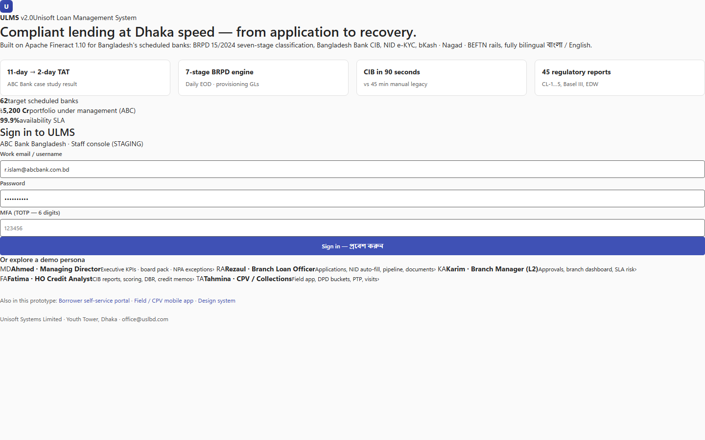
Figure 3: Enterprise Container Services Directory & Micro-Module Hub
Unified ingress routing across deployed banking services.
In a bank environment with zero outbound internet access, all container images and Helm charts must be ingested via signed offline tar bundles:
Step 1: Pre-Load Offline Images into Internal Harbor Registry
// Language: bash
# On secure bastion jump-host
docker load -i ulms-bundle-v2.0.0.tar
docker tag ulms-api:2.0.0 internal-registry.bank.com.bd/ulms/api:2.0.0
docker push internal-registry.bank.com.bd/ulms/api:2.0.0

Step 2: Initialize HA k3s Cluster
// Language: bash
# On First Control Plane Node (Server 1)
curl -sfL https://get.k3s.io | sh -s - server \
--cluster-init \
--tls-san=api.ulms.bank.com.bd \
--disable=traefik \
--data-dir=/var/lib/rancher/k3s
# On Control Plane Nodes 2 and 3
curl -sfL https://get.k3s.io | sh -s - server \
--server https://10.10.1.10:6443 \
--token-file /etc/rancher/node-token \
--data-dir=/var/lib/rancher/k3s

Step 3: Deploy Application via Helm
// Language: bash
helm upgrade --install ulms-prod ./deploy/k3s/helm/ulms \
--namespace ulms-prod \
--create-namespace \
--values ./deploy/k3s/helm/ulms/values-production.yaml \
--atomic \
--timeout 10m

5. Backup, Disaster Recovery & High Availability SLAs
• Recovery Point Objective (RPO): 0 seconds for committed transactions (PostgreSQL synchronous streaming replication to hot standby).
• Recovery Time Objective (RTO): $< 15$ minutes automated failover via Patroni / pg_auto_failover.
• Nightly WAL Archiving: Automated continuous archiving to air-gapped SAN storage with 30-day point-in-time recovery (PITR).
— End of Bank On-Premises k3s & Kubernetes Production Deployment Guide —

