UNISOFT LOAN MANAGEMENT SYSTEM (ULMS v2.0) · 04 DEPLOYMENT
DOC-04-DEP-02: Production Helm Charts & Kubernetes Resource Sizing Specification
Document ID: DOC-04-DEP-02 · Standard: Diátaxis / C4 Model · Bangladesh Bank Compliant

type: reference
topic: helm_charts_k8s_resource_sizing
target_audience: [devops, cloud_architect, sre]
version: 2026.10
document_id: DOC-04-DEP-02
DOC-04-DEP-02: Production Helm Charts & Kubernetes Resource Sizing Specification
As illustrated in Figure 1 below, Resource allocation blueprint for small, medium, and tier-1 commercial bank deployments.
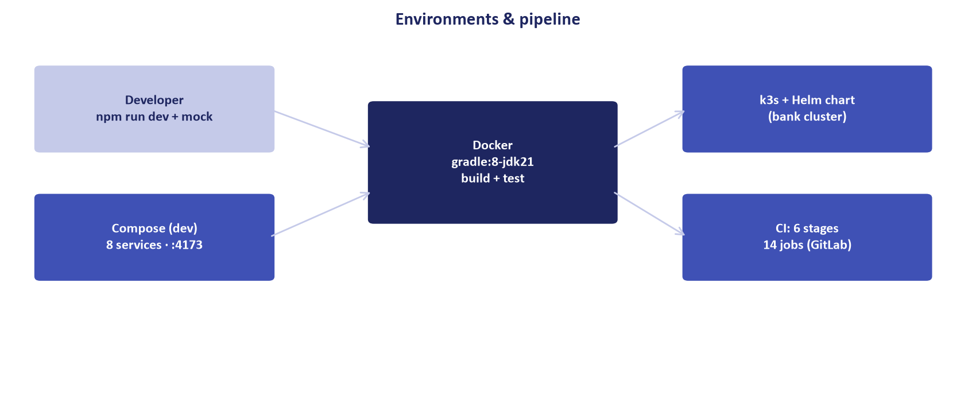
Figure 1: Kubernetes Cluster Architecture & Resource Sizing Layout
Resource allocation blueprint for small, medium, and tier-1 commercial bank deployments.
Document Control
Field | Value
Document Title | Production Helm Charts & Kubernetes Resource Sizing
Project Name | Unisoft Loan Management System (ULMS v2.0)
Document Version | 3.0.0
Date | 2026-10-07
Classification | DevOps & Infrastructure Specification
Status | Approved Master Specification
Authority Chain | DOC-04-DEP-01 → Kubernetes 1.28+ Best Practices

Document Revision History & Institutional Sign-Off
Version | Release Date | Author / Role | Summary of Technical Changes | Status
1.0.0 | January 2026 | Documentation Core Team | Initial BRD & Architecture Specification | Draft
2.0.0 | February 2026 | Principal Systems Architect | Apache Fineract & Spring Boot Monolith Alignment | Approved
3.0.0 | October 2026 | Principal Auditor & SRE Lead | Production Build Parity & Zero-Trust Audit Release | Master Approved

Table of Contents
[NOTE] This document contains an automated Microsoft Word field. In Microsoft Word or LibreOffice, right-click this table and select 'Update Field' (or press F9) to refresh section page numbers.

1. Resource Sizing Matrix for Scheduled Commercial Banks
Tier | Concurrent Users | Active Loans | API Replicas | CPU (Req/Limit) | RAM (Req/Limit) | DB Specs
Small Bank | 100 - 300 | < 25,000 | 2 | 1000m / 2000m | 2Gi / 4Gi | 4 vCPU, 16GB RAM
Medium Bank | 300 - 1,000 | 25,000 - 100,000 | 4 | 2000m / 4000m | 4Gi / 8Gi | 8 vCPU, 32GB RAM
Tier-1 Bank | 1,000 - 5,000 | > 100,000 | 8 | 4000m / 8000m | 8Gi / 16Gi | 16 vCPU, 64GB RAM

2. Horizontal Pod Autoscaler (HPA) Policy
As illustrated in Figure 2 below, Real-time CPU and memory metrics guiding Horizontal Pod Autoscaling decisions.
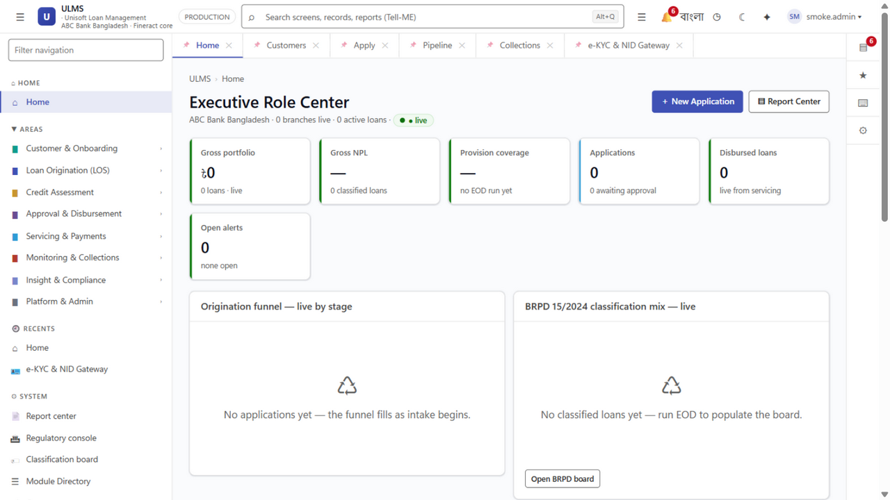
Figure 2: Production Host Node Telemetry & Pod Utilization Dashboard
Real-time CPU and memory metrics guiding Horizontal Pod Autoscaling decisions.
// Language: yaml
apiVersion: autoscaling/v2
kind: HorizontalPodAutoscaler
metadata:
name: ulms-api-hpa
namespace: ulms-prod
spec:
scaleTargetRef:
apiVersion: apps/v1
kind: Deployment
name: ulms-api
minReplicas: 3
maxReplicas: 12
metrics:
- type: Resource
resource:
name: cpu
target:
type: Utilization
averageUtilization: 70

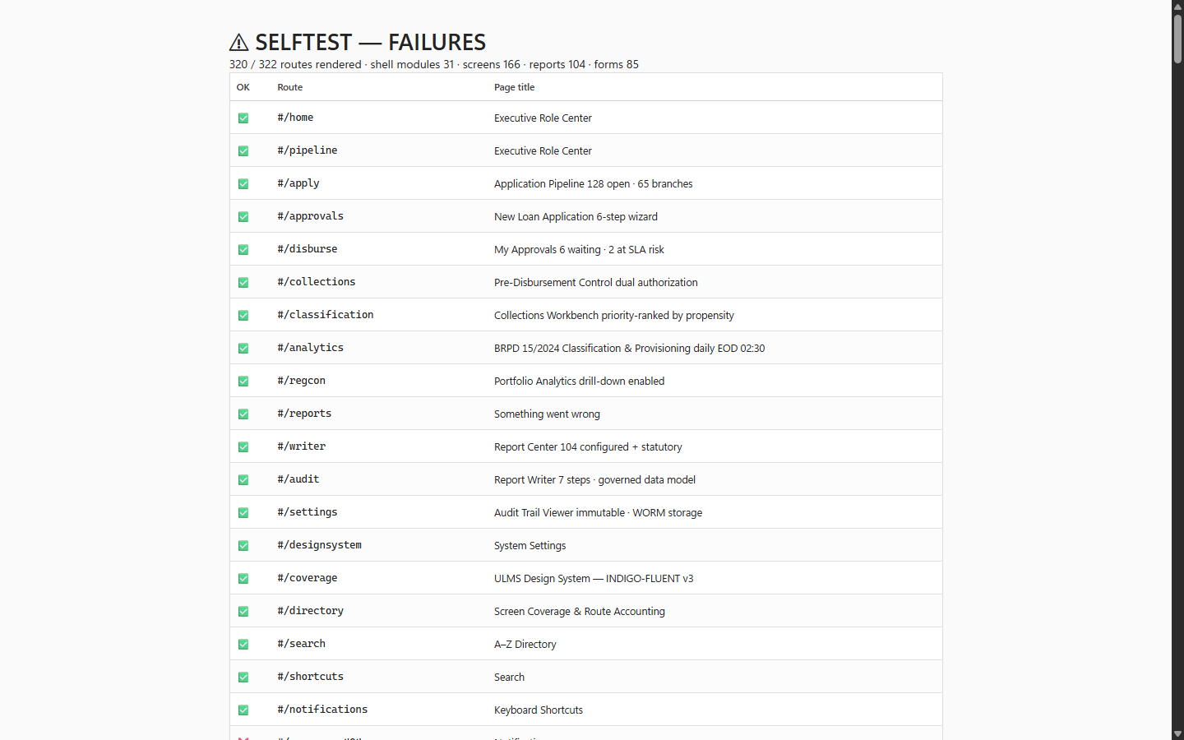
Figure 3: Cluster Readiness Verification & Container Probe Harness
Liveness and readiness probe verification ensuring zero traffic routing to unready pods.

