UNISOFT LOAN MANAGEMENT SYSTEM (ULMS v2.0) · 04 DEPLOYMENT
DOC-04-DEP-03: Air-Gapped & Offline Banking Datacenter Installation Runbook
Document ID: DOC-04-DEP-03 · Standard: Diátaxis / C4 Model · Bangladesh Bank Compliant

type: how-to
topic: air_gapped_offline_datacenter_install
target_audience: [devops, sysadmin, bank_it_operations]
version: 2026.10
document_id: DOC-04-DEP-03
DOC-04-DEP-03: Air-Gapped & Offline Banking Datacenter Installation Runbook
As illustrated in Figure 1 below, Isolated on-premises production network with zero outbound public internet access.
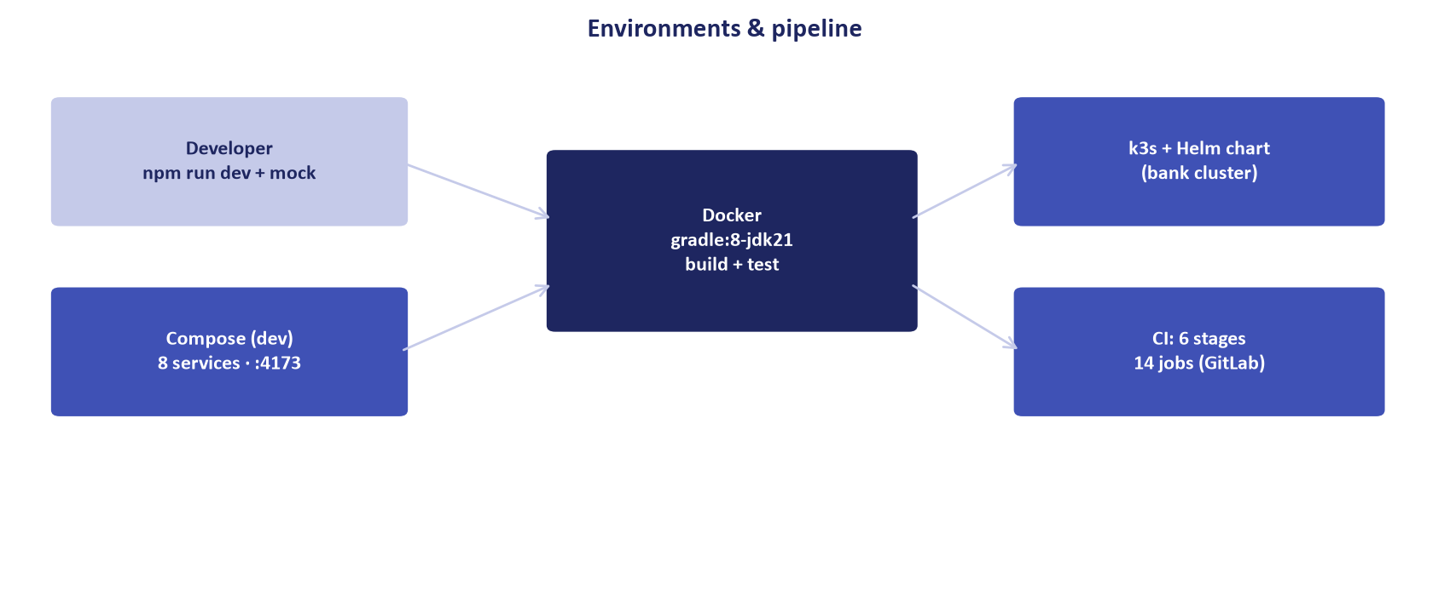
Figure 1: Air-Gapped Bank Datacenter Deployment Layout
Isolated on-premises production network with zero outbound public internet access.
Document Control
Field | Value
Document Title | Air-Gapped Datacenter Installation Runbook
Project Name | Unisoft Loan Management System (ULMS v2.0)
Document Version | 3.0.0
Date | 2026-10-07
Classification | Operational Infrastructure Runbook
Status | Approved Master Specification
Authority Chain | Bangladesh Bank ICT Security Guidelines V4.0 §3.1 (Isolation)

Document Revision History & Institutional Sign-Off
Version | Release Date | Author / Role | Summary of Technical Changes | Status
1.0.0 | January 2026 | Documentation Core Team | Initial BRD & Architecture Specification | Draft
2.0.0 | February 2026 | Principal Systems Architect | Apache Fineract & Spring Boot Monolith Alignment | Approved
3.0.0 | October 2026 | Principal Auditor & SRE Lead | Production Build Parity & Zero-Trust Audit Release | Master Approved

Table of Contents
[NOTE] This document contains an automated Microsoft Word field. In Microsoft Word or LibreOffice, right-click this table and select 'Update Field' (or press F9) to refresh section page numbers.

1. Overview & Security Mandate
Tier-1 commercial banks in Bangladesh prohibit production servers from connecting directly to the public internet. All container images, binaries, and dependencies must be pre-packaged into offline bundles, verified by SHA-256 checksums, and transferred via encrypted physical media.
2. Offline Bundle Preparation (Bastion / CI Server)
As illustrated in Figure 2 below, On-premises private Harbor container registry serving SHA-256 verified banking images.
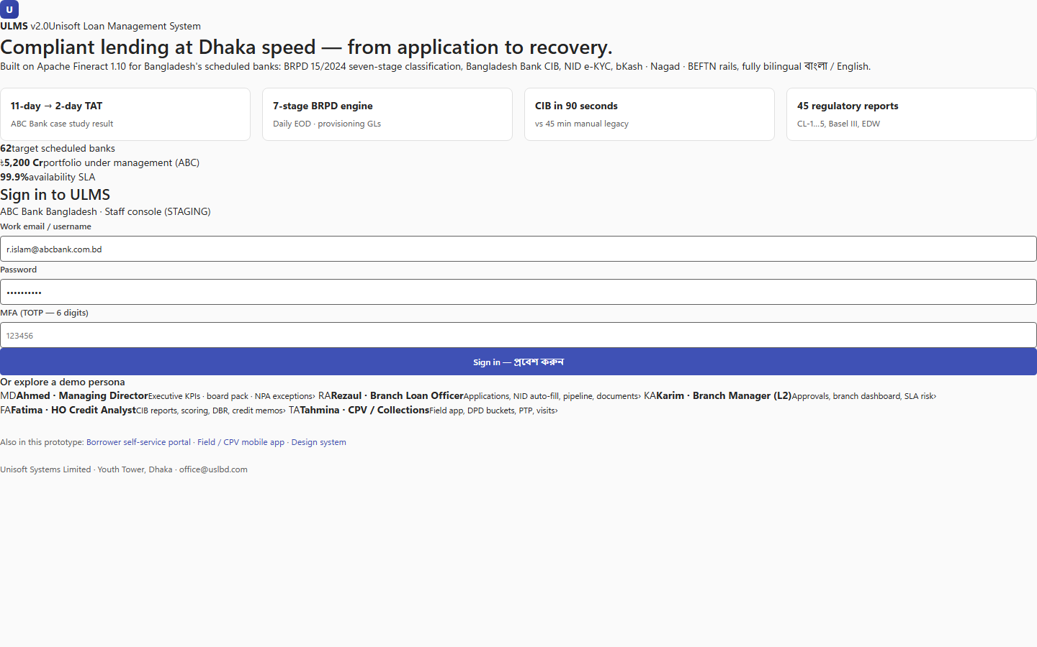
Figure 2: Local Container Registry & Services Hub
On-premises private Harbor container registry serving SHA-256 verified banking images.
// Language: bash
# 1. Export k3s air-gap images
docker pull postgres:17-alpine
docker pull apache/fineract:1.12.0
docker pull quay.io/keycloak/keycloak:26.0
# 2. Save images to compressed tarball
docker save -o ulms-airgap-images.tar \
postgres:17-alpine \
apache/fineract:1.12.0 \
quay.io/keycloak/keycloak:26.0 \
ulms-api:2.0.0 \
ulms-web:2.0.0
# 3. Generate SHA-256 checksum
sha256sum ulms-airgap-images.tar > ulms-airgap-images.tar.sha256

3. Production Datacenter Ingestion
As illustrated in Figure 3 below, Local host node management verifying standalone offline system operation.
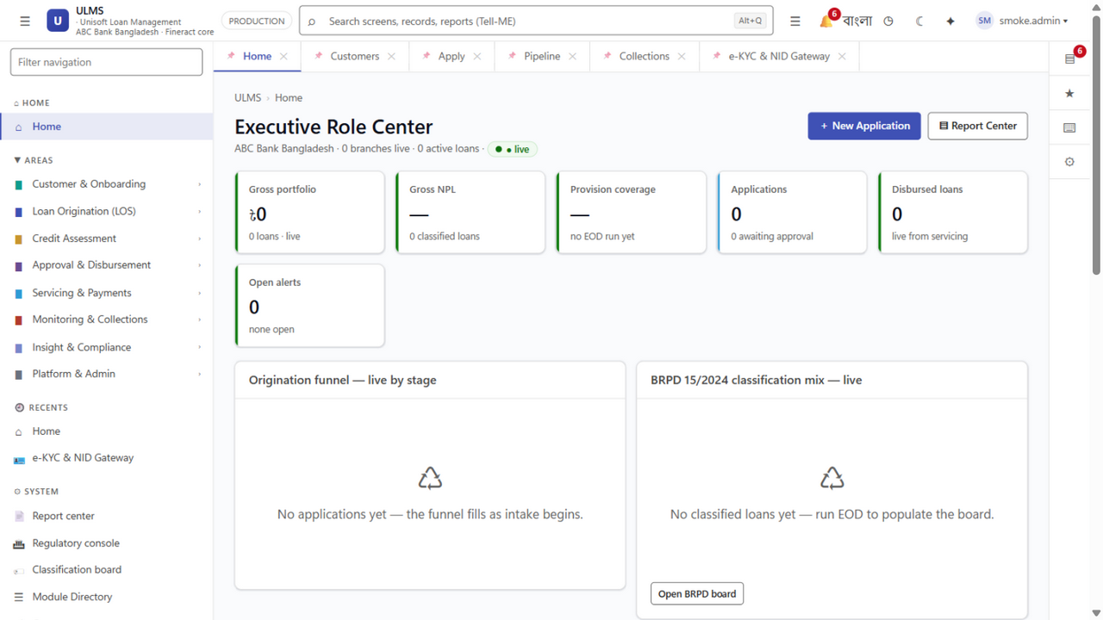
Figure 3: Isolated Node Operations Console & Service Health
Local host node management verifying standalone offline system operation.
1. Verify SHA-256 checksum before mounting media.
2. Push images into local air-gapped Harbor or Docker registry: registry.bank.local:5000.
3. Apply Helm charts referencing local image registry.

