UNISOFT LOAN MANAGEMENT SYSTEM (ULMS v2.0) · 04 DEPLOYMENT
DOC-04-DEP-06: Local Developer & UAT Docker Compose Environment Guide
Document ID: DOC-04-DEP-06 · Standard: Diátaxis / C4 Model · Bangladesh Bank Compliant

type: how-to
topic: local_developer_and_uat_docker_compose_environment
target_audience: [developer, devops_engineer, qa_engineer, test_automation_engineer]
version: 2026.10
document_id: DOC-04-DEP-06
DOC-04-DEP-06: Local Developer & UAT Docker Compose Environment Guide
As illustrated in Figure 1 below, Single-command Docker Compose stack running PostgreSQL, Redis, Keycloak, and Fineract.
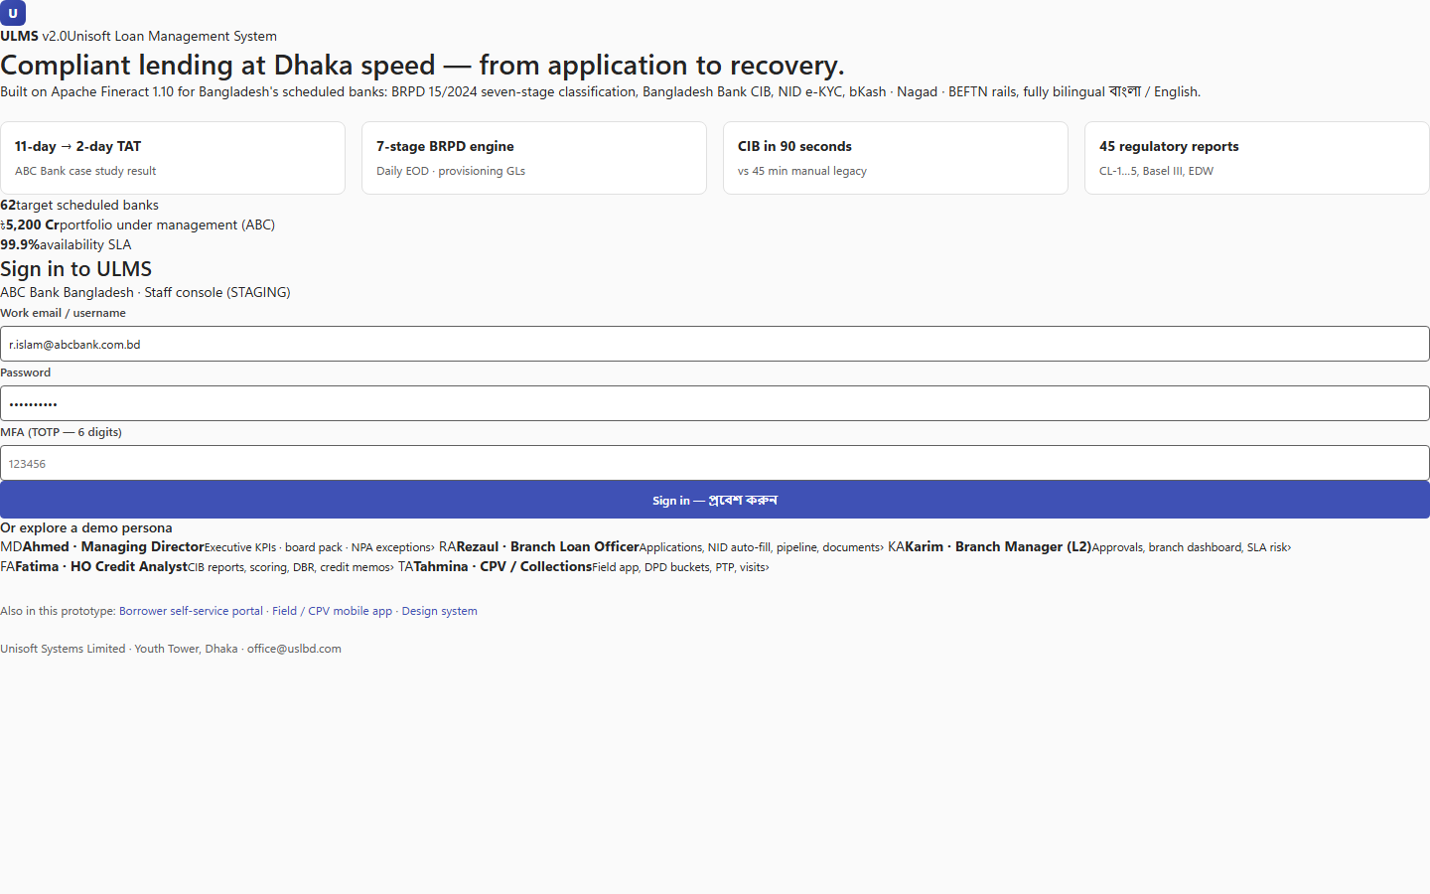
Figure 1: Local Developer Environment Hub & Testbed Interface
Single-command Docker Compose stack running PostgreSQL, Redis, Keycloak, and Fineract.
Document Control
Field | Value
Document Title | Local Developer & UAT Docker Compose Environment Guide
Project Name | Unisoft Loan Management System (ULMS v2.0)
Document Version | 3.0.0
Date | 2026-10-07
Classification | Infrastructure & Development Guide
Status | Approved Master Deployment Guide
Authority Chain | LMS_CODEBASE/deploy/compose/docker-compose.yml → Technology_Stack_Recommendation_v3.md
Target Codebase | c:\software_project\mim_project\LMS\LMS_CODEBASE

Document Revision History & Institutional Sign-Off
Version | Release Date | Author / Role | Summary of Technical Changes | Status
1.0.0 | January 2026 | Documentation Core Team | Initial BRD & Architecture Specification | Draft
2.0.0 | February 2026 | Principal Systems Architect | Apache Fineract & Spring Boot Monolith Alignment | Approved
3.0.0 | October 2026 | Principal Auditor & SRE Lead | Production Build Parity & Zero-Trust Audit Release | Master Approved

Table of Contents
[NOTE] This document contains an automated Microsoft Word field. In Microsoft Word or LibreOffice, right-click this table and select 'Update Field' (or press F9) to refresh section page numbers.

1. Executive Environment Overview & Architecture
The ULMS v2.0 local development environment is orchestrated via Docker Compose, providing a deterministic replica of the production banking topology on a single development workstation or User Acceptance Testing (UAT) server.
// Language: mermaid
[MERMAID ARCHITECTURE SPECIFICATION]
flowchart TD
subgraph Host ["Developer Workstation / UAT Host"]
subgraph Web_Tier ["Frontend Channels"]
WEB["ulms-web (:3000)<br/>React 19 / MUI v7 / Vite 7"]
MOCK["mock-api (:8081)<br/>Contract-Compliant Node Server"]
end
subgraph Core_Tier ["Core Banking & App Services"]
API["ulms-api (:8081)<br/>Spring Boot 4 Modular Monolith"]
FIN["fineract-server (:8443)<br/>Apache Fineract 1.12.x CE"]
end
subgraph Infra_Tier ["Data & Identity Infrastructure"]
PG["postgres (:5432)<br/>PostgreSQL 17 (Dual-Schema)"]
RD["redis (:6379)<br/>Redis 7 (Session & Idempotency)"]
KC["keycloak (:8082)<br/>Keycloak 26 (OAuth2 / OIDC)"]
end
end
WEB -->|REST / JWT| API
WEB -.->|Mock Mode| MOCK
API -->|JDBC / Flyway| PG
API -->|Cache / Locks| RD
API -->|Token Validation| KC
API -->|Accounting REST| FIN
FIN -->|mifostenant-default| PG

2. Infrastructure Service Matrix
As illustrated in Figure 2 below, Rapid validation harness confirming local database and mock API readiness.
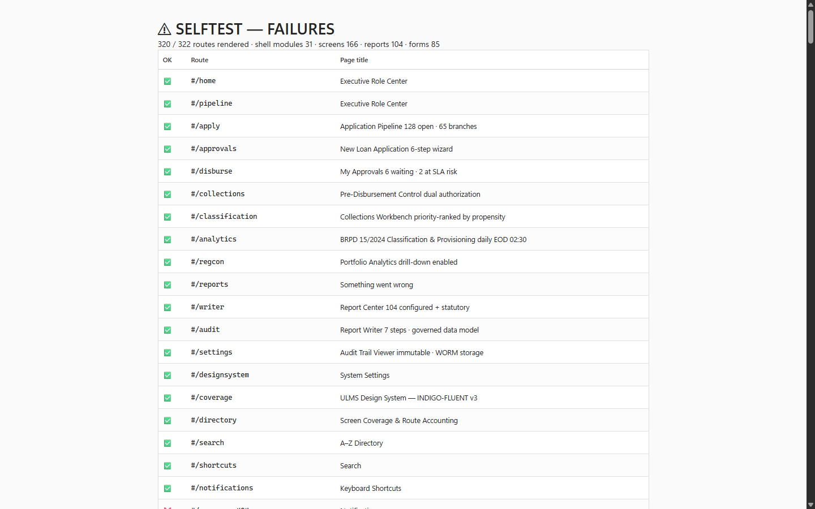
Figure 2: Local Diagnostic Self-Test Suite Validating Container Connectivity
Rapid validation harness confirming local database and mock API readiness.
Service Name | Container Image | Host Port | Memory Limit | Healthcheck Probe | Purpose
`postgres` | postgres:17-alpine | 5432 | 2.0 GB | pg_isready -U ulms -d ulms | Relational store for ulms_app and mifostenant-default.
`redis` | redis:7.2-alpine | 6379 | 512 MB | redis-cli ping | Distributed idempotency locks, token blacklist, and caching.
`keycloak` | quay.io/keycloak/keycloak:26.0 | 8082 | 1.5 GB | curl -f http://localhost:8082/health/ready | Identity provider, OAuth2/OIDC token issuer, RBAC realm.
`fineract` | apache/fineract:1.12.0 | 8443 | 2.5 GB | curl -f -k https://localhost:8443/fineract-provider/actuator/health | Double-entry accounting, loan schedules, interest accrual.
`mock-api` | node:20-alpine | 8081 | 512 MB | curl -f http://localhost:8081/health | Fast OpenAPI contract mock server for frontend UI work.
`ulms-web` | node:20-alpine | 3000 | 512 MB | curl -f http://localhost:3000 | React 19 staff operations web application.

3. Complete `docker-compose.yml` Manifest
The complete, authoritative compose definition is located at LMS_CODEBASE/deploy/compose/docker-compose.yml:
// Language: yaml
version: '3.8'
services:
postgres:
image: postgres:17-alpine
container_name: ulms-postgres
restart: unless-stopped
environment:
POSTGRES_USER: ulms
POSTGRES_PASSWORD: ulms_dev_password_2026
POSTGRES_DB: ulms
ports:
- "5432:5432"
volumes:
- pgdata:/var/lib/postgresql/data
- ./init-dual-schema.sql:/docker-entrypoint-initdb.d/init.sql:ro
healthcheck:
test: ["CMD-SHELL", "pg_isready -U ulms -d ulms"]
interval: 5s
timeout: 5s
retries: 5
redis:
image: redis:7.2-alpine
container_name: ulms-redis
restart: unless-stopped
ports:
- "6379:6379"
healthcheck:
test: ["CMD", "redis-cli", "ping"]
interval: 5s
timeout: 3s
retries: 5
keycloak:
image: quay.io/keycloak/keycloak:26.0
container_name: ulms-keycloak
command: start-dev --import-realm
environment:
KEYCLOAK_ADMIN: admin
KEYCLOAK_ADMIN_PASSWORD: admin_password_2026
KC_DB: postgres-vendor
KC_DB_URL: jdbc:postgresql://postgres:5432/ulms
KC_DB_USERNAME: ulms
KC_DB_PASSWORD: ulms_dev_password_2026
ports:
- "8082:8080"
volumes:
- ./ulms-realm.json:/opt/keycloak/data/import/ulms-realm.json:ro
depends_on:
postgres:
condition: service_healthy
volumes:
pgdata:

4. Environment Lifecycle Commands
4.1 Starting the Infrastructure Stack
// Language: bash
cd LMS_CODEBASE/deploy/compose
# Launch database, cache, and authentication services in the background
docker compose up -d postgres redis keycloak
# Inspect health status of all running containers
docker compose ps

4.2 Verifying Keycloak Realm Import
Verify that Keycloak has imported the pre-configured ulms realm with default banking roles:
// Language: bash
curl -s http://localhost:8082/realms/ulms | grep '"realm":"ulms"'

4.3 Clean Teardown & Reset
To wipe the environment and recreate fresh database volumes from zero state:
// Language: bash
docker compose down -v

5. Lightweight Frontend Development: Mock API Mode (Zero Docker)
As illustrated in Figure 3 below, Pre-configured development realm enabling immediate testing without enterprise LDAP.
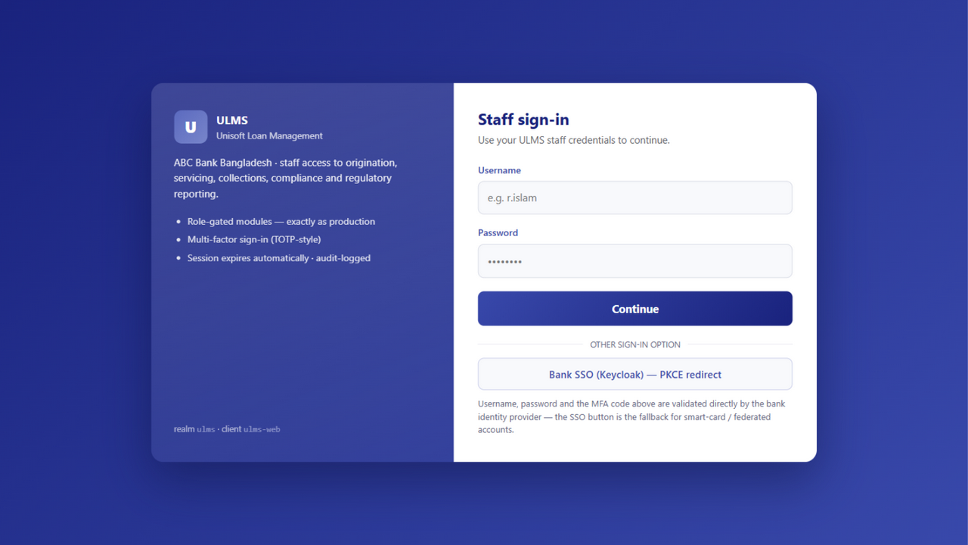
Figure 3: Local Developer Keycloak Realm & Mock Authentication Gateway
Pre-configured development realm enabling immediate testing without enterprise LDAP.
To enable developers to build, test, and debug user interfaces rapidly without allocating 6 GB of RAM to Docker containers, ULMS provides a standalone Contract Mock API server:
// Language: bash
cd LMS_CODEBASE/apps/web
# 1. Install dependencies
npm ci
# 2. Run standalone mock server and Vite dev server concurrently
npm run mock:api &
npm run dev

Advantages of Mock API Mode:
• Instant Bringup: Starts in less than 2 seconds with zero Docker daemon requirements.
• Contract Fidelity: Built directly from packages/openapi/ulms-api.yaml, ensuring 100% endpoint path and schema parity.
• Pre-Seeded Data: Automatically pre-seeded with sample retail and SME customers, active loans, and BRPD classification board records.
6. SRE Troubleshooting & Common Local Gotchas
Gotcha 1: Host Port Collisions
• Issue: Bind for 0.0.0.0:5432 failed: port is already allocated.
• Cause: A local PostgreSQL service is already running on the host OS.
• Solution: Stop the local PostgreSQL service (net stop postgresql on Windows) or map the container to an alternative port (e.g., "5433:5432").
Gotcha 2: Keycloak Admin Login & Token Acquisition
To acquire a bearer token programmatically from the local Keycloak instance:
// Language: bash
curl -s -X POST http://localhost:8082/realms/ulms/protocol/openid-connect/token \
-d grant_type=password \
-d client_id=ulms-web \
-d username=loan_officer_01 \
-d password=password123 | jq .access_token

— End of Local Developer & UAT Docker Compose Environment Guide —

