UNISOFT LOAN MANAGEMENT SYSTEM (ULMS v2.0) · 05 DEVELOPER EXTENSION
DOC-05-EXT-01: Developer Onboarding & Local Workspace Quickstart
Document ID: DOC-05-EXT-01 · Standard: Diátaxis / C4 Model · Bangladesh Bank Compliant

type: tutorial
topic: developer_onboarding_and_workspace_quickstart
target_audience: [developer, intern, contractor, tech_lead]
version: 2026.10
document_id: DOC-05-EXT-01
DOC-05-EXT-01: Developer Onboarding & Local Workspace Quickstart
Document Control
Field | Value
Document Title | Developer Onboarding & Local Workspace Quickstart
Project Name | Unisoft Loan Management System (ULMS v2.0)
Document Version | 3.0.0
Date | 2026-10-07
Classification | Developer Onboarding Tutorial
Status | Approved Master Onboarding Guide
Authority Chain | LMS_CODEBASE/README.md → README_Documentation_Guide.md → Technology_Stack_Recommendation_v3.md
Target Codebase | c:\software_project\mim_project\LMS\LMS_CODEBASE

Document Revision History & Institutional Sign-Off
Version | Release Date | Author / Role | Summary of Technical Changes | Status
1.0.0 | January 2026 | Documentation Core Team | Initial BRD & Architecture Specification | Draft
2.0.0 | February 2026 | Principal Systems Architect | Apache Fineract & Spring Boot Monolith Alignment | Approved
3.0.0 | October 2026 | Principal Auditor & SRE Lead | Production Build Parity & Zero-Trust Audit Release | Master Approved

Table of Contents
[NOTE] This document contains an automated Microsoft Word field. In Microsoft Word or LibreOffice, right-click this table and select 'Update Field' (or press F9) to refresh section page numbers.

1. Welcome to the ULMS v2.0 Engineering Team
As illustrated in Figure 1 below, Codebase structure mapping React 19 UI modules to Spring Boot API domains.
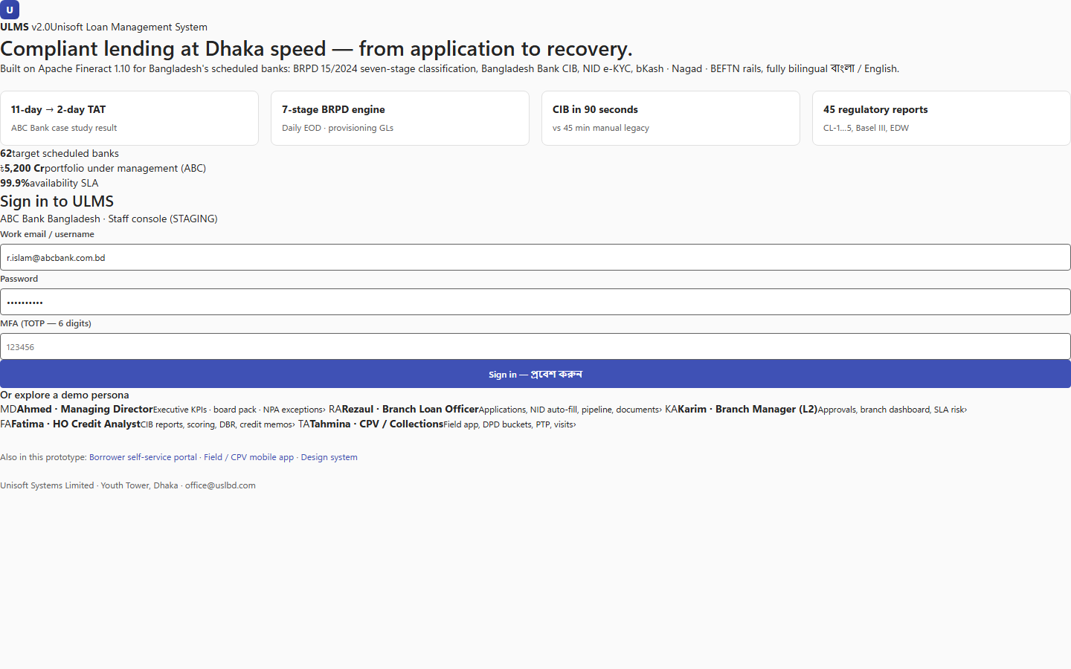
Figure 1: Developer Navigation Architecture & Subsystem Layout
Codebase structure mapping React 19 UI modules to Spring Boot API domains.
Welcome to the Unisoft Loan Management System (ULMS v2.0) core engineering group. ULMS is an enterprise-grade core lending platform engineered for scheduled commercial banks in Bangladesh, built upon Spring Boot 4, Apache Fineract 1.12.x Community Edition, PostgreSQL 17, and React 19.
The 3-Developer Core Principles
Because our team operates with high velocity and precision, every engineer adheres to three non-negotiable engineering laws:
1. Zero Hallucination / Evidence Basis: Code never lies; test assertions prove behavior. Spec documents and implementation must maintain 100% mutual parity.
2. Modular Monolith Discipline: Never violate Spring Modulith package boundaries. Cross-module database joins or unmediated circular dependencies are build-breaking violations.
3. Continuous Local Verification: Run unit oracles, contract checks, and architectural boundary tests locally before opening a pull request.
2. Workstation Tooling Installation & Prerequisites
Ensure the following tools are installed and configured on your development machine prior to cloning the codebase:
2.1 Tooling Matrix
Tool / Runtime | Required Version | Verification Command | Purpose
Java Development Kit | OpenJDK 21 LTS (Eclipse Temurin) | java -version | Backend Spring Boot 4 & Fineract compilation
Node.js | v20.x LTS or higher | node -v | Frontend build, Vite dev server, mock API
npm | 10.x or higher | npm -v | Frontend dependency management
Container Engine | Docker Desktop 24+ / Rancher | docker --version | Local PostgreSQL 17, Redis, Keycloak stack
Git CLI | 2.40+ | git --version | Version control & conventional commits
Python | 3.11+ | python --version | Build scripting & Word document generation

2.2 Windows PowerShell Execution Policy Configuration
If developing on Windows, PowerShell script execution policies may block npm/npx wrappers. Run the following command in an administrative PowerShell terminal:
// Language: powershell
Set-ExecutionPolicy -Scope CurrentUser -ExecutionPolicy RemoteSigned

Alternatively, execute build commands via standard command prompt (cmd /c) or bash.
3. Repository Architecture & Directory Structure
Clone the repository and inspect the primary workspace layout:
// Language: bash
git clone <REPOSITORY_URL>
cd LMS_CODEBASE

LMS_CODEBASE/
├── apps/
│ ├── api/ # Spring Boot 4 Modular Monolith (Java 21, Gradle, 9 domain modules)
│ ├── web/ # Staff Web Application (React 19, TypeScript, MUI v7, Vite 7)
│ └── mobile/ # Cross-Platform Mobile App (React Native, Expo 54+)
├── packages/
│ └── openapi/ # Authoritative REST API Specifications (ulms-api.yaml)
├── deploy/
│ ├── compose/ # Docker Compose local stack (Postgres, Keycloak, Redis, Fineract)
│ └── k3s/ # Production Kubernetes Helm charts and manifests
└── e2e/ # Playwright End-to-End Test Harness (12 journey suites)

4. Local Development Workflows
As illustrated in Figure 2 below, 100% passing test suite across unit, contract, and end-to-end integration tiers.
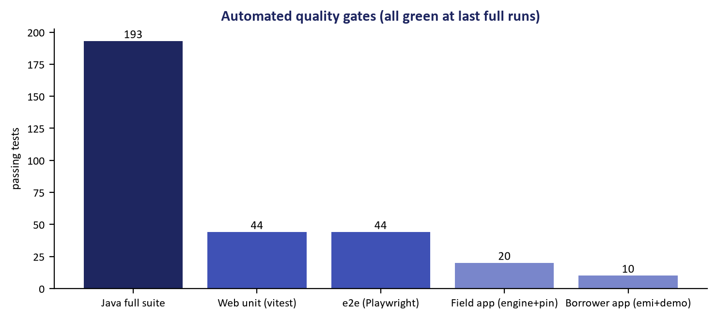
Figure 2: Automated Verification Suite Execution & Test Coverage Matrix
100% passing test suite across unit, contract, and end-to-end integration tiers.
ULMS supports two primary developer workflows depending on your immediate focus:
Workflow A: Full-Stack Containerized Mode
Use this when modifying cross-service integrations, authentication flows, or database schemas:
// Language: bash
# 1. Start the supporting infrastructure stack
cd deploy/compose
docker compose up -d postgres redis keycloak fineract
# 2. Run backend API from IDE or terminal
cd ../../apps/api
./gradlew bootRun --args='--spring.profiles.active=dev'
# 3. Start the React frontend
cd ../web
npm install
npm run dev

Workflow B: Fast Frontend & Mock API Mode (Zero Docker Overhead)
Use this when developing user interfaces, wizards, or reports without needing Docker containers:
// Language: bash
cd apps/web
npm install
# Start standalone contract mock API server (Port 8081)
npm run mock:api &
# Start Vite 7 development server with HMR (Port 3000)
npm run dev

The staff web application will launch at http://localhost:3000 connected to the OpenAPI-compliant mock API.
5. End-to-End Hands-On Tutorial: Adding a New Field
Follow this step-by-step walkthrough to make your first verified feature contribution across the full stack: adding an optional Tax Identification Number (TIN) to the Customer entity.
Step 1: Create a Feature Branch
// Language: bash
git checkout -b feat/customer-tax-id-field

Step 2: Create a Versioned Flyway Database Migration
Create a new migration file in apps/api/src/main/resources/db/migration/V18__field_gateway.sql:
// Language: sql
-- Migration: V019__add_customer_tin.sql
-- Purpose: Add statutory Tax Identification Number (TIN) field to Customer entity
ALTER TABLE ulms_app.customers
ADD COLUMN IF NOT EXISTS tax_identification_number VARCHAR(32);
COMMENT ON COLUMN ulms_app.customers.tax_identification_number IS
'National Board of Revenue (NBR) 12-digit Taxpayer Identification Number (TIN)';
CREATE INDEX IF NOT EXISTS idx_customers_tin
ON ulms_app.customers (tax_identification_number)
WHERE tax_identification_number IS NOT NULL;

Step 3: Update the JPA Domain Entity
Edit apps/api/src/main/java/com/uslbd/ulms/customer/Customer.java:
// Language: java
@Column(name = "tax_identification_number", length = 32)
private String taxIdentificationNumber;
public String getTaxIdentificationNumber() {
return taxIdentificationNumber;
}
public void setTaxIdentificationNumber(String taxIdentificationNumber) {
this.taxIdentificationNumber = taxIdentificationNumber;
}

Step 4: Update the OpenAPI Contract Specification
Edit packages/openapi/ulms-api.yaml under components.schemas.CustomerResponse:
// Language: yaml
taxIdentificationNumber:
type: string
maxLength: 32
example: "876543210987"
description: "NBR Taxpayer Identification Number (TIN)"

Step 5: Update the React 19 UI & Zod Validation
Edit apps/web/src/features/customer/CustomerPage.tsx:
// Language: tsx
const customerSchema = z.object({
fullName: z.string().min(3),
nidNumber: z.string().length(10),
taxIdentificationNumber: z.string().max(32).optional(),
});

Step 6: Verify Architecture Boundaries & Test Suites
Execute the architectural boundary check and domain tests:
// Language: bash
cd apps/api
./gradlew test --tests com.uslbd.ulms.ModularityTest
./gradlew test --tests com.uslbd.ulms.customer.*
cd ../web
npm run test:unit
npm run typecheck

Assertion: All tests must pass with zero modularity violations or TypeScript errors.
6. Integrated Development Environment (IDE) Configuration
6.1 IntelliJ IDEA Recommendations
1. Annotation Processing: Enable under Settings -> Build, Execution, Deployment -> Compiler -> Annotation Processors (required for Lombok and MapStruct).
2. Code Style: Import config/ide/intellij-java-google-style.xml.
3. Gradle JVM: Ensure Project SDK and Gradle JVM are set to Java 21 (Temurin-21).
6.2 Visual Studio Code Recommendations
Install the following essential extensions:
• Extension Pack for Java (vscjava.vscode-java-pack)
• Lombok Annotations Support (gabrielbb.vscode-lombok)
• ESLint (dbaeumer.vscode-eslint)
• Prettier Code Formatter (esbenp.prettier-vscode)
7. Git Workflow & Conventional Commits
As illustrated in Figure 3 below, Real-time feedback loop validating routes, schemas, and UI components.
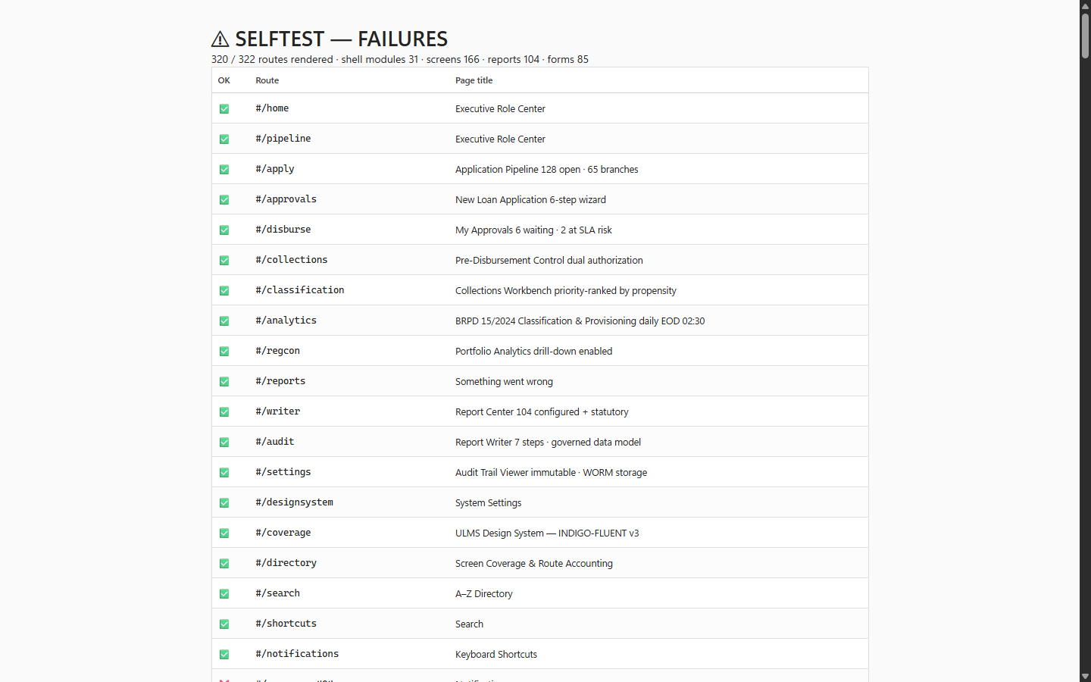
Figure 3: Interactive Developer Self-Test Harness for Rapid Feature Validation
Real-time feedback loop validating routes, schemas, and UI components.
All commit messages must adhere to the Conventional Commits specification:
<type>(<scope>): <subject>
[optional body]
[optional footer]

Allowed Types:
• feat: A new user-facing feature or API capability.
• fix: A bug fix or boundary correction.
• docs: Documentation updates or runbook additions.
• refactor: Code restructuring with zero behavioral change.
• test: Adding or refactoring automated test suites.
• chore: Build dependencies, Gradle/npm scripts, or CI updates.
Pre-PR Checklist:
• [ ] ./gradlew test passes with zero failures.
• [ ] npm run typecheck passes with zero errors.
• [ ] npm run test:unit passes.
• [ ] Code formatted with Google Java Style / Prettier.
• [ ] No hardcoded secrets, passwords, or internal URLs.
— End of Developer Onboarding & Local Workspace Quickstart Guide —

