UNISOFT LOAN MANAGEMENT SYSTEM (ULMS v2.0) · 05 DEVELOPER EXTENSION
DOC-05-EXT-03: Credit Approval Hierarchy, Multi-Tier Delegation & Matrix Customization Guide
Document ID: DOC-05-EXT-03 · Standard: Diátaxis / C4 Model · Bangladesh Bank Compliant

type: how-to
topic: credit_approval_hierarchy_ladder_customization
target_audience: [backend_developer, product_manager, risk_officer]
version: 2026.10
document_id: DOC-05-EXT-03
DOC-05-EXT-03: Credit Approval Hierarchy, Multi-Tier Delegation & Matrix Customization Guide
As illustrated in Figure 1 below, Authoritative delegation tiers mapping financial approval limits from Branch Officer to Board.
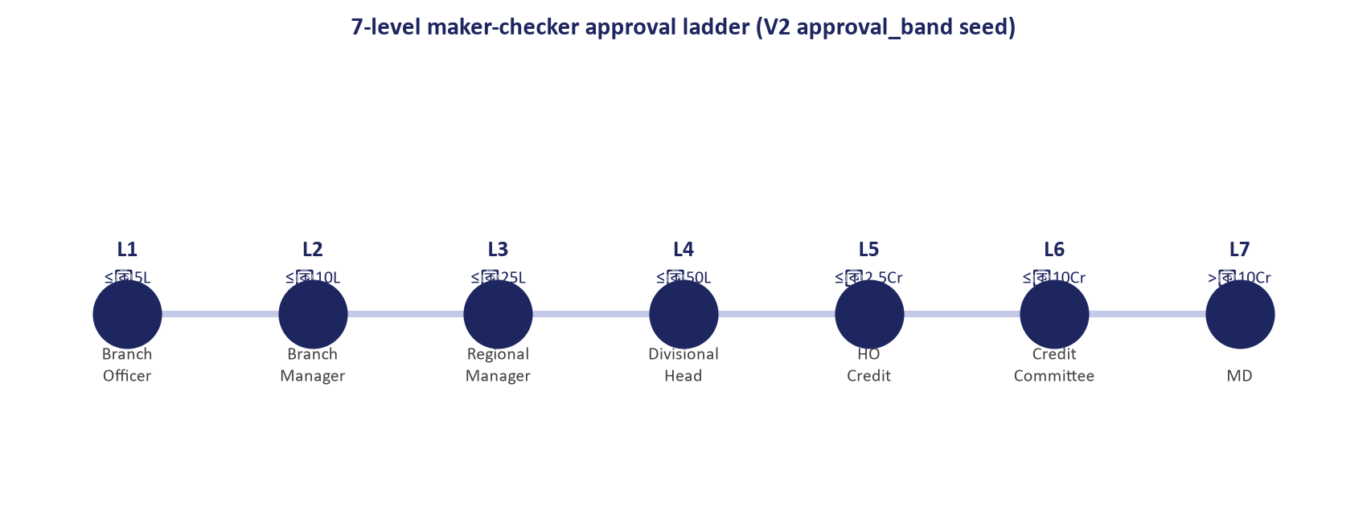
Figure 1: 7-Level Credit Approval Authority Delegation Ladder
Authoritative delegation tiers mapping financial approval limits from Branch Officer to Board.
Document Control
Field | Value
Document Title | Credit Approval Hierarchy & Delegation Matrix Customization
Project Name | Unisoft Loan Management System (ULMS v2.0)
Document Version | 3.0.0
Date | 2026-10-07
Classification | Developer Extension & Configuration Guide
Status | Approved Master Specification
Authority Chain | Bank Company Act 1991 → BRPD Circular 15/2024 → ulms.approval_band

Document Revision History & Institutional Sign-Off
Version | Release Date | Author / Role | Summary of Technical Changes | Status
1.0.0 | January 2026 | Documentation Core Team | Initial BRD & Architecture Specification | Draft
2.0.0 | February 2026 | Principal Systems Architect | Apache Fineract & Spring Boot Monolith Alignment | Approved
3.0.0 | October 2026 | Principal Auditor & SRE Lead | Production Build Parity & Zero-Trust Audit Release | Master Approved

Table of Contents
[NOTE] This document contains an automated Microsoft Word field. In Microsoft Word or LibreOffice, right-click this table and select 'Update Field' (or press F9) to refresh section page numbers.

1. Approval Ladder Architecture & Band Matrix
Under Bangladesh commercial banking practice, loan approval authorities follow strict delegated financial power matrices. ULMS models this via the 7-tier ulms.approval_band table (V5__credit_approval.sql):
Ladder Level | Approver Role | Min Amount (BDT) | Max Amount (BDT) | Dual-Auth Required? | Committee Escalation
Ladder 1 | Branch Credit Officer | 10,000 | 500,000 | No | No
Ladder 2 | Branch Manager | 500,001 | 2,500,000 | Yes (Maker-Checker) | No
Ladder 3 | Regional Credit Head | 2,500,001 | 10,000,000 | Yes | No
Ladder 4 | Head of Credit (CRM) | 10,000,001 | 50,000,000 | Yes | CRM Committee
Ladder 5 | Managing Director & CEO | 50,000,001 | 150,000,000 | Yes | Executive Committee
Ladder 6 | Executive Committee (EC) | 150,000,001 | 500,000,000 | Board Quorum | Board Committee
Ladder 7 | Board of Directors | > 500,000,000 | Unlimited | Full Board | Full Board of Directors

2. Extending Approval Logic in Java Codebase
As illustrated in Figure 3 below, Live view of loan application evaluation against configured approval bands.
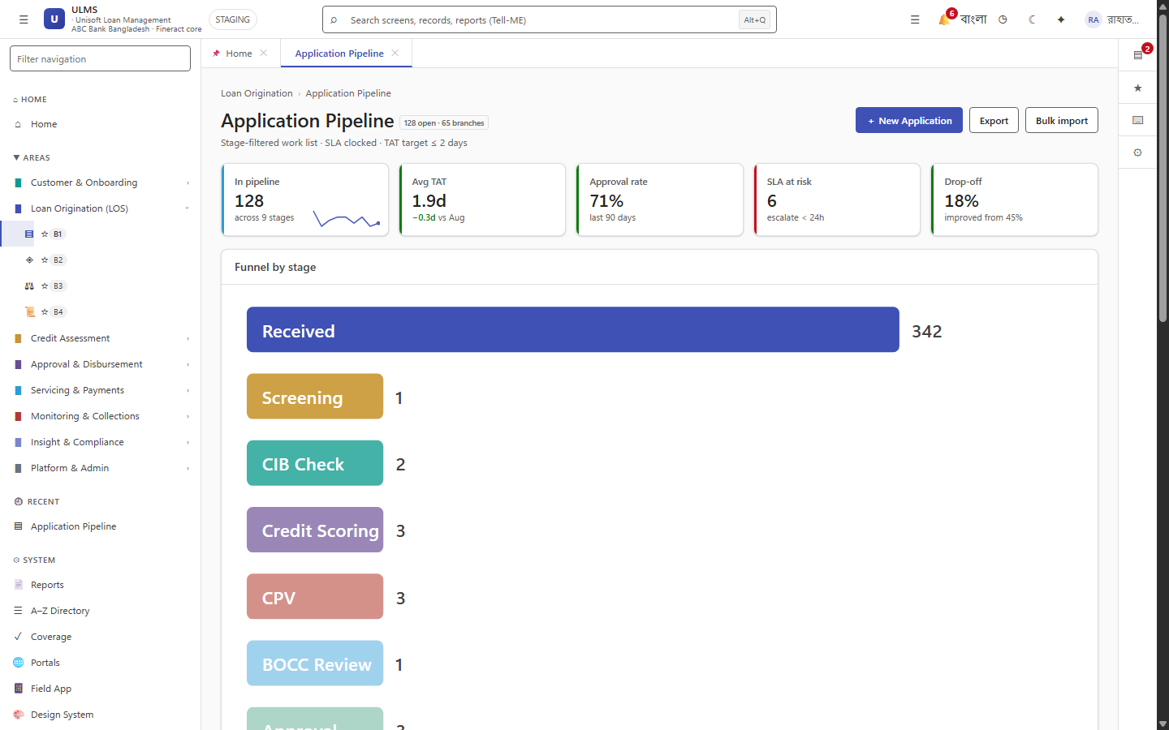
Figure 3: Production Approval Band Selection & Workflow State
Live view of loan application evaluation against configured approval bands.
Approval ladder escalation is managed in com.uslbd.ulms.approval.ApprovalService:
// Language: java
public ApprovalTier determineRequiredTier(long requestedAmountMinor, LoanProduct product) {
if (requestedAmountMinor <= 50_000_000_00L) { // 500,000 BDT
return ApprovalTier.LADDER_1;
} else if (requestedAmountMinor <= 250_000_000_00L) { // 2.5M BDT
return ApprovalTier.LADDER_2;
}
// Custom bank delegation tiers configured via ulms.approval_band
return approvalBandRepository.findByAmountRange(requestedAmountMinor);
}

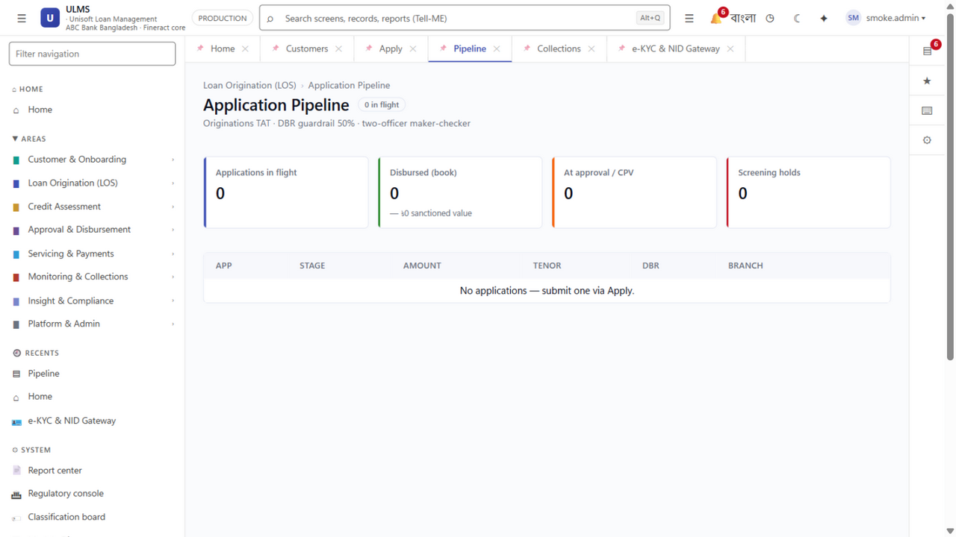
Figure 2: Credit Underwriting Pipeline Escalation Worklist
Multi-stage approval queues routing loans dynamically based on requested loan amount.

