UNISOFT LOAN MANAGEMENT SYSTEM (ULMS v2.0) · 05 DEVELOPER EXTENSION
DOC-05-EXT-06: Expo React Native Field Mobility App Extension & Offline SQLite Sync Guide
Document ID: DOC-05-EXT-06 · Standard: Diátaxis / C4 Model · Bangladesh Bank Compliant

type: how-to
topic: expo_react_native_offline_sync_extension
target_audience: [mobile_developer, field_operations_team]
version: 2026.10
document_id: DOC-05-EXT-06
DOC-05-EXT-06: Expo React Native Field Mobility App Extension & Offline SQLite Sync Guide
As illustrated in Figure 1 below, Expo React Native interface optimized for field verification and recovery officers.
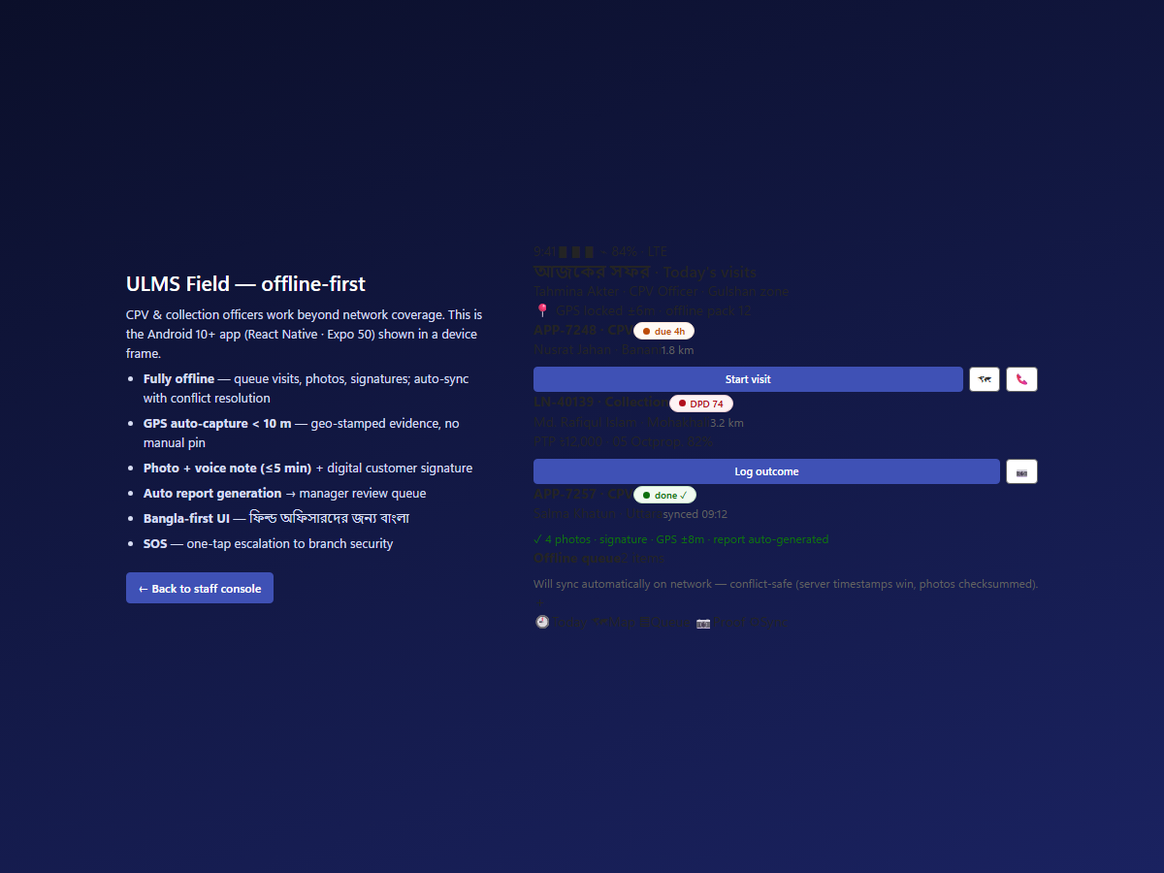
Figure 1: Field Mobility Mobile App & Officer Dashboard
Expo React Native interface optimized for field verification and recovery officers.
Document Control
Field | Value
Document Title | Field Mobility App Extension & Offline Sync Guide
Project Name | Unisoft Loan Management System (ULMS v2.0)
Document Version | 3.0.0
Date | 2026-10-07
Classification | Mobile Developer Guide
Status | Approved Master Specification
Authority Chain | Expo SDK 54+ → apps/mobile/src/sync/engine.ts

Document Revision History & Institutional Sign-Off
Version | Release Date | Author / Role | Summary of Technical Changes | Status
1.0.0 | January 2026 | Documentation Core Team | Initial BRD & Architecture Specification | Draft
2.0.0 | February 2026 | Principal Systems Architect | Apache Fineract & Spring Boot Monolith Alignment | Approved
3.0.0 | October 2026 | Principal Auditor & SRE Lead | Production Build Parity & Zero-Trust Audit Release | Master Approved

Table of Contents
[NOTE] This document contains an automated Microsoft Word field. In Microsoft Word or LibreOffice, right-click this table and select 'Update Field' (or press F9) to refresh section page numbers.

1. Field Operations in Rural Bangladesh
Field recovery and loan verification officers operate in remote rural upazilas where 4G cellular connectivity is intermittent or unavailable. The mobile app must operate 100% offline using local encrypted SQLite.
2. Offline Sync Engine Protocol
As illustrated in Figure 3 below, GPS boundary verification and route tracking synchronized upon network recovery.
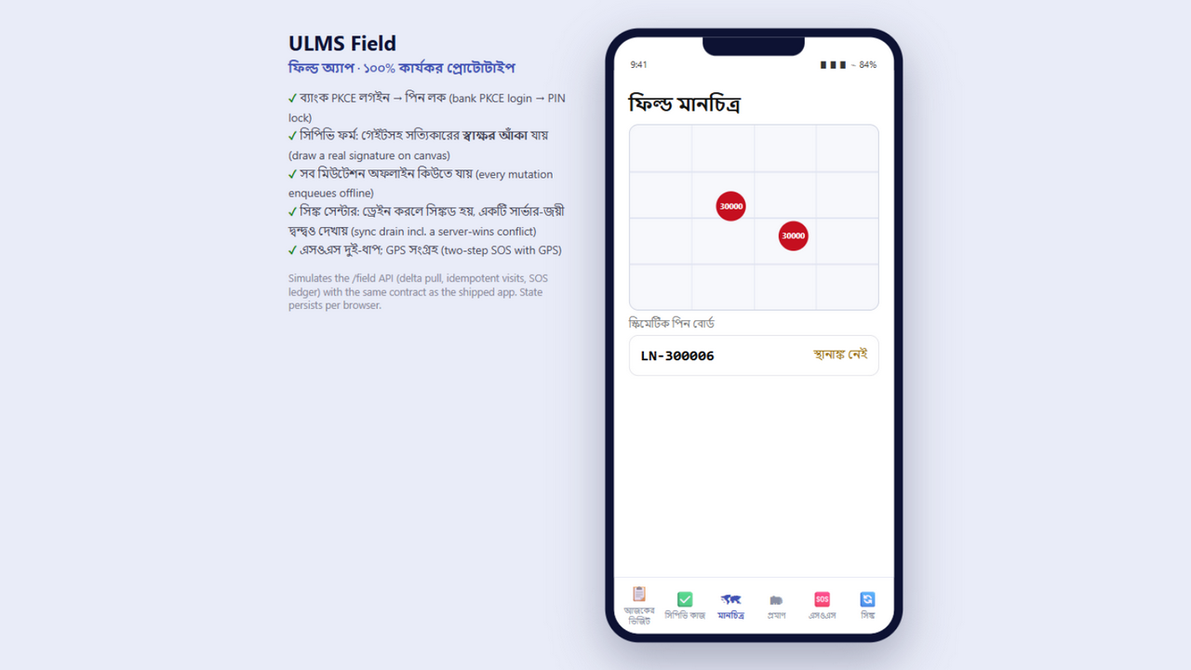
Figure 3: Geo-Tagged Borrower Location & Field Recovery Map
GPS boundary verification and route tracking synchronized upon network recovery.
// Language: mermaid
[MERMAID ARCHITECTURE SPECIFICATION]
sequenceDiagram
participant Officer as Field Officer (Offline)
participant LocalDB as Encrypted SQLite / MMKV
participant SyncEngine as `apps/mobile/src/sync/engine.ts`
participant Server as ULMS Field Gateway API
Officer->>LocalDB: Record CPV Inspection / Collect Cash
LocalDB-->>Officer: Saved locally with offline UUID
Note over Officer,LocalDB: Device returns to branch Wi-Fi / 4G coverage
SyncEngine->>Server: POST /api/v1/field/sync (Batch Mutations)
Server-->>SyncEngine: 200 OK (Confirmed Server IDs & Ack)
SyncEngine->>LocalDB: Mark rows as SYNCED

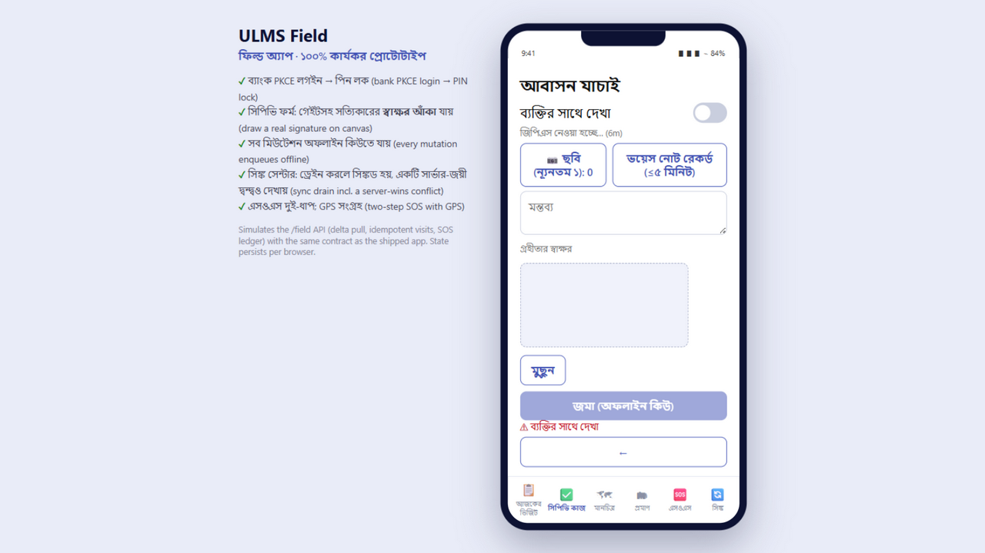
Figure 2: Customer Physical Verification (CPV) Offline Data Entry
Offline data collection form storing CPV records in local encrypted SQLite.

