UNISOFT LOAN MANAGEMENT SYSTEM (ULMS v2.0) · 05 DEVELOPER EXTENSION
DOC-05-EXT-07: Bangladesh Bank Regulatory Return XML/CSV Generation Extension Guide
Document ID: DOC-05-EXT-07 · Standard: Diátaxis / C4 Model · Bangladesh Bank Compliant

type: how-to
topic: regulatory_return_xml_csv_generation
target_audience: [backend_developer, compliance_developer, reporting_analyst]
version: 2026.10
document_id: DOC-05-EXT-07
DOC-05-EXT-07: Bangladesh Bank Regulatory Return XML/CSV Generation Extension Guide
As illustrated in Figure 1 below, Central reporting hub for scheduled commercial bank statutory returns.
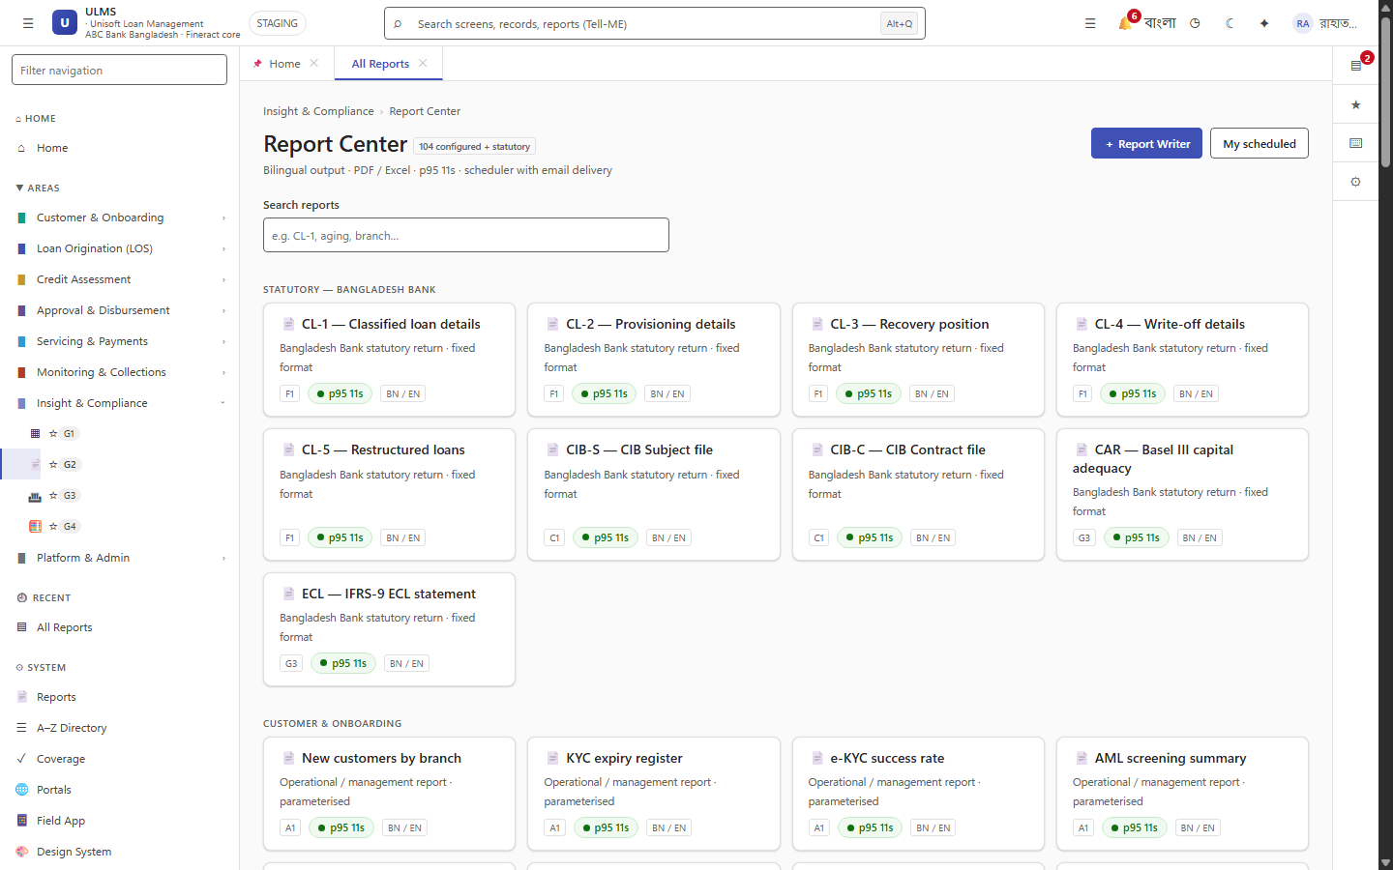
Figure 1: Bangladesh Bank Regulatory Returns & MIS Reporting Center
Central reporting hub for scheduled commercial bank statutory returns.
Document Control
Field | Value
Document Title | Regulatory Return XML/CSV Generation Extension Guide
Project Name | Unisoft Loan Management System (ULMS v2.0)
Document Version | 3.0.0
Date | 2026-10-07
Classification | Statutory Developer Guide
Status | Approved Master Specification
Authority Chain | Bangladesh Bank Regcon Guidelines → BRPD Circular 15/2024

Document Revision History & Institutional Sign-Off
Version | Release Date | Author / Role | Summary of Technical Changes | Status
1.0.0 | January 2026 | Documentation Core Team | Initial BRD & Architecture Specification | Draft
2.0.0 | February 2026 | Principal Systems Architect | Apache Fineract & Spring Boot Monolith Alignment | Approved
3.0.0 | October 2026 | Principal Auditor & SRE Lead | Production Build Parity & Zero-Trust Audit Release | Master Approved

Table of Contents
[NOTE] This document contains an automated Microsoft Word field. In Microsoft Word or LibreOffice, right-click this table and select 'Update Field' (or press F9) to refresh section page numbers.

1. Regulatory Reporting Architecture
Bangladesh Bank mandates quarterly and monthly returns in strict XML and CSV formats (SBS-1, SBS-2, SBS-3, CIB Monthly, and BRPD CL-1 to CL-5).
ULMS provides the RegulatoryReportBuilder interface:
// Language: java
package com.uslbd.ulms.compliance.reports;
public interface RegulatoryReportBuilder {
ReportMetadata getMetadata();
byte[] generateReport(LocalDate reportingPeriod, ReportFormat format);
ValidationResult validateAgainstXsd(byte[] payload);
}

2. Adding a New Return (e.g. SBS-3 SME Portfolio Return)
As illustrated in Figure 2 below, Real-time aggregation of loan portfolios into BRPD Circular 15/2024 CL tables.
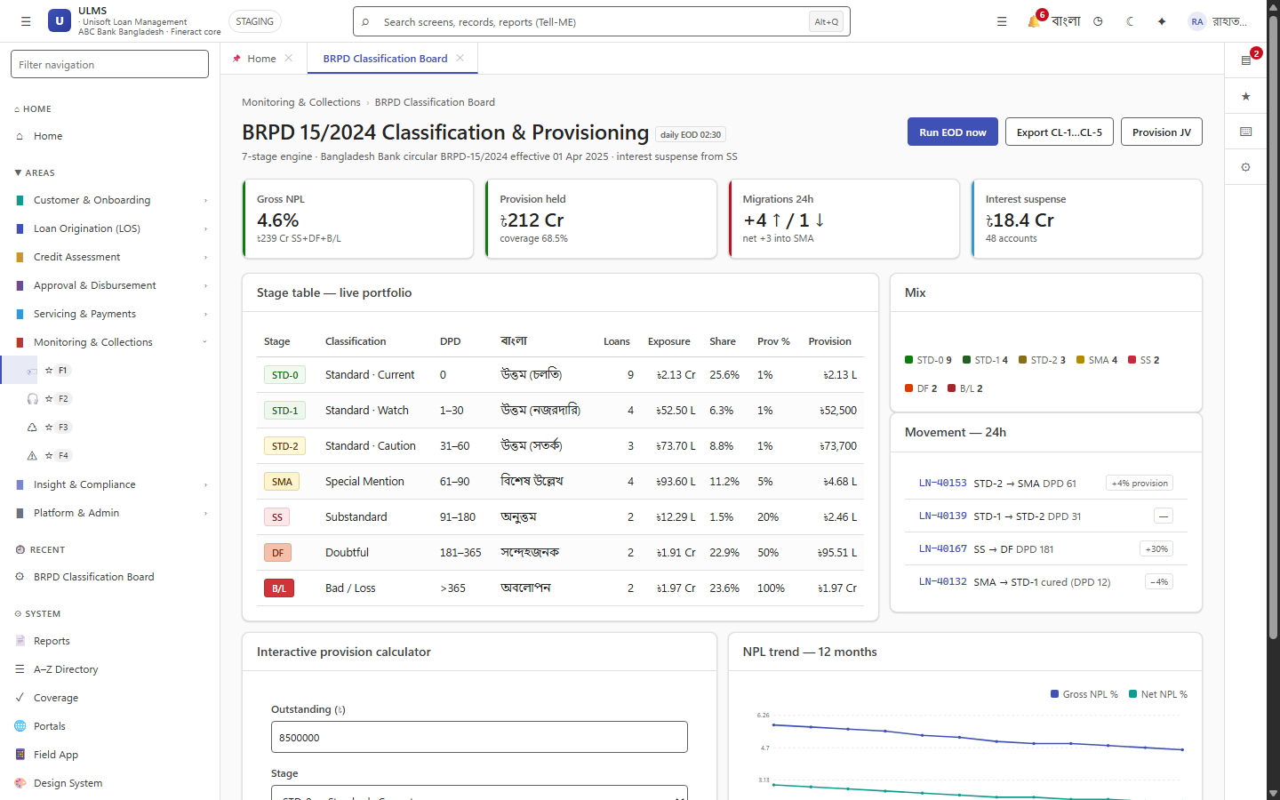
Figure 2: Statutory 7-Stage Classification Reporting Board
Real-time aggregation of loan portfolios into BRPD Circular 15/2024 CL tables.
1. Implement Sbs3ReportBuilder.java in com.uslbd.ulms.compliance.reports.
2. Extract aggregated loan exposure by industrial sector from ulms.loan.
3. Format output adhering to BB Regcon XML Schema Definition (XSD).
4. Register report definition in ulms.loan_product.
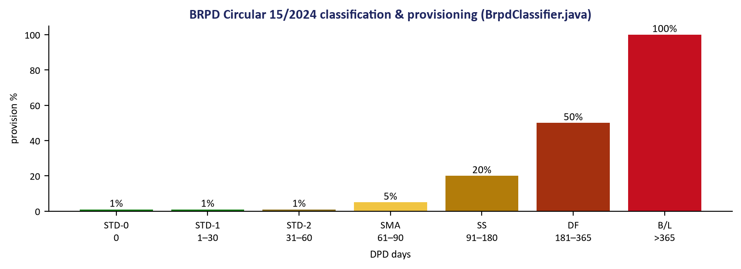
Figure 3: Bangladesh Bank Statutory Calculation Decision Matrix
Authoritative schema rules driving XML return payload generation and XSD validation.

