UNISOFT LOAN MANAGEMENT SYSTEM (ULMS v2.0) · 06 QUALITY ASSURANCE
DOC-06-QA-02: Security Hardening, SAST/DAST & OWASP ASVS Verification Specification
Document ID: DOC-06-QA-02 · Standard: Diátaxis / C4 Model · Bangladesh Bank Compliant

type: reference
topic: security_hardening_sast_dast_owasp_asvs
target_audience: [security_lead, penetration_tester, compliance_auditor]
version: 2026.10
document_id: DOC-06-QA-02
DOC-06-QA-02: Security Hardening, SAST/DAST & OWASP ASVS Verification Specification
As illustrated in Figure 1 below, Level 2 compliance verifying credential defense, MFA, and brute-force lockout protections.
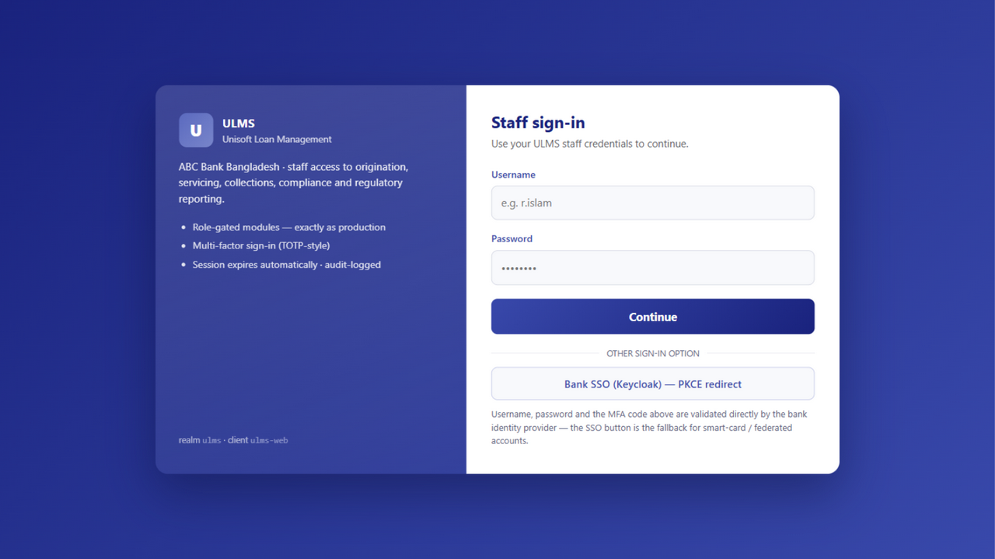
Figure 1: OWASP ASVS Verified Staff Authentication Portal
Level 2 compliance verifying credential defense, MFA, and brute-force lockout protections.
Document Control
Field | Value
Document Title | Security Hardening & OWASP ASVS Specification
Project Name | Unisoft Loan Management System (ULMS v2.0)
Document Version | 3.0.0
Date | 2026-10-07
Classification | Information Security Specification
Status | Approved Master Specification
Authority Chain | OWASP ASVS v4.0.3 Level 2 → BB ICT Security Guidelines V4.0 §5.0

Document Revision History & Institutional Sign-Off
Version | Release Date | Author / Role | Summary of Technical Changes | Status
1.0.0 | January 2026 | Documentation Core Team | Initial BRD & Architecture Specification | Draft
2.0.0 | February 2026 | Principal Systems Architect | Apache Fineract & Spring Boot Monolith Alignment | Approved
3.0.0 | October 2026 | Principal Auditor & SRE Lead | Production Build Parity & Zero-Trust Audit Release | Master Approved

Table of Contents
[NOTE] This document contains an automated Microsoft Word field. In Microsoft Word or LibreOffice, right-click this table and select 'Update Field' (or press F9) to refresh section page numbers.

1. OWASP ASVS Level 2 Verification Matrix
ASVS Area | Standard Requirement | ULMS Implementation | Verification Tool
V1 Architecture | Secure architecture and trust boundaries | Spring Modulith boundary rules | ArchUnit & ModularityTest
V2 Authentication | Strong credentials and MFA | Keycloak 26 OIDC with WebAuthn/TOTP | ZAP DAST Scanner
V3 Session Mgmt | Secure cookies and token timeout | Stateless JWT, 15m access token expiry | Burp Suite
V4 Access Control | Object-level authorization | Spring @PreAuthorize("hasRole(...)") | SonarQube SAST
V5 Cryptography | Strong encryption in transit and rest | TLS 1.3, AES-256 for PII/collateral | Trivy Container Scan

2. Continuous SAST/DAST Verification Gates
As illustrated in Figure 3 below, Continuous security pipeline blocking high-severity CVEs and code vulnerabilities.
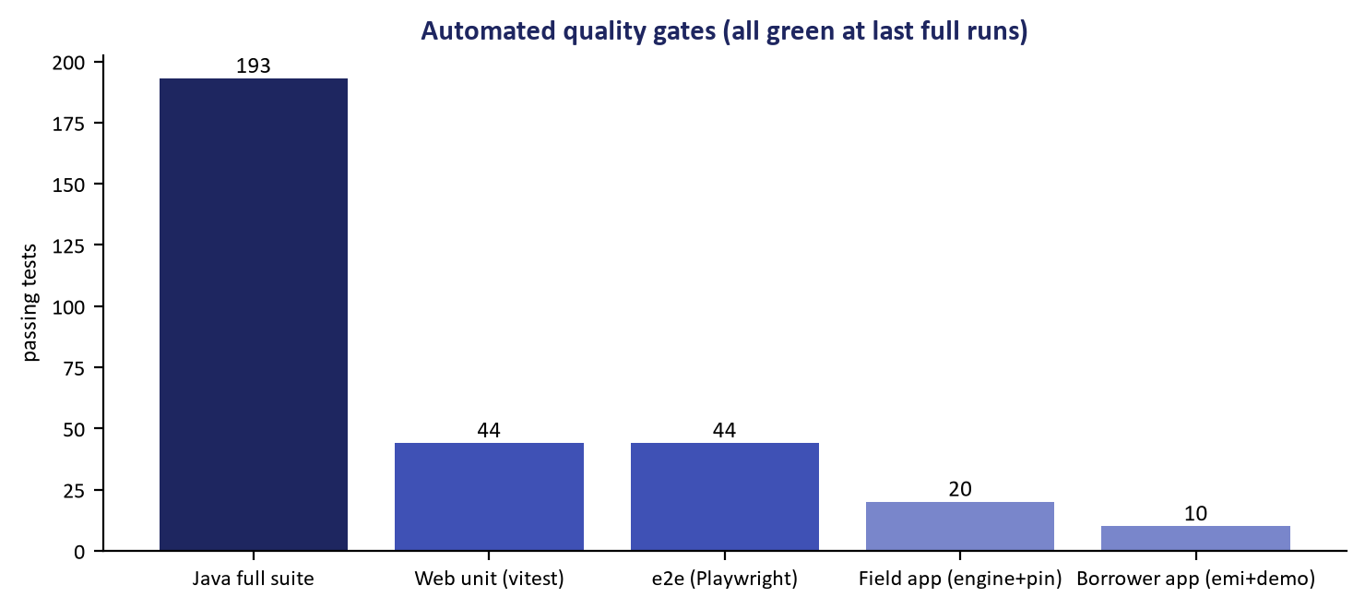
Figure 3: Automated SAST, DAST & Dependency Security Gates
Continuous security pipeline blocking high-severity CVEs and code vulnerabilities.
In every CI pipeline:
• SonarQube SAST: Zero blocker, critical, or high security bugs.
• OWASP Dependency-Check: Zero dependencies with CVSS score $\ge 7.0$.
• Trivy Container Scanner: Zero vulnerabilities in base Alpine Linux OS packages.
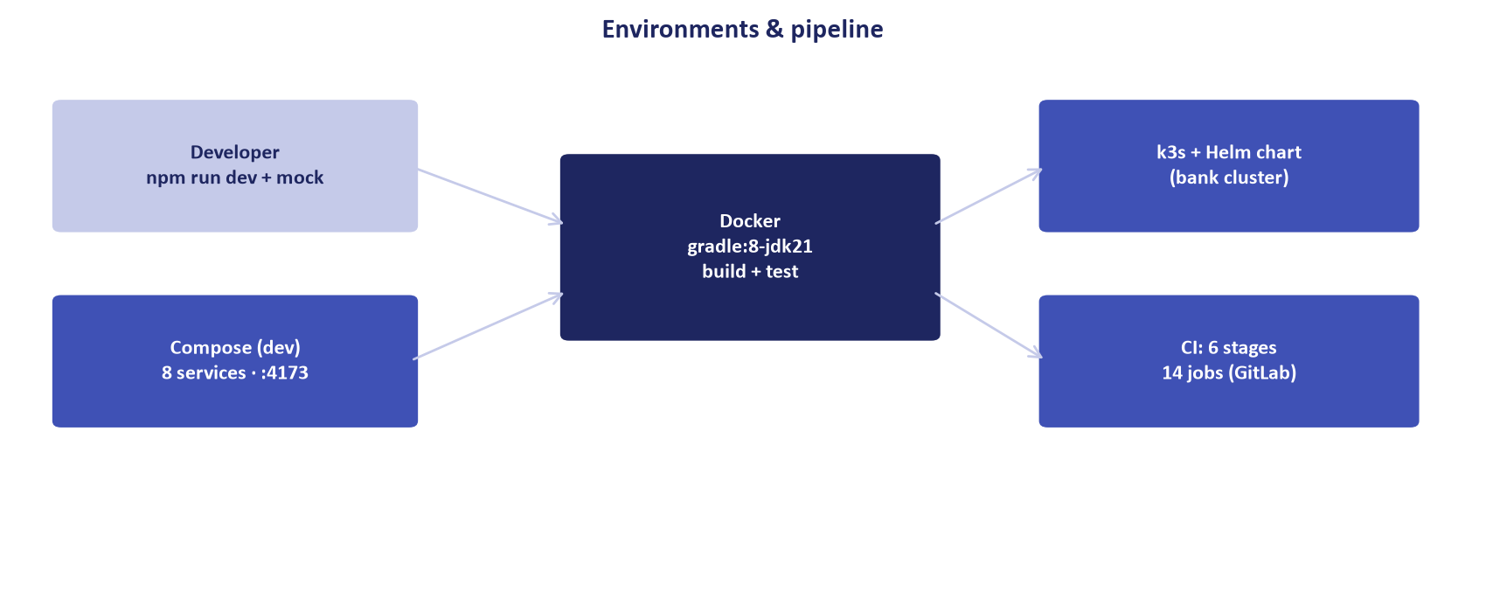
Figure 2: Hardened Network Perimeter & Least-Privilege Architecture
Network zoning, TLS 1.3 encryption, and AES-256 data-at-rest security guarantees.

