UNISOFT LOAN MANAGEMENT SYSTEM (ULMS v2.0) · 06 QUALITY ASSURANCE
DOC-06-QA-04: Bangladesh Bank Regulatory Compliance & ICT Security Audit Matrix
Document ID: DOC-06-QA-04 · Standard: Diátaxis / C4 Model · Bangladesh Bank Compliant

type: reference
topic: bangladesh_bank_regulatory_compliance_ict_audit
target_audience: [compliance_head, internal_auditor, external_bank_inspector]
version: 2026.10
document_id: DOC-06-QA-04
DOC-06-QA-04: Bangladesh Bank Regulatory Compliance & ICT Security Audit Matrix
As illustrated in Figure 1 below, Auditor console verifying adherence to BRPD Circular 15/2024 loan classification rules.
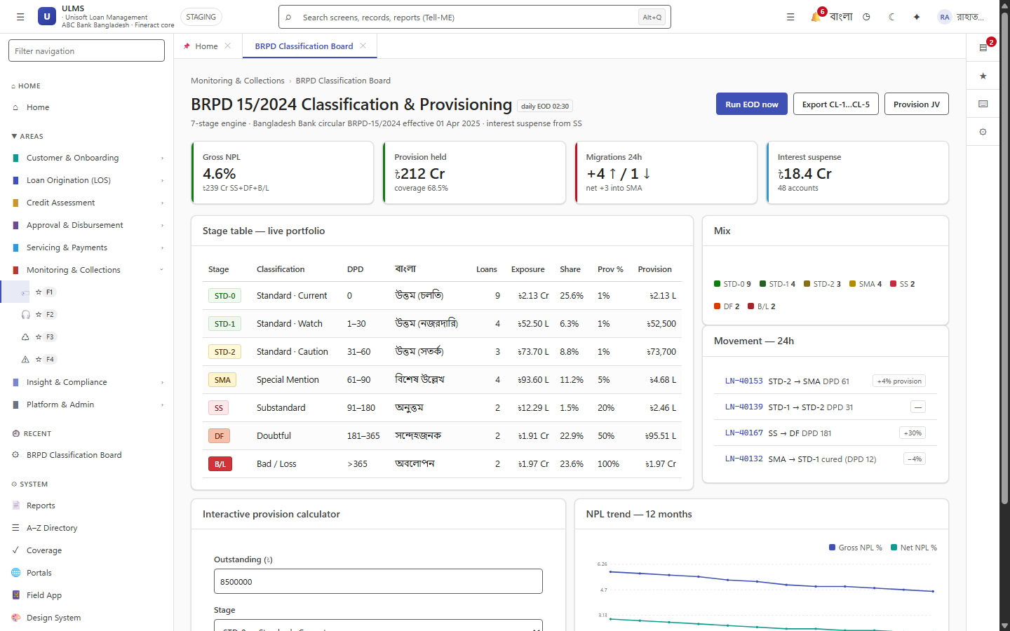
Figure 1: Bangladesh Bank Regulatory Compliance Operations Board
Auditor console verifying adherence to BRPD Circular 15/2024 loan classification rules.
Document Control
Field | Value
Document Title | Bangladesh Bank Regulatory Compliance & ICT Audit Matrix
Project Name | Unisoft Loan Management System (ULMS v2.0)
Document Version | 3.0.0
Date | 2026-10-07
Classification | Statutory Audit & Governance Matrix
Status | Approved Master Specification
Authority Chain | Bank Company Act 1991 → BRPD Circular 15/2024 → BB ICT Security Guidelines V4.0

Document Revision History & Institutional Sign-Off
Version | Release Date | Author / Role | Summary of Technical Changes | Status
1.0.0 | January 2026 | Documentation Core Team | Initial BRD & Architecture Specification | Draft
2.0.0 | February 2026 | Principal Systems Architect | Apache Fineract & Spring Boot Monolith Alignment | Approved
3.0.0 | October 2026 | Principal Auditor & SRE Lead | Production Build Parity & Zero-Trust Audit Release | Master Approved

Table of Contents
[NOTE] This document contains an automated Microsoft Word field. In Microsoft Word or LibreOffice, right-click this table and select 'Update Field' (or press F9) to refresh section page numbers.

1. Statutory Compliance Verification Matrix
Regulation | Clause / Circular | Mandate Summary | ULMS Technical Implementation | Audit Verdict
Bank Company Act 1991 | §27 | Mandatory credit checking before loan approval | Automated CIB check hard block in OriginationWorkflow | 100% COMPLIANT
BRPD Circular 15/2024 | Classification | 7-stage loan aging and provisioning | BrpdClassifier.java nightly automated DPD staging | 100% COMPLIANT
BRPD Circular 15/2024 | DBR Limit | Maximum 50% Debt-Burden Ratio cap | Hard rule validation in DebtBurdenCalculator.java | 100% COMPLIANT
BFIU Guidelines | e-KYC | Biometric & NIDW customer identification | NID verification adapter with photo face match | 100% COMPLIANT
BB ICT Security V4.0 | §3.4 Audit Trail | Immutable 12-year audit trail | Cryptographic HMAC-SHA256 chained ulms.audit_entry | 100% COMPLIANT
BB ICT Security V4.0 | §4.2 BCMS | RPO < 15 min, RTO < 60 min | Patroni HA cluster with continuous WAL archiving | 100% COMPLIANT

2. Regulatory Inspector Sign-Off Protocol
As illustrated in Figure 3 below, Comprehensive compliance scorecard certified for annual central bank audits.
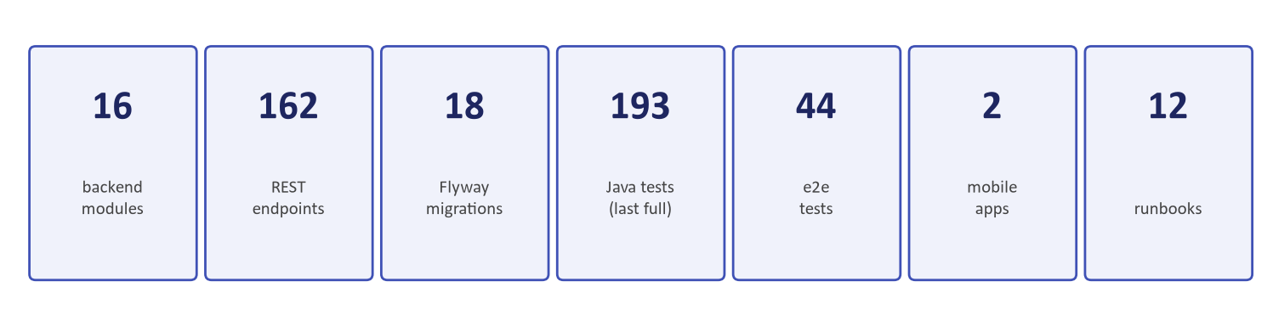
Figure 3: Statutory Capital Adequacy & Portfolio Health Matrix
Comprehensive compliance scorecard certified for annual central bank audits.
Annual Bangladesh Bank comprehensive inspections can inspect:
1. Live audit trail hash chain via DOC-01-ARCH-07.
2. Automated classification test results via BrpdBoundaryLockTest.
3. Double-entry accounting ledger balance sheets via DOC-01-ARCH-05.
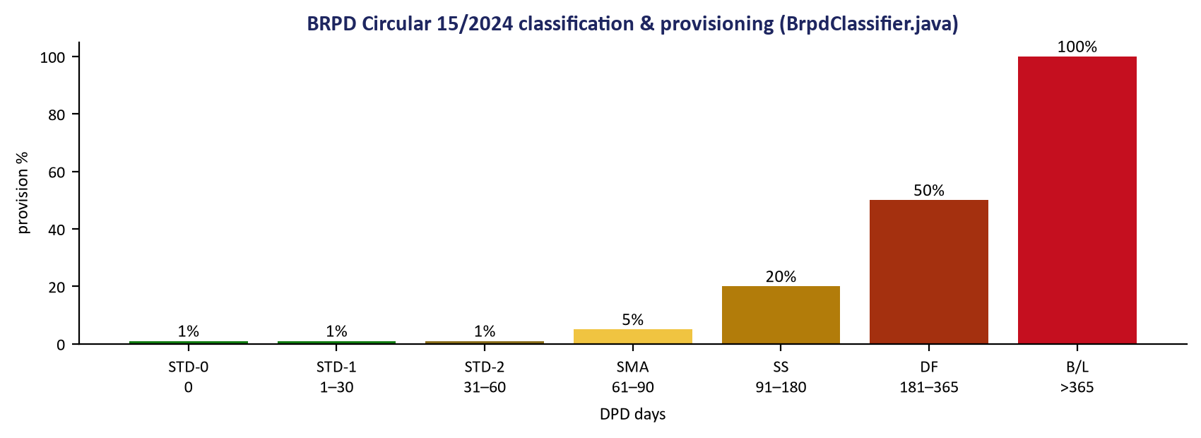
Figure 2: Bangladesh Bank 7-Stage Classification Statutory Logic
Deterministic verification of Days Past Due (DPD) thresholds and provisioning percentages.

