UNISOFT LOAN MANAGEMENT SYSTEM (ULMS v2.0) · 02 TROUBLESHOOTING
DOC-02-TS-07: Payment Gateway Webhook Storms & Double-Posting Reconciliation Runbook
Document ID: DOC-02-TS-07 · Standard: Diátaxis / C4 Model · Bangladesh Bank Compliant

type: how-to
topic: webhook_storms_duplicate_posting
target_audience: [backend_engineer, sre, treasury_officer]
version: 2026.10
document_id: DOC-02-TS-07
DOC-02-TS-07: Payment Gateway Webhook Storms & Double-Posting Reconciliation Runbook
As illustrated in Figure 1 below, High-frequency repayment notifications received from external payment aggregators.
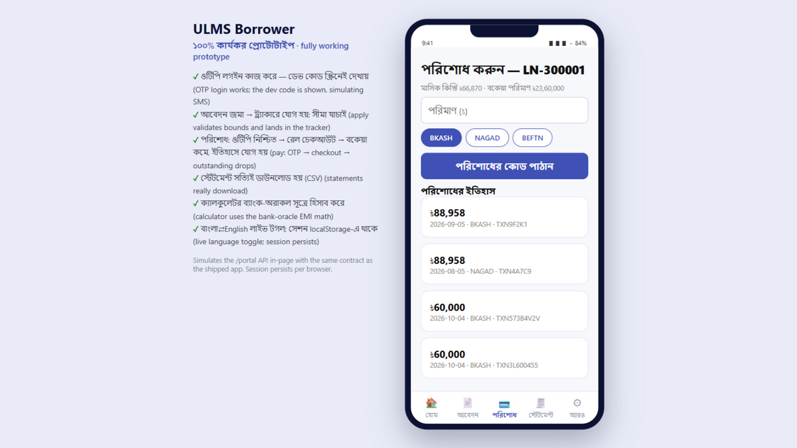
Figure 1: MFS Digital Repayment Channel & Gateway Webhook Receiver
High-frequency repayment notifications received from external payment aggregators.
Document Control
Field | Value
Document Title | Payment Gateway Webhook Storms & Double-Posting Diagnostics
Project Name | Unisoft Loan Management System (ULMS v2.0)
Document Version | 3.0.0
Date | 2026-10-07
Classification | Operational Troubleshooting Runbook
Status | Approved Master Specification
Authority Chain | DOC-01-ARCH-03 → com.uslbd.ulms.integration.rails

Document Revision History & Institutional Sign-Off
Version | Release Date | Author / Role | Summary of Technical Changes | Status
1.0.0 | January 2026 | Documentation Core Team | Initial BRD & Architecture Specification | Draft
2.0.0 | February 2026 | Principal Systems Architect | Apache Fineract & Spring Boot Monolith Alignment | Approved
3.0.0 | October 2026 | Principal Auditor & SRE Lead | Production Build Parity & Zero-Trust Audit Release | Master Approved
3.1.0 | October 2026 | Independent Forensic Re-audit | Factual corrections per audit/docx_forensic_audit_2026-10-08.md | Applied

Table of Contents
[NOTE] This document contains an automated Microsoft Word field. In Microsoft Word or LibreOffice, right-click this table and select 'Update Field' (or press F9) to refresh section page numbers.

1. Problem Statement
When an MFS rail (bKash/Nagad) experiences upstream latency, its notification engine may retry payment webhook delivery dozens of times within seconds. Without strict idempotency, this causes:
• Duplicate loan installment credits to the same account.
• Over-collection leading to negative outstanding balances.
• Thread starvation on POST /api/v1/loans/payments/reconcile.
2. Invariant Protection Machinery
ULMS guarantees zero duplicate credits via database-level unique constraints in ulms.payment:
// Language: sql
-- Unique constraint preventing duplicate processing of external transaction IDs
ALTER TABLE ulms.payment
ADD CONSTRAINT uk_payment_external_tx_ref UNIQUE (payment_rail, external_tx_ref);

When a duplicate webhook hits the controller:
1. RailWebhookHandler checks existence of external_tx_ref.
2. Verify the HMAC signature (ULMS_RAILS_WEBHOOK_SECRET) and timestamp drift BEFORE any response — reject invalid signatures with 401. If valid and already processed, respond with HTTP 200 OK (so the rail ceases retries) without re-executing ledger posting.
3. If concurrent requests arrive simultaneously, the second transaction is aborted with a PostgreSQL unique violation and gracefully swallowed.
3. Discrepancy Resolution Protocol
As illustrated in Figure 3 below, Accurate installment credit and fee allocation with zero duplicate ledger postings.
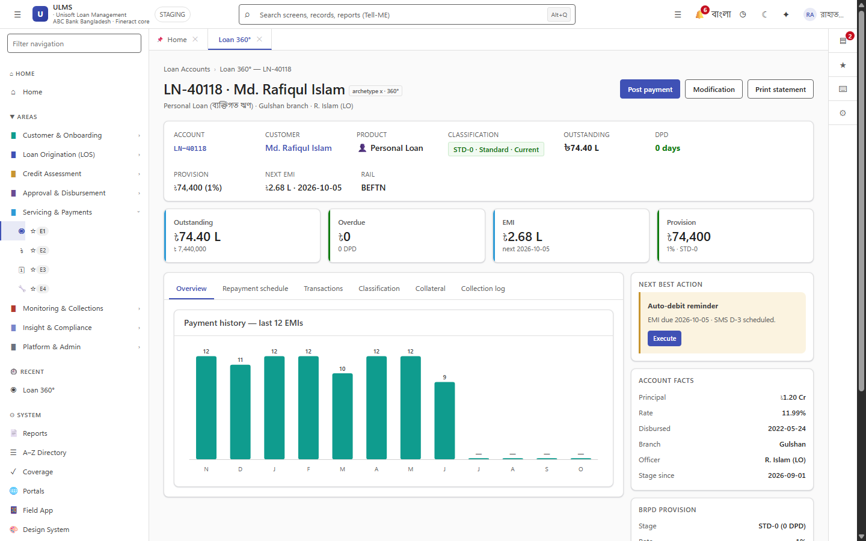
Figure 3: Loan Servicing Ledger Reconciled Following Webhook Ingestion
Accurate installment credit and fee allocation with zero duplicate ledger postings.
If an upstream gateway sends conflicting amounts under the same transaction ID:
1. Lock affected account temporarily: -- no locked column on ulms.loan; serialize via SELECT ... FOR UPDATE on the loan row plus the idempotency_key table.
2. Inspect payment rail logs: SELECT * FROM ulms.payment WHERE external_tx_ref = :ref.
3. Run treasury adjustment journal voucher via FineractJournalPort.
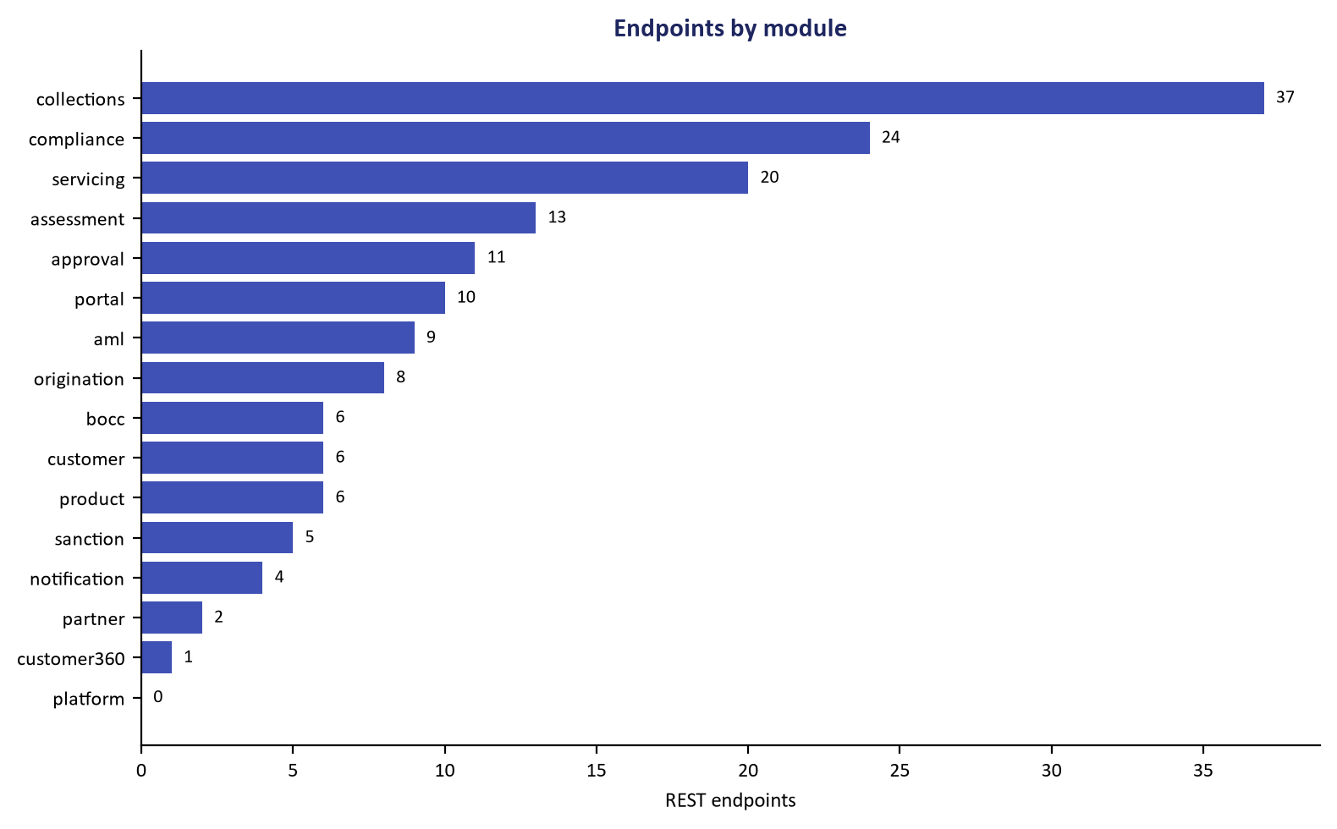
Figure 2: Webhook Endpoint Specification & Idempotency Key Protection
RFC 9457 contract specifications enforcing unique external transaction reference locks.
Addendum — v3.1.0 corrections (Independent Forensic Re-audit, 8 October 2026)
Corrections (v3.1.0): webhook handling now verifies the HMAC signature and timestamp drift before any 200 ACK (the verifier fails closed when ULMS_RAILS_WEBHOOK_SECRET is unset); the nonexistent ulms.loan.locked column replaced with row-level locking via SELECT ... FOR UPDATE + the idempotency_key table. The POST /api/v1/loans/payments/reconcile route cited here is the contract-verified canonical (per the corpus audit GAP-05 alignment).

