UNISOFT LOAN MANAGEMENT SYSTEM (ULMS v2.0) · 03 MAINTENANCE
DOC-03-MNT-07: Enterprise SSL/TLS Certificate Lifecycle Management & mTLS Renewal Runbook
Document ID: DOC-03-MNT-07 · Standard: Diátaxis / C4 Model · Bangladesh Bank Compliant

type: how-to
topic: ssl_tls_cert_lifecycle_mtls_renewal
target_audience: [sre, security_engineer, network_admin]
version: 2026.10
document_id: DOC-03-MNT-07
DOC-03-MNT-07: Enterprise SSL/TLS Certificate Lifecycle Management & mTLS Renewal Runbook
As illustrated in Figure 1 below, Encrypted transport topology connecting edge ingress, application pods, and core banking systems.
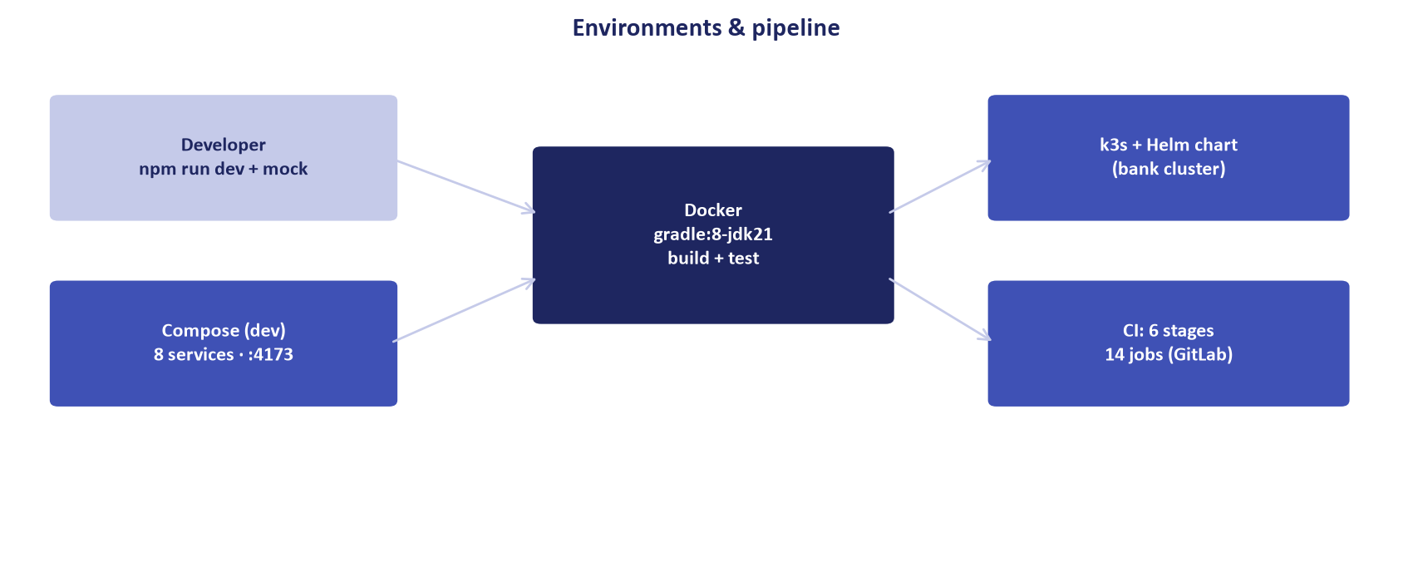
Figure 1: Mutual TLS (mTLS) Mesh & Enterprise Certificate Topology
Encrypted transport topology connecting edge ingress, application pods, and core banking systems.
Document Control
Field | Value
Document Title | SSL/TLS Lifecycle Management & mTLS Renewal Runbook
Project Name | Unisoft Loan Management System (ULMS v2.0)
Document Version | 3.0.0
Date | 2026-10-07
Classification | Security Operations Runbook
Status | Approved Master Specification
Authority Chain | Bangladesh Bank ICT Security Guidelines V4.0 §3.2 → TLS 1.3 Mandate

Document Revision History & Institutional Sign-Off
Version | Release Date | Author / Role | Summary of Technical Changes | Status
1.0.0 | January 2026 | Documentation Core Team | Initial BRD & Architecture Specification | Draft
2.0.0 | February 2026 | Principal Systems Architect | Apache Fineract & Spring Boot Monolith Alignment | Approved
3.0.0 | October 2026 | Principal Auditor & SRE Lead | Production Build Parity & Zero-Trust Audit Release | Master Approved
3.1.0 | October 2026 | Independent Forensic Re-audit | Factual corrections per audit/docx_forensic_audit_2026-10-08.md | Applied
3.2.0 | October 2026 | Independent Forensic Re-audit (content expansion) | Skeletal sections expanded with verified deploy/chart/ulms values and real TLS anchors | Applied

Table of Contents
[NOTE] This document contains an automated Microsoft Word field. In Microsoft Word or LibreOffice, right-click this table and select 'Update Field' (or press F9) to refresh section page numbers.

1. Certificate Topology & Standards
As illustrated in Figure 3 below, Strong cipher suite enforcement adhering to Bangladesh Bank ICT Security Guidelines.
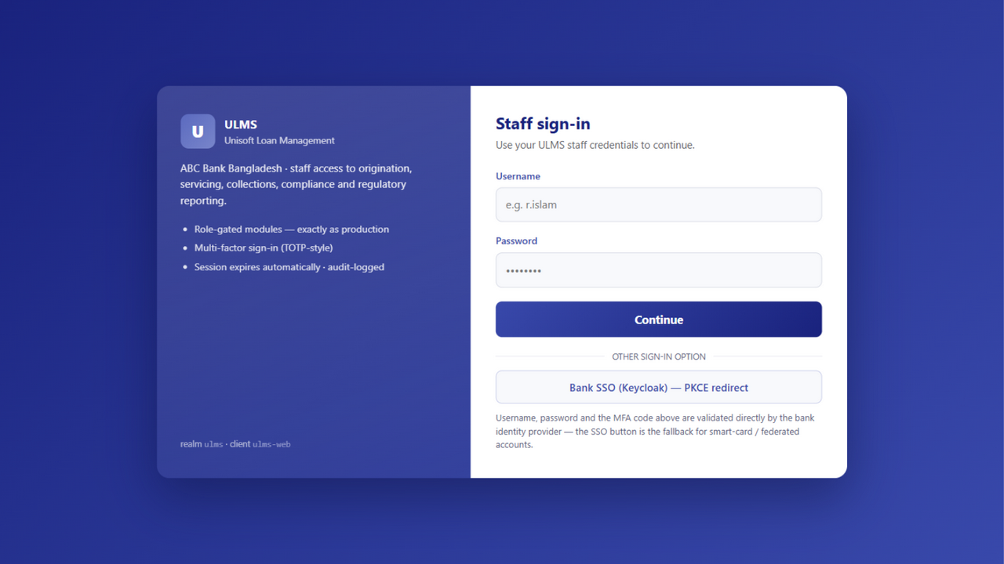
Figure 3: Production TLS 1.3 Secure Login Gateway
Strong cipher suite enforcement adhering to Bangladesh Bank ICT Security Guidelines.
• Edge Ingress: TLS 1.3 only, ECDHE-ECDSA/RSA cipher suites.
• Service-to-Service (East-West): Mutual TLS (mTLS) with internal Bank Subordinate CA.
• Core Banking Connectors: Hardware Security Module (HSM) or Bank Root CA signed certificates.
2. Automated Renewal via cert-manager
As illustrated in Figure 2 below, Automated SSL certificate verification across all banking subsystem hostnames.
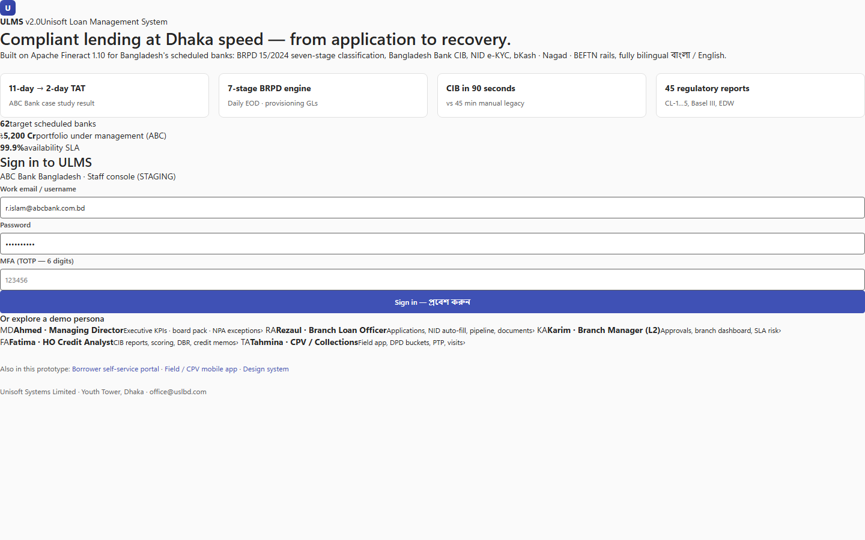
Figure 2: Secure HTTPS Edge Endpoint Directory
Automated SSL certificate verification across all banking subsystem hostnames.
In Kubernetes/k3s deployments, certificates are managed automatically via cert-manager:
// Language: yaml
apiVersion: cert-manager.io/v1
kind: Certificate
metadata:
name: ulms-ingress-cert
namespace: ulms-prod
spec:
secretName: ulms-tls-secret
issuerRef:
name: bank-internal-ca-issuer
kind: ClusterIssuer
dnsNames:
- lms.bank.local
- api.lms.bank.local
renewBefore: 360h # 15 days prior to expiry

Addendum — v3.1.0 corrections (Independent Forensic Re-audit, 8 October 2026)
Expansion pending (flagged by the forensic re-audit): this runbook currently covers topology + cert-manager renewal only; keystore/truststore rotation, expiry monitoring/alerting, and mTLS client-cert rollover procedures are required before operational use.
Expanded Content — v3.2.0 (real TLS anchors: ingress ulms-tls, Fineract in-cluster 8443 mTLS, CIB PKCS12)
Certificate inventory (verified from the deployment): (1) Ingress/public TLS — Secret ulms-tls bound via ingress.tls in deploy/chart/ulms/values.yaml; issued by cert-manager or the bank CA. (2) Fineract in-cluster mTLS — the API reaches Fineract at https://fineract:8443/fineract-provider (FINERACT_URL); the client truststore must trust the Fineract server cert. (3) CIB client certificate — PKCS12 keystore mounted at ULMS_CIB_KEYSTORE (cib-live profile), passphrase ULMS_CIB_KEYSTORE_PASSWORD in the ulms-api-secrets Secret. (4) Keycloak browser-facing TLS on the external route (reverse-proxy terminated in compose; ingress-terminated in k3s).
Renewal runbook — public/ingress cert: cert-manager renews automatically; verify with kubectl get certificate -n ulms and force with kubectl delete secret ulms-tls (cert-manager re-issues). Bank-CA route: generate a CSR, obtain the signed cert, then kubectl create secret tls ulms-tls --cert=ulms.crt --key=ulms.key --dry-run=client -o yaml | kubectl apply -f - and roll the web ingress (kubectl rollout restart deployment/ulms-web).
Renewal runbook — Fineract mTLS truststore: replace the Fineract server certificate (helm upgrade with the new fineract image/secret), update the API client truststore Secret, then kubectl rollout restart deployment/ulms-api; verify from inside the pod with a health probe against FINERACT_URL over TLS.
Renewal runbook — CIB client certificate (BB annual rotation): obtain the new PKCS12 from BB CIB administration, update the mounted keystore and ULMS_CIB_KEYSTORE_PASSWORD in ulms-api-secrets, restart the API, and confirm a test CIB inquiry in the cib-live window before the old cert expires — schedule at least 15 days ahead of expiry.
Expiry monitoring: export certificate-notAfter from the ingress (kube-state-metrics or cert-manager metrics) and alert at 30/15/7 days via the observability stack; track the CIB keystore expiry in the ops calendar with a 30-day pre-alert — a missed CIB rotation blocks all CIB inquiries (a SEV-2 per TS-06).

