UNISOFT SYSTEMS LIMITED · A SUBSIDIARY OF SMART TECHNOLOGIES BD LTD
Competitive Battlecard - ULMS v2.0 vs. Nucleus Software FinnOne Neo
Commercial Banking Documentation · Document Ref: DOC-13-BAT-03

Document Identifier | Release Version | Security Classification | Publication Date | Target Audience
DOC-13-BAT-03 | 2.0.0 | Confidential Internal Sales Enablement | 2026-10-08 | [account_executive, solution_architect, sales_director, pre_sales_engineer]

Competitive Battlecard: ULMS v2.0 vs. Nucleus Software FinnOne Neo

Head-to-Head Competitive Intelligence, Cross-Border Vulnerabilities & Differentiation Playbook
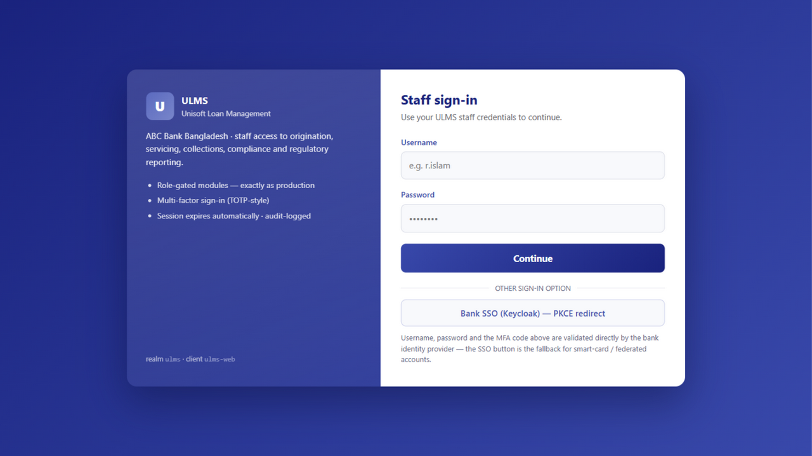
Figure 1: Sovereign Security — Local Biometric Authentication & Zero Offshore Data Transmission
Document Identifier: DOC-13-BAT-03
Target Competitor: Nucleus Software Exports Limited (FinnOne Neo Lending Suite)
Author: Lead Competitive Intelligence Architect & Head of Banking Strategy
Publisher: Unisoft Systems Limited (A Subsidiary of Smart Technologies BD Ltd)
Classification: Strictly Confidential — Internal Sales Team Only

1. Executive Competitor Profile
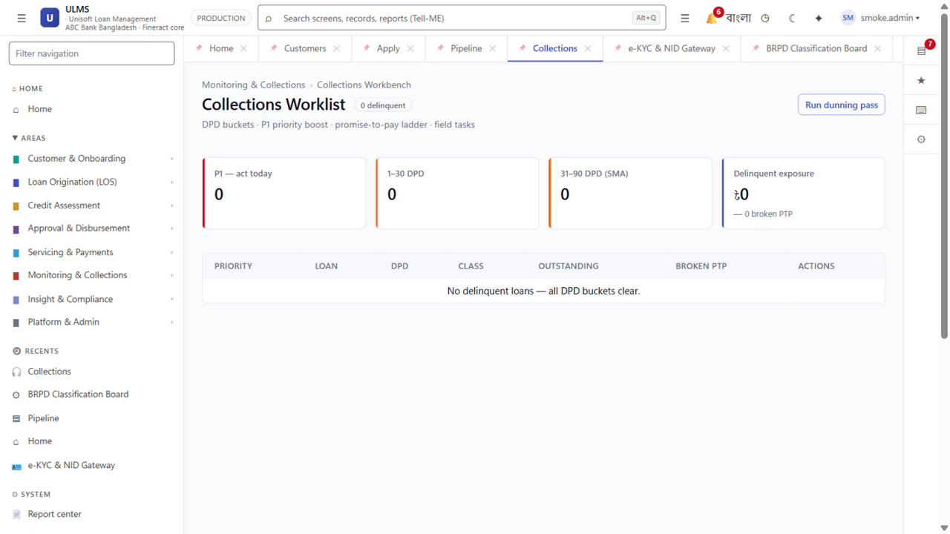
Figure 2: Operations Advantage — Real-Time DPD Bucket Tracking & Local Recovery Rails
Parameter | Nucleus Software FinnOne Neo | Unisoft ULMS v2.0
Headquarters & Origin | Noida, India | Dhaka, Bangladesh (Smart Technologies Group)
Bangladesh Footprint | Several NBFIs & Private Commercial Banks | 150+ Enterprise Deployments, National Banking Footprint
Primary Architecture | Proprietary Java EE Monolith, Oracle DB Dependent | Modular Monolith (Spring Boot 4, PostgreSQL 17, React 19)
Pricing & Currency | USD Denominated ($1.2M – $2.5M USD) | 100% BDT Denominated (BDT 4.00 Crore Turnkey)
Cross-Border Tax Burden | 20% Withholding Tax (WHT) + Cross-border Remittance Friction | 100% Domestic Billing; 0% Cross-Border Tax Penalties
Local Presence | Small liaison office / remote flying engineers | Dedicated 40+ Person Engineering HQ in Begum Rokeya Sarani, Dhaka

2. Competitor Strengths (Where FinnOne Neo Excels)
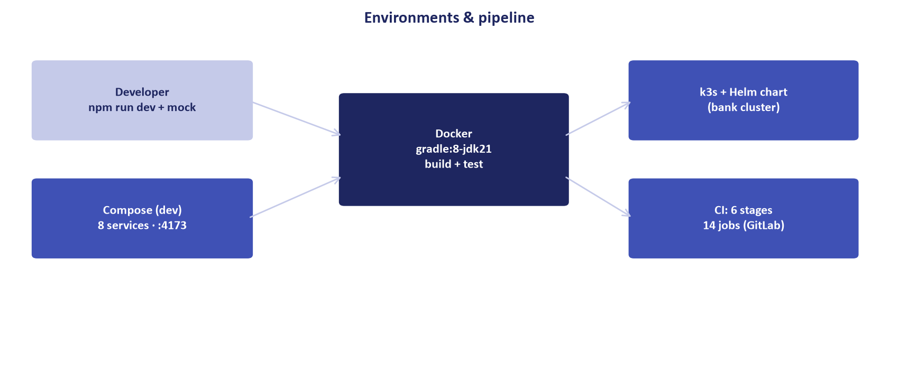
Figure 3: Sovereign Hosting — 100% In-Country Sovereign Deployment vs. Offshore Managed Services
- Established Retail Lending Reputation: Extensive adoption across Indian non-banking financial companies (NBFCs) and retail banks.
- Granular LOS Features: Deep consumer loan origination rule engines for personal, auto, and home financing.
- Regional Brand Equity: Recognized across South Asia and the Middle East for specialized retail loan servicing.

3. Competitor Critical Vulnerabilities (Where ULMS Wins)
System Architecture Specification (Mermaid DSL): [Diagram Topology: flowchart TD]
flowchart TD
subgraph FinnOne ["FinnOne Neo Vulnerabilities"]
F1["Cross-Border Remittance & 20% WHT Friction"]
F2["Offshore Support Delays & India Travel Bureaucracy"]
F3["Proprietary Oracle DB Overhead & License Multipliers"]
F4["Retrofitted Bangladesh Bank BRPD 15 Regulatory Rules"] F5["Thin Bangladesh Reference Base vs Local 40+ HQ"] end

1. The Cross-Border Payment and Tax Penalty Trap:
- The Reality: Contracting with Nucleus Software requires cross-border remittances to India. The National Board of Revenue (NBR) enforces a mandatory 20% Advance Income Tax (AIT) withholding on foreign software royalties, plus central bank approvals for outward foreign exchange remittances.
- The Pitch: "With FinnOne, your bank pays a 20% tax surcharge on every invoice and navigates central bank forex red tape. ULMS is 100% domestically billed in BDT by Unisoft Systems Limited (backed by Smart Technologies BD Ltd), with zero remittance delays and full NBR tax credits."

2. The Offshore Support Bottleneck:
- The Reality: Nucleus relies heavily on offshore development teams in Noida, India. When critical production issues arise or urgent custom patches are needed for Bangladesh Bank circulars, banks face visa delays, remote communication bottlenecks, and expensive fly-in consulting fees.
- The Pitch: "When an auditor from Bangladesh Bank is sitting in your boardroom demanding an explanation, Unisoft's senior software architects can be physically on-site in your Motijheel or Gulshan datacenter within 30 minutes (metro) / 2 hours (national)."

3. Costly Infrastructure Sizing (Oracle Lock-In):
- The Reality: FinnOne Neo requires expensive Oracle Database Enterprise Edition licenses and high-spec proprietary application servers, adding millions of Taka in mandatory third-party software overhead.
- The Pitch: "ULMS v2.0 runs on high-performance PostgreSQL 17, cutting your relational database licensing fees to zero while delivering sub-second response times on commodity server hardware."

4. Head-to-Head Feature Comparison Matrix
Functional Dimension | FinnOne Neo | Unisoft ULMS v2.0 | Win Evaluation
Contract Currency & Tax | USD ($1.5M+) + 20% WHT | 100% BDT (BDT 4.0 Cr) + NBR Tax Credit | ULMS Decisive Win
BRPD 15/2024 7-Stage Classification | Custom Adaptation (Scripted) | Native Deterministic Core Engine | ULMS Decisive Win
Bangladesh Bank CIB Online Gateway | Custom Integration Layer | Native Automated REST Parser | ULMS Decisive Win
Election Commission e-KYC Verification | Third-Party Middleware | Integrated Face Match & NID OCR | ULMS Decisive Win
Database Licensing Cost | Requires Oracle DB ($150k+ extra) | Zero Cost: PostgreSQL 17 | ULMS Decisive Win
On-Site SLA in Dhaka | Remote or 48-72h Flight Notice | Guaranteed 30-Minute Metro / 2-Hour National On-Site | ULMS Decisive Win
Implementation Timeline | 9 to 14 Months | 12 Weeks Turnkey Pilot | ULMS Decisive Win

5. Trap-Setting RFP Questions to Disqualify FinnOne Neo
- For the Procurement & Finance Committee:
> "Is the bidding vendor an incorporated legal entity in Bangladesh capable of issuing VAT invoices directly under NBR SRO regulations, or does the contract require cross-border outward foreign exchange remittance subject to withholding tax?"
- For the ICT Architecture Committee:
> "Does the proposed solution mandate proprietary commercial RDBMS licenses (such as Oracle Enterprise Edition) with core-based pricing, or can it operate natively on enterprise open-source PostgreSQL 17?"
- For the Operations & Recovery Committee:
> "Does the field collection module feature native offline caching with automatic GPS geotagging and SMS dispatch over local telecom aggregators (Grameenphone, Robi, Banglalink) without third-party global SMS gateway costs?"
Unisoft Systems Limited — Competitive Intelligence & Banking Sales Operations.

