UNISOFT SYSTEMS LIMITED · A SUBSIDIARY OF SMART TECHNOLOGIES BD LTD
Regulatory Whitepaper: Automated Compliance with BRPD Circular 15/2024
Commercial Banking Documentation · Document Ref: DOC-35-REG-01

Document Identifier | Release Version | Security Classification | Publication Date | Target Audience
DOC-35-REG-01 | 2.0.0 | Authoritative Technical & Regulatory Whitepaper | 2026-10-08 | [cro, head_of_credit, compliance_officer, external_auditor]

The 7-Stage Loan Classification & Statutory Provisioning Engine in ULMS v2.0
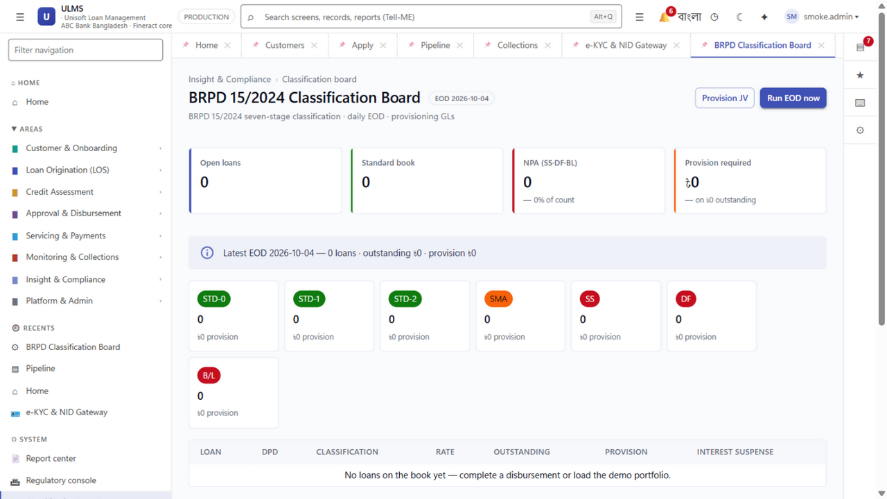
Figure 1: Production UI — Live 7-Stage BRPD 15/2024 Classification & Provisioning Engine
Document Identifier: DOC-35-REG-01
Statutory Reference: Bangladesh Bank BRPD Circular No. 15 dated November 27, 2024 (and related directives)
Author: Head of Regulatory Compliance & Senior Credit Risk Architect
Publisher: Unisoft Systems Limited (A Subsidiary of Smart Technologies BD Ltd)
Classification: Authoritative Technical & Regulatory Whitepaper
Version: 2.0.0

1. Executive Summary & Regulatory Context
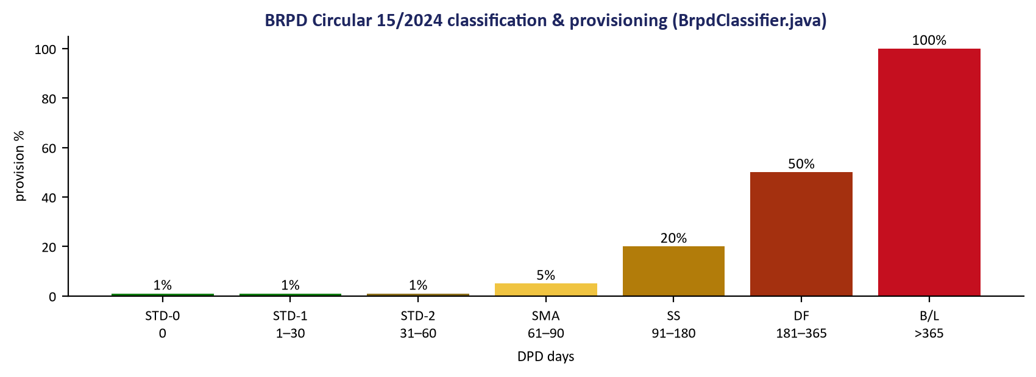
Figure 2: Statutory Matrix — Bangladesh Bank Granular Provisioning Percentages & DPD Bands
On November 27, 2024, the Banking Regulation and Policy Department (BRPD) of Bangladesh Bank issued Circular No. 15/2024, marking the most significant overhaul of credit asset classification and provisioning rules in Bangladesh in over a decade.

Statutory Implementation Timeline:
- Circular Issuance Date: November 27, 2024
- Statutory Effective Date: April 1, 2025 (Mandatory transition from historical 4-stage to 7-stage classification)
- Comprehensive CL Reporting Date: September 30, 2025 (Quarterly CL-1 to CL-5 returns submitted to Bangladesh Bank under the full 7-stage taxonomy)
- Mandatory IFRS-9 ECL Convergence: December 31, 2027
Replacing the historical 4-stage framework, BRPD 15/2024 established a strict 7-stage granular classification regime aimed at aligning Bangladesh’s banking sector with international Basel III norms and paving the way for mandatory IFRS-9 Expected Credit Loss (ECL) enforcement by December 31, 2027.
System Architecture Specification (Mermaid DSL): [Diagram Topology: flowchart LR]
flowchart LR
subgraph Performing ["Performing Assets (General Provision)"]
S0["1. STD-0: Standard Current<br/>0 DPD · 1.0% GP"]
S1["2. STD-1: Standard Watch<br/>1–30 DPD · 1.0% GP"]
S2["3. STD-2: Standard Caution<br/>31–60 DPD · 1.0% GP"]
SMA["4. SMA: Special Mention<br/>61–90 DPD · 5.0% GP"] SS["5. SS: Substandard<br/>91-180 DPD - 20% GP"] DF["6. DF: Doubtful<br/>181-365 DPD - 50% GP"] BL["7. B-L: Bad-Loss<br/>over 365 DPD - 100% GP"] end

For commercial banks, manually tracking Days Past Due (DPD) across thousands of accounts using spreadsheets creates acute operational risks: misclassification fines, delayed reporting, and balance-sheet restatement orders.
ULMS v2.0 solves this challenge through an embedded, automated BRPD 15/2024 Compliance Engine that deterministically calculates DPD, nets central bank eligible collateral, determines exact general and specific provisions, and exports standardized CL returns nightly.

2. Exhaustive 7-Stage Classification Taxonomy & Asset Categories
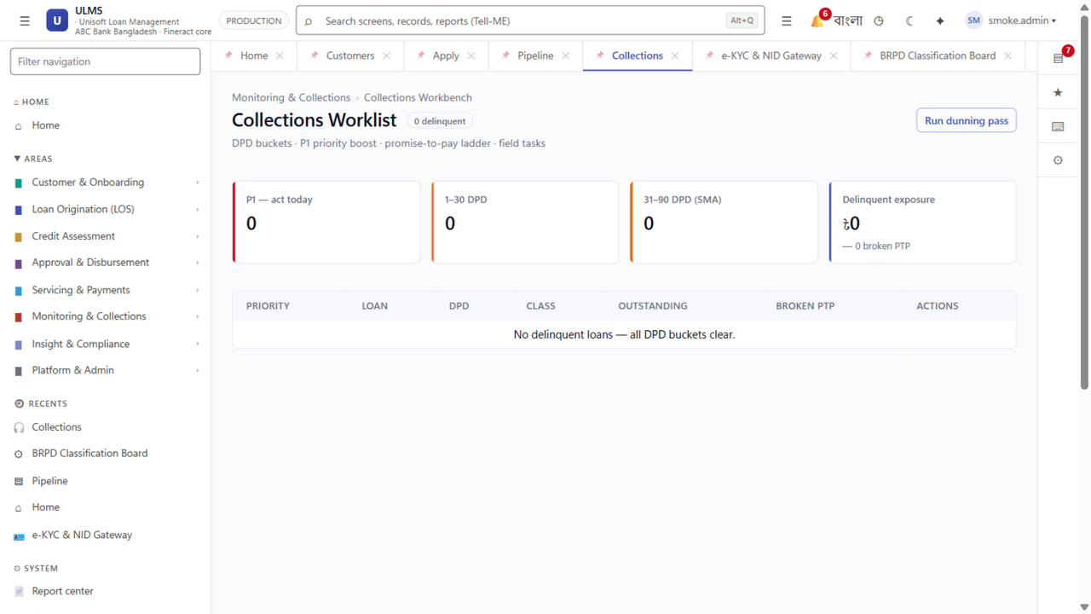
Figure 3: Delinquency Ledger — DPD Aging Analysis & Collateral Netting Traceability

2.1 The Four Regulated Credit Asset Categories
BRPD Circular 15/2024 establishes distinct classification criteria across four primary loan categories:
- Continuous Loans (Cash Credit, Overdrafts): Revolving credit facilities with sanctioned validity limits. DPD is calculated from limit expiry date or when drawings exceed limit continuously for 30+ days.
- Demand Loans (PAD, FBP, LIM, Payment Against Documents): Short-term trade finance loans payable on demand. DPD is calculated from maturity or creation date if unretired.
- Fixed Term Loans (Retail EMI, SME Term, Industrial Term, Lease Finance): Installment-based term credit. DPD is tracked against the oldest overdue installment.
- Short-Term Agricultural Credit & Micro-Credit: Agricultural crop loans and micro-credit. Classified as SMA if overdue 30–60 days, SS if 61–180 days, DF if 181–365 days, and B/L if past due exceeding 12 months after maturity.

2.2 7-Stage Classification Matrix & Statutory Provision Rates
Under BRPD Circular 15/2024, credit facilities are classified based on objective Days Past Due (DPD) thresholds, qualitative judgment, and rescheduling history:
Stage Code | Classification Name | Days Past Due (DPD) Range | Provision Category | Base Statutory Provision Rate | Commercial & Retail Loans | SME / Agri Credit Loans
STD-0 | Standard (Current) | Exactly 0 Days | General Provision (GP) | 1.0% | 1.0% | 0.25% – 1.0%
STD-1 | Standard (Watch) | 1 to 30 Days | General Provision (GP) | 1.0% | 1.0% | 0.25% – 1.0%
STD-2 | Standard (Caution) | 31 to 60 Days | General Provision (GP) | 1.0% | 1.0% | 0.25% – 1.0%
SMA | Special Mention Account | 61 to 90 Days | General Provision (GP) | 5.0% | 5.0% | 5.0%
SS | Sub-Standard (NPL) | 91 to 180 Days | Specific Provision (SP) | 20.0% | 20.0% | 20.0%
DF | Doubtful (NPL) | 181 to 365 Days | Specific Provision (SP) | 50.0% | 50.0% | 50.0%
B/L | Bad / Loss (NPL) | Greater than 365 Days | Specific Provision (SP) | 100.0% | 100.0% | 100.0%

Key Regulatory Enforcements:
- Continuous Revolving Credit & Overdrafts: DPD is measured from the date of limit expiration or when drawings exceed the sanctioned limit continuously for 30+ days.
- Fixed Term / Installment Credit: DPD is measured from the due date of any unpaid monthly or quarterly installment.
- Cross-Default Contagion: If an uncollateralized borrower is classified as Sub-Standard or worse on one facility, ULMS automatically tags all other facilities of the same borrower across the bank for downgrade review.

3. Mathematical Collateral Netting & Provisioning Algorithm
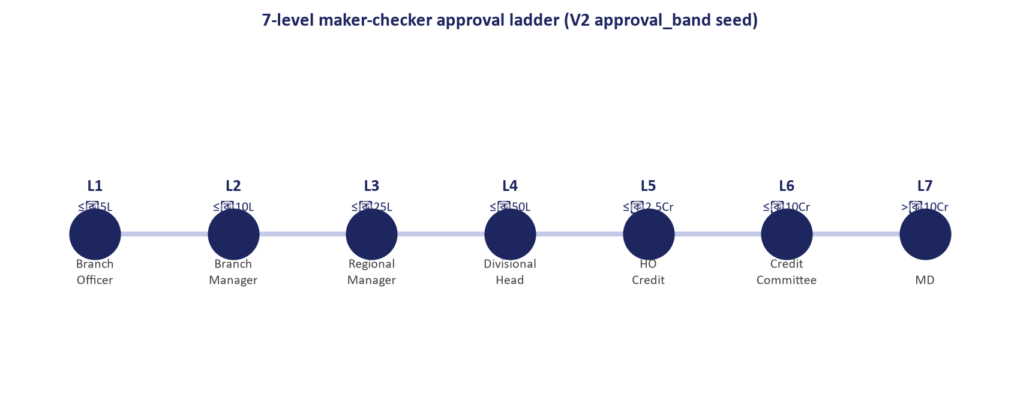
Figure 4: Sanction Governance — Rescheduling & Restructuring Delegation Authority Matrix
The calculation of specific provisions under central bank guidelines permits the deduction of Eligible Security / Collateral before applying the statutory provisioning percentage.

3.1 Central Bank Eligible Collateral Categories & Haircuts
Per Bangladesh Bank regulations, only strictly defined collateral can be deducted against outstanding exposure:
- Cash Collateral & FDR Liens: 100% of face value (zero haircut).
- Government Treasury Bonds / Sanchayapatra: 100% of surrender/face value.
- Immovable Landed Property / Registered Mortgages: Maximum of 80% of forced sale value determined by an accredited surveyor within the last 3 years.
- Hypothecated Stock & Raw Materials: Maximum of 50% of audited valuation, subject to strict inspection recency (<90 days).

3.2 Formal Mathematical Provisioning Formula
For any credit facility $i$ with Outstanding Exposure $E_i$ and Central Bank Eligible Collateral $C_i$:
Case A: Performing Loans (STD-0, STD-1, STD-2, SMA)
General provisions are computed directly on the gross outstanding exposure without collateral deduction:
$$\text{GP}_i = E_i \times R_{\text{GP}}$$
Where $R_{\text{GP}}$ is the applicable general provision rate (1.0% for Standard; 5.0% for SMA).
Case B: Non-Performing Loans (SS, DF, B/L)
Specific provisions are computed on the Net Base for Provision after subtracting eligible collateral:
$$\text{Base for Provision } B_i = \max\left(0,\, E_i - \text{Interest Suspense}_i - C_i^{\text{eligible}}\right)$$
$$\text{Specific Provision } \text{SP}_i = B_i \times R_{\text{SP}}$$
Where $R_{\text{SP}}$ is the statutory specific provision rate (20% for SS, 50% for DF, 100% for B/L).

3.3 Interest Suspense Accounting Treatment (BRPD Mandate)
Per Bangladesh Bank regulations, when any facility degrades to Sub-Standard (SS), Doubtful (DF), or Bad/Loss (B/L):
- Accrual Reversal: All unrealized interest accrued during the current accounting period must be immediately reversed from the Profit & Loss statement:
- Debit: Interest Income Account (P&L)
- Credit: Interest Suspense Account (Balance Sheet Liability / Contra-Asset)
- Ongoing Accrual Treatment: Any subsequent interest charged on the classified account cannot be recognized as bank earnings:
- Debit: Loan Outstanding / Advance Account (Asset)
- Credit: Interest Suspense Account (Balance Sheet)
- Cash Realization Rule: Interest in suspense is recognized as income if and only if actual cash collection occurs:
- Debit: Cash / Clearing Account
- Credit: Loan Outstanding / Advance Account
- Simultaneous Reversal: Debit Interest Suspense Account / Credit Interest Income Account (P&L)
ULMS v2.0 automates these journal vouchers via the core BrpdClassifier service, generating standardized ISO 20022 / CBS GL staging feeds nightly.

4. End-of-Day (EOD) Automated Classification Engine
ULMS v2.0 executes an automated classification batch every business day at 23:59:00:
System Architecture Specification (Mermaid DSL): [Diagram Topology: sequenceDiagram]
sequenceDiagram
autonumber
participant Sched as Spring Scheduler
participant Engine as BrpdClassifier Service
participant DB as PostgreSQL 17 Database
participant GL as Core Banking / GL Staging

Zero-Human-Error Guarantee:
- The batch operates autonomously without manual spreadsheet intervention.
- Any manual classification override by a senior credit committee requires mandatory two-factor authorization, justification text, and is logged in the permanent audit trail.

5. Rescheduling, Restructuring & Concession Tracking
Under BRPD guidelines, rescheduled loans cannot be immediately upgraded to Standard Current (STD-0). ULMS enforces central bank restructuring rules:
- Mandatory Down Payment Verification: The system requires proof of down payment (typically 2.5% to 7.5% depending on whether it is a 1st, 2nd, or 3rd reschedule) before recalculating the amortization schedule.
- Six-Month Seasoning Period: Rescheduled accounts remain in a probationary status for at least 6 months with flawless repayments before they can qualify for an automated upgrade.
- Reschedule Counter Tracking: The system maintains an indelible counter of how many times a facility has been rescheduled across the borrower's lifetime.

6. Automated Regulatory Returns (CL-1 to CL-5)
ULMS v2.0 natively generates the complete suite of central bank regulatory returns required under BRPD guidelines:
Return Code | Central Bank Form Title | Reporting Frequency | Generation Method
CL-1 | Quarterly Statement of Outstanding Credit, Classification & Provisioning | Quarterly | Automated One-Click Export (CSV / Excel / PDF)
CL-2 | Breakdown of Sectoral & Large Borrower Classifications | Quarterly | Aggregated by BB Sector Code & Single Borrower Limits
CL-3 | Statement of Top 20 Defaulted Borrowers & Action Plans | Quarterly | Auto-sorted by gross defaulted balance
CL-4 | Statement of Rescheduled & Restructured Loans | Quarterly | Filtered by active probationary reschedule tags
CL-5 | Statement of Written-Off Loans & Recovery Progress | Quarterly | Historical ledger tracking recovery collections

7. Audit Defense & Regulatory Certification
When Bangladesh Bank inspection teams conduct on-site examinations:
- Instant Audit Trails: Compliance officers can produce a complete, unalterable timeline showing every repayment, missed due date, DPD milestone, and provision recalculation.
- Contractual Regulatory Guarantee: Unisoft includes a formal warranty in its Master Software License Agreement guaranteeing that the ULMS classification engine complies 100% with BRPD Circular 15/2024, with guaranteed free regulatory patches for future central bank amendments.
Unisoft Systems Limited — Regulatory Compliance & Financial Architecture.
Addendum — v3.1.0 corrections (Independent Forensic Re-audit, 8 October 2026)
Statutory currency note: BRPD Circular No. 05 of 25 June 2025 amends and complements Circular No. 15 of 27 November 2024 (risk-sensitivity enhancements to loan classification and provisioning). The seven-stage DPD/provisioning tables in this paper state the Circular 15/2024 baseline; the free regulatory-update commitment covers Circular 05/2025 changes. Issuance (27 Nov 2024) and effectiveness (1 Apr 2025) verified against Bangladesh Bank publications.
IFRS-9 roadmap (verified): the BRPD circular of 23 January 2025 requires full ECL-based provisioning by December 2027, with pilot coverage — branches holding at least 75% of the loan portfolio — by June 2027.

