UNISOFT SYSTEMS LIMITED

ULMS — Unisoft Loan Management System
Comprehensive Technical Documentation
Version 2.0 · October 2026
Prepared for ABC Bank Bangladesh (pilot) — staff web, borrower and field mobile apps, Fineract core

(Open in Word → Ctrl+A → F9 to populate)

1. Executive Summary
ULMS is a bank-grade loan management system for Bangladesh scheduled commercial banks: a Java 21 / Spring Boot 4 modular-monolith backend, a React 19 staff web application, two Expo 54 mobile apps (borrower + field officer), Apache Fineract CE as the core ledger, PostgreSQL 17, and Keycloak 26 identity — deployable from Docker Compose to k3s via a Helm chart. The build implements the full Bangladesh regulatory core: BRPD Circular 15/2024 seven-stage classification and provisioning, IFRS-9 ECL staging, Basel III capital adequacy, BFIU AML/CTRF (STR/CTR/goAML), and a 12-return regulatory reporting catalog.
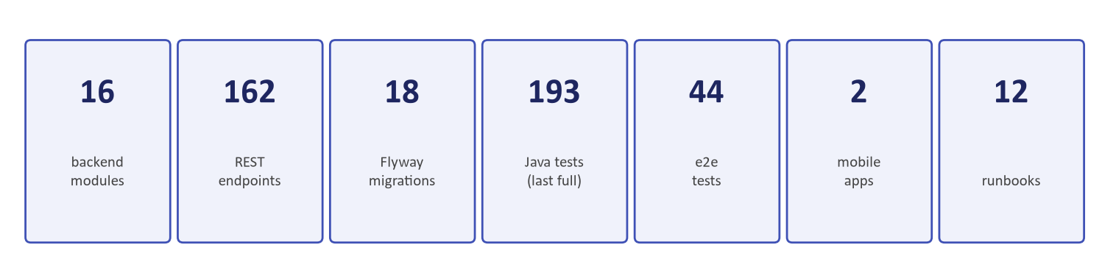
Exhibit 1 — Program KPIs at a glance
SCOPE NOTE This document covers the shipped build (build stage complete). Live-bank cutover items — external credentials, clustered Keycloak, production k3s rollout — follow the go-live checklist and RB-11A flip runbook.

2. System Overview & Architecture
The system is a modular monolith by binding decision (Technology Stack v3): all sixteen business modules run in one deployable Spring Boot 4 unit — module boundaries enforced by Spring Modulith with owned ports for the two historically cyclic edges — fronted by an nginx-served React SPA and two native mobile clients. Apache Fineract CE is the immutable loan subledger; ULMS mirrors loan state for its BRPD/boards projections.
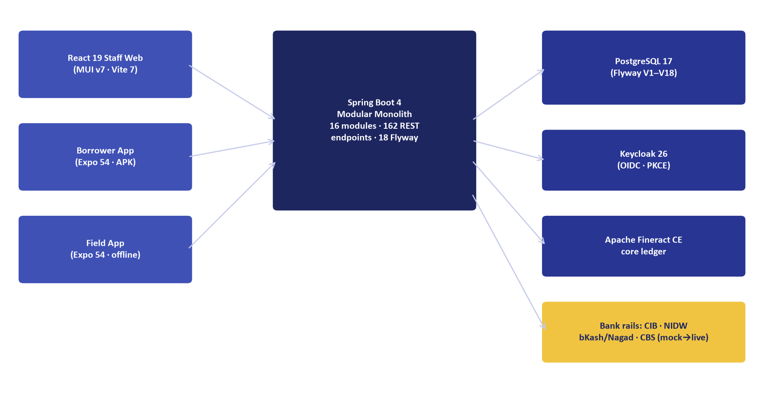
Exhibit 2 — Component architecture

2.1 Technology Stack (binding — v3)
Layer | Technology | Notes
Backend | Java 21 · Spring Boot 4 · Gradle 8 | Modular monolith · Spring Modulith verification
Database | PostgreSQL 17 · Flyway | 18 migrations V1–V18
Identity | Keycloak 26 (OIDC + PKCE) | Realm ulms; direct-grant MFA on staff login
Web | React 19 · MUI v7 · Vite 7 · TS 5.8 | Dynamics-365 shell, bilingual EN/BN
Mobile | Expo 54 · React Native 0.81 | Borrower app (signed APK) + field app (offline-first)
Core ledger | Apache Fineract CE (pinned SHA) | Loan lifecycle subledger
Ops | Compose → k3s · Helm · Prometheus/Grafana | 6 CI stages, 14 jobs (GitLab)
Docs/spec | OpenAPI 3.0 (redocly-valid) | 140 documented paths

3. Modules & Functions
Sixteen backend packages implement the platform (162 REST endpoints total). Each module section: purpose, endpoints, and the business rules its service layer enforces; the endpoint table lists verb, path, and the role gate.
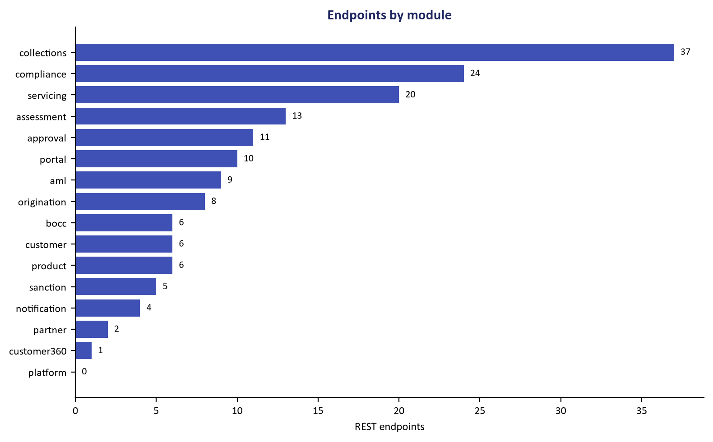
Exhibit 3 — REST endpoints by module

3.1 Aml
AML/CFT: screening lists, monitoring alerts, CTR/STR, goAML submission, sanctions screening port.
Verb | Path | Roles
GET | /api/v1/customers/{idOrCif}/guarantors | collections,compliance,admin, compliance,admin
POST | /api/v1/customers/{idOrCif}/guarantors | collections,compliance,admin, compliance,admin
GET | /api/v1/customers/{idOrCif}/aml | collections,compliance,admin, compliance,admin
POST | /api/v1/customers/{idOrCif}/str | collections,compliance,admin, compliance,admin
GET | /api/v1/customers/{idOrCif}/ctrs | collections,compliance,admin, compliance,admin
GET | /api/v1/customers/{idOrCif}/monitoring-alerts | collections,compliance,admin, compliance,admin
GET | /api/v1/customers/{idOrCif}/goaml.xml | collections,compliance,admin, compliance,admin
POST | /api/v1/customers/{idOrCif}/goaml/submit | collections,compliance,admin, compliance,admin
GET | /api/v1/goaml/submissions | collections,compliance,admin, compliance,admin
- STR ≥৳20L cash threshold alert; goAML env-gated with ack bookkeeping
- Screening normalize folds diacritics; EDD on hits

3.2 Approval
7-level maker-checker ladder, dual-phase nodes, DELEGATE, APPROVE_WITH_CONDITIONS, disbursement dual-auth.
Verb | Path | Roles
GET | /api/v1/approvals/ladder | branch-manager,regional-manager,ho-credit,admin, branch-offi
GET | /api/v1/approvals/my-inbox | branch-manager,regional-manager,ho-credit,admin, branch-offi
GET | /api/v1/approvals/current/{applicationId} | branch-manager,regional-manager,ho-credit,admin, branch-offi
POST | /api/v1/approvals/{taskId}/act | branch-manager,regional-manager,ho-credit,admin, branch-offi
GET | /api/v1/approvals/conditions/{applicationId} | branch-manager,regional-manager,ho-credit,admin, branch-offi
POST | /api/v1/approvals/conditions/{conditionId}/resolve | branch-manager,regional-manager,ho-credit,admin, branch-offi
POST | /api/v1/disbursements/{applicationId}/prepare | branch-manager,regional-manager,ho-credit,admin, branch-offi
POST | /api/v1/disbursements/{id}/authorize | branch-manager,regional-manager,ho-credit,admin, branch-offi
POST | /api/v1/disbursements/{id}/release | branch-manager,regional-manager,ho-credit,admin, branch-offi
GET | /api/v1/disbursements/{id} | branch-manager,regional-manager,ho-credit,admin, branch-offi
GET | /api/v1/disbursements/application/{applicationId} | branch-manager,regional-manager,ho-credit,admin, branch-offi
- Bands (V2 seed): L1 ≤৳5L … L6 ≤৳10Cr, L7 above — ladder level derived from amount
- Dual-auth disbursement: preparer ≠ authorizer ≠ releaser (three distinct pairs of hands)
- Conditions precedent block disbursement until SATISFIED/WAIVED

3.3 Assessment
Credit assessment: CIB bureau parsing (stock+flow), scorecard, DBR, collateral valuation & LTV.
Verb | Path | Roles
POST | /api/v1/assessments/cib/{cif} | branch-officer,admin, branch-officer,credit-analyst,admin, b
POST | /api/v1/assessments/cib/file | branch-officer,admin, branch-officer,credit-analyst,admin, b
GET | /api/v1/assessments/cib/{cif} | branch-officer,admin, branch-officer,credit-analyst,admin, b
POST | /api/v1/assessments/{applicationId}/score | branch-officer,admin, branch-officer,credit-analyst,admin, b
POST | /api/v1/assessments/{applicationId}/dbr | branch-officer,admin, branch-officer,credit-analyst,admin, b
GET | /api/v1/assessments/{applicationId}/score | branch-officer,admin, branch-officer,credit-analyst,admin, b
POST | /api/v1/assessments/{applicationId}/collateral | branch-officer,admin, branch-officer,credit-analyst,admin, b
POST | /api/v1/assessments/collateral/{collateralId}/valuation | branch-officer,admin, branch-officer,credit-analyst,admin, b
GET | /api/v1/assessments/collateral/{collateralId}/valuation | branch-officer,admin, branch-officer,credit-analyst,admin, b
GET | /api/v1/assessments/{applicationId}/collateral | branch-officer,admin, branch-officer,credit-analyst,admin, b
GET | /api/v1/customers/{customerId}/collateral | branch-officer,admin, branch-officer,credit-analyst,admin, b
POST | /api/v1/customers/{customerId}/collateral | branch-officer,admin, branch-officer,credit-analyst,admin, b
- Scorecard grades A≥680 / B≥620 / C≥540 (recalibrated — 760+ was unreachable)
- CIB retries: 429 non-retryable; 5xx retried 1+3 with circuit breaker to RB-05 queue

3.4 Bocc
Board of Directors credit committee: schedule, attendance, quorum (simple majority), votes, auto-minutes.
Verb | Path | Roles
GET | /api/v1/bocc/meetings/ | branch-manager,admin
POST | /api/v1/bocc/meetings/ | branch-manager,admin
GET | /api/v1/bocc/meetings/{id} | branch-manager,admin
POST | /api/v1/bocc/meetings/{id}/attendance | branch-manager,admin
POST | /api/v1/bocc/meetings/{id}/vote | branch-manager,admin
POST | /api/v1/bocc/meetings/{id}/close | branch-manager,admin

3.5 Collections
Delinquency engine: worklist priority, dunning ladder, PTP lifecycle, field tasks + /field gateway, watchlist, legal, write-off, recovery, auctions.
Verb | Path | Roles
GET | /api/v1/collections/auctions/ | collections,admin, collections,branch-manager,admin, collect
POST | /api/v1/collections/auctions/ | collections,admin, collections,branch-manager,admin, collect
POST | /api/v1/collections/auctions/{id}/held | collections,admin, collections,branch-manager,admin, collect
POST | /api/v1/collections/auctions/{id}/sold | collections,admin, collections,branch-manager,admin, collect
POST | /api/v1/collections/auctions/{id}/unsold | collections,admin, collections,branch-manager,admin, collect
POST | /api/v1/collections/auctions/{id}/cancel | collections,admin, collections,branch-manager,admin, collect
GET | /api/v1/collections/worklist | collections,admin, collections,branch-manager,admin, collect
POST | /api/v1/collections/{loanId}/actions/{actionType} | collections,admin, collections,branch-manager,admin, collect
GET | /api/v1/collections/{loanId}/actions | collections,admin, collections,branch-manager,admin, collect
POST | /api/v1/collections/{loanId}/ptp | collections,admin, collections,branch-manager,admin, collect
POST | /api/v1/collections/ptp/{ptpId}/outcome | collections,admin, collections,branch-manager,admin, collect
GET | /api/v1/collections/ptp/calendar | collections,admin, collections,branch-manager,admin, collect
- Dunning timers by DPD bucket; PTP kept/broken derives from payments at promise date
- Field visits idempotent by clientUuid with server-wins task state; SOS ledger + ack
- ≥EMI payment regularizes DPD; auction proceeds post as 5%-incentive recovery

3.6 Compliance
EOD batch, BRPD classification board, provisions, IFRS-9 ECL, Basel III CAR, Regcon returns, parallel-run.
Verb | Path | Roles
GET | /api/v1/compliance/basel/summary | compliance,admin, compliance,branch-manager,admin, complianc
POST | /api/v1/compliance/basel/parallel/snapshot | compliance,admin, compliance,branch-manager,admin, complianc
POST | /api/v1/compliance/basel/parallel/bank-value | compliance,admin, compliance,branch-manager,admin, complianc
GET | /api/v1/compliance/basel/parallel/report | compliance,admin, compliance,branch-manager,admin, complianc
POST | /api/v1/compliance/regcon/push | compliance,admin, compliance,branch-manager,admin, complianc
POST | /api/v1/compliance/eod/run | compliance,admin, compliance,branch-manager,admin, complianc
GET | /api/v1/compliance/classification | compliance,admin, compliance,branch-manager,admin, complianc
GET | /api/v1/compliance/provision-calculator | compliance,admin, compliance,branch-manager,admin, complianc
GET | /api/v1/compliance/alerts | compliance,admin, compliance,branch-manager,admin, complianc
POST | /api/v1/compliance/provision-jv | compliance,admin, compliance,branch-manager,admin, complianc
GET | /api/v1/compliance/provision-jv | compliance,admin, compliance,branch-manager,admin, complianc
GET | /api/v1/compliance/returns | compliance,admin, compliance,branch-manager,admin, complianc
- BRPD stages STD-0/1/2 → SMA → SS → DF → B/L with 1/1/1/5/20/50/100% provisioning
- Regcon: 12-return catalog with maker-checker sign-off and WORM pack generation

3.7 Customer
Customer master, e-KYC/NID screening, branch scoping, merge-duplicate hygiene, risk classification.
Verb | Path | Roles
POST | /api/v1/customers/ | admin,compliance, branch-officer,admin, branch-officer,compl
GET | /api/v1/customers/ | admin,compliance, branch-officer,admin, branch-officer,compl
POST | /api/v1/customers/{id}/kyc-refresh | admin,compliance, branch-officer,admin, branch-officer,compl
POST | /api/v1/customers/{id}/screen | admin,compliance, branch-officer,admin, branch-officer,compl
POST | /api/v1/customers/{survivorCif}/merge-duplicate | admin,compliance, branch-officer,admin, branch-officer,compl
POST | /api/v1/customers/{cif}/risk | admin,compliance, branch-officer,admin, branch-officer,compl
- BD mobile format enforced (+8801…); screening consults the AML watchlist port
- KYC refresh cadence 1/2/3 years by risk band; merges are idempotent by canonical CIF

3.8 Customer360
Aggregated 360 view projection over the customer aggregate.
Verb | Path | Roles
GET | /api/v1/customers/{idOrCif} | staff JWT

3.9 Notification
Bilingual (BN/EN) SMS/email templates, delivery outbox with provider fallback chain — all-fail is recorded FAILED, never dropped.
Verb | Path | Roles
GET | /api/v1/notifications/templates | staff JWT
POST | /api/v1/notifications/templates | staff JWT
GET | /api/v1/notifications/outbox | staff JWT
POST | /api/v1/notifications/send | staff JWT

3.10 Origination
Loan application lifecycle: draft → submit (CIB pull + scoring) → CPV gate → approval ladder entry.
Verb | Path | Roles
POST | /api/v1/applications/ | branch-officer,admin, branch-officer,collections,admin
PATCH | /api/v1/applications/{id} | branch-officer,admin, branch-officer,collections,admin
POST | /api/v1/applications/{id}/submit | branch-officer,admin, branch-officer,collections,admin
POST | /api/v1/applications/{id}/cpv | branch-officer,admin, branch-officer,collections,admin
POST | /api/v1/applications/{id}/documents | branch-officer,admin, branch-officer,collections,admin
GET | /api/v1/applications/{id}/documents | branch-officer,admin, branch-officer,collections,admin
GET | /api/v1/applications/{id} | branch-officer,admin, branch-officer,collections,admin
GET | /api/v1/applications/ | branch-officer,admin, branch-officer,collections,admin
- Server-computed DBR ceiling 50%; product bounds enforced at draft and portal apply
- CPV pass starts the ladder; fail rolls the application back to screening

3.11 Partner
Lending-partner API channel: hashed API keys, 60/min token bucket, Idempotency-Key replay.
Verb | Path | Roles
POST | /api/v1/partner/applications | staff JWT
GET | /api/v1/partner/applications/{id}/status | staff JWT

3.12 Platform
Shared kernel: workflow engine, audit (WORM), outbox (ADR-004), security principal, money math.

3.13 Portal
Borrower self-service: OTP login, own-CIF loans/tracker/payments/apply/statements — strictly own-CIF row scope.
Verb | Path | Roles
GET | /api/v1/portal/me | branch-officer,collections,admin
GET | /api/v1/portal/me/application | branch-officer,collections,admin
GET | /api/v1/portal/me/payments | branch-officer,collections,admin
POST | /api/v1/portal/me/applications | branch-officer,collections,admin
POST | /api/v1/portal/me/documents | branch-officer,collections,admin
POST | /api/v1/portal/otp | branch-officer,collections,admin
POST | /api/v1/portal/otp/verify | branch-officer,collections,admin
POST | /api/v1/portal/me/payments/initiate | branch-officer,collections,admin
GET | /api/v1/portal/me/loans/{loanId}/statement | branch-officer,collections,admin
GET | /api/v1/portal/me/loans/{loanId}/statement.csv | branch-officer,collections,admin

3.14 Product
Versioned loan-product catalog with maker-checker activation and eligibility oracle.
Verb | Path | Roles
GET | /api/v1/products/ | staff JWT
GET | /api/v1/products/{code} | staff JWT
POST | /api/v1/products/ | staff JWT
PATCH | /api/v1/products/{code} | staff JWT
POST | /api/v1/products/{code}/activate | staff JWT
GET | /api/v1/products/{code}/eligibility | staff JWT
- One live version per code (DRAFT→ACTIVE→RETIRED); PATCH amends drafts only
- Eligibility = bounds + tenor + EMI parity with MoneyMath

3.15 Sanction
Sanction letter generation with tokenized acceptance and resend (replaces prior).
Verb | Path | Roles
POST | /api/v1/sanctions/{applicationId}/generate | branch-manager,regional-manager,divisional-head,ho-credit,cr
POST | /api/v1/sanctions/{id}/resend | branch-manager,regional-manager,divisional-head,ho-credit,cr
GET | /api/v1/sanctions/ | branch-manager,regional-manager,divisional-head,ho-credit,cr
GET | /api/v1/sanctions/{id} | branch-manager,regional-manager,divisional-head,ho-credit,cr
POST | /api/v1/sanctions/{id}/accept | branch-manager,regional-manager,divisional-head,ho-credit,cr

3.16 Servicing
Loan book: schedules, payments, statements, settle quotes, fees, reschedule, top-up, moratorium, BLR.
Verb | Path | Roles
GET | /api/v1/certificates/tax/{year} | branch-manager,ho-credit,admin, branch-manager,regional-mana
GET | /api/v1/certificates/tax/{year}/pdf | branch-manager,ho-credit,admin, branch-manager,regional-mana
POST | /hooks/payments/{rail} | branch-manager,ho-credit,admin, branch-manager,regional-mana
GET | /api/v1/loans/ | branch-manager,ho-credit,admin, branch-manager,regional-mana
GET | /api/v1/loans/{id} | branch-manager,ho-credit,admin, branch-manager,regional-mana
POST | /api/v1/loans/{id}/fees | branch-manager,ho-credit,admin, branch-manager,regional-mana
POST | /api/v1/loans/{id}/payments | branch-manager,ho-credit,admin, branch-manager,regional-mana
GET | /api/v1/loans/{id}/payments | branch-manager,ho-credit,admin, branch-manager,regional-mana
POST | /api/v1/loans/{id}/payment-intents | branch-manager,ho-credit,admin, branch-manager,regional-mana
GET | /api/v1/loans/{id}/payment-intents | branch-manager,ho-credit,admin, branch-manager,regional-mana
GET | /api/v1/loans/{id}/schedule | branch-manager,ho-credit,admin, branch-manager,regional-mana
GET | /api/v1/loans/{id}/statement | branch-manager,ho-credit,admin, branch-manager,regional-mana
- Payments idempotent by external ref; statements as JSON + CSV
- BLR (base lending rate) admin + re-price; moratorium is collections/compliance-gated

4. End-to-End Workflows

4.1 Credit-to-Cash (origination → disbursement)
Step 1. Officer drafts an application (product bounds + DBR guardrail server-enforced).
Step 2. Submit triggers the CIB ONLINE pull (cached 1h; 429 non-retryable; circuit breaker on sustained 5xx) and scorecard computation.
Step 3. CPV verification (field app or branch) gates ladder entry — fail rolls back to screening.
Step 4. Ladder approval at the amount-derived level; L1 nodes are maker-checker dual; higher-value files can be DELEGATED within level or approved WITH CONDITIONS (conditions block disbursement until SATISFIED/WAIVED).
Step 5. Sanction letter issued with a tokenized acceptance link (resend replaces).
Step 6. Disbursement is triple-gated: prepare ≠ authorize ≠ release; release executes Fineract disbursement and writes the ULMS loan mirror.
Step 7. STR alert raised automatically if cash disbursed ≥ ৳10L (BFIU threshold).

4.2 Nightly EOD & classification
23:30 Asia/Dhaka: payments recompute DPD; BrpdClassifier assigns the 7-stage classification; provisions post per the 1/1/1/5/20/50/100% schedule; interest suspense applies SS+; the board projection and IFRS-9 ECL stages refresh; Regcon WORM packs regenerate after (02:00/02:20).
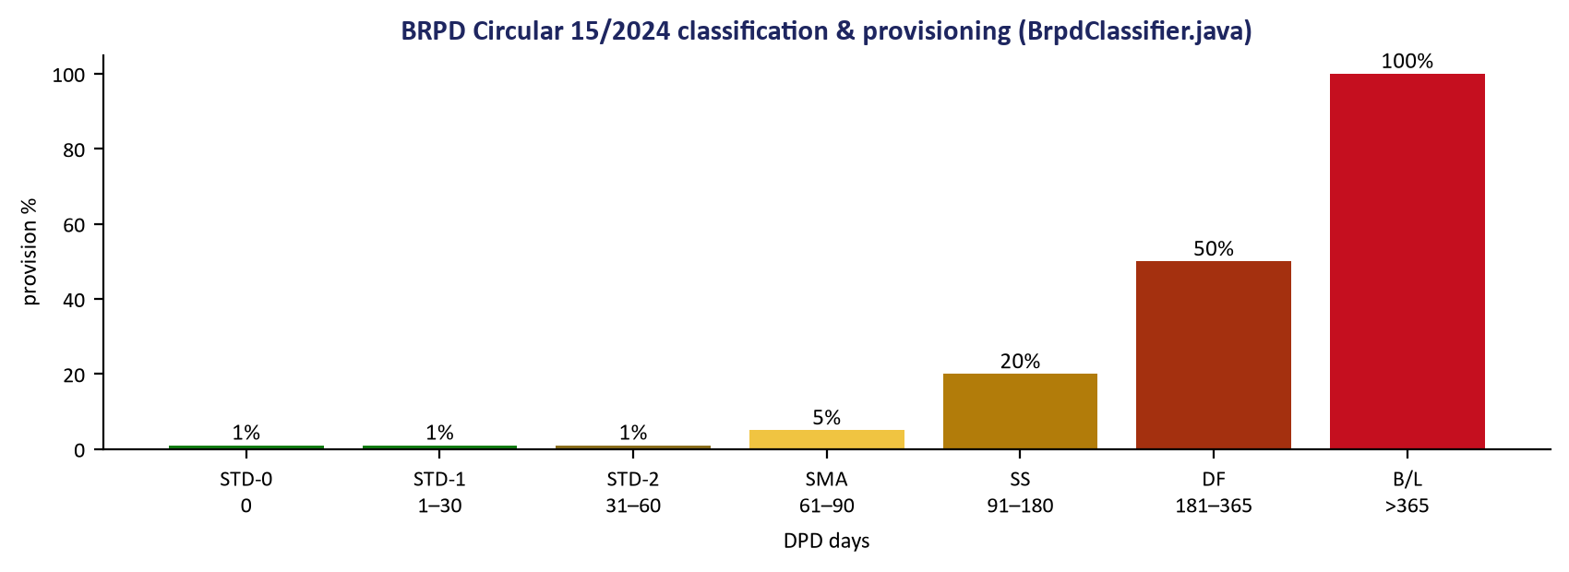
Exhibit 4 — BRPD 15/2024 stages and provisioning

4.3 Approval ladder mechanics
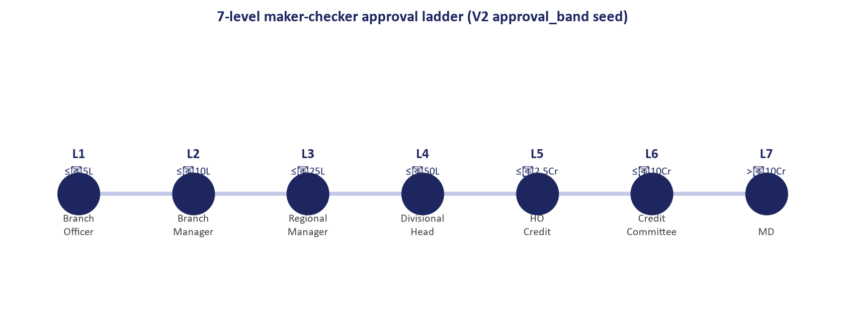
Exhibit 5 — 7-level approval ladder
LADDER DATA Bands are configuration rows (approval_band, V2 seed), not code — the bank can retune limits with a data change. L1 nodes are maker-checker dual; SLA 48h/level with 02:15 nightly escalation.

5. User Journeys (production screens)

5.1 Staff — sign-in and daily cockpit
Staff sign in at the production web (nginx + Keycloak direct-grant, MFA step, SSO as secondary). The environment chip reads PRODUCTION — the real build mode, never a hardcoded label.
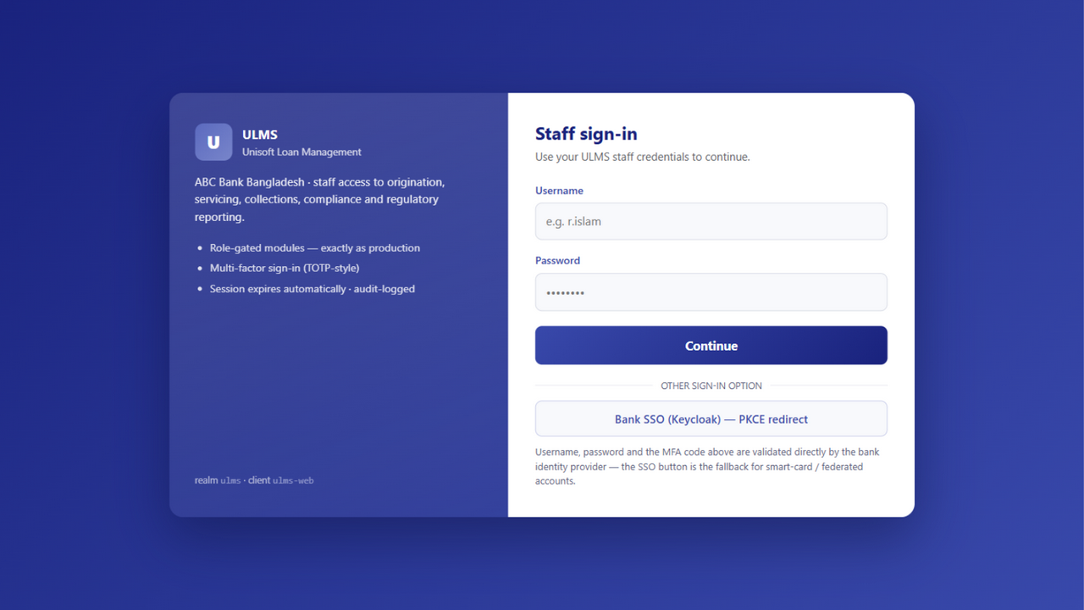
Exhibit 6a — Staff sign-in (production, MFA step)
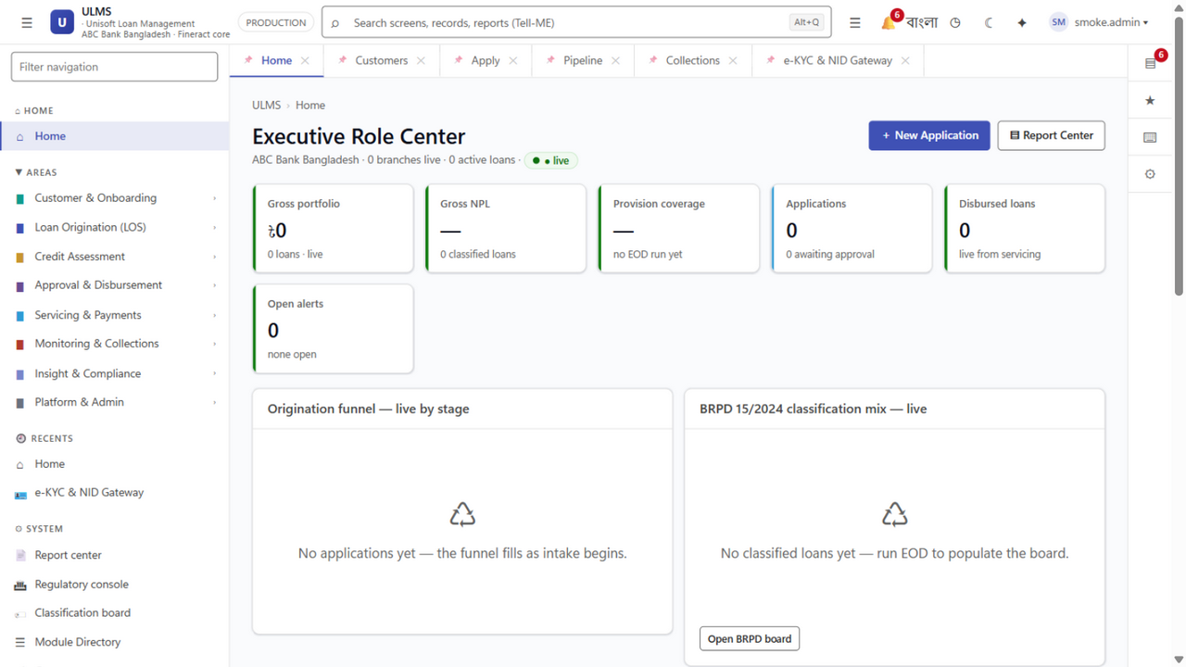
Exhibit 6 — Staff home, signed in (production)
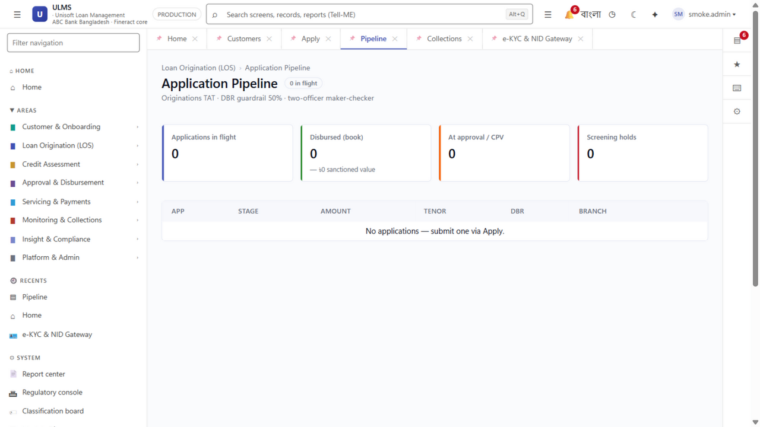
Exhibit 7 — Application pipeline & approval drawer
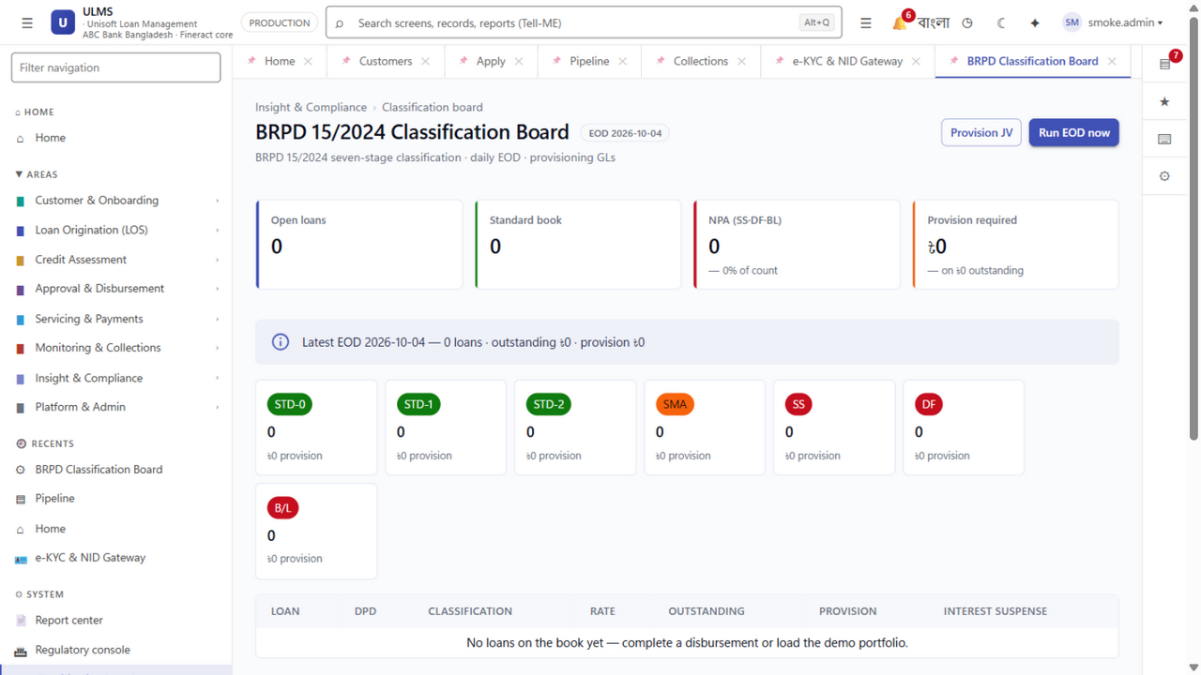
Exhibit 8 — BRPD classification board
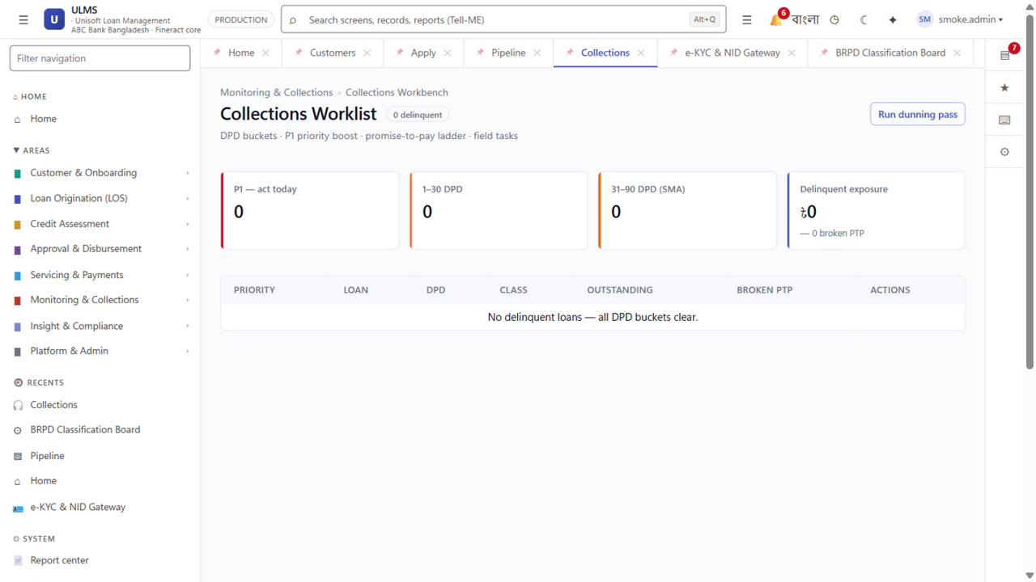
Exhibit 9 — Collections workbench

5.2 Borrower — OTP to payment (mobile app)
The borrower app ships as a signed Android APK (iOS project verified for the bank's Mac/EAS step). Its demo mode embeds the same simulation as the validated prototype, so the journey below is executable on any phone without a backend.
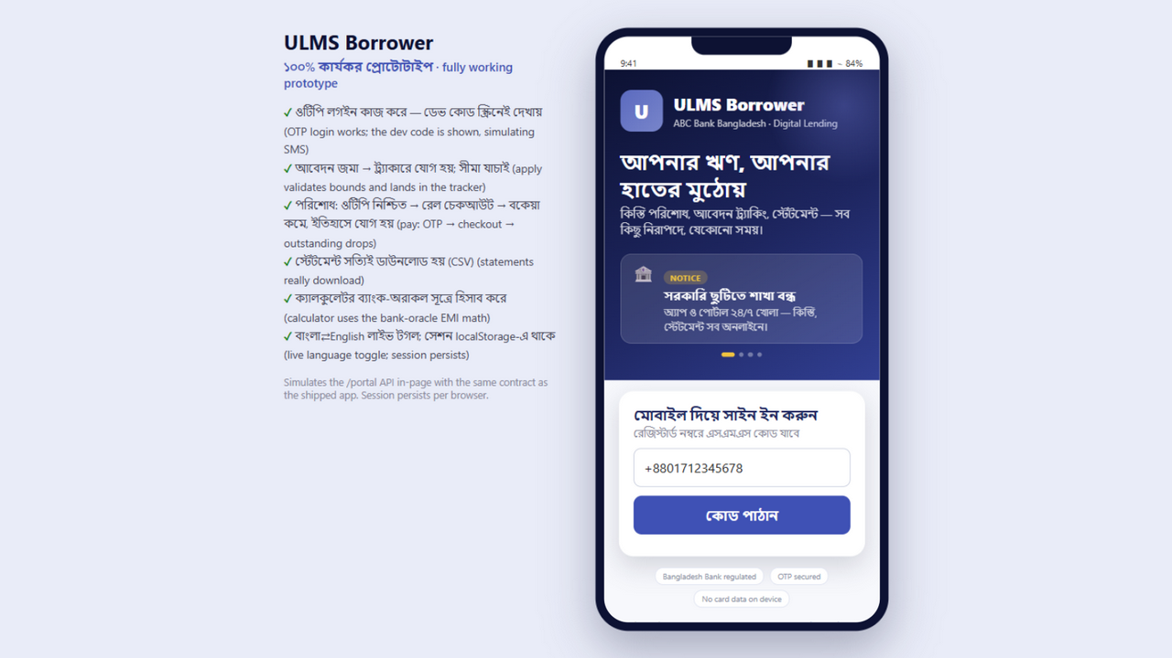
Exhibit 10 — Borrower app: OTP sign-in
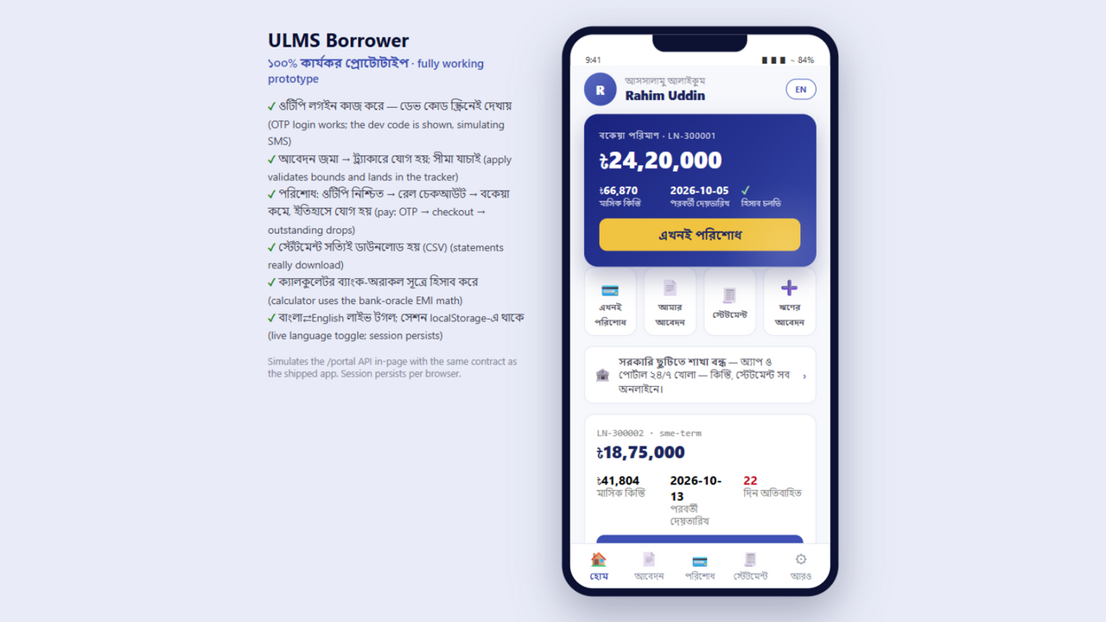
Exhibit 11 — Borrower home: hero balance card
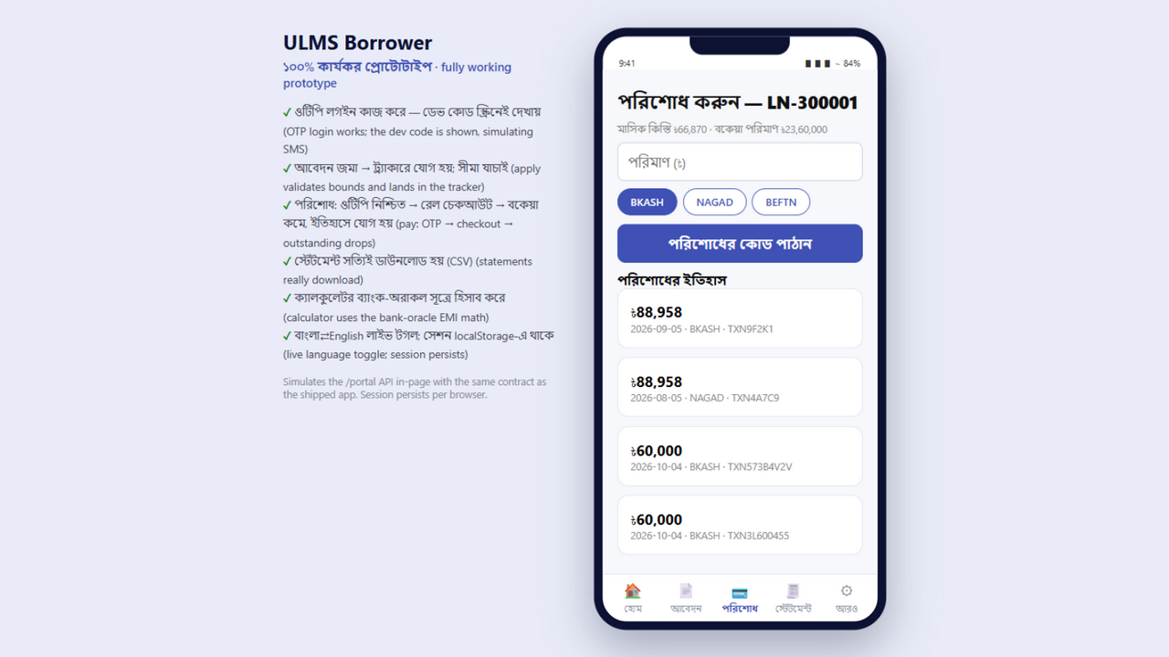
Exhibit 12 — Borrower pay: rail selection + OTP confirmation

5.3 Field officer — offline-first verification
The field app runs the six-tab offline cockpit: today's visits, CPV form (signature canvas, voice note, GPS gate), schematic map, proof gallery, two-step SOS, and the sync center whose drain demonstrates server-wins conflict handling.
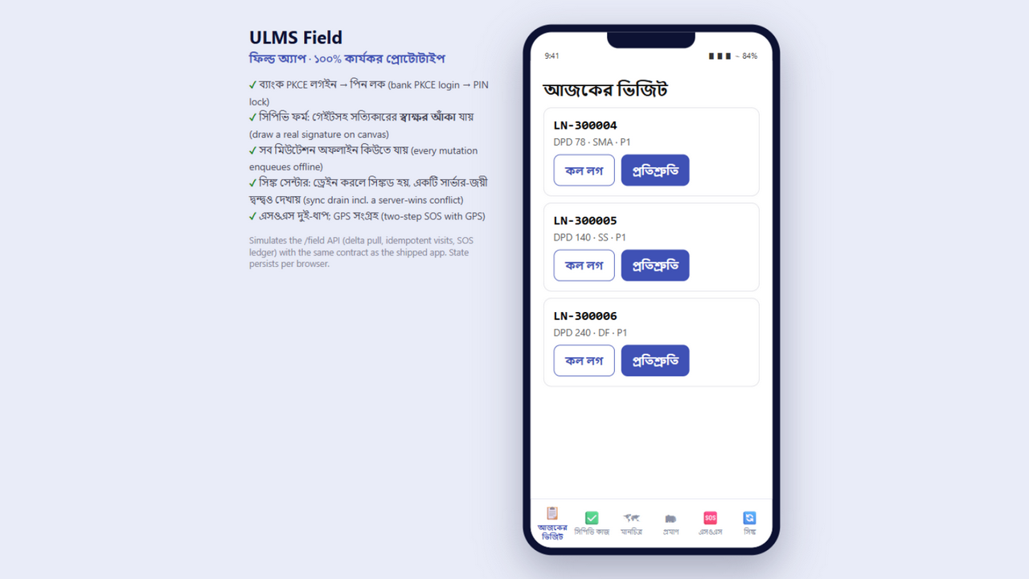
Exhibit 13 — Field app login (bank PKCE)
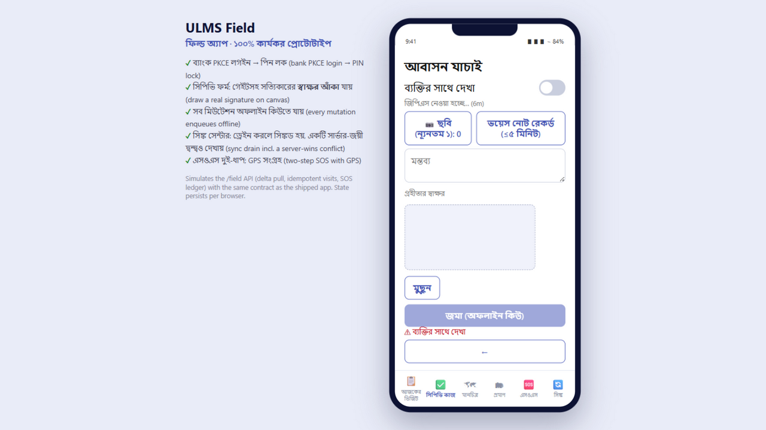
Exhibit 14 — CPV verification form with signature canvas
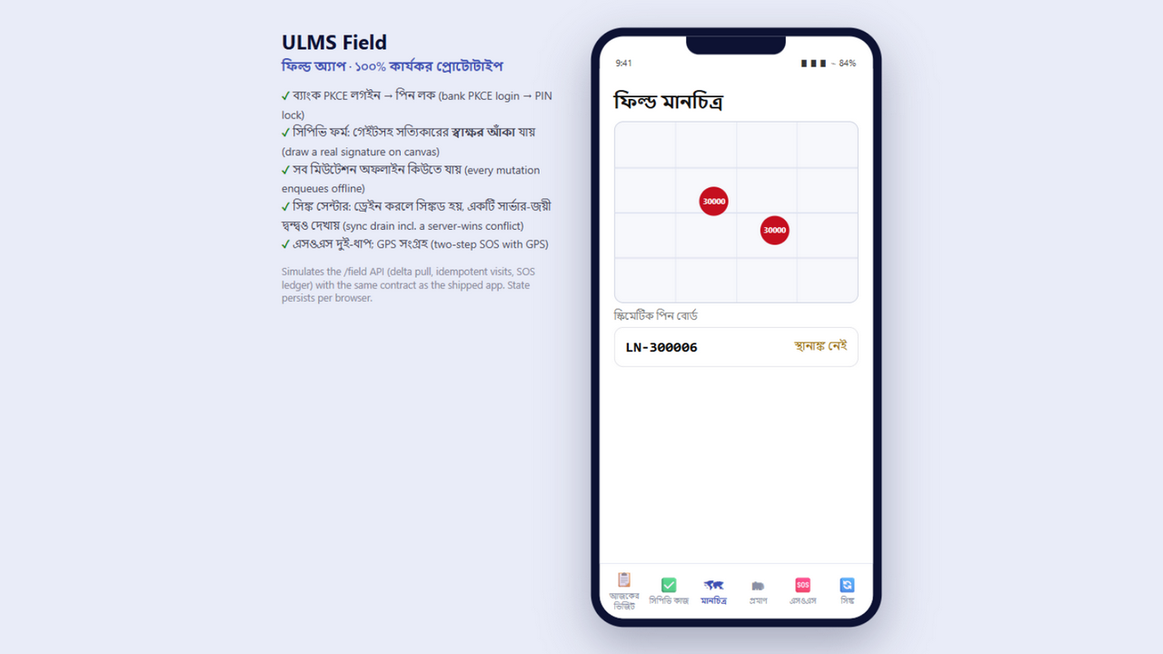
Exhibit 15 — Field map with borrower pins

6. Database Schema
18 Flyway migrations (V1__origination_workflow → V18__field_gateway) own the schema — JPA validates, never generates. Key aggregates: customers + KYC/screening, applications + workflow tasks/transitions (signature evidence on approvals), loans + payments, approval_band config, watchlist/auction/field_visit/SOS ledgers, outbox_event (ADR-004) and the WORM audit_entry.
Migration | Introduces
V1–V4 | Origination + workflow, CIB/compliance, concurrency & audit, actor widths
V5–V9 | Collateral, CIB pull tables, concurrency, servicing/collections, collections parity
V10–V14 | R3-R5 modules (products/sanctions/BOCC/outbox), R10 business logic depth
V15 | Q3 UAT flips: signature evidence, goAML, Basel parallel-run
V16–V17 | Q1 depth: approval conditions, watchlist, auctions
V18 | Field gateway: idempotent visits, SOS ledger, task pins

7. Deployment Guide (step by step)
Three environments ship: local dev (mock, zero Docker), verification compose (8 services), and the bank k3s cluster via Helm. Prerequisites: Docker, Node 20+, and the .env values from .env.example.
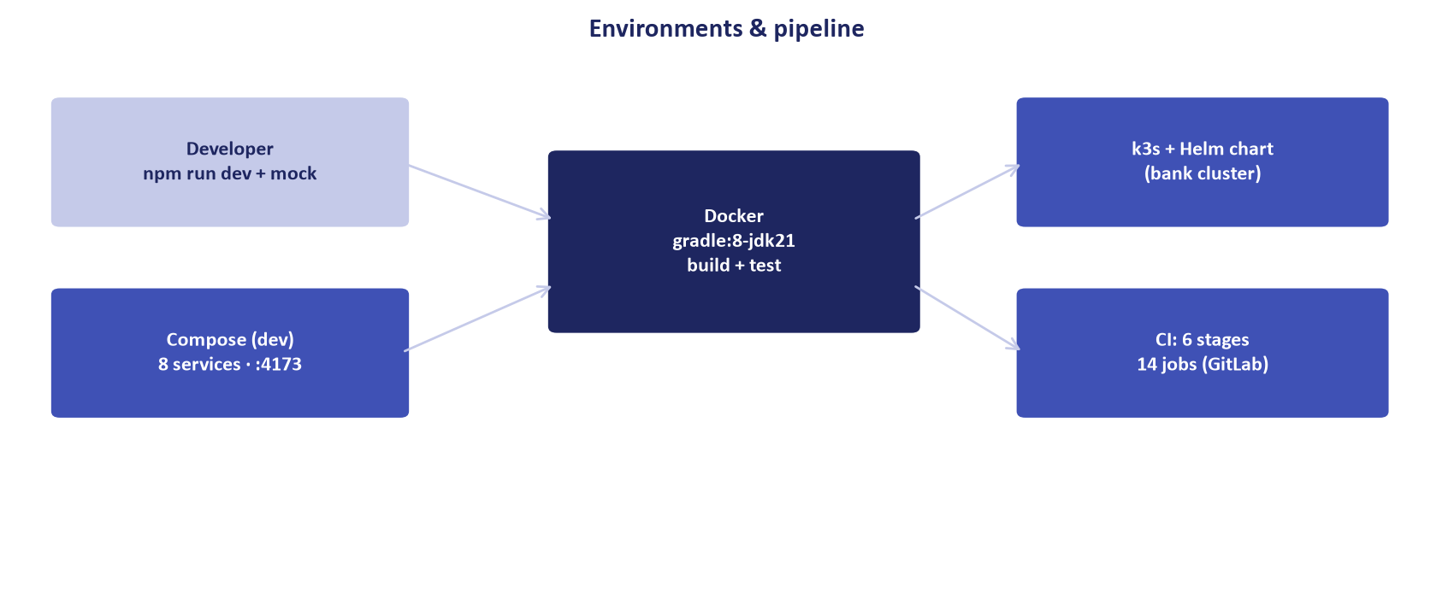
Exhibit 16 — Environments and pipeline

7.1 Local development (mock API)
cd LMS_CODEBASE/apps/web
npm install
npm run mock:api # in-memory OpenAPI mock on :8081
npm run dev # Vite on :5173 (mock wired in)

7.2 Verification stack (real services)
cd LMS_CODEBASE/deploy/compose
cp ../../.env.example .env # fill values
docker compose up -d # 8 services; healthchecks gate readiness
# staff web → http://localhost:4173 (Keycloak MFA login)

7.3 Bank cluster (k3s + Helm)
docker build -t ulms-api:p1 LMS_CODEBASE/apps/api
docker build -t ulms-web:p1 LMS_CODEBASE/apps/web
helm upgrade --install ulms deploy/chart/ulms --atomic

7.3a Scheduled jobs (Asia/Dhaka)
Schedule | Job
*/15 min | Workflow SLA scan — warn 80%, breach, auto-escalate at SLA+50%
23:30 | EOD batch — DPD, BRPD classification, provisions, interest suspense
02:00 | Regcon WORM pack generation
02:15 | Collections watchlist nightly scan (auto STD-2 flags)
02:20 | Regcon return refresh after WORM anchor
03:15 | KYC refresh due-dates (1/2/3-year cadence)
04:00 | Regulatory push drill trigger
06:00 | Dunning-ladder pass (DPD buckets)
08:00 | EMI-D3 reminders (ahead of the banking day)
every 5s | Outbox relay (ADR-004) — at-least-once, idempotent consumers

7.3b Operational runbooks (RB-01–RB-12)
Runbook | Covers
RB-02 | Database backup & restore (verified drill)
RB-03 | EOD rerun
RB-05 | CIB outage queue handling
RB-06 | Secret rotation
RB-08 | Release rollback
RB-11/11A | Live-integration flip matrix (mock→bank, values-only)
RB-12 | Data migration rehearsal (45k loans, zero-sum verified)

7.4 Mobile release builds
# Android (signed APK — produced)
cd mobile_app && bash mobileapp_apk/android/build-apk.sh
# → mobileapp_apk/android/ulms-borrower-release.apk
# iOS: expo prebuild project at mobileapp_apk/apple/ios-project (needs Mac/EAS)
FLIP RUNBOOK Mock→live cutover is values-only per RB-11A: profile flips (cib-live, nidw-live, rails-live, cbs-live, sms-live) + build-time VITE_USE_MOCK_API=0 — no code changes.

8. Testing & Quality Gates
Every layer has an executable gate; the numbers below are from the recorded full runs in this workspace (Java full suite re-run at each phase gate; latest 193/0 across 52 classes).
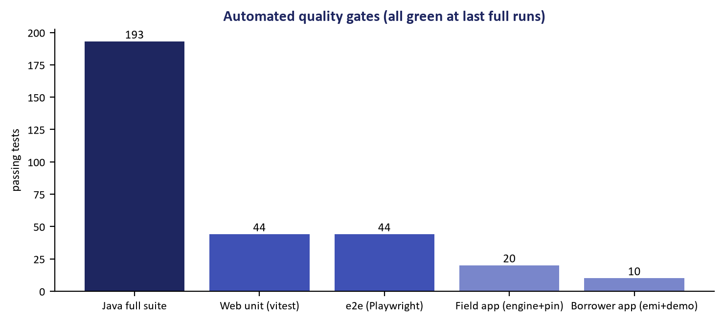
Exhibit 17 — Automated gates by suite
Suite | Scope | How to run
Java (193) | Modulith, BRPD/ECL/Basel oracles, WireMock contracts, journeys | Docker gradle:8-jdk21 test (Testcontainers PG17)
Web unit (44) | Money math parity, search indexing, PIN, bilingual templates | npm run test:unit
e2e (44) | Login→sanction→disburse, portal OTP, WCAG axe gate (7 surfaces) | cd e2e && npx playwright test
Field app (20) | Offline sync engine, backoff, PIN core, field-gateway ops | cd apps/mobile && npm test
Borrower app (10) | EMI parity with bank oracle, demo brain (OTP/bounds/pay) | cd mobile_app && npm test

9. Enhancement & Extension Guide
The vertical-slice recipe for a new capability (the same path every R10/Q1 module followed):
1. Entity + Flyway migration (V19+) — JPA validates; never generate.
2. Repository + service (business rules + @PreAuthorize gate), unit test with Testcontainers PG17.
3. Controller endpoint; add the path to packages/openapi/ulms-api.yaml (redocly must stay valid).
4. Mock route in apps/web/scripts/mockApi (contract parity for e2e without Docker).
5. Web API client + screen; mobile client where the journey needs it.
6. Playwright/vitest coverage; run the touched suites in Docker.
EXAMPLES IN REPO Collections watchlist/auctions (V17) and the field gateway (V18) are recent reference slices — each added table + service + controller + spec + mock + screen in one commit series.

10. Security & Compliance
Control | Implementation
Identity | Keycloak 26 OIDC; staff single-page login = direct grant + MFA; SSO PKCE secondary
Authorization | Role gates per endpoint; ladder-level gates on approvals; own-CIF row scope on portal
Dual control | Maker-checker ladder; triple-gated disbursement; field SOS ledger
Audit | WORM audit_entry on every mutation; workflow transitions carry signature evidence
Secrets | Env/Vault only — repo has zero usable credential literals (verified by scans)
Regulatory | BRPD 15/2024, IFRS-9, Basel III, BFIU AML (STR/CTR/goAML), 12-return Regcon
Web | CSP + nosniff + XFO headers; WCAG axe gate in e2e; bilingual including Bangla numerals

11. Mobile Applications Appendix

11.1 Borrower app (Android release shipped)
Artifact | Detail
APK | ulms-borrower-release.apk — signed (demo key), com.uslbd.ulmsborrower v0.1.0, minSdk 24, arm64
Demo login | +8801712345678 · OTP auto-fills (demo mode simulates SMS)
Modes | No EXPO_PUBLIC_API_BASE → embedded prototype simulation; set it → real /portal backend
iOS | Verified Xcode project at mobileapp_apk/apple (IPA needs Mac/EAS per Apple licensing)

11.2 Field app
Capability | Detail
Offline queue | Durable AsyncStorage queue; backoff 1/2/4/8/16s + jitter; 5-attempt cap; terminal states never reprocess
Sync rules | Task status server-wins; evidence append-only; visits idempotent by clientUuid
Security | Bank PKCE login + app-PIN lock (salted hash, 30s lockout/3 misses); biometric at EAS build
Gateway | GET /field/tasks delta + bundleVersion; POST /field/visits|ptp|sos; SOS ack desk

11.3 Known limitations, deferrals, and roadmap
Stated plainly so reviewers can plan around them — none are hidden:
- Externally bound — Live-bank cutover requires external items: CIB/NIDW/rail/CBS credentials, clustered production Keycloak, bank GitLab CI runner, EAS/MDM signing. Mechanism is the values-only RB-11A flip matrix.
- Deferred by decision — Multi-tenancy (decision D3), Islamic Murabaha (phase 4), outbox→Kafka bridge, websockets — recorded architecture decisions, revisit triggers documented.
- UX contract scope — ~120 prototype archetype screens remain reference layouts (binding UX contract, badged as such); converting them to live aggregates is the analytics workstream.
- Environment — Local Docker Desktop (host) has proven crash-prone under sustained build load; always-on demo should move to the bank k3s cluster.

11.4 Glossary
Term | Meaning
BRPD 15/2024 | Bangladesh Bank circular defining the 7-stage loan classification and provisioning
DPD | Days Past Due — drives classification stage
SMA / SS / DF / B/L | Special Mention, Substandard, Doubtful, Bad/Loss classification stages
ECL | Expected Credit Loss (IFRS-9) provisioning model
CAR / RWA | Capital Adequacy Ratio / Risk-Weighted Assets (Basel III)
STR / CTR | Suspicious / Currency Transaction Report (BFIU AML)
goAML | BFIU's XML reporting standard for AML submissions
DBR | Debt Burden Ratio — instalments over income, 50% guardrail
CPV | Contact Point Verification (field or branch)
PTP | Promise To Pay (collections)
EMI / LTV | Equated Monthly Instalment / Loan-To-Value
BOCC | Board of Directors Credit Committee
Regcon | Regulatory reporting & control (12-return catalog, WORM packs)
NIDW | National ID Wing (Election Commission e-KYC)
CBS | Core Banking System (Finacle facade with SAGA compensation)
Maker-checker | Four-eyes control: one user prepares, a different user approves

11.5 Document control
Version | Date | Author | Change
1.0 | 2026-10-05 | ULMS build agent (ZCode) | First comprehensive release — architecture, 16 modules, workflows, journeys, deploy/test/enhance guides, mobile appendix, glossary

12. Exhibits Index
Exhibit | Content
1 / 17 | Program KPIs · automated gates
2 | Component architecture
3 | Endpoints by module
4 | BRPD stages & provisioning
5 | Approval ladder
6–9 | Staff production screens (home, pipeline, board, collections)
10–12 | Borrower app (login, home, pay)
13–15 | Field app (login, CPV form, map)
16 | Environments & pipeline

