Exercises
Q1. How many rows are in penguins? How many columns? (Hint, use google to help
you)

[1] 344 8

Q2. What does the bill_depth_mm variable in the penguins data frame describe? Read
the help for ?penguins to nd out.

penguins {palmerpenguins} | R Documentation

Size measurements for adult foraging penguins near Palmer Station, Antarctica

Description
Includes measurements for penguin species, island in Palmer Archipelago, size (flipper length, body mass, bill dimensions), and sex. This is a subset of penguins_raw.

Usage
penguins

Format
A tibble with 344 rows and 8 variables:
species
a factor denoting penguin species (Adélie, Chinstrap and Gentoo)
island
a factor denoting island in Palmer Archipelago, Antarctica (Biscoe, Dream or Torgersen)
bill_length_mm
a number denoting bill length (millimeters)
bill_depth_mm
a number denoting bill depth (millimeters)
flipper_length_mm
an integer denoting flipper length (millimeters)
body_mass_g
an integer denoting body mass (grams)
sex
a factor denoting penguin sex (female, male)
year
an integer denoting the study year (2007, 2008, or 2009)

Source
Adélie penguins: Palmer Station Antarctica LTER and K. Gorman. 2020. Structural size measurements and isotopic signatures of foraging among adult male and female Adélie penguins (Pygoscelis adeliae) nesting along the Palmer Archipelago near Palmer Station, 2007-2009 ver 5. Environmental Data Initiative. doi: 10.6073/pasta/98b16d7d563f265cb52372c8ca99e60f
Gentoo penguins: Palmer Station Antarctica LTER and K. Gorman. 2020. Structural size measurements and isotopic signatures of foraging among adult male and female Gentoo penguin (Pygoscelis papua) nesting along the Palmer Archipelago near Palmer Station, 2007-2009 ver 5. Environmental Data Initiative. doi: 10.6073/pasta/7fca67fb28d56ee2ffa3d9370ebda689
Chinstrap penguins: Palmer Station Antarctica LTER and K. Gorman. 2020. Structural size measurements and isotopic signatures of foraging among adult male and female Chinstrap penguin (Pygoscelis antarcticus) nesting along the Palmer Archipelago near Palmer Station, 2007-2009 ver 6. Environmental Data Initiative. doi: 10.6073/pasta/c14dfcfada8ea13a17536e73eb6fbe9e
Originally published in: Gorman KB, Williams TD, Fraser WR (2014) Ecological Sexual Dimorphism and Environmental Variability within a Community of Antarctic Penguins (Genus Pygoscelis). PLoS ONE 9(3): e90081. doi:10.1371/journal.pone.0090081

Q3. Make a scatterplot of bill_depth_mm vs. bill_length_mm. That is, make a scat-
terplot with bill_depth_mm on the y-axis and bill_length_mm on the x-axis. De-
scribe the relationship between these two variables.

library(ggplot2)
library(palmerpenguins)

ggplot(data = penguins, aes(x = bill_length_mm, y = bill_depth_mm, color = species)) +
geom_point(alpha = 0.8) +
theme_minimal() +
labs(title = "Bill Depth vs. Bill Length",
x = "Bill Length (mm)",
y = "Bill Depth (mm)",
color = "Species")

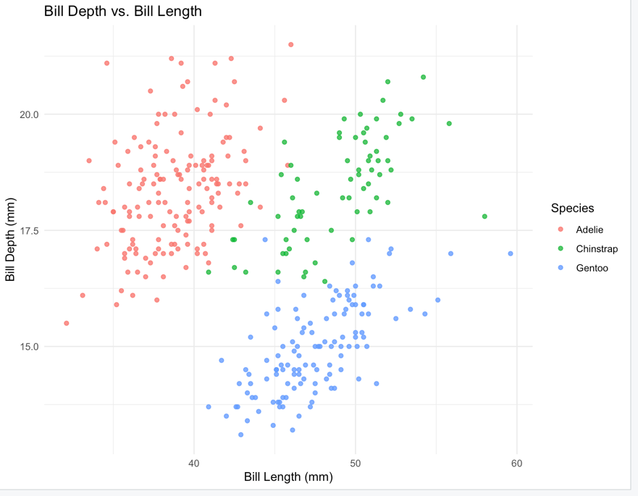

Q4. What happens if you make a scatterplot of species vs. bill_depth_mm? What
might be a better choice of geom?

> ggplot(data = penguins, aes(x = species, y = bill_depth_mm, fill = species)) +
+ geom_boxplot() +
+ theme_minimal() +
+ labs(title = "Bill Depth Distribution by Species",
+ x = "Species",
+ y = "Bill Depth (mm)",
+ fill = "Species")

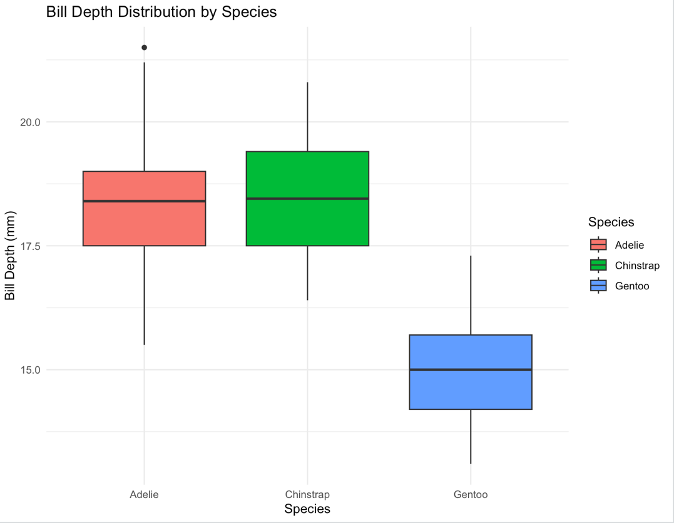

Q5. Why does the following give an error and how would you x it?

The error message you're encountering is because geom_point() requires both x and y aesthetics to be defined, but you haven't specified them. In ggplot2, the x and y arguments are used to define the variables that will be plotted on the x and y axes, respectively.

To fix this error, you need to specify which variables from the penguins dataset you want to plot on the x and y axes. Here's an example:

library(ggplot2)
library(palmerpenguins)

ggplot(data = penguins, aes(x = flipper_length_mm, y = body_mass_g)) +
geom_point() +
theme_minimal()
Explanation of the code:

ggplot(data = penguins, aes(x = flipper_length_mm, y = body_mass_g)): This initializes the ggplot system with the penguins dataset and sets the aesthetic mappings for the plot. Here, flipper_length_mm is plotted on the x-axis and body_mass_g on the y-axis.
geom_point(): This adds a layer of points to the plot. Since x and y are defined in the ggplot() function, geom_point() knows which variables to plot.
theme_minimal(): This applies a minimal theme to the plot.
Remember to replace flipper_length_mm and body_mass_g with the variables you are interested in if you want to plot something else.

Q6. What does the na.rm argument do in geom_point()? What is the default value of
the argument? Create a scatterplot where you successfully use this argument set
to TRUE.

The na.rm argument in geom_point() is used to remove any points with missing (NA) values from the plot. If na.rm is set to TRUE, any row in the data that has an NA value for either the x or y variable will be excluded from the plot. The default value of na.rm is FALSE, which means that by default, geom_point() does not remove points with NA values.

Below is an example of how to use the na.rm argument set to TRUE:

> library(ggplot2)
> library(palmerpenguins)
>
> # Create a scatterplot with na.rm = TRUE
> ggplot(data = penguins, aes(x = flipper_length_mm, y = body_mass_g)) +
+ geom_point(na.rm = TRUE) +
+ theme_minimal()

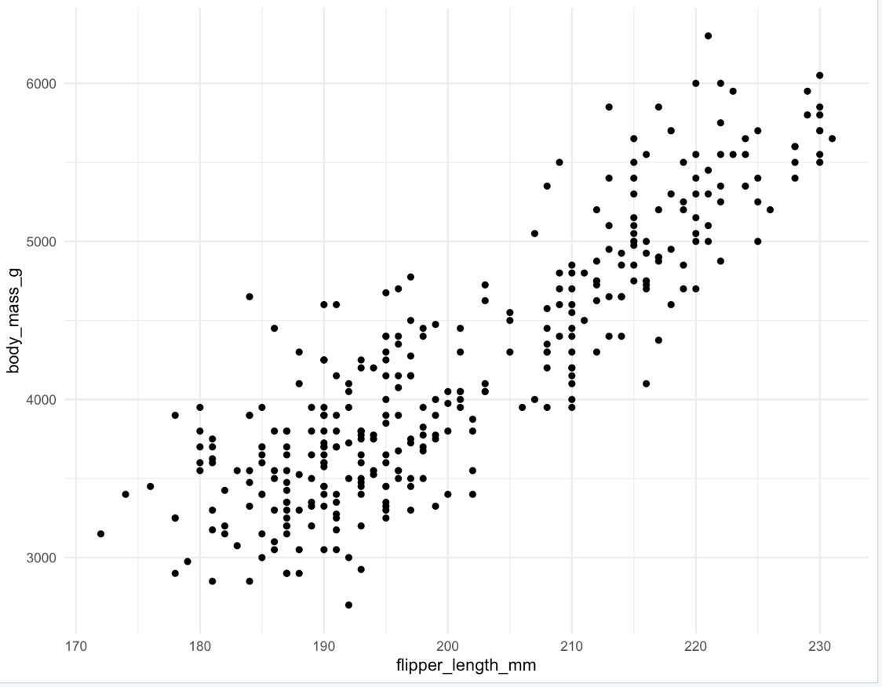

Q7. Add the following caption to the plot you made in the previous exercise: Data
come from the palmerpenguins package. Hint: Take a look at the documentation
for labs().

# Create a scatterplot with na.rm = TRUE and add a caption
ggplot(data = penguins, aes(x = flipper_length_mm, y = body_mass_g)) +
geom_point(na.rm = TRUE) +
theme_minimal() +
labs(caption = "Data come from the palmerpenguins package.")

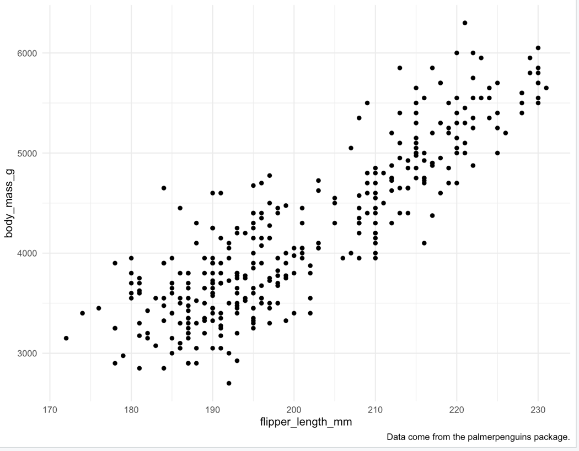

Q8. Recreate the following visualization. What aesthetic should bill_depth_mm be
mapped to? And should it be mapped at the global level or at the geom level?

library(ggplot2)
library(palmerpenguins)

# Scatter plot with body_mass_g on the y-axis and flipper_length_mm on the x-axis
# Color represents bill_depth_mm in shades of blue
p <- ggplot(data = penguins, aes(x = flipper_length_mm, y = body_mass_g, color = bill_depth_mm)) +
geom_point(size = 3, alpha = 0.8) + # Set point size and transparency
scale_color_gradient(low = "lightblue", high = "darkblue") + # Set the color gradient for bill_depth_mm
geom_smooth(method = "lm", se = TRUE, color = "blue", fill = "lightgray", size = 1.5, linetype = "solid") + # Add linear regression line with shaded confidence interval
theme_minimal() + # Use a minimal theme
labs(title = "Penguin Body Mass vs. Flipper Length",
x = "Flipper Length (mm)",
y = "Body Mass (g)",
color = "Bill Depth (mm)")

# Print the plot
print(p)

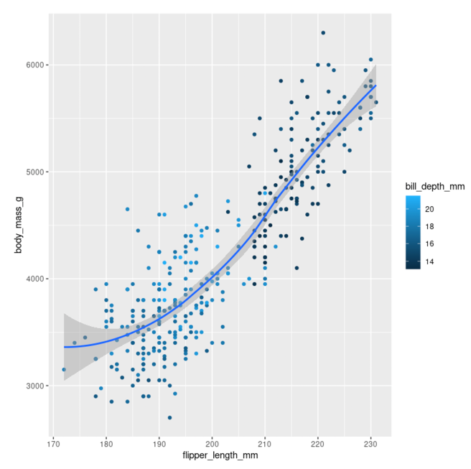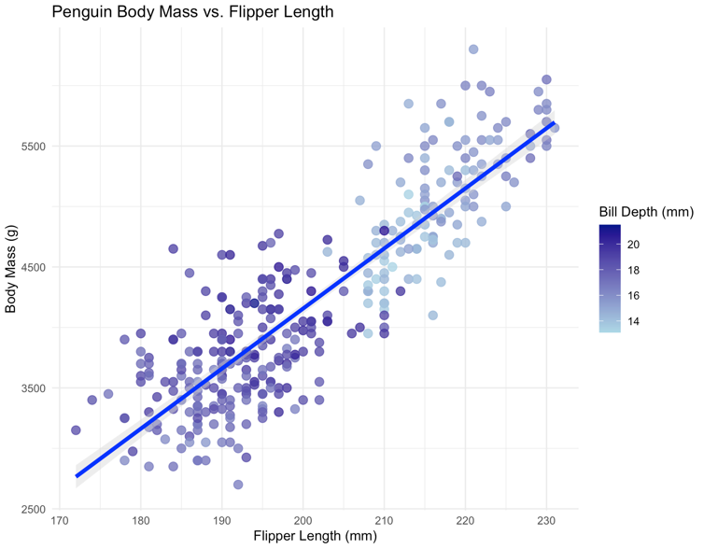

Q9. Run this code in your head and predict what the output will look like. Then, run
the code in R and check your predictions.

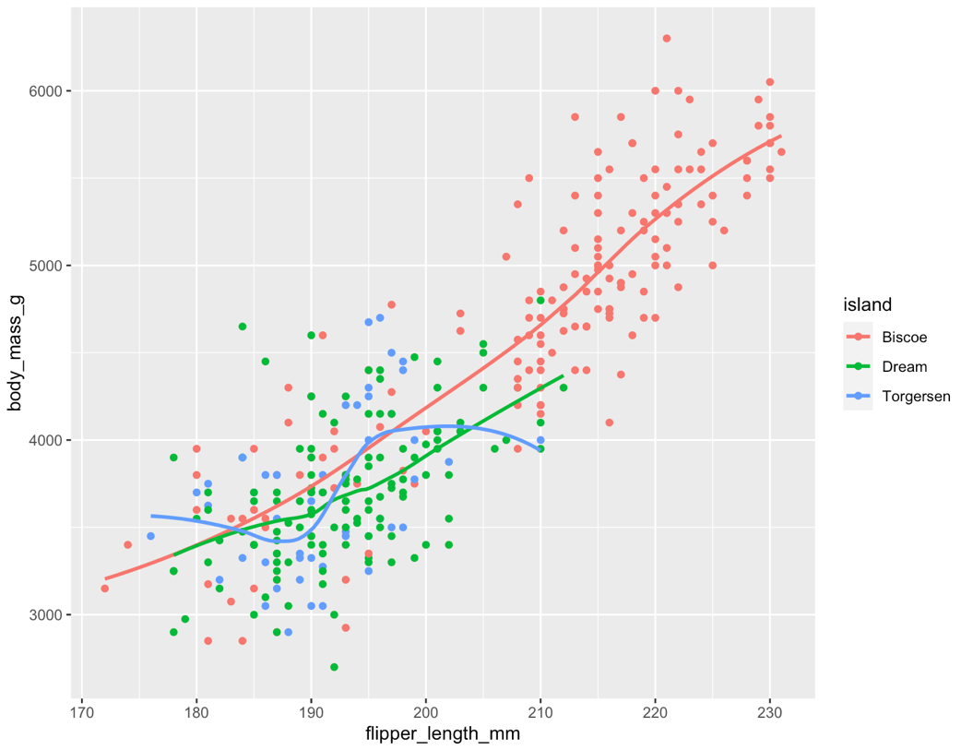

Q10. Will these two graphs look different? Why/why not?

ggplot(
data = penguins,
mapping = aes(x = flipper_length_mm, y = body_mass_g)
) +
geom_point() +
geom_smooth()

ggplot() +
geom_point(
data = penguins,
mapping = aes(x = flipper_length_mm, y = body_mass_g)
) +
geom_smooth(
data = penguins,
mapping = aes(x = flipper_length_mm, y = body_mass_g)
)

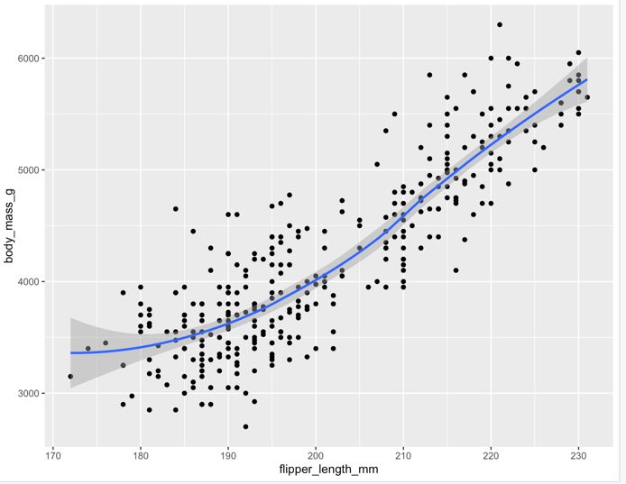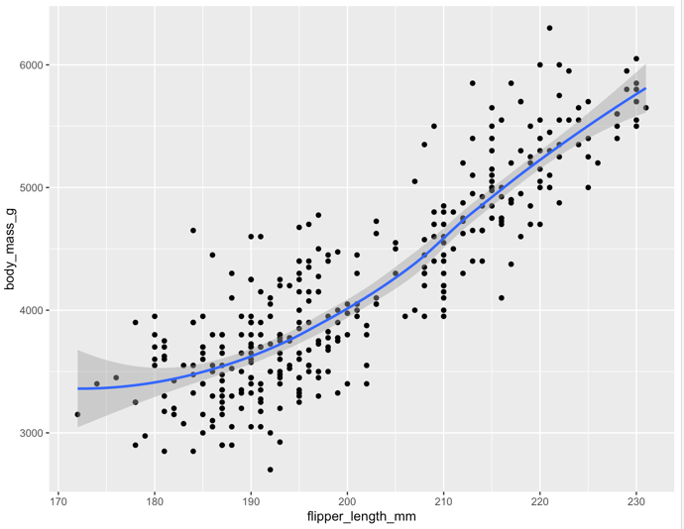

They will appear the same.

