For Age vs bodyfat we have correlation coefficient r = 0.291. It’s tricky to interpret this so we construct a scatterplot.
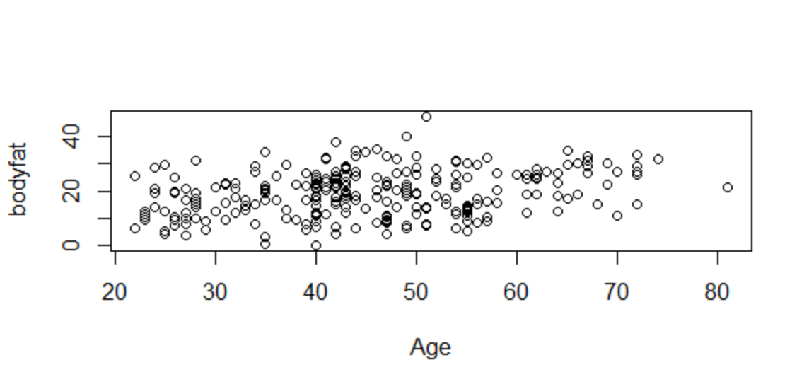
It’s difficult to say anything definitive about the relationship between Age and bodyfat. Our model is

Bodyfat = 0.19Age + 10.46

We append this line to our scatterplot to obtain
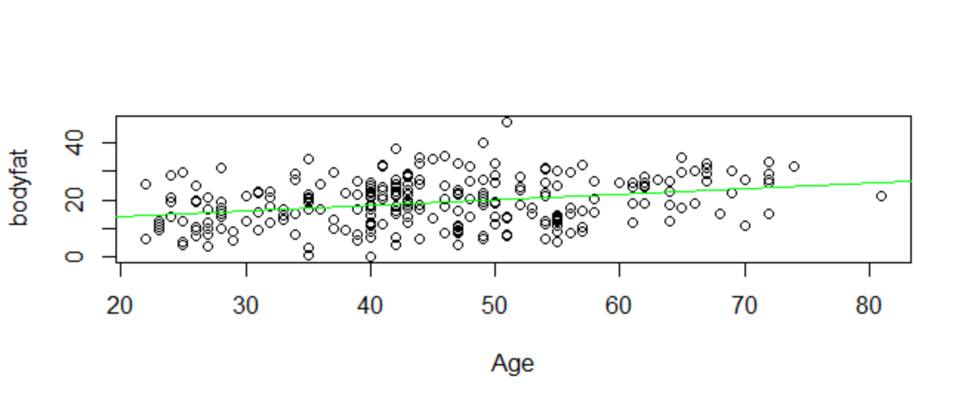
There seems to be a weak positive linear relationship between Age and bodyfat but we can also see that there are many data points which are quite far from the regression line. We should be quite cautious about using our model for any predictive analysis of the relationship.

