Exploratory Data Analysis of the BodyFat dataset in R

Liam Naughton

7CS039 Statistics for AI & Data Science

1. Introduction

In this report we present an exploratory data analysis conducted using R [1] of the BodyFat dataset adapted from [2]. The dataset contains the estimates of the percentage of body fat determined by underwater weighing and various body circumference measurements for 252 men under the following heading

- Age (years)
- Weight (lbs)
- Height (inches)
- Neck circumference (cm)
- Chest circumference (cm)
- Abdomen 2 circumference (cm)
- Hip circumference (cm)
- Thigh circumference (cm)
- Knee circumference (cm)
- Ankle circumference (cm)
- Biceps (extended) circumference (cm)
- Forearm circumference (cm)
- Wrist circumference (cm)

2. Data Summary

2.1 Numerical Summary

Numerical summaries of each of the columns in the data set are shown below.

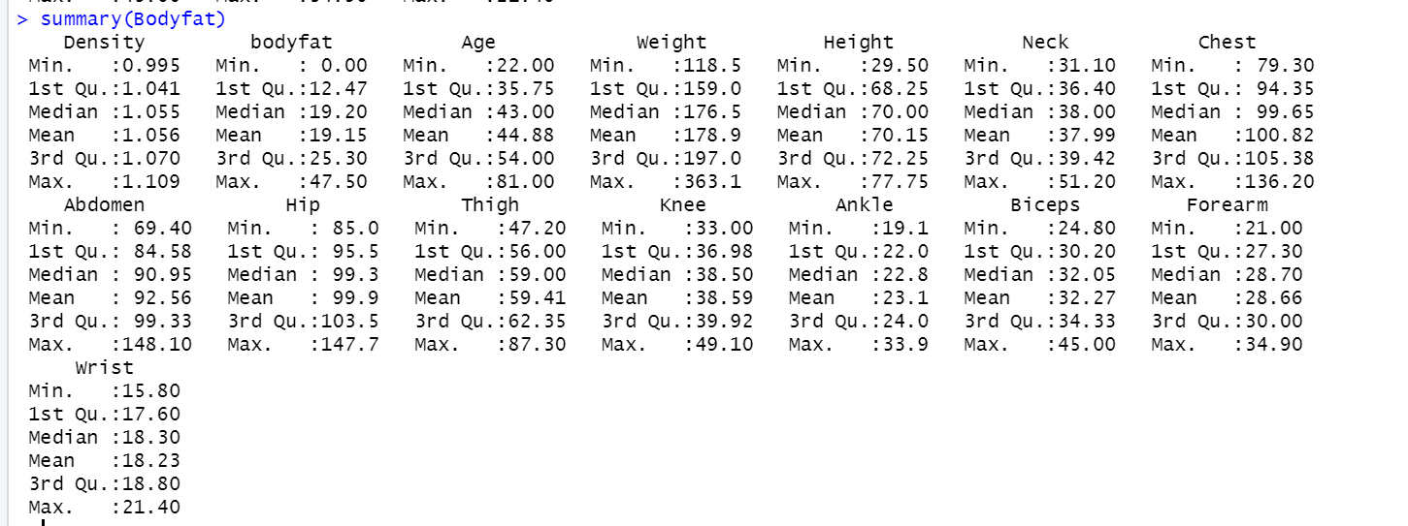

Note to self – Bodyfat min is zero what does that mean?
Note to self – Weight max is very high?
Comment on any extreme values, are they present for all variables? Are they likely to be outliers?

2.2 Graphical Summary

Graphical summaries of the variables are shown below.

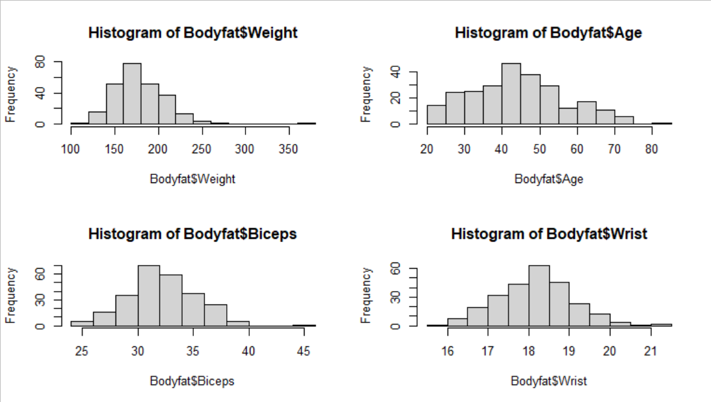

In the histogram for Weight we observe a single extremely high value. This is likely to be an outlier and we are mindful that this value may have an undue influence on our analysis.

3. Regression Analysis

The scatter plot below

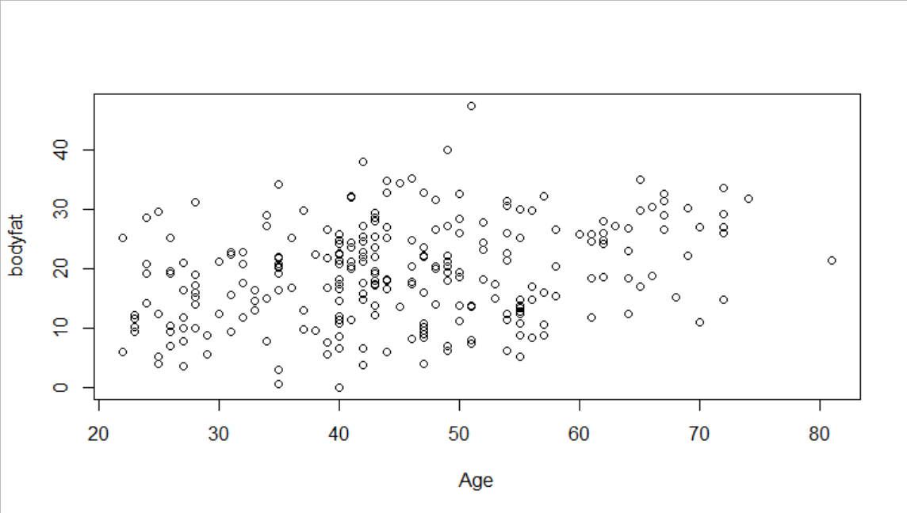
From the plot we observe a week positive linear relationship between the two variable.

Type in the regression line.

4. Commentary

As in lab 3 I want you to discuss the relationships between the variables, taking into account the correlation coefficients.

5. Significance Test

Only necessary to use p values to make conclusion here – there is no need to mention the test statistic. Tell me the tests that you do and the associated p value and then draw conclusions as appropriate.

References

[1] R Core Team (2020). R: A language and environment for statistical computing. R Foundation for Statistical Computing, Vienna, Austria.
URL https://www.R-project.org/

[2] Roger W. Johnson (1996), ''Fitting Percentage of Body Fat to Simple Body Measurements'', Journal of Statistics Education.

