MAZA Platform Engineering Documentation
Version 0.2
Generated from the current repositories on 2026-04-20
This document supersedes the narrative content in Maza App Documentation V.01.docx and aligns the documentation with the current Expo app, CRM, and Strapi backend.

- Expo mobile and web app: C:\Users\User\Documents\UNICEF\coisas\org.maza.app
- Strapi backend: C:\Users\User\Documents\UNICEF\maza-strapi-backend
- CRM/admin console: C:\Users\User\Documents\UNICEF\maza-crm

1. Executive Summary
MAZA is a three-part platform composed of an Expo-based mobile application, a Strapi backend, and a CRM web application. The CRM is the operational interface used to create and manage content. Strapi is the system of record and integration layer. The Expo app is the end-user delivery channel for learning content, career guidance, opportunities, profile data, and certificates.
- Expo app version observed in app.json: 4.4.4
- Expo SDK observed in package.json: ~54.0.33
- Primary API base URL in mobile source: https://strapi.mazas.org/api
- CRM uses an environment-driven base URL through VITE_API_URL.
- Jobs are fetched from an external WordPress API at https://www.emprego.co.mz/wp-api.

2. System Context
At runtime, the platform behaves as a content supply chain. Administrators and content teams use the CRM to create and publish subjects, journeys, and courses. The CRM writes to Strapi over authenticated REST endpoints. The Expo app reads published data from Strapi, writes user progress and profile updates back to Strapi, and uses a separate external jobs feed for opportunities.

3. Repository Responsibilities
Repository | Primary Role | Key Technologies | Operational Notes
org.maza.app | End-user mobile and web application | Expo, React Native, Expo Router, React Query, Axios | Consumes Strapi and external jobs API; distributed through EAS and exportable to web.
maza-strapi-backend | Content management API, auth, analytics, and business logic | Strapi 5, Node.js, custom users-permissions extension | Provides custom routes for courses, analytics, forum, user progress, AI survey, OTP, and certificates.
maza-crm | Admin and analytics interface for MAZA operators | Vite, React, TanStack Router, React Query, Axios | Writes directly to Strapi using JWT auth and media uploads.

4. Architecture Diagrams
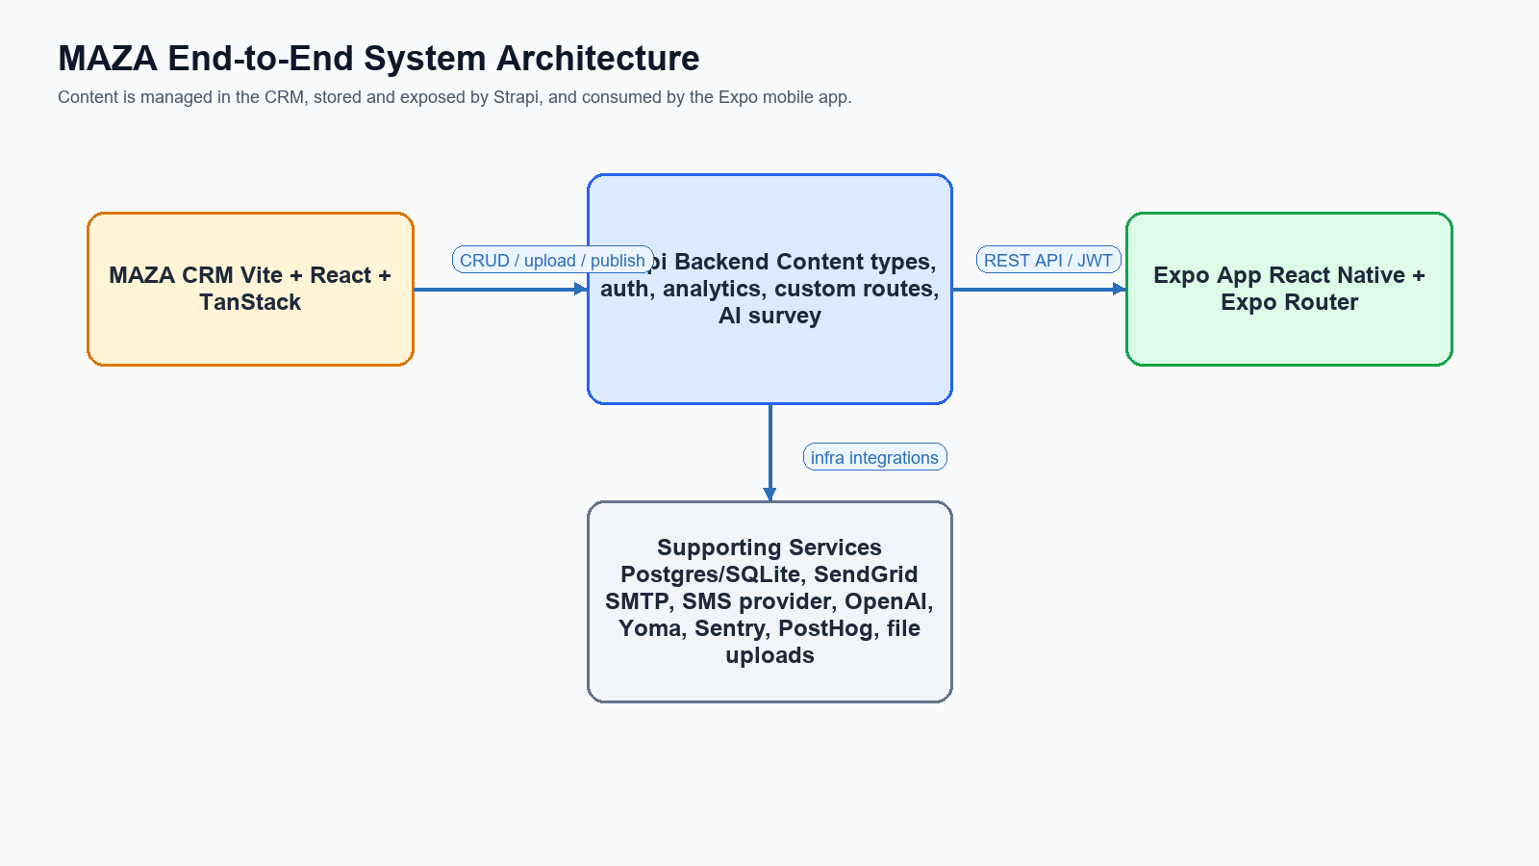
Figure 1. End-to-end system architecture
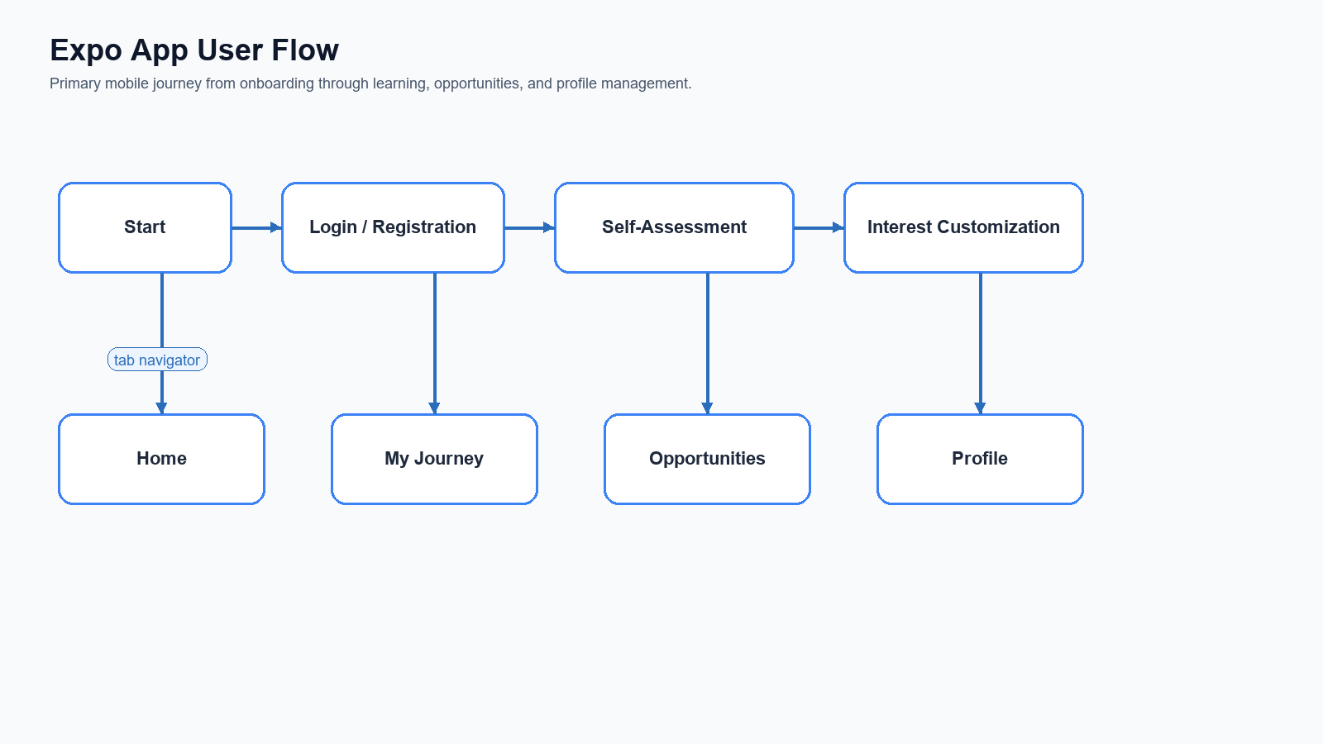
Figure 2. Primary mobile user flow
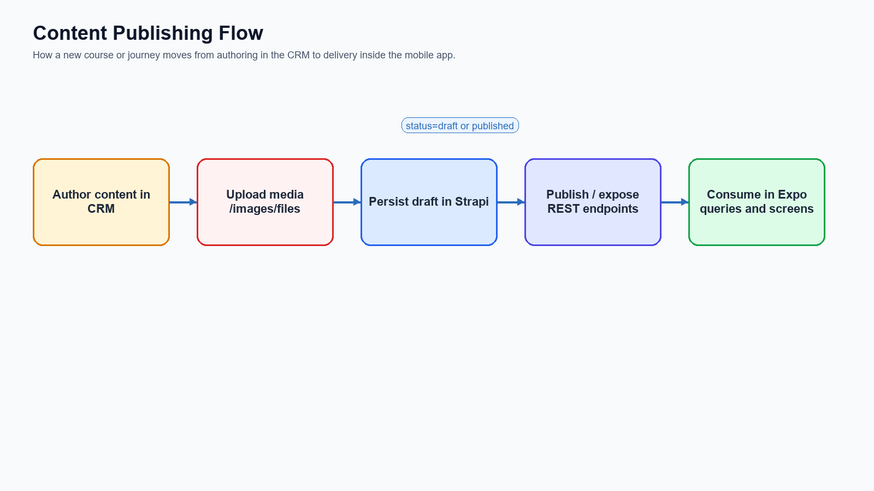
Figure 3. Content publishing and delivery flow
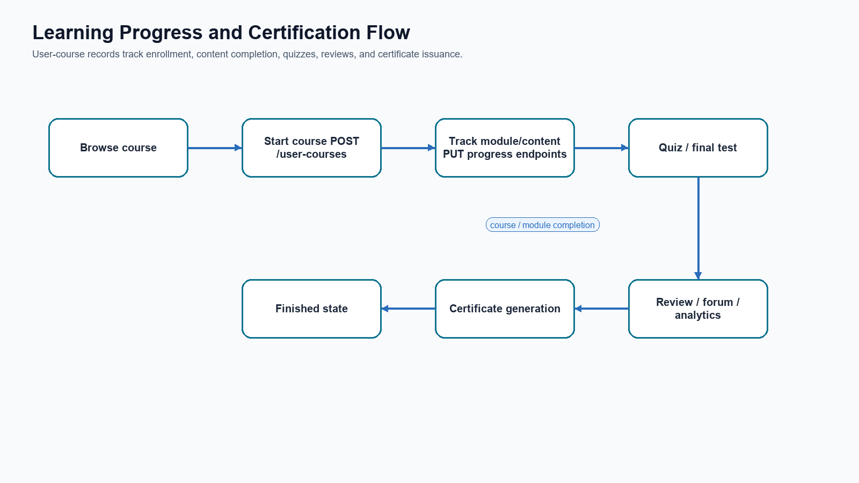
Figure 4. Course progress and certification flow
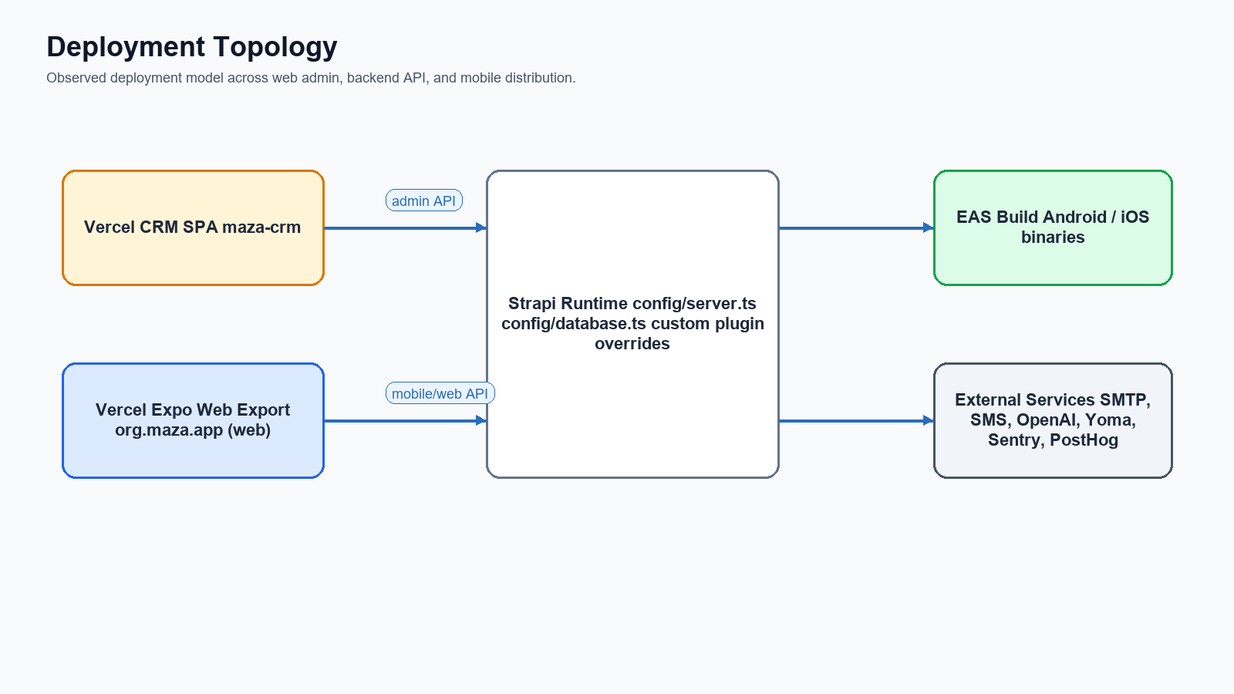
Figure 5. Deployment topology

5. Expo App Architecture
The mobile app is built as an Expo Router application with a root stack and a tab navigator. It uses React Query for server state, AsyncStorage for session persistence, Sentry for crash and performance monitoring, and PostHog for product analytics.
- Root providers include QueryClientProvider, ThemeProvider, SafeAreaProvider, Sentry, and PostHog.
- Authentication state is cached in AsyncStorage under the @user key.
- The tab shell exposes Home, My Journey, Opportunities, and Profile.
- The app includes dedicated onboarding, self-assessment, search, room, jobs, challenges, missions, and user profile flows.

5.1 Key Mobile Modules
Module | Representative Files | Responsibility
Navigation | app/_layout.tsx, app/(tabs)/_layout.tsx | Bootstraps providers and controls root and tab navigation.
Authentication | app/services/authService.ts, app/hooks/useAuthMutations.ts | OTP login, email login, registration, password reset, profile session management.
Catalog and Learning | services/catalog.ts, app/room/* | Course detail, enrollment, progress tracking, quizzes, reviews, forum, certificates.
Home and Discovery | services/home.ts, app/(tabs)/index.tsx, app/search/* | Home feed, new/popular/suggested courses, subject discovery.
Opportunities | services/jobsApi.ts, app/(tabs)/opportunities.tsx, app/jobs/* | Job discovery flow backed by external emprego.co.mz API.
Onboarding | services/self-assessment.ts, services/survey.ts, util/onboarding.ts | AI-guided self-assessment, route gating, interest customization.
Observability | utils/analytics.ts, @sentry/react-native | User identification, screen tracking, runtime telemetry.

5.2 Observed Route Inventory
Route File | Purpose
(tabs)/_layout.tsx | Feature screen or supporting route.
(tabs)/courses.tsx | Learning journey tab.
(tabs)/index.tsx | Home tab.
(tabs)/opportunities.tsx | Jobs/opportunities tab.
(tabs)/profile.tsx | Profile tab.
+html.tsx | Feature screen or supporting route.
+not-found.tsx | Feature screen or supporting route.
_layout.tsx | Application root layout and provider tree.
challenges/[id].tsx | Feature screen or supporting route.
challenges/index.tsx | Feature screen or supporting route.
jobs/[slug].tsx | Job detail.
jobs/search.tsx | Job search results.
journeys/[id].tsx | Journey detail.
journeys/index.tsx | Journey listing.
login/create-email.tsx | Feature screen or supporting route.
login/forgot-password.tsx | Feature screen or supporting route.
login/index.tsx | Phone-first login entry.
login/login-email.tsx | Email/password login.
login/otp.tsx | OTP verification.
login/reset-password.tsx | Feature screen or supporting route.
missions/index.tsx | Feature screen or supporting route.
missions/questions.tsx | Feature screen or supporting route.
missions/streaks.tsx | Feature screen or supporting route.
missions/warning.tsx | Feature screen or supporting route.
modal.tsx | Generic modal screen.
onboarding/_layout.tsx | Feature screen or supporting route.
The complete route inventory contains 47 files and is reproduced in Annex A.

5.3 Mobile Dependencies
Dependency | Observed Version
expo | ~54.0.33
expo-router | ~6.0.21
@tanstack/react-query | ^5.64.2
axios | 1.12.0
@sentry/react-native | ~7.2.0
posthog-react-native | ^4.23.0
react-native-pdf | ^7.0.3
react-native-youtube-iframe | ^2.4.1

6. Integration Architecture
The integration model is API-first. Both the CRM and Expo app call Strapi over REST. The mobile app combines authenticated and unauthenticated endpoints, while the CRM authenticates operators and then performs content CRUD, publishing, upload, analytics, and user management operations.

6.1 Mobile to Strapi
Capability | Endpoint Pattern | Notes
Profile retrieval | GET /users/me | JWT-protected; used by onboarding, profile, and session refresh.
Email/OTP login | POST /auth/login | Supports password and OTP variants in the same route.
OTP request | POST /otps | Phone-first authentication bootstrap.
Registration | POST /users | Creates mobile user and may trigger Yoma account creation asynchronously.
Survey/self-assessment | POST /users-permissions/survey | Custom AI-backed conversational assessment route.
Interests | POST/DELETE /users-permissions/interests | Connects and disconnects user interests.
Catalog | GET /courses, /courses/{id}, /subjects, /journeys | Drives home, search, and journey flows.
Enrollment/progress | POST/GET/PUT /user-courses... | Tracks course state, content completion, and quiz grades.
Community | GET/POST /courses/{id}/forum... | Forum comments and replies.
Reviews | GET/POST /reviews | Course reviews.
Certificates | GET /certificates | Certificate retrieval after course completion.

6.2 CRM to Strapi
CRM Area | Endpoint Pattern | Purpose
Authentication | POST /auth/crm | Role-restricted login for crm_admin, crm_editor, crm_analytics.
Courses | GET /courses/all, GET /courses/{id}, POST /courses, PUT /courses/{id} | Create/edit/publish learning content.
Media | POST /upload | Uploads course images and generic assets.
Journeys | GET/POST/PUT /journeys | Learning pathway management.
Subjects | GET/POST/PUT /subjects | Category and subject management.
Analytics | GET /events/stats/*, /courses/stats/* | Dashboard counts and trend data.
Users | GET/PUT/DELETE /users... | Profile inspection, role changes, and account blocking/deactivation.

6.3 External Services
Service | Repository Touchpoint | Role
emprego.co.mz WordPress API | Expo app services/jobsApi.ts | External job opportunities feed.
OpenAI API | Strapi users-permissions extension | Conversational self-assessment and recommendation engine.
Yoma API | Strapi users-permissions extension | External youth account creation / identity linkage.
SMS Provider (MozeSMS / Wei / Twilio) | Strapi OTP and environment config | OTP delivery and phone verification workflows.
SendGrid / SMTP | Strapi plugins.ts | Email delivery and system messaging.
PostHog | Expo app | Product analytics and user/session identification.
Sentry | Expo app | Crash, trace, and performance monitoring.

7. Strapi Backend Architecture
The backend is a Strapi 5 application extended through custom APIs, content-type lifecycle hooks, and a substantial override of the users-permissions plugin. It functions as both a CMS and the core application backend for MAZA.
- Primary custom APIs include analytics, certificate, course, event, journey, OTP, review, subject, and user-course.
- The users-permissions plugin is extended for mobile login, CRM login, AI self-assessment, interests management, and admin-controlled user updates/deactivation.
- The backend logs key product events such as account creation, login success/failure, profile updates, and assessment completion.
- Database configuration supports sqlite and postgres; local development defaults to sqlite while production-oriented settings include PostgreSQL parameters.

7.1 Core Content and Domain Objects
Domain Object | Purpose | Observed Related Files
Course | Primary learning unit with content modules, forum, reviews, and statistics. | src/api/course/*
Subject | Topic/category layer used for organization and filtering. | src/api/subject/*
Journey | Learning pathway tying together categories/courses. | src/api/journey/*
User-Course | Enrollment, progress, quiz completion, and state tracking. | src/api/user-course/*
Certificate | Issued after completion and exposed to the mobile app. | src/api/certificate/*
Event | Analytics and audit event storage. | src/api/event/*
OTP | Authentication helper for phone-based access. | src/api/otp/*

7.2 Backend Runtime Configuration
- config/server.ts exposes host, port, URL, proxy, and Strapi app keys.
- config/plugins.ts configures users-permissions JWT lifetime to 180 days and email delivery via nodemailer/SMTP.
- config/middlewares.ts loosens frameguard and adds custom CSP allowances for localhost and S3 media.
- The AWS S3 upload provider is present but currently commented in config/plugins.ts, which suggests either local or alternate upload behavior in the observed state.

7.3 AI Self-Assessment Implementation
The self-assessment is handled server-side inside the users-permissions extension. The server builds a developer prompt in Portuguese, injects demographic context from the authenticated user, and calls the OpenAI Chat Completions API. When the assistant emits the sentinel token ###SURVEY_DONE###, Strapi stores the final recommendation back onto the user profile and logs an ASSESS_SURVEY event.

8. CRM Architecture
The CRM is a Vite-based React SPA organized around TanStack Router and React Query. It is the operational surface for content creation, publication, uploads, analytics dashboards, and user administration. Its API client is fully environment-driven through VITE_API_URL and injects the CRM JWT token on each request.
Area | Representative Files | Responsibility
API Client | src/lib/api-client.ts | Base URL, auth token injection, and 401 handling.
Course Management | src/http/courses/*, routes/dashboard/courses/* | Course CRUD, publish/unpublish, image uploads, course builder UX.
Journey Management | src/http/journeys/* | Journey list/detail and mutations.
Subject Management | src/http/subjects/* | Subject CRUD and subject analytics.
Analytics | src/http/analytics/queries.ts | Signups, active users, course engagement, password resets, certificate downloads, trends.
User Management | src/http/users/* | User lookup, update, role changes, and deactivation workflows.
The CRM README still contains template TanStack content, so the implementation source is currently a more reliable source of truth than the repository README.

9. Deployment and Environments

9.1 Expo App
- app.json defines bundle/package identifier org.maza.app for both iOS and Android.
- EAS profiles include development, staging, preview, and production.
- vercel.json exports a static web build using `npx expo export --platform web` with SPA rewrites.
- Observed production API endpoint in source is hardcoded to https://strapi.mazas.org/api.

9.2 CRM
- The CRM is configured as a Vercel-style SPA with a catch-all rewrite to /index.html.
- Environment variable VITE_API_URL points the CRM to the Strapi API base.
- Production build command is `pnpm build` and local development runs with `pnpm dev` on port 3000.

9.3 Strapi Backend
- The backend exposes develop, start, build, and deploy scripts plus a local setup script.
- config/database.ts supports sqlite for local work and postgres for production deployments.
- Deployment requires APP_KEYS, JWT secrets, database connection values, SMTP/SMS config, and API keys for OpenAI and Yoma if those integrations are enabled.

9.4 Minimal Release Workflow
- Update or create content in the CRM.
- Publish content through Strapi-backed endpoints so the mobile app can see the published variant.
- Verify catalog and journey payloads through Strapi or the CRM list views.
- Build mobile binaries with EAS for Android/iOS as needed.
- Deploy CRM and backend changes to their hosting targets.
- Smoke-test mobile login, onboarding, course enrollment, opportunities, and certificate retrieval against production APIs.

10. Operations, Monitoring, and Security
Concern | Observed Mechanism | Notes
Crash monitoring | Sentry in Expo root layout | Initialized outside development mode.
Product analytics | PostHog in Expo app | User identified by documentId plus name/identifier metadata.
JWT auth | Strapi users-permissions | CRM and mobile flows use different login entry points.
Session storage | AsyncStorage in Expo, local auth storage in CRM | Mobile stores user session under @user.
Rate limiting | users-permissions rateLimit middleware | Applied to auth routes configured in the extension.
Email and SMS | SMTP and SMS providers in Strapi config | Requires production-grade credentials and sender identities.

11. Observed Risks and Alignment Notes
- The mobile README is outdated. It lists older versions and historical API endpoints that do not match current source files.
- The mobile API layer hardcodes the production Strapi URL in services/api.ts while .env.example advertises EXPO_PUBLIC_BASE_URL. This creates configuration drift risk.
- util/onboarding.ts checks whether `survey` is an array, but the backend self-assessment persists survey recommendations as a string. This may cause onboarding completion checks to misbehave.
- The CRM README is still template boilerplate and does not document the actual domain model or deployment process.
- Course publishing in CRM currently sets a hardcoded publishedAt timestamp in one mutation path, which should be replaced with a runtime timestamp or dedicated publish route usage.
- Several files show encoding artifacts in Portuguese strings. Documentation, UI validation, and API messages would benefit from a repository-wide encoding cleanup.

12. Mermaid Appendix
The following Mermaid blocks can be reused in Markdown documentation, wiki pages, PRs, or engineering knowledge bases.

System Architecture
flowchart LR
CRM["MAZA CRM"]
STRAPI["Strapi Backend"]
APP["Expo App"]
EXT["OpenAI / Yoma / SMTP / SMS / Analytics"]
CRM -->|CRUD / publish / upload| STRAPI
APP -->|JWT-authenticated reads and writes| STRAPI
STRAPI --> EXT
APP -->|Jobs feed| JOBS["emprego.co.mz WP API"]

User Journey
flowchart LR
Start --> Login
Login --> Assessment
Assessment --> Interests
Interests --> Home
Home --> Journey
Home --> Opportunities
Home --> Profile
Journey --> Room
Room --> Certificate

Content Publishing
flowchart LR
Author["Author in CRM"] --> Upload["Upload media"]
Upload --> Draft["Save draft in Strapi"]
Draft --> Publish["Publish content"]
Publish --> Query["Expo queries data"]
Query --> Render["Render course/journey in app"]

Learning Progress
flowchart LR
Browse --> Enroll["POST /user-courses"]
Enroll --> Watch["Complete content"]
Watch --> Quiz["Module quiz / final test"]
Quiz --> Finish["Finished state"]
Finish --> Certificate["Generate / fetch certificate"]
Finish --> Review["Review and analytics events"]

Annex A. Full Route Inventory
Route File | Purpose
(tabs)/_layout.tsx | Feature screen or supporting route.
(tabs)/courses.tsx | Learning journey tab.
(tabs)/index.tsx | Home tab.
(tabs)/opportunities.tsx | Jobs/opportunities tab.
(tabs)/profile.tsx | Profile tab.
+html.tsx | Feature screen or supporting route.
+not-found.tsx | Feature screen or supporting route.
_layout.tsx | Application root layout and provider tree.
challenges/[id].tsx | Feature screen or supporting route.
challenges/index.tsx | Feature screen or supporting route.
jobs/[slug].tsx | Job detail.
jobs/search.tsx | Job search results.
journeys/[id].tsx | Journey detail.
journeys/index.tsx | Journey listing.
login/create-email.tsx | Feature screen or supporting route.
login/forgot-password.tsx | Feature screen or supporting route.
login/index.tsx | Phone-first login entry.
login/login-email.tsx | Email/password login.
login/otp.tsx | OTP verification.
login/reset-password.tsx | Feature screen or supporting route.
missions/index.tsx | Feature screen or supporting route.
missions/questions.tsx | Feature screen or supporting route.
missions/streaks.tsx | Feature screen or supporting route.
missions/warning.tsx | Feature screen or supporting route.
modal.tsx | Generic modal screen.
onboarding/_layout.tsx | Feature screen or supporting route.
onboarding/self-assessment.tsx | AI self-assessment interview.
onboarding/survey.tsx | Survey-driven onboarding.
path/index.tsx | Feature screen or supporting route.
path/types.ts | Feature screen or supporting route.
room/certificate.tsx | Certificate view/download.
room/html-viewer.tsx | Feature screen or supporting route.
room/lessons.tsx | Course lesson navigation.
room/pdf-viewer.tsx | Feature screen or supporting route.
room/picture-viewer.tsx | Feature screen or supporting route.
room/quiz.tsx | Quiz and final test handling.
room/text-viewer.tsx | Feature screen or supporting route.
room/watch.tsx | Video/content playback.
search/index.tsx | Feature screen or supporting route.
start/customize.tsx | Interest personalization.
start/index.tsx | Feature screen or supporting route.
start/language.tsx | Feature screen or supporting route.
start/photo.tsx | Feature screen or supporting route.
user/certificate.tsx | Feature screen or supporting route.
user/certificates.tsx | Feature screen or supporting route.
user/change-password.tsx | Feature screen or supporting route.
user/edit.tsx | Feature screen or supporting route.

Annex B. Environment Variables
Repository | Variable | Purpose
Expo app | EXPO_PUBLIC_BASE_URL | Declared example env var for API base URL; not currently used by services/api.ts.
Expo app | EXPO_PUBLIC_POSTHOG_API_KEY | Initializes PostHog analytics client.
CRM | VITE_API_URL | Points the CRM to Strapi API base URL.
Strapi | SERVER_ADDRESS | Public server URL used by config/server.ts.
Strapi | DATABASE_* / DATABASE_URL | Database connection configuration.
Strapi | OPENAI_API_* | AI survey provider configuration.
Strapi | SMTP_* / SENDGRID_API_KEY | Email delivery settings.
Strapi | YOMA_* | External youth account provisioning.
Strapi | MOZESMS_* / TWILIO_* / WEI_* | OTP and SMS integration settings.

Annex C. Build Profiles
Profile | Internal Distribution | Env Overrides | Platform Notes
development | yes | {} | {"developmentClient": true, "android": {"gradleCommand": ":app:assembleDebug", "buildType": "apk"}}
staging | yes | {"EXPO_PUBLIC_ENVIRONMENT": "staging"} | {"android": {"buildType": "apk"}, "ios": {"buildConfiguration": "Release"}}
preview | yes | {} | {"android": {"buildType": "apk"}}
production | no | {"EXPO_PUBLIC_ENVIRONMENT": "production"} | {"autoIncrement": true}

Annex D. Document Metadata
- Source document reviewed: C:\Users\User\Documents\MAZA\Maza App Documentation V.01.docx
- Generated document path: C:\Users\User\Documents\UNICEF\coisas\org.maza.app\docs\generated\Maza_App_Documentation_V02.docx
- Expo app path: C:\Users\User\Documents\UNICEF\coisas\org.maza.app
- CRM path: C:\Users\User\Documents\UNICEF\maza-crm
- Backend path: C:\Users\User\Documents\UNICEF\maza-strapi-backend
- Observed Expo version: 4.4.4

