Homework2

Maria C. Codlin

# Homework 2

Every Saturday, at the same time, a primatologist goes and sits in the forest in the morning and listens for titi monkey calls, counting the number of calls they hear in a 2 hour window from 5am to 7am. Based on previous knowledge, she believes that the mean number calls she will hear in that time is exactly 15. Let X represent the appropriate Poisson random variable of the number of calls heard in each monitoring session.

What is the probability that she will hear more than 8 calls during any given session? What is the probability that she will hear no calls in a session? What is the probability that she will hear exactly 3 calls in a session? Plot the relevant Poisson mass function over the values in range 0 ≤ x ≤ 30. Simulate 104 results from this distribution (i.e., 2 years of Saturday monitoring sessions). Plot the simulated results using hist() and use xlim() to set the horizontal limits to be from 0 to 30. How does your histogram compare to the shape of the probability mass function you plotted above?

## Notes on Poisson from R-tutor (Ignore this bit, this is notes for me)

<http://www.r-tutor.com/elementary-statistics/probability-distributions/poisson-distribution> Poisson Distribution

The Poisson distribution is the probability distribution of independent event occurrences in an interval. If λ is the mean occurrence per interval, then the probability of having x occurrences within a given interval is:

x -λ

f(x) = λ-e-- where x = 0,1,2,3,... x! Problem If there are twelve cars crossing a bridge per minute on average, find the probability of having seventeen or more cars crossing the bridge in a particular minute.

Solution The probability of having sixteen or less cars crossing the bridge in a particular minute is given by the function ppois.

ppois(16, lambda=12) # lower tail

## [1] 0.898709

#[1] 0.89871  
#Hence the probability of having seventeen or more cars crossing the bridge in a minute is in the upper tail of the probability density function.  
  
ppois(16, lambda=12, lower=FALSE) # upper tail

## [1] 0.101291

#[1] 0.10129  
#Answer: If there are twelve cars crossing a bridge per minute on average, the probability of having seventeen or more cars crossing the bridge in a particular minute is 10.1%.

# Answers

## What is the probability that she will hear more than 8 calls during any given session?

round(ppois(8, lambda=15, lower.tail=FALSE), 3)

## [1] 0.963

## What is the probability that she will hear no calls in a session?

round(ppois(0, lambda=15),7)

## [1] 3e-07

## What is the probability that she will hear exactly 3 calls in a session?

round(dpois(3, lambda=15),5) #dpois is exact while ppois is with tail

## [1] 0.00017

## Plot the relevant Poisson mass function over the values in range 0 ≤ x ≤ 30

barplot(dpois(x=0:30, lambda=15), ylim=c(0,0.15), space=0, names.arg=0:30, ylab="Probability", xlab="# of calls", col=rainbow(20))

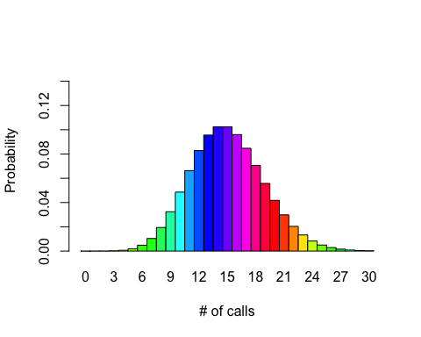

## Simulate 104 results from this distribution (i.e., 2 years of Saturday monitoring sessions). Plot the simulated results using hist() and use xlim() to set the horizontal limits to be from 0 to 30. How does your histogram compare to the shape of the probability mass function you plotted above?

sim<-rpois(n=104, lambda=15)  
hist(sim, ylim=c(0,30), xlim=c(0,30), ylab="frequency", xlab="simulated observed call count", main="simulated frequency of call counts", col="aquamarine")

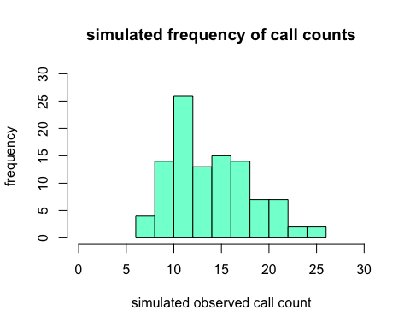

This histogram shows the simulated frequency of observed calls over a two year period. It generally seems to be a fair approximation of a normal distribution.

