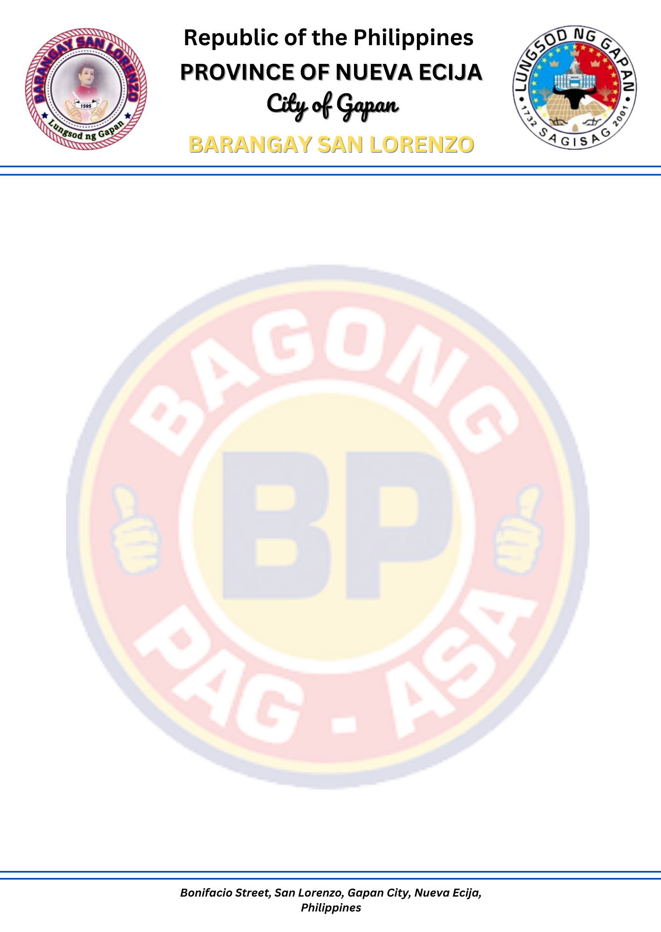
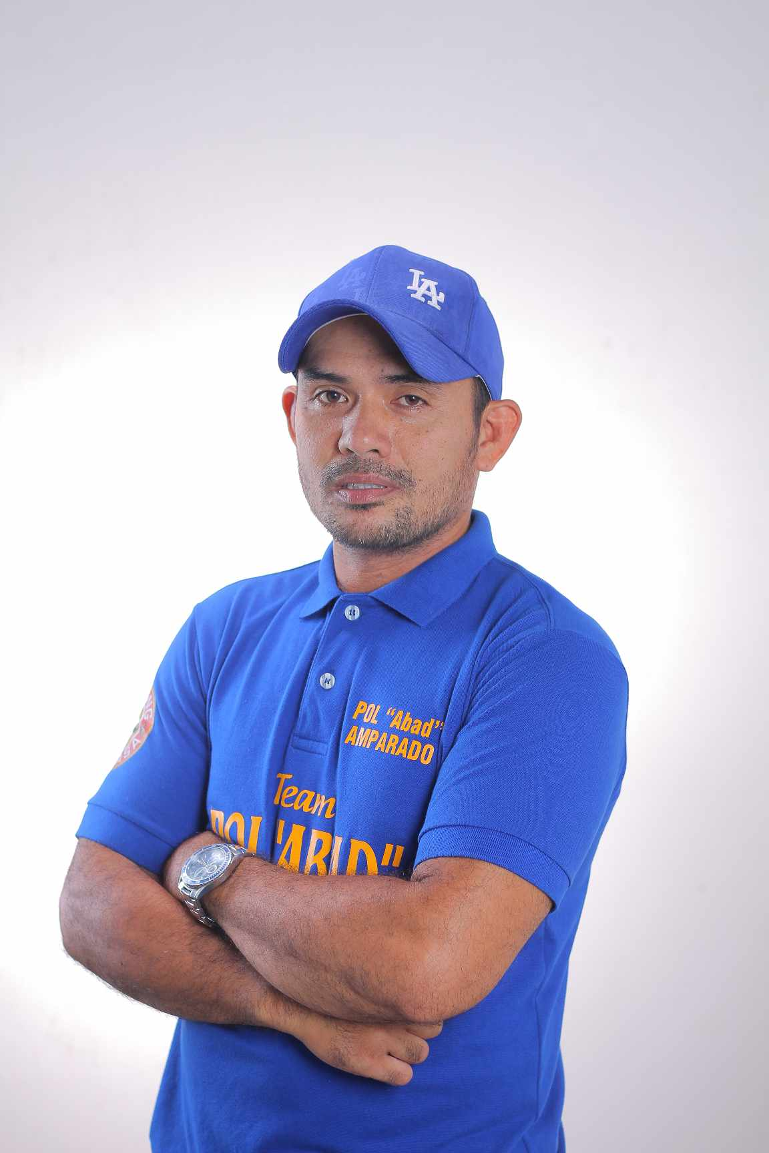

OFFICE OF THE PUNONG BARANGAY
BRGY BUSINESS PERMIT

TO WHOM IT MAY CONCERN:

This is to certify that $business name owned and managed by ${FULL_NAME} located at ${BUSINESS_ADDRESS}

This certification is issued upon request of ${FULL_NAME} for any legal puropose it may serve.

Signed this ${DAY} day of ${MONTH_YEAR}, in the City of Gapan, province of Nueva Ecija.

Signed by:

___________________________

WITNESSED BY:

WILLIAM DS. TIRRADO PAUL MICHAEL A. AMPARADO
BARANGAY SECRETARY PUNONG BARANGAY

