
Erbil Polytechnic University

Erbil technical Administrative institute

Information Management Systems – 3rd Semester

Advanced Programming C++

Function in C++

Supervised by: Samir Bilal
Mazear Kamaran
Omar Adnan Mustafa Dler
Ali Salahadin Mansour Wrea


2025-2026

Table of Contents
Introduction 1
What Is a Function in C++ ? 2
Benefits of Using Functions 3
Function Parameters and Arguments 5
Scope and Storage of Functions 8
Types of Functions in C++ 9
Summary and Learning Outcomes 10
References 11

Introduction

A function in C++ is a self-contained block of code that performs a specific and well-defined task. It serves as one of the fundamental building blocks of structured and modular programming. Functions promote efficiency, clarity, and reusability by allowing programmers to divide large and complex programs into smaller, manageable parts. Instead of repeating the same instructions throughout a program, a function can be defined once and called multiple times whenever its operation is needed.
This report explores the key concepts related to functions in C++, including their structure, purpose, and role in program organization. It examines the different types of parameters and arguments used to pass data between functions, discusses the scope and storage of functions to explain how and where variables can be accessed, and outlines the main classifications of functions—such as user-defined, library, and special types. Together, these topics provide a complete understanding of how functions operate and how they contribute to efficient and organized programming in C++.

What Is a Function in C++ ?

In C++, a function is a block of code that performs a specific task. Functions are important because they help programmers organize their work, avoid repeating code, and make programs easier to understand and manage. By using functions, large programs can be divided into smaller, simpler parts.
Every function has four main parts. The first part is the return type, which tells what kind of value the function will give back. If a function does not give back any value, the return type is void. The second part is the function name, which is used to identify and call the function. The third part is parameters, which are optional values given to the function to use when it runs. The last part is the function body, which contains the statements that perform the task.
The general form of a function can be written like this: the return type is declared first, followed by the function name, the parameters inside parentheses, and the instructions inside braces. This structure allows the program to recognize and run the function whenever it is needed.

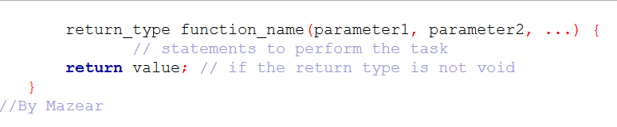

Benefits of Using Functions

Functions provide many advantages in C++ programming. One of the main benefits is reusability. A function can be written once and used many times throughout a program. This saves time and reduces errors because the same code does not need to be written repeatedly.
Functions also help keep programs organized. By dividing a program into smaller parts, each function can handle a specific task. This makes the program easier to read and understand, especially in larger programs with many operations.
Another benefit is that functions make debugging and maintenance simpler. If an error occurs, it can often be fixed inside the function without affecting other parts of the program. This improves the reliability of the program.
In addition, functions allow better collaboration. In large projects, multiple programmers can work on different functions at the same time. Each function can be tested independently, which helps save time and avoid conflicts.
Finally, functions make programs scalable. As a program grows or new features are added, functions allow these changes to be made without rewriting the entire code.
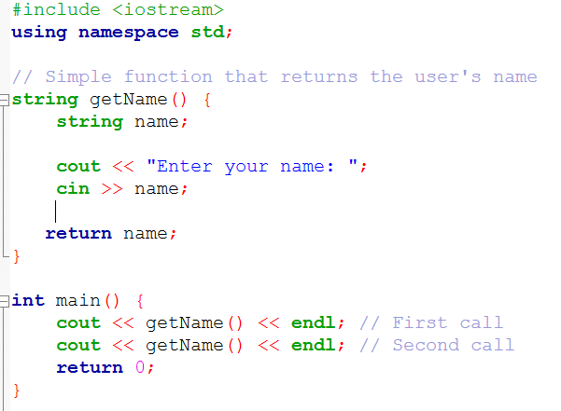
To illustrate these benefits, consider a simple example. The following function asks the user to enter their name and then displays the information. The function can be called multiple inputs.
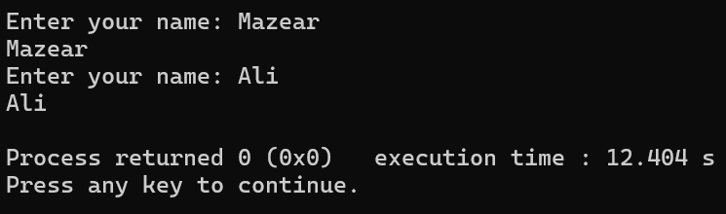

Function Parameters and Arguments

In C++, functions often need additional information to perform their tasks. This information is provided through parameters, which are variables listed in the function’s definition and act as placeholders for the values that will be used when the function is called. The actual values passed to these parameters are called arguments. Using parameters allows functions to work with different inputs without changing the function’s code.
There are several types of parameters. Input parameters allow a function to receive data and process it internally without affecting variables outside the function. Output parameters let a function modify values that are accessible outside the function, usually through references. Default parameters have predefined values that are used if no argument is provided, making the function more flexible and reducing the need for repetitive code.
It is also important to understand the distinction between formal parameters and actual arguments. Formal parameters are the variables declared in the function definition and exist only during the execution of the function. Actual arguments are the real values provided when calling the function. This distinction helps make functions reusable and adaptable to different situations.
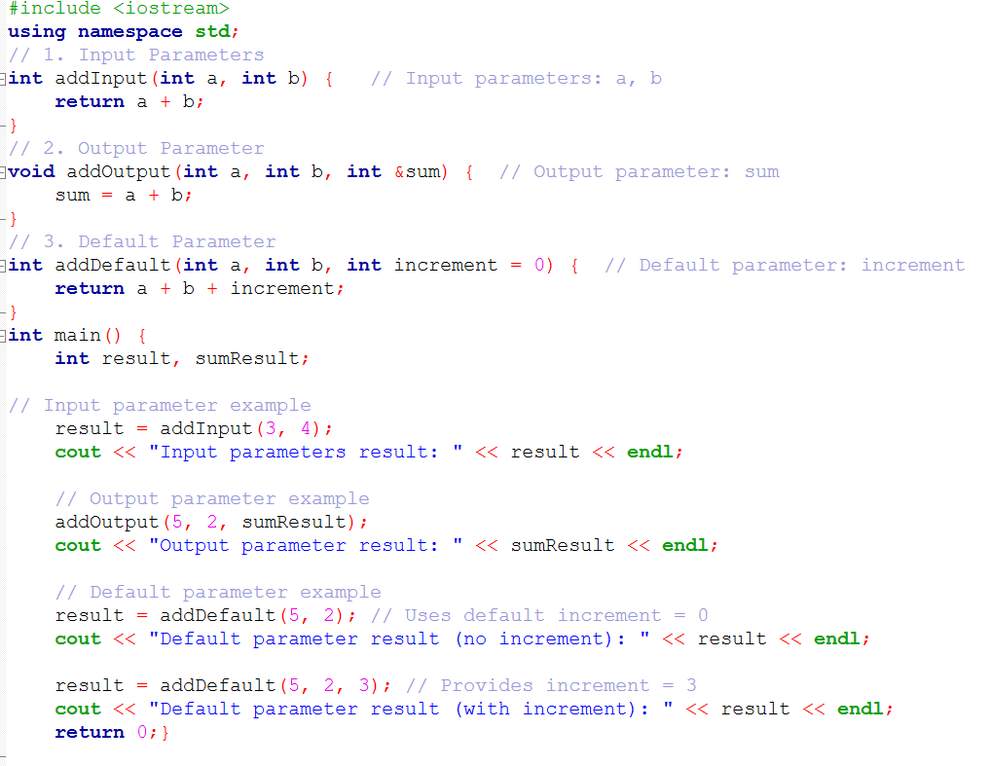
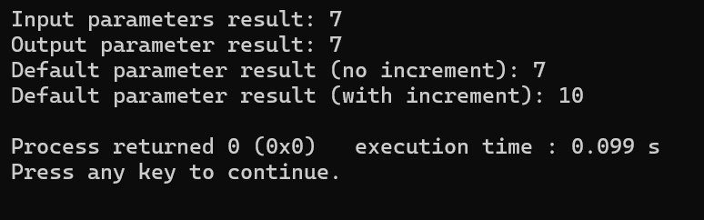

Scope and Storage of Functions

In C++, the scope of a function determines where the function and its variables can be accessed within a program. Generally, functions are defined outside the main function so they can be called from anywhere in the program. Variables declared inside a function are local to that function, meaning they can only be used within that function. This helps prevent conflicts with variables in other parts of the program and makes code easier to manage.
The storage of function variables affects their lifetime and visibility. Local variables are created when a function is called and destroyed when the function ends. Static variables, on the other hand, retain their values between function calls, allowing the function to remember information from previous executions. Global variables are declared outside any function and can be accessed by all functions in the program, but their use should be limited to avoid unexpected behavior.
Understanding the scope and storage of functions is essential for writing organized, reliable, and efficient programs. By controlling where variables can be accessed and how long they exist, programmers can reduce errors and ensure that each function works independently without interfering with others.

Types of Functions in C++

Functions in C++ can be classified based on their return type, usage, and origin. Broadly, they are divided into three categories: user-defined functions, library functions, and special types of functions.
User-defined functions are created by programmers to perform specific tasks within a program. They allow the code to be organized, reused, and easier to maintain. These functions can be further classified into value-returning functions, which perform operations and return a result to the calling part of the program, and void functions, which perform tasks without returning any value.Library functions are pre-built functions provided by C++ to simplify common tasks such as input/output operations, string handling, or mathematical calculations. Using library functions saves time and ensures reliable, tested operations, as programmers do not need to write these functionalities from scratch.
Special types of functions include inline functions, which suggest to the compiler to insert the function code directly where it is called to improve performance; recursive functions, which call themselves to solve problems in a repetitive manner; and friend functions, which are used to give access to private data of a class without being members of that class. There are also static functions, which retain their value between calls, and lambda functions, which are anonymous functions defined at the point of use, usually for short tasks.
Understanding these types of functions helps programmers select the most appropriate approach for each task, making programs more efficient, readable, and easier to manage

Summary and Learning Outcomes

This report explained the core ideas of functions in C++. It defined what a function is and described its structure—return type, name, parameters, and body—showing how functions break a program into smaller, readable, and reusable parts. It covered how parameters and arguments move data in and out of functions, including input, output, and default parameters. The report also examined scope and storage to explain how variable accessibility and lifetime work. It then reviewed different types of functions, such as user-defined, library, recursive, and inline functions, each with its own purpose. Overall, the report showed how functions improve code organization, reusability, and efficiency, helping programmers write cleaner and more scalable programs.

References

- Meyers, Scott. Effective Modern C++: 42 Specific Ways to Improve Your Use of C++11 and C++14. O’Reilly Media, 2014.

- Dewhurst, Stephen C., and Kathy T. Stark. Programming in C++. 2nd Edition, Prentice Hall PTR, 1995.

- Alexandrescu, Andrei. Modern C++ Design: Generic Programming and Design Patterns Applied. Addison-Wesley, 2001.

- Meyers, Scott. Effective C++ (Third Edition). Addison-Wesley, 200

