Heddoko desktop application Guide

# Copyright Notice

2015, 2016 Heddoko Inc. All rights reserved. Heddoko Inc. distributes this document with software that includes an end-user license agreement and is furnished under license and may be used only in accordance with the terms of the license agreement. The contents of this document are protected under copyright law. The contents of this guide are furnished for informational use only and are subject to change without notice. Heddoko Inc. assumes no responsibility or liability for any errors or inaccuracies that may appear in the informational content contained in this guide. This publication may not be copied, modified, or reproduced in any form or for any purpose, nor can any derivative works be created therefrom without Heddoko Inc.’s prior written consent. Heddoko Inc. reserves the right to revise and improve its products as it sees fit. This document describes the state of a product at the time of document’s last revision, and may not reflect the product at all times in the future. In no event shall Heddoko Inc. be liable to any person or entity with respect to any loss or damage that is incidental to or consequential upon the instructions found in this document or the computer software and hardware products described herein. The use of this document is subject to the disclaimer of liability found in the end–user license agreement. "Heddoko" is a trademark of Heddoko Inc., either registered or pending registration in several jurisdictions Other trade names used in this document may be trademarks or registered trademarks of the manufacturers or vendors of the respective products. All specifications are subject to change without notice.

# Document Information

Document title: Heddoko Desktop Application Guide

Document Number: EN.INS.0.v0.1.0

Document update date: February 2016

You can send your comments, corrections and suggestions about this guide to [Mohammed@heddoko.com](mailto:Mohammed@Heddoko.com?subject=Re:%20Heddoko%20Desktop%20Guide%20EN.INS.0.v0.1.0)

# About This Guide

This guide explains how to install and use the Heddoko Desktop application. It assumes that you are familiar with Microsoft Windows administration.

Table of Contents

Copyright Notice 2

Document Information 2

About This Guide 3

Installing Heddoko Desktop 5

Pre-installation checklist 5

Application components 6

Heddoko Launcher 6

Launch Application without a Brainpack connection 6

Launch Application with a Brainpack connection 6

Heddoko Desktop Application 8

Live View 9

Recording View 10

# Installing Heddoko Desktop

## Pre-installation checklist

* Ensure that your computer’s operating system is a minimum Microsoft® Windows 8
* Ensure that Microsoft® .NET Framework 4.5.2 is installed (<https://www.microsoft.com/en-ca/download/details.aspx?id=42642>)
* Ensure that you have a Bluetooth dongle that supports the Microsoft® Bluetooth driver stack
* Any Brainpack you wish to connect to the application needs to be paired first through Windows.

## Updating the Application

In the event that the application needs to be updated to a later day version, the previous version of the application needs to be uninstalled first. This can be done through Programs and Features and uninstalling **Heddoko Desktop**

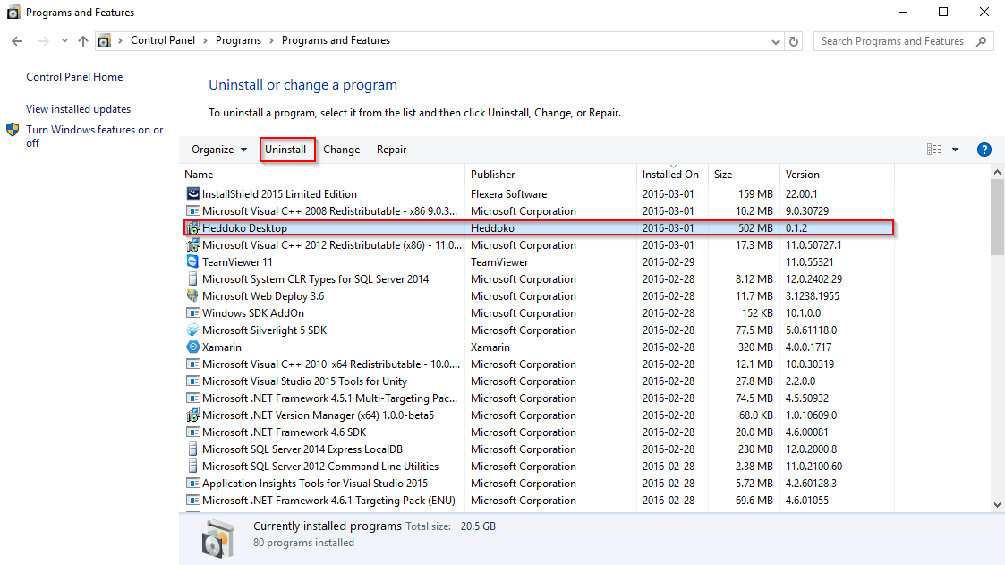

# Application components

## Heddoko Launcher

In order to be able to run the Heddoko Desktop application, you need to start it from the Heddoko launcher. This launcher allows you to set the default recordings path and search for Brainpacks in the immediate vicinity.

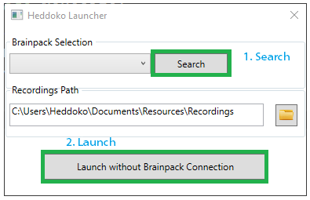

Figure 1 Heddoko Launcher

### Launching the Application without a Brainpack connection

To start the Heddoko Application without connecting to any Brainpacks, simply click on the Launch button(Figure 1). This mode lets you preview recordings copied from the Brainpack’s SD card.

### Launch Application with a Brainpack connection

Ensure that Brainpacks are located within the vicinity. Click on the Search button (Figure 1) and select the Brainpacks that will be connected to first. The Launch button will now read “Launch with Brainpack Connection”(Figure 2). If the Launcher failed to detect any Brainpacks in the vicinity, make sure that you have paired the Brainpack with Windows, then click on “Search Again”(Figure 2).

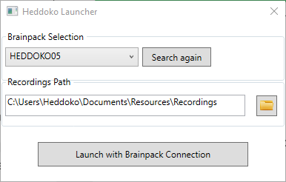

Figure 2

## Heddoko Desktop Application



Figure 3

### Live View

In order to access the live view, click on the Connect to Brainpack (figure 3), the application will switch to the Brainpack pairing view. Click on pair in order to start the pairing process. Once the avatar turns green (figure 4), the application has successfully paired with the suit.

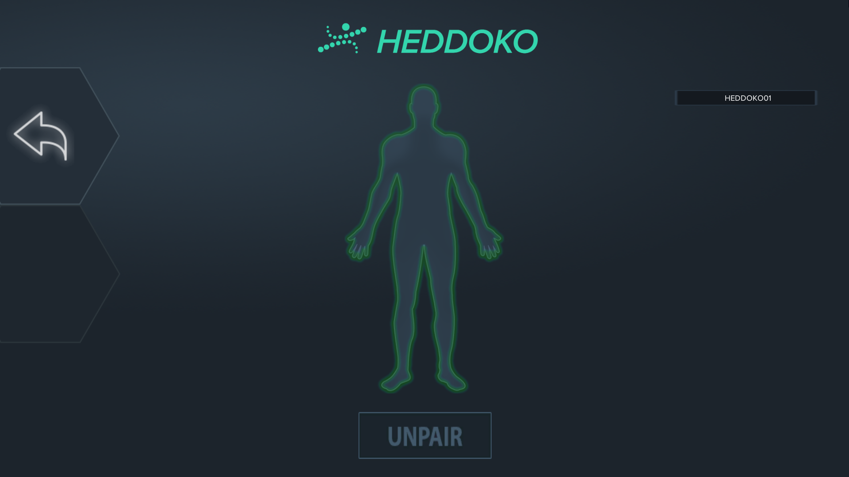

Figure 4

Click on the back button to go back to the main title and click on the Live View (figure 3) button. Once in this view, make sure that the Brainpack hardware state is set to Recording, this will ensure the application is mapping live data onto the Avatar.

### Recording View

If a default recordings folder has been selected from the Launcher, then the Recordings view will contain all possible recordings located in the selected directory (figure 5). Selecting a recording will automatically start playback of the recording.

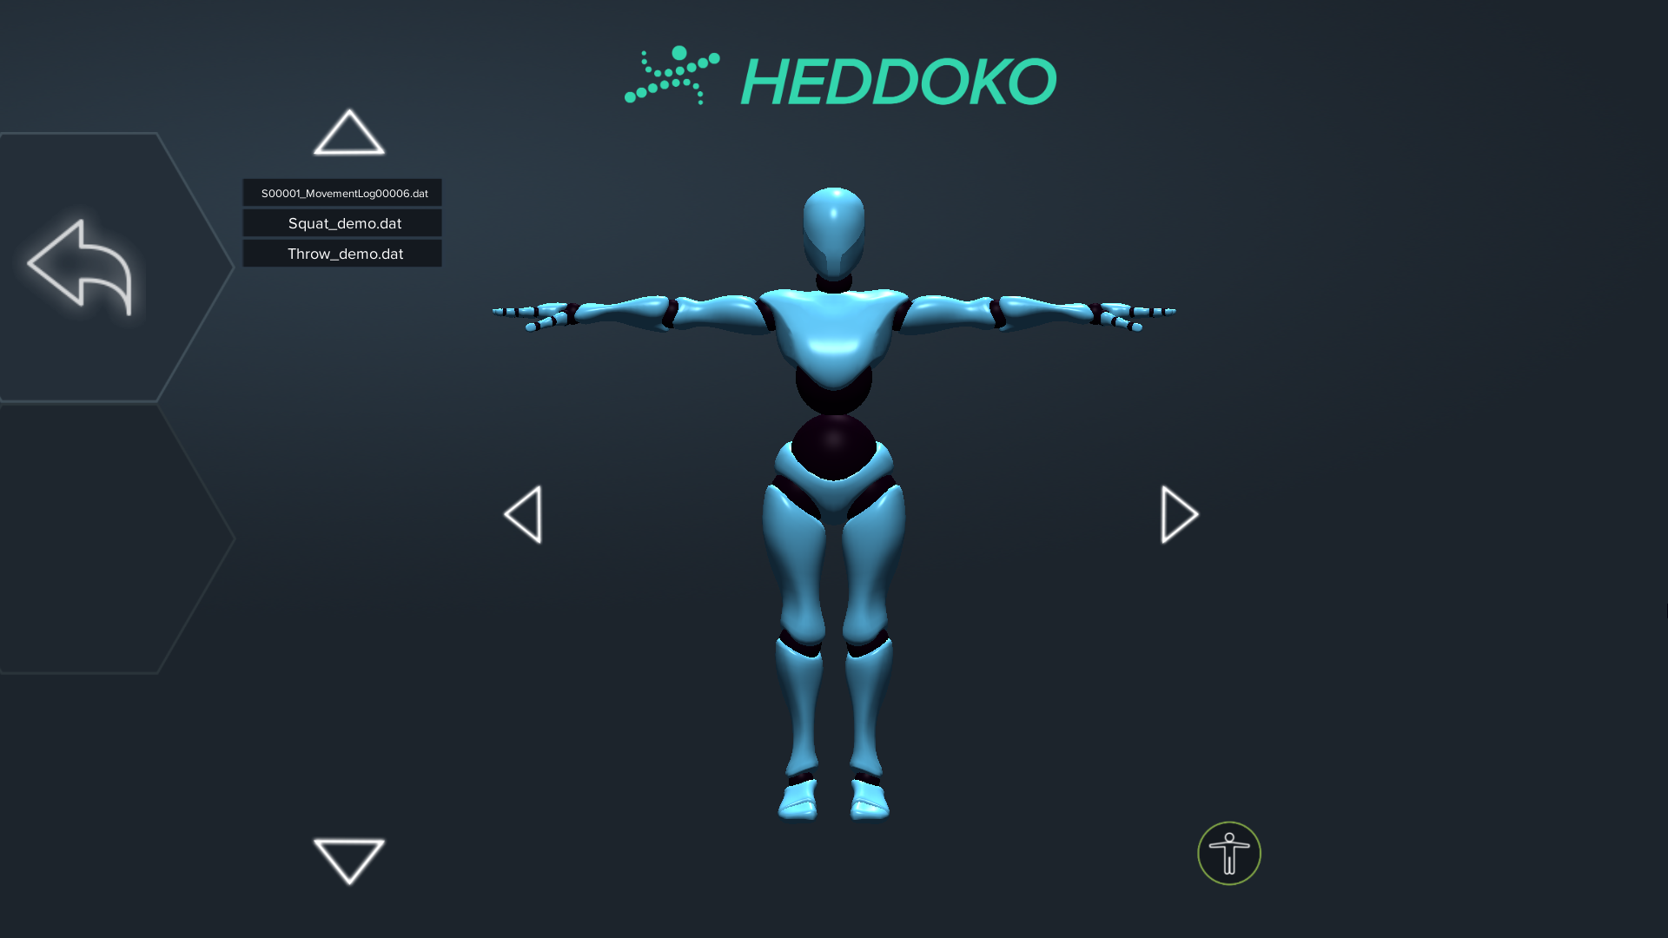

Figure 5