**Name : مازن زين العابدين حسن مرزوق**

**B.N: 627**

**Date : 5\6\2020**

**Topic:** **programming languages**

**Github link:** <https://github.com/mazen-zein/ece006/projects>

**Github page :** [**https://mazen-zein.github.io/ece006/**](https://mazen-zein.github.io/ece006/)

**Application brief :** The programming language: It is the language in which a person communicates with the computer, and in other words it is the means by which we control the behavior of the computer, as these languages ​​vary between several levels, and they are not only zeros and units as some believe, but are multiple levels but all of them are eventually converted To zeros and units or what is called the machine language, and the levels of these languages ​​are:

High-level languages: C # - Python - PHP.

Low-level languages: as Assembly.

Machine language: It is the language of zeros and units.

Uses of programming languages

Programming languages ​​vary in their uses to include operating systems, office applications, Internet applications, websites, and smartphone applications, and each programming language has different capabilities and features, and from the uses of programming languages ​​we mention:

Operating system languages: C ++ - Assembly - C.

Office application languages: C # - Java - Python.

Website languages: JavaScript - PHP - Python.

Mobile application languages: Java - Swift - Object C.

Of course, there are many other languages, and these languages ​​cannot be limited, except that they are just some examples.

**Screeshots :**

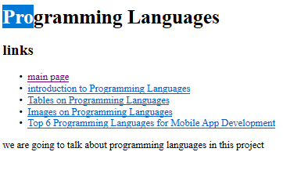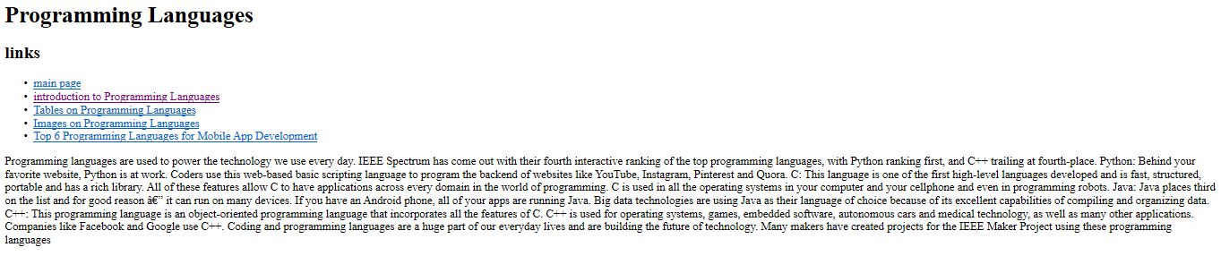

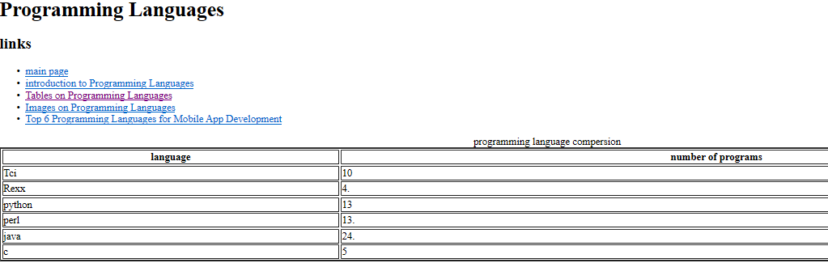

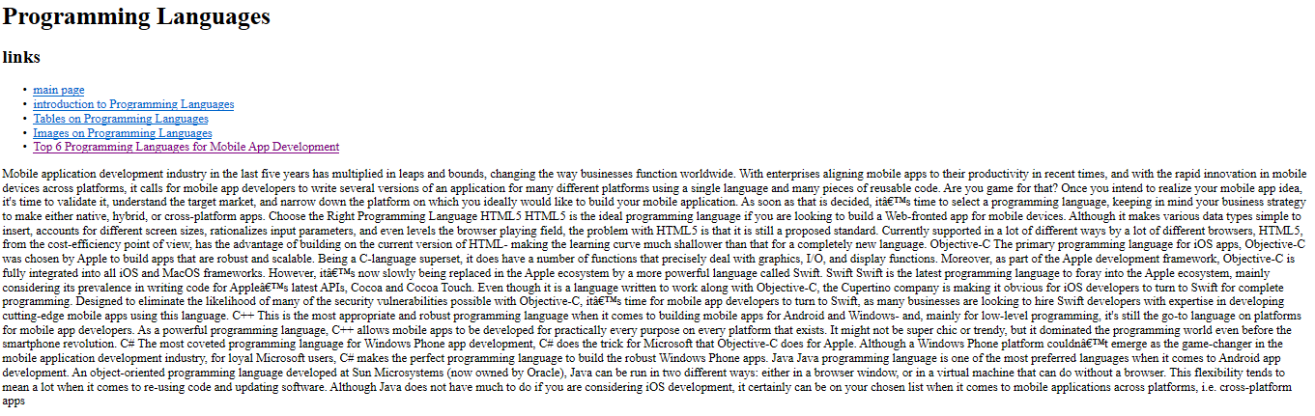

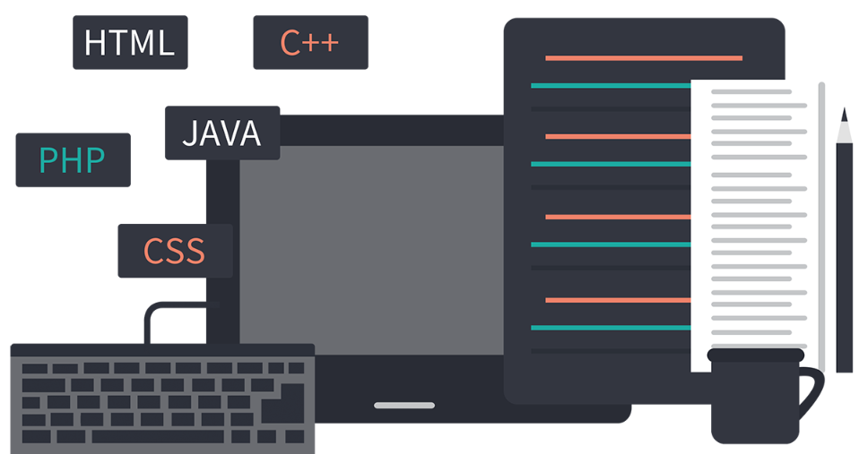

**Source code:** 