جامعة المنوفية
كلية الحاسبات والمعلومات
2026-2027
Menofyia University
System Analysis & design Project
second year
2026-2027


No. | Name | Group
1 | Mazen Medhat Moatamed Mahmoud | 2
2 | Mostafa Nabil Abdel Gawad Ali | 2
3 | Mohamed Adel Mohamed ghoniem | 2
4
5
6

Smart Queue Management System
Task 2

Methodology
Agile / Iterative Development
The project will use an Agile/Iterative approach. Work is divided into small iterations, and the team reviews each deliverable before moving forward. This approach is suitable because queue rules and the customer/staff interface may need adjustments after feedback.
Iteration | Main activities | Deliverable
1 — Requirements | Identify customer, staff, and manager needs; define ticket states and service rules. | Approved requirements list
2 — Core queue | Create tickets, assign numbers, call next ticket, update status. | Working queue prototype
3 — Monitoring | Display current queue and ticket status; estimate waiting time only when sufficient data exists. | Queue display and status view
4 — Reports and testing | Create basic reports; test normal, busy, and error cases; correct issues. | Tested release candidate
5 — Deployment | Prepare user instructions, deploy the system, and collect feedback. | Initial deployed version

The team will review each iteration, correct issues, and use feedback to improve the next version.
Time Estimation
The following estimates represent a proposed project schedule in working days. Durations may be updated when the team confirms the scope and available resources.
ID | Activity | Duration (days) | Predecessor
A | System request and scope | 4 | —
B | Feasibility study | 5 | A
C | Requirements gathering | 8 | B
D | Process and data analysis | 8 | C
E | Database and system design | 12 | D
F | Interface design | 10 | D
G | Implementation | 25 | E, F
H | Testing and correction | 7 | G
I | Deployment and documentation | 5 | H

Total planned duration: 74 working days. Database/system design and interface design can run in parallel after process and data analysis.
Case Study: Busy Service Center
A service center handles customers requesting different services. During busy periods, customers may not know their position in the queue, staff may lose track of waiting tickets, and managers may lack reliable information about service performance. The proposed system issues a unique ticket, maintains its status, and provides a queue display and basic reports.
Case Study—Busy Service Center
Stakeholders | Customers, service staff, service-center manager, system administrator
Inputs | Selected service, ticket request, staff actions, ticket status updates
Processes | Issue unique ticket; maintain queue order; call next ticket; update status; summarize activity
Outputs | Ticket number, current status, queue display, daily operational summary
Expected benefits | Clearer queue order, less manual tracking, fewer record errors, better visibility of service activity
Assumptions / limits | A reliable network is needed for online access; estimated waiting time is indicative and depends on service duration and queue conditions.
PERT Chart
PERT (Program Evaluation and Review Technique) shows activities, dependencies, and estimated durations. Activities E and F run in parallel after D; implementation starts only after both design activities are complete.
ID | Activity | Predecessor(s) | Duration (days)
A | System request and scope | — | 4
B | Feasibility study | A | 5
C | Requirements gathering | B | 8
D | Process and data analysis | C | 8
E | Database and system design | D | 12
F | Interface design | D | 10
G | Implementation | E, F | 25
H | Testing and correction | G | 7
I | Deployment and documentation | H | 5

Critical path: A–B–C–D–E–G–H–I = 74 working days. This is a proposed planning estimate; actual durations should be updated as work progresses.
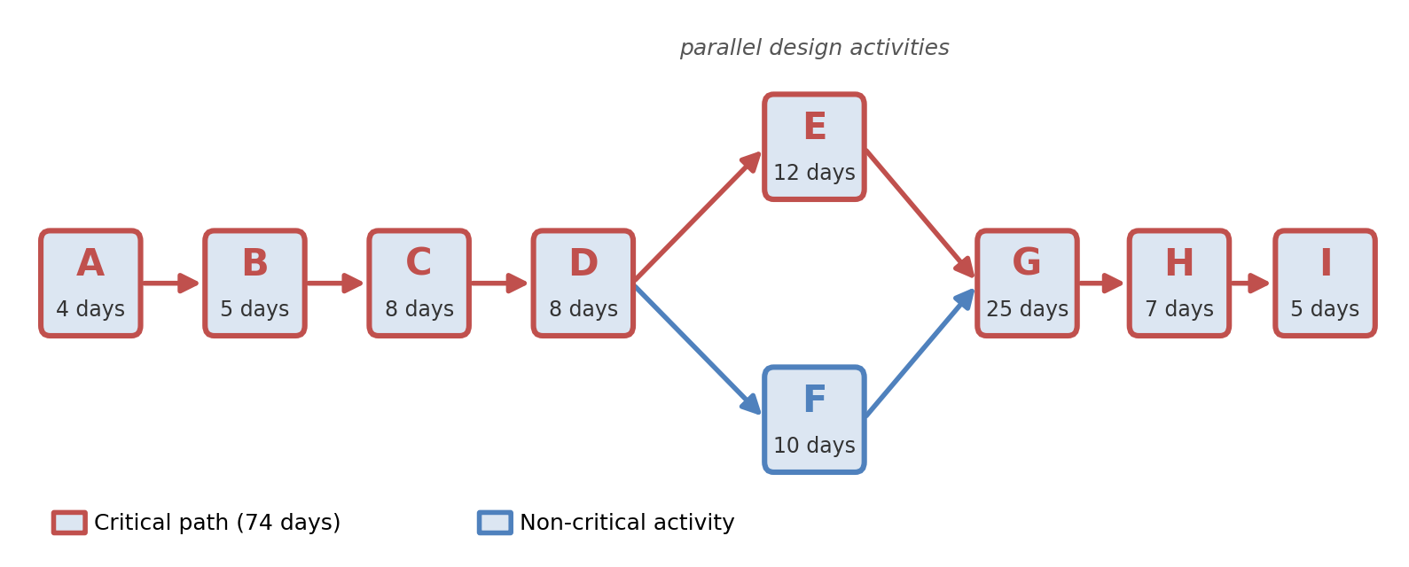
Gantt Chart
The schedule below follows the PERT dependencies. Activities E and F run in parallel; implementation starts after both have finished.
Activity | Start day | Finish day | Duration | Dependency
A — System request and scope | 1 | 4 | 4 | —
B — Feasibility study | 5 | 9 | 5 | A
C — Requirements gathering | 10 | 17 | 8 | B
D — Process and data analysis | 18 | 25 | 8 | C
E — Database and system design | 26 | 37 | 12 | D
F — Interface design | 26 | 35 | 10 | D
G — Implementation | 38 | 62 | 25 | E, F
H — Testing and correction | 63 | 69 | 7 | G
I — Deployment and documentation | 70 | 74 | 5 | H

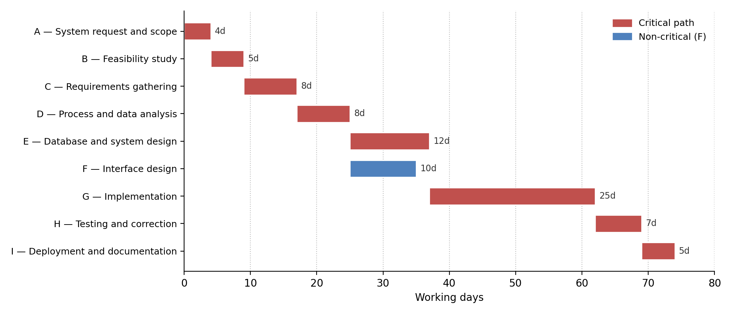
Timeline (working days)
Activity | 1–10 | 11–20 | 21–30 | 31–40 | 41–50 | 51–60 | 61–70 | 71–74 | Days
A | ■ |  |  |  |  |  |  |  | 4
B | ■ |  |  |  |  |  |  |  | 5
C | ■ | ■ |  |  |  |  |  |  | 8
D |  | ■ | ■ |  |  |  |  |  | 8
E |  |  | ■ | ■ |  |  |  |  | 12
F |  |  | ■ | ■ |  |  |  |  | 10
G |  |  |  | ■ | ■ | ■ | ■ |  | 25
H |  |  |  |  |  |  | ■ |  | 7
I |  |  |  |  |  |  | ■ | ■ | 5

