Decision Tree Documentation

**Implemented by :**

**Mazen Fayez : 20186021**

**Hania Osama : 20186040**

**Youssef Fathy : 20166045**

**At training size = 25 %**

Iteration 1 :

Tree size = 13

Accuracy = 0.907

Iteration 2:

Treesize = 27

Accuracy = 0.9325

Iteration 3:

Treesize = 21

Accuracy = 0.929

Tree graph from 1 to 3

**Train size is 40%**

Tree size = 25

Accuracy = 0.961

**Train size 50%**

Tree size = 37

Accuracy = 0.963

**Train size 70%**

Tree size = 33

Accuracy = 0.931

**At 40% training size**

Iteration 1 :

Tree size = 31

Accuracy = 0.957

Iteration 2:

Tree size = 23

Accuracy = 0.927

Iteration 3:

Tree size =43

Accuracy = 0.934

Iteration 4:

Tree size = 31

Accuracy = 0.938

Iteration 5:

Tree size = 19

Accuracy = 0.942

Min tree size = 19

Max tree size = 43

Mean tree size = 29.4

**At training size 50%**

Iteration 1 :

Tree size = 25

Accuracy = 0.9308

Iteration 2:

Tree size = 39

Accuracy = 0.89

Iteration 3:

Tree size =27

Accuracy = 0.907

Iteration 4:

Tree size = 39

Accuracy = 0.898

Iteration 5:

Tree size = 33

Accuracy = 0.953

Min tree size = 25

Max tree size = 39

Mean tree size = 32.6

**At training size 60%**

Iteration 1 :

Tree size = 39

Accuracy = 0.948

Iteration 2:

Tree size = 39

Accuracy = 0.936

Iteration 3:

Tree size =37

Accuracy = 0.919

Iteration 4:

Tree size = 53

Accuracy = 0.9655

Iteration 5:

Tree size = 35

Accuracy = 0.925

Min tree size = 35

Max tree size = 53

Mean tree size =40.6

**Training size 70%**

Iteration 1 :

Tree size = 31

Accuracy = 0.90

Iteration 2:

Tree size = 57

Accuracy = 0.94

Iteration 3:

Tree size =61

Accuracy = 0.938

Iteration 4:

Tree size = 55

Accuracy = 0.954

Iteration 5:

Tree size = 59

Accuracy = 0.969

Min tree size = 61

Max tree size = 31

Mean tree size = 52.6

**Training size 80%**

Iteration 1 :

Tree size = 59

Accuracy = 0.965

Iteration 2:

Tree size = 45

Accuracy = 0.90

Iteration 3:

Tree size =51

Accuracy = 0.954

Iteration 4:

Tree size = 55

Accuracy = 0.919

Iteration 5:

Tree size = 39

Accuracy = 0.919

Min tree size = 39

Max tree size = 59

Mean tree size = 49.8

The best accuracy was in training set size of 70% and the accuracy was 0.969 and the tree graph is as shown below

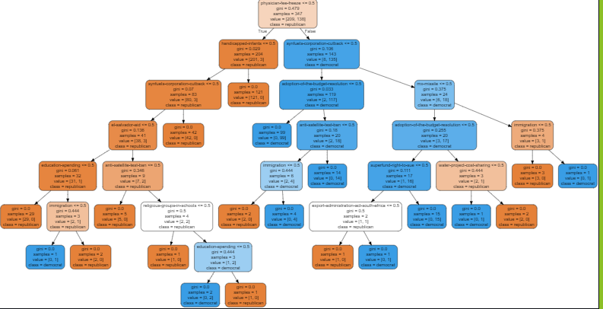

K-NN Problem

Below you will find the accuracy at each point from 1 to 9

With the expected class and the actual class and number of correct instances and the total number of instances

Results :

At K=1

predicted class : [7.] Actual class: 3.0

Number of correctly classified instances: 243 ,Total number of instances: 484 , Accuracy: 50.21 %

At K=2

predicted class : [7.] Actual class: 7.0

Number of correctly classified instances: 243 ,Total number of instances: 484 , Accuracy: 50.21 %

At K=3

predicted class : [7.] Actual class: 7.0

Number of correctly classified instances: 247 ,Total number of instances: 484 , Accuracy: 51.03 %

At K=4

predicted class : [2.] Actual class: 2.0

Number of correctly classified instances: 268 ,Total number of instances: 484 , Accuracy: 55.37 %

At K=5

predicted class : [2.] Actual class: 2.0

Number of correctly classified instances: 272 ,Total number of instances: 484 , Accuracy: 56.20 %

At K=6

predicted class : [7.] Actual class: 2.0

Number of correctly classified instances: 270 ,Total number of instances: 484 , Accuracy: 55.79 %

At K=7

predicted class : [1.] Actual class: 7.0

Number of correctly classified instances: 264 ,Total number of instances: 484 , Accuracy: 54.55 %

At K=8

predicted class : [7.] Actual class: 1.0

Number of correctly classified instances: 269 ,Total number of instances: 484 , Accuracy: 55.58 %

At K=9

predicted class : [2.] Actual class: 7.0

Number of correctly classified instances: 265 ,Total number of instances: 484 , Accuracy: 54.75 %