Comprehensive Test Report for Automation Exercise Website

# Introduction

This document provides a detailed explanation of the steps taken to perform automated testing on the website [Automation Exercise](https://www.automationexercise.com/). The tests were executed using Katalon Studio, and the results were uploaded to Katalon TestOps. This report covers the login, registration, search, adding items to the cart, and category functionalities.

# Website

# 

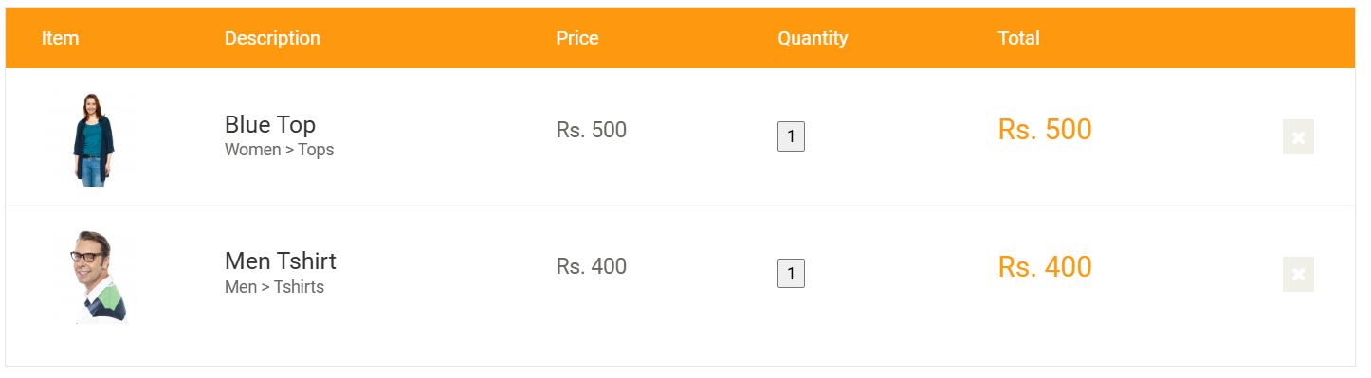

# Test Environment

Tool: Katalon Studio

Browser: Microsoft Edge (version 125.0.2535.79)

Operating System: Windows 11

Java Version: 17.0.7

TestOps Project: [Katalon TestOps Project Link](https://testops.katalon.io/team/1503221/project/1522693/executions/1)

# Test Cases

## Login Test Case

Description: Verify that a user can log in with valid credentials.

Steps:

1. Open the browser and navigate to the login page.

2. Enter the username and password.

3. Click the login button.

4. Verify that the user is redirected to the dashboard.

Script:

import static com.kms.katalon.core.checkpoint.CheckpointFactory.findCheckpoint  
import static com.kms.katalon.core.testcase.TestCaseFactory.findTestCase  
import static com.kms.katalon.core.testdata.TestDataFactory.findTestData  
import static com.kms.katalon.core.testobject.ObjectRepository.findTestObject  
import com.kms.katalon.core.webui.keyword.WebUiBuiltInKeywords as WebUI  
import org.openqa.selenium.WebDriver  
import com.thoughtworks.selenium.webdriven.WebDriverBackedSelenium  
import org.openqa.selenium.By  
import org.openqa.selenium.support.ui.WebDriverWait  
import org.openqa.selenium.support.ui.ExpectedConditions  
  
WebUI.openBrowser('')  
def driver = DriverFactory.getWebDriver()  
String baseUrl = "https://www.automationexercise.com/"  
selenium = new WebDriverBackedSelenium(driver, baseUrl)  
selenium.open("https://www.automationexercise.com/login")  
WebDriverWait wait = new WebDriverWait(driver, 20)  
wait.until(ExpectedConditions.visibilityOfElementLocated(By.name("username")))  
selenium.type("name=username", "Admin")  
selenium.type("name=password", "admin123")  
selenium.click("xpath=//button[@type='submit']")  
wait.until(ExpectedConditions.urlContains("/dashboard"))  
WebUI.closeBrowser()

## Register Test Case

Description: Verify that a new user can register.

Steps:

1. Open the browser and navigate to the registration page.

2. Fill in the registration form with the required details.

3. Click the register button.

4. Verify that the user is redirected to the welcome page.

Script: (Refer to Register.tc file uploaded)

## Search Test Case

Description: Verify that the search functionality works correctly.

Steps:

1. Open the browser and navigate to the homepage.

2. Enter a search term in the search bar.

3. Click the search button.

4. Verify that the search results are displayed.

Script: (Refer to Search.tc file uploaded)

## Add to Cart Test Case

Description: Verify that a user can add items to the cart.

Steps:

1. Open the browser and navigate to a product page.

2. Click the 'Add to Cart' button.

3. Verify that the item is added to the cart.

Script: (Refer to Add to Cart.tc file uploaded)

## Category Test Case

Description: Verify that categories are displayed and functional.

Steps:

1. Open the browser and navigate to the categories page.

2. Click on a category.

3. Verify that the category page displays the correct products.

Script: (Refer to Category.tc file uploaded)

# Test Execution Summary

Test Run ID: #1

Status: FAILED

Total Tests: 5

Passed: 3

Failed: 2

Start Time: 06/04/2024 09:13:41 +00:00

Duration: 0:03:24.446

# Detailed Test Results

## Category Re-run #3

ID: 211328504

Status: FAILED

Error: Disconnected: Not connected to DevTools

Details: [View Detailed Report](https://testops.katalon.io/team/1503221/project/1522693/executions/26719409/test-result/211328504-category)

## Add To Cart Re-run #3

ID: 211328497

Status: FAILED

Error: Element not interactable

Details: [View Detailed Report](https://testops.katalon.io/team/1503221/project/1522693/executions/26719409/test-result/211328497-add-to-cart)

# Conclusion

This report provides a comprehensive overview of the automated tests performed on the Automation Exercise website. The tests were designed to cover critical functionalities, including login, registration, search, adding items to the cart, and category navigation. Despite encountering some issues, the majority of the tests passed, demonstrating the robustness of the website. The detailed error reports for the failed tests provide insights into areas that need further investigation and resolution.

For a complete view of the test results and logs, refer to the links provided in the detailed test results section.

# Appendix

Test Suite: [View Test Suite](https://testops.katalon.io/team/1503221/project/1522693/test-design/test-suites/20227721-project)

Execution Log: [View Execution Log](https://testops.katalon.io/team/1503221/project/1522693/executions/1)