**Mazen Al Hakim**

**Database**

Introduction:

Any software should have a database where user can store and manipulate data. My Point-of-Sales System has a database that is specific for it, where user (mainly cashier) can store stock products with all the information related with each product, store the clients and suppliers with the needed information. In addition, user can store daily sold products for later calculations.

Database Tables:

1. Suppliers table:

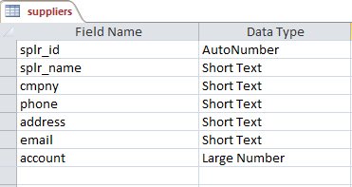

All suppliers needed information are stored in it.

1. Products table:

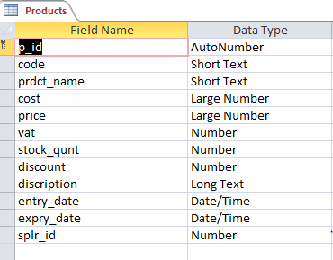

This table is used to store all information needed about the products in the stock, it takes the supplier id from the suppliers table as a foreign key.

1. Clients table:

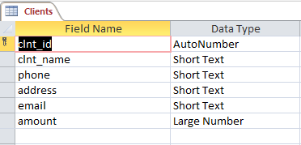

It is used to save all needed information about the clients.

1. Client_payments table:

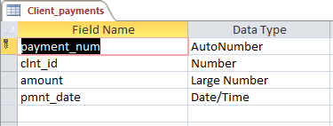

Used to store clients’ payments with the date and amount paid. It takes the client id from Clients table as a foreign key.

1. Invoices table:

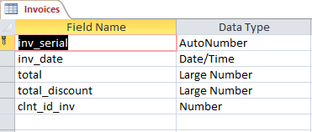

Table for storing invoices main information.

It takes client id as a foreign key from clients table.

1. Inv_details:

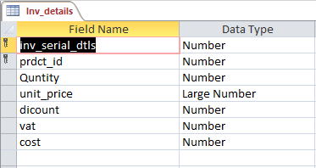

This table is to store the detailed information for each invoice for later calculations. It takes the invoice serial and product id as a foreign key from Invoices and Products tables respectively.

1. Users table:

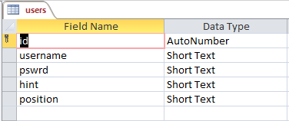

This table stores the users that can open the software, its created for security goal.

* **Relations:**

