CS213 – Object Oriented Programming

First Semester 2022 – 2023

Assignment #3 Report

By:

Amr Hesham Mohamed

ID: 20210280

Mazen Mahmoud Shoukry

ID:20210318

Task 1:

MAvector

Task 2:

20210280: problems 1, 2 and 3 in sheet 3

20210318: problems 4, 5, and 6 in sheet 3

Task 4:

20210280: problems 7 and 8 in sheet 3 for the bonus

20210318: problems 9 and 10 in sheet 3 for the bonus

Github:

20210280: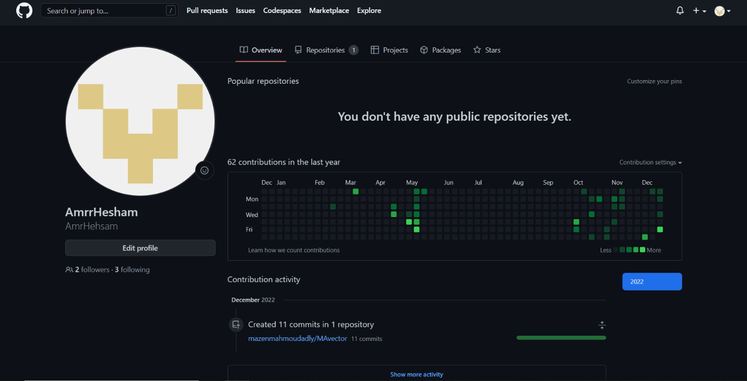

20210318:

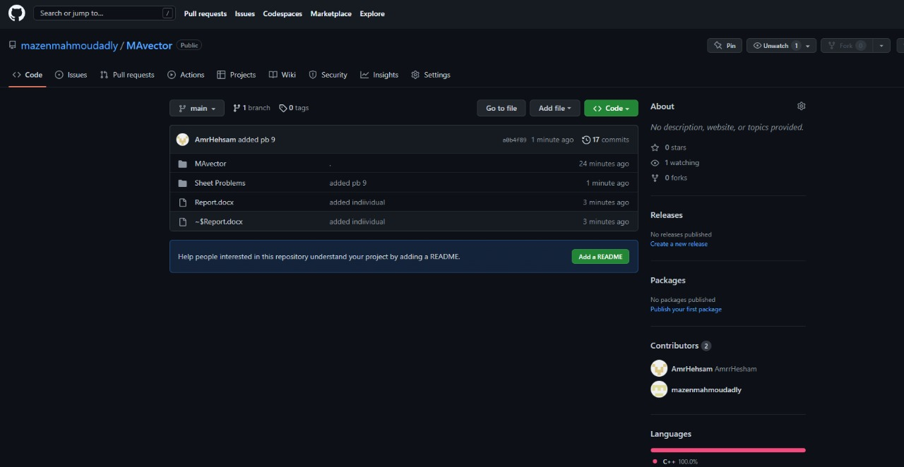

Our repo:

