
The German International University for Applied Sciences
Faculty of Business Informatics

Business Intelligence and Analytics
Final Project Report

Date: June 5, 2026
Submitted by:
Name | Student ID
Mazen Maged | 13005396
Marwan Mohamed | 13005980
Yousof Khaled | 13007173
Ahmed Walid | 13001202
Eslam Yasser | 13005335
Ali Tamer | 13003448

1. Introduction

Project Overview
This project presents the design and implementation of a complete Business Intelligence solution for retail sales analytics. The solution leverages industry-standard tools and methodologies to transform raw transactional data into actionable business insights.

Technologies Used
- SQL Server
- ETL Pipelines
- Data Warehouse Architecture
- Star Schema Modeling
- Power BI Dashboards
- DAX Measures
- Time Intelligence Analytics

Business Domains Integrated
- Online Sales
- POS Sales
- Customers
- Products
- Promotions
- Stores
- Warehouses
- Employees

The objective of the project is to transform raw operational data into meaningful business insights that support strategic, tactical, and operational decision-making.

Business Problem
Retail organizations generate large volumes of transactional data from multiple channels such as online platforms, point-of-sale systems, warehouse operations, and promotional campaigns.
Without a centralized analytical system, it becomes difficult to:
- Monitor business performance
- Compare sales channels
- Analyze customer behavior
- Evaluate promotions
- Track warehouse efficiency
- Support managerial decision-making

This project solves these problems by building a centralized data warehouse and interactive Power BI dashboards.

Project Objectives
The main objectives of this project are:
- Build a scalable data warehouse using Star Schema architecture.
- Design ETL pipelines for loading and transforming data.
- Create dimension and fact tables.
- Develop analytical DAX measures.
- Implement KPI-driven dashboards.
- Support multiple business personas.
- Perform cross-schema analytical comparisons.
- Enable interactive business reporting using Power BI.

2. Dataset Description

Data Sources
The project uses retail business datasets covering multiple operational areas. The datasets were organized into a three-layer architecture:
- Bronze Layer — raw data
- Silver Layer — cleaned and transformed data
- Gold Layer — dimensional warehouse model

Main Business Entities

Customers
Contains customer demographic and loyalty information.
Key attributes: customer_id, first_name, last_name, gender, city, loyalty_level, email.

Products
Contains product catalogue information.
Key attributes: product_id, product_name, category, brand, price.

Promotions
Contains promotional campaign information.
Key attributes: promo_id, promo_type, discount_percentage, start_date, end_date.

Stores
Contains retail store location and region data.
Key attributes: store_id, store_name, city, region.

Warehouses
Contains warehouse operational information.
Key attributes: warehouse_id, warehouse_name, city.

Employees
Contains employee operational data.
Key attributes: employee_id, employee_name, department, store_id.

Online Sales
Contains e-commerce sales transactions.
Key attributes: transaction_id, customer_id, product_id, promo_id, quantity, total_amount, transaction_date.

POS Sales
Contains point-of-sale retail transactions.
Key attributes: transaction_id, customer_id, product_id, store_id, quantity, total_amount, transaction_date.

3. Data Warehouse Architecture

Three-Layer (Medallion) Architecture
The project follows a Medallion Architecture approach with three distinct layers:

Bronze Layer
Stores raw source data without modifications. This is the landing zone for all incoming data.

Silver Layer
Stores cleaned and transformed datasets. Transformation operations include:
- Removing duplicates
- Handling null values
- Standardizing formats
- Data cleansing and type conversion

Gold Layer
Stores dimensional warehouse tables optimized for analytics and reporting. This layer feeds directly into Power BI dashboards.

Star Schema Design
The Gold Layer was designed using a Star Schema model to maximize query performance and analytical efficiency.

Fact Tables
- fact_online_sales
- fact_pos_sales

Dimension Tables
- dim_customer
- dim_product
- dim_store
- dim_warehouse
- dim_employee
- dim_promotion
- dim_date

The Star Schema improves query performance, analytical efficiency, dashboard usability, and scalability.

4. ETL Process

Extract
Data was extracted from source datasets into the Bronze Layer, preserving all original data without modification.

Transform
Transformation operations applied during the Silver Layer processing included:
- Removing duplicate records
- Trimming whitespace from text fields
- Handling null and missing values
- Standardizing categorical values
- Data type conversion and validation
- Generating surrogate keys for dimension tables

Load
The transformed data was loaded into Silver Layer tables and subsequently into Gold Layer dimensional warehouse tables. Fact tables were linked with dimension tables using foreign keys to establish referential integrity.

5. DAX Measures and KPIs
Several DAX measures were created to support comprehensive business analysis across all personas and dashboards.

Core Measures
- Total Revenue
- Total Online Revenue
- Total POS Revenue
- Total Transactions
- Distinct Customers
- Total Quantity Sold
- Average Order Value
- Revenue Per Customer

Time Intelligence Measures
- Revenue YTD (Year-to-Date)
- Revenue MTD (Month-to-Date)
- Revenue QTD (Quarter-to-Date)
- Previous Year Revenue
- YoY Growth %

These measures enabled trend analysis, seasonal analysis, growth monitoring, and comparative analytical reporting.

6. Dashboard Users and Personas

Persona 1: Executive Manager
Role: Monitors overall business performance and drives strategic decisions.

Responsibilities
- Revenue monitoring
- Strategic decisions
- Growth tracking
- Promotion evaluation

Dashboard Needs
- Total revenue overview
- Sales trends
- Top products
- Promotion performance
- Growth KPIs

Persona 2: Sales Manager
Role: Manages sales operations and analyzes customer behavior.

Responsibilities
- Customer analysis
- Sales optimization
- Regional performance monitoring
- Sales channel analysis

Dashboard Needs
- City-level sales performance
- Customer loyalty analysis
- Product performance metrics
- Online vs POS channel comparison

Persona 3: Warehouse / Operations Manager
Role: Oversees warehouse efficiency and operational logistics.

Responsibilities
- Warehouse performance monitoring
- Inventory movement tracking
- Operational efficiency evaluation
- Logistics optimization

Dashboard Needs
- Warehouse sales data
- Warehouse utilization metrics
- Product distribution analysis
- Operational trend monitoring

7. Business Questions

7.1 Executive Manager Questions

Q1. Total Revenue Across All Channels
What is the total revenue generated across all sales channels?

Q2. Revenue Trends Over Time
How does revenue trend over time by year, quarter, and month?

Q3. Top Revenue-Generating Products
Which products generate the highest revenue?

Q4. Promotion Contribution to Sales
Which promotions contribute most to total sales?

Q5. Peak Sales Periods
What are the peak sales periods during the year?

7.2 Sales Manager Questions

Q6. Top Cities by Sales Revenue
Which cities generate the highest sales revenue?

Q7. Customer Loyalty Revenue Contribution
Which customer loyalty levels contribute most to revenue?

Q8. Average Order Value
What is the average order value per customer?

Q9. Promotional Product Performance
Which products perform best during promotional campaigns?

Q10. Online vs POS Sales Comparison
How do online sales compare with POS sales?

7.3 Warehouse / Operations Manager Questions

Q11. Highest Volume Warehouses
Which warehouses process the highest sales volume?

Q12. Top Revenue Warehouses
Which warehouses generate the highest revenue?

Q13. Product Distribution by Warehouse
Which products are distributed most frequently by warehouse?

Q14. Warehouse Sales Trends
How do warehouse sales change over time?

Q15. High-Performing Warehouse Products
Which warehouses support the highest-selling products?

7.4 Cross-Schema (Cross-Channel) Questions

Q1. Online vs POS Revenue Over Time
How does online revenue compare to POS revenue over time?

Q2. Cross-Channel Product Performance
Which products perform best across both online and POS channels?

Q3. Promotion Effectiveness by Channel
Which promotions are more effective in online sales versus POS sales?

Q4. Customer Purchasing Behavior by Channel
How does customer purchasing behaviour differ between online and POS transactions?

8. Dashboard Design Principles
The dashboards were designed following established business intelligence design principles to ensure clarity, usability, and analytical effectiveness.

Core Design Principles
- Consistent visual themes across all dashboards
- Clean, uncluttered layouts
- Readable visual hierarchy
- Interactive slicers for dynamic filtering
- KPI-focused reporting
- Business-oriented storytelling

Advanced Features Incorporated
- DAX measures for complex calculations
- Time intelligence for trend analysis
- Hierarchies for drill-down navigation
- Filters and slicers for interactivity
- Cross-schema analytical comparisons
- Comparative analytics across channels

9. Key Insights
Several important business insights were identified through the analytical dashboards:
- Online and POS sales exhibit different seasonal trends.
- Certain promotions perform better in online channels than in-store.
- High loyalty customers generate significantly more revenue than standard customers.
- Some warehouses contribute disproportionately to product distribution.
- A small group of products generates the majority of total revenue.
- Peak sales periods occur during specific months and active promotional campaigns.

10. Conclusion
This project successfully implemented a complete Business Intelligence solution using SQL Server and Power BI. The solution transformed raw retail datasets into actionable analytical insights through dimensional modeling, ETL pipelines, KPI engineering, interactive dashboards, and cross-channel analytics.
The final dashboards support strategic, operational, and analytical decision-making for multiple business personas, demonstrating the practical value of a well-architected data warehouse and modern BI tooling.

Key Competencies Demonstrated
- Data Warehousing
- ETL Development
- Business Intelligence
- Data Visualization
- DAX Analytics
- Dashboard Storytelling

11. Dashboard Screenshots and Explanations

11.1 Executive Overview Dashboard
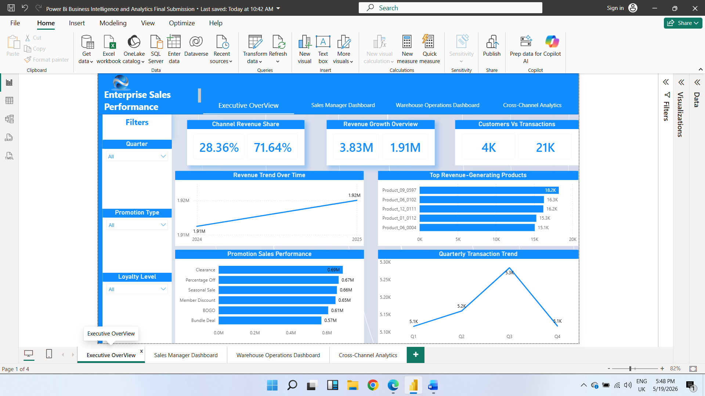
Figure 1 — Executive Overview Dashboard
The Executive Overview Dashboard provides a high-level summary of the organization's overall sales performance and operational efficiency. It is designed for senior management and decision-makers to quickly monitor key business metrics, identify performance trends, and evaluate strategic outcomes across the enterprise.
The dashboard combines KPI indicators, trend analysis, product performance evaluation, and promotional effectiveness into a single interactive interface that supports data-driven decision-making.

Key Components
1. Channel Revenue Share
This KPI comparison visual displays the percentage contribution of Online Revenue and POS (Point-of-Sale) Revenue to total company revenue.
- Online Revenue Share: 28.36%
- POS Revenue Share: 71.64%
This comparison helps management understand the dominance of physical store sales versus online sales channels and evaluate channel performance balance.
2. Revenue Growth Overview
This KPI section compares current total revenue against previous year revenue, providing a quick overview of year-over-year financial performance.
3. Customers vs. Transactions
This KPI comparison evaluates customer activity by comparing the number of distinct customers with total transactions, providing insight into purchasing behavior and overall sales activity.
4. Revenue Trend Over Time
This line chart displays total revenue across monthly periods, helping management identify seasonal patterns, growth trends, and anomalies in revenue performance.
5. Top Products by Revenue
This horizontal bar chart ranks products by total revenue generated, enabling management to identify the most valuable products and optimize product strategy accordingly.
6. Revenue by Promotion Type
This visual analyzes revenue generated by different promotional types including Clearance, Percentage Off, Seasonal Sale, Member Discount, and BOGO, supporting promotional strategy evaluation.
7. YoY Revenue Growth
This time intelligence visual compares monthly revenue against the same period in the previous year, helping management monitor growth momentum and identify underperforming periods.

Interactive Slicers
The dashboard includes interactive slicers that allow users to dynamically filter results by Year, Quarter, and Product Category.

Business Value
- Provides a comprehensive view of overall business performance
- Enables rapid identification of revenue trends and anomalies
- Supports strategic decision-making through KPI monitoring
- Evaluates promotional effectiveness across the organization
- Facilitates year-over-year performance benchmarking

11.2 Sales Manager Dashboard
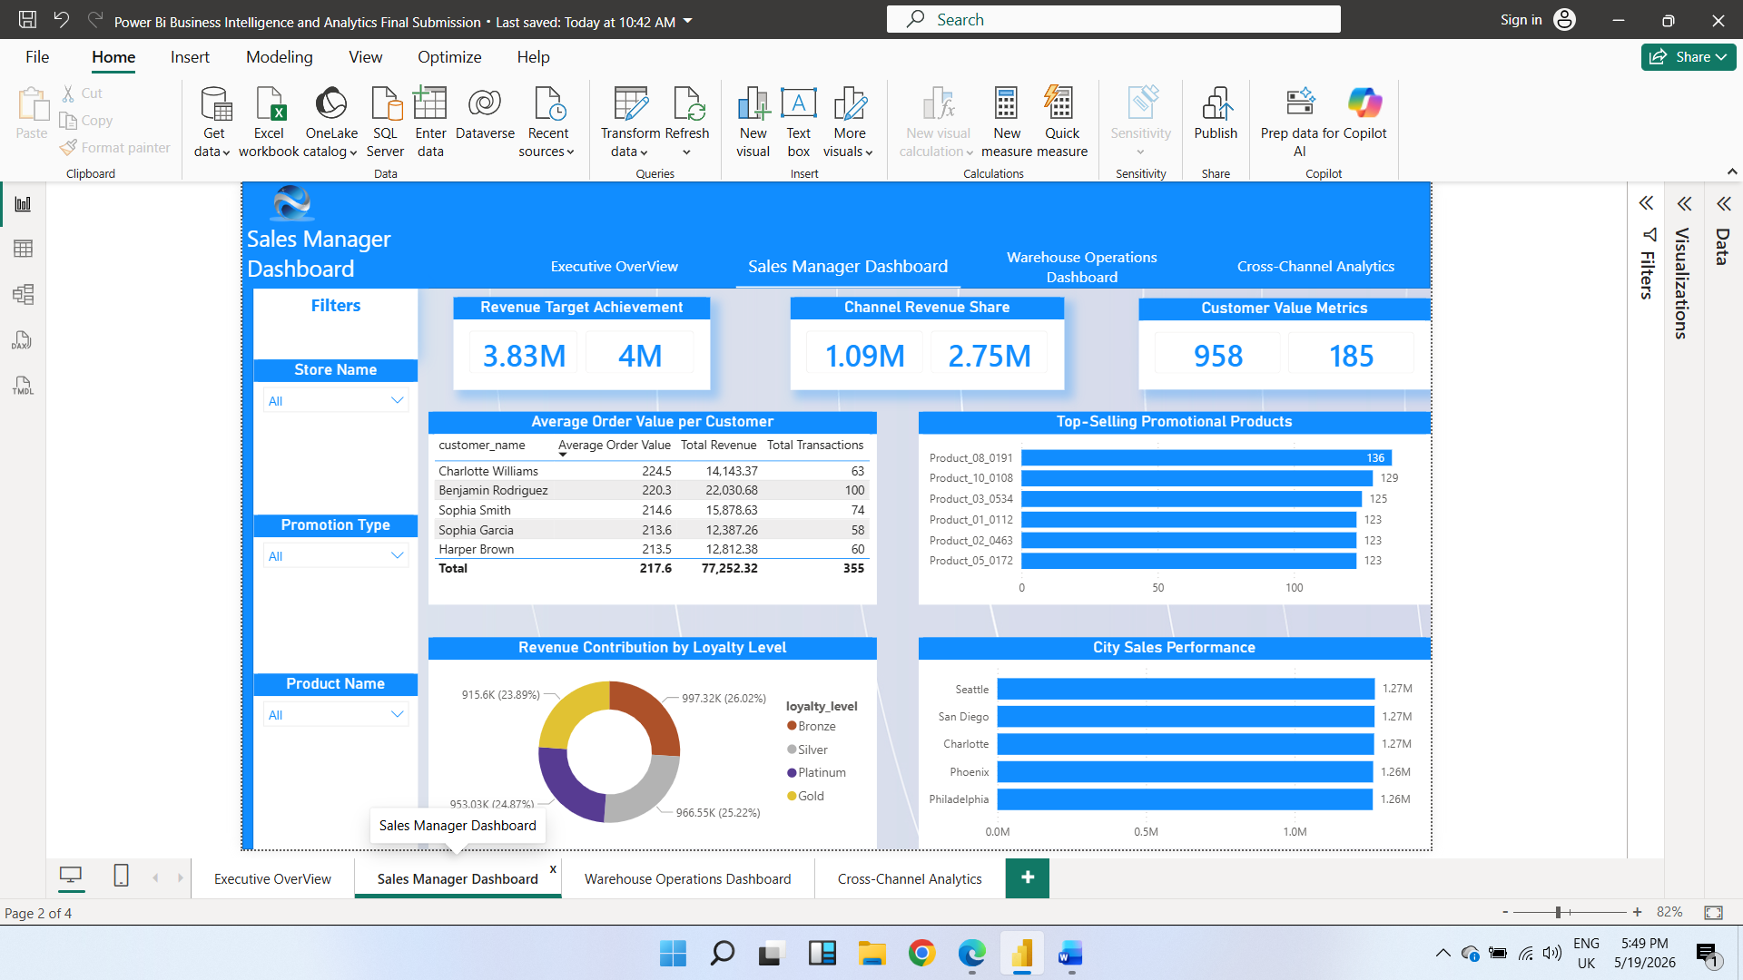
Figure 2 — Sales Manager Dashboard
The Sales Manager Dashboard is designed to support sales operations management through customer behavior analysis, product performance tracking, and regional sales evaluation. The dashboard provides sales managers with tools to identify valuable customers and support operational decision-making through interactive visual analytics.
The dashboard integrates KPI indicators, customer-level analysis, product performance tracking, loyalty segmentation, and regional sales comparisons into a centralized management interface.

Key Components
1. Revenue Performance KPIs
Displays total revenue alongside targets, providing a quick performance summary for sales managers.
2. Customer Lifetime Value
This KPI compares revenue per customer against average order value, helping identify the most valuable customer segments.
3. Top Customers by Revenue
This bar chart ranks customers by total revenue contribution, enabling sales managers to identify and prioritize high-value customers.
4. Product Revenue Performance
This visual compares product revenue performance across the sales channel, highlighting top performers and underperforming items.
5. Revenue by Promotion
This visual displays promotional campaign effectiveness by comparing revenue generated across different promotion types.
6. Revenue by Loyalty Level
This visual compares revenue contribution across customer loyalty tiers, helping management evaluate loyalty program effectiveness.
7. City Sales Performance
This horizontal bar chart compares sales performance across different cities, identifying high-performing markets and supporting geographic sales strategy decisions.

Interactive Slicers
Users can dynamically filter dashboard results by Store Name, Promotion Type, and Product Name.

Business Value
- Tracks revenue performance against business targets
- Monitors customer purchasing behavior and customer value
- Identifies top-performing promotional products
- Evaluates loyalty program effectiveness
- Compares regional sales performance across cities

11.3 Warehouse Operations Dashboard
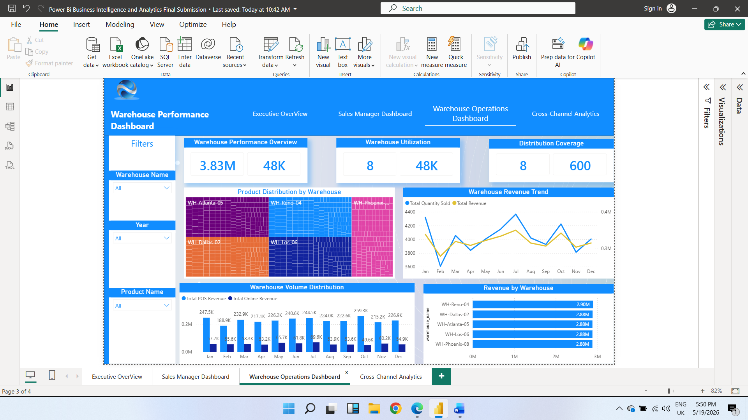
Figure 3 — Warehouse Operations Dashboard
The Warehouse Operations Dashboard is designed to monitor warehouse activity, operational efficiency, product distribution, and warehouse-level revenue performance. This dashboard provides operational managers with a centralized view of warehouse utilization, inventory movement, sales distribution, and warehouse contribution to overall business performance.

Key Components
1. Warehouse Performance Overview
KPI summary displaying total revenue generated and total quantity sold across all warehouses.
2. Warehouse Utilization
Compares the number of active warehouses against total operational volume to assess utilization efficiency.
3. Distribution Coverage
Measures total active warehouses against distribution capacity to provide insight into network scale and operational reach.
4. Product Distribution by Warehouse
This treemap visual displays how products are distributed across warehouses, identifying allocation patterns and inventory concentration.
5. Warehouse Revenue Trend
Line chart comparing total quantity sold and total revenue across monthly periods, enabling operational managers to monitor performance consistency.
6. Warehouse Volume Distribution
Clustered column chart comparing total POS revenue and total online revenue across monthly periods for channel-based warehouse performance analysis.
7. Revenue by Warehouse
Horizontal bar chart comparing revenue performance across individual warehouses to identify top performers and support optimization decisions.

Interactive Slicers
Users can filter operational analysis by Warehouse Name, Year, and Product Name.

Business Value
- Monitors warehouse productivity and utilization
- Evaluates warehouse contribution to total revenue
- Tracks warehouse operational trends over time
- Supports inventory distribution analysis
- Compares revenue generation across warehouse locations

11.4 Cross-Channel Analytics Dashboard
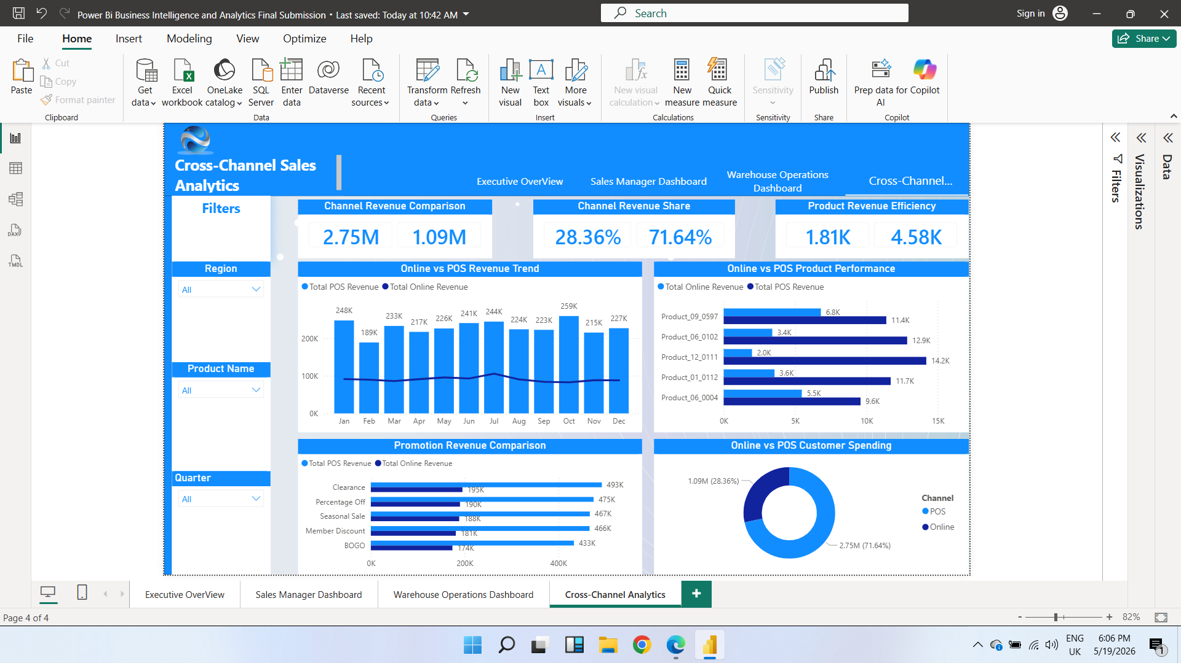
Figure 4 — Cross-Channel Analytics Dashboard
The Cross-Channel Analytics Dashboard is designed to analyze and compare business performance across both Online Sales and POS (Point-of-Sale) Sales channels. The dashboard provides management with insights into channel contribution, customer purchasing behavior, product performance, promotional effectiveness, and revenue trends across different sales platforms.

Key Components
1. Channel Revenue Comparison
KPI comparison visual displaying total revenue generated from POS and online sales channels, identifying the dominant revenue source.
2. Channel Revenue Share
Displays the percentage share of total revenue by channel:
- Online Revenue Share: 28.36%
- POS Revenue Share: 71.64%
3. Product Revenue Efficiency
Compares average online product revenue against average POS product revenue to identify which channel generates stronger product-level performance.
4. Online vs POS Revenue Trend
Combo chart comparing total POS revenue and total online revenue across monthly periods, enabling monitoring of seasonal performance differences between channels.
5. Online vs POS Product Performance
Horizontal bar chart comparing product revenue across both channels, identifying products performing better online versus through POS.
6. Promotion Revenue Comparison
Compares promotion effectiveness across channels for: Clearance, Percentage Off, Seasonal Sale, Member Discount, and BOGO promotions.
7. Online vs POS Customer Spending
Donut chart comparing customer spending distribution between online and POS channels, providing insight into customer engagement patterns.

Interactive Slicers
Users can filter analysis by Region, Product Name, and Quarter.

Business Value
- Compares Online and POS sales performance side by side
- Evaluates channel revenue contribution
- Identifies channel-specific product performance patterns
- Measures promotional campaign effectiveness across channels
- Monitors customer spending behavior
- Supports omnichannel business strategy development

